WEB TECHNOLOGIES
Assignment 2
Forms, Sidebars, Web Typography and Navigation
Three webpages built from scratch with semantic HTML5 and hand-written CSS3. Each question is documented with its objective, the techniques applied, annotated code snippets and a screenshot of the finished interface.
Submitted by | Areesha Khan
Course | Web Technologies
Submission date | 10 October 2026
Questions covered | Q1 – Q3 (three questions)
Technologies | HTML5, CSS3 (hand-written, no framework)
Live site | https://areeshakhan25.github.io/web-assignments/
Source repository | https://github.com/AreeshaKhan25/web-assignments

Contents
1. Question 1 — Campus Management System Login
2. Question 2 — Sidebar, Google Fonts and Horizontal Navigation
2A. Part A — A styled sidebar
2B. Part B — Different Google Fonts for headings and paragraphs
2C. Part C — A navigation list displayed horizontally
3. Question 3 — Contact Form Page
4. Conclusion

Introduction
This report documents the three questions of Assignment 2. As in the first assignment, every page is written in plain HTML5 and CSS3 with no framework and no build step; all styling lives in a single commented <style> block inside each file.
Where Assignment 1 concentrated on the box model and page composition, this assignment focuses on three further areas:
- Forms — labels, inputs, selects and textareas styled consistently, with accessible focus states
- Layout patterns — a fixed-width sidebar beside fluid content, and overlay layouts above a photograph
- Web typography — loading and pairing two Google Fonts so headings and body copy are distinct
- Navigation — turning a vertical list into a horizontal navigation bar
- CSS-generated art — backgrounds and textures produced from gradients rather than image files
Question 2 is split into three parts. Rather than producing three disconnected fragments, all three parts are demonstrated together on one coherent page, which is explained in detail in that section.
QUESTION 1

Campus Management System Login

Objective
Reproduce the CUI Wah Campus Management System v3.0 sign-in screen: a translucent login card beside a campus news panel, both floating above a full-bleed photograph of the campus, with a row of quick portal links and social icons across the bottom.

Approach
The body itself carries the campus photograph as a cover background, and a full-size overlay div darkens it slightly so white text stays readable. Two panels sit side by side inside a shared rounded shell: the sign-in card is almost opaque, while the news panel uses a lower opacity plus backdrop-filter: blur so the photograph shows through — the frosted effect in the original interface.
Requirement | How it was implemented
Page background | background-size: cover on the body with background-position: center bottom
Contrast overlay | An absolutely positioned div at inset: 0 filled with rgba(0,0,0,0.15)
Stacking | The overlay sits at z-index 0; the content sits at z-index 10 above it
Login panel | rgba(255,255,255,0.96) — nearly opaque for legibility
News panel | rgba(255,255,255,0.72) plus backdrop-filter: blur(2px) for the frosted look
Form fields | A shared .input-custom class with a slate fill and a navy focus ring
Icon placement | Icons pinned inside the fields using position: absolute and inset
Footer links | A flex row that wraps, with a 14px column gap and a 4px row gap
Responsive | Below 768px the two panels stack and the left border becomes a top border

Key code
/* The campus photograph fills the whole page */
body {
min-height: 100vh;
display: flex;
flex-direction: column;
justify-content: space-between;
position: relative;

background-image: url('https://cuiwah.edu.pk/assets/img/footer-back.jpg');
background-size: cover;
background-position: center bottom;
background-repeat: no-repeat;
}

/* A soft dark overlay that lifts text contrast over the photo */
.page-overlay {
position: absolute;
inset: 0;
background-color: rgba(0, 0, 0, 0.15);
pointer-events: none;
z-index: 0;
}
The full-bleed background and its contrast overlay.
/* Nearly opaque sign-in card */
.login-panel {
width: 50%;
padding: 28px 32px;
background-color: rgba(255, 255, 255, 0.96);
box-shadow: 0 4px 20px rgba(0, 0, 0, 0.25);
}

/* Frosted news panel — the campus photo shows through */
.news-panel {
width: 50%;
padding: 24px;
background-color: rgba(255, 255, 255, 0.72);
backdrop-filter: blur(2px);
border-left: 1px solid rgba(226, 232, 240, 0.5);
box-shadow: 0 4px 20px rgba(0, 0, 0, 0.2);
}
Two different opacities create the contrast between the two panels.
<!-- An icon pinned inside the field using absolute positioning -->
<div class="field">
<input class="input-custom" type="text" aria-label="Username or Email"
placeholder="Username / Email" value="shahidkhan@ciitwah.edu.pk">
<span class="field-icon"><i class="fa-solid fa-envelope"></i></span>
</div>
The field wrapper is position: relative so the icon can be positioned against it.
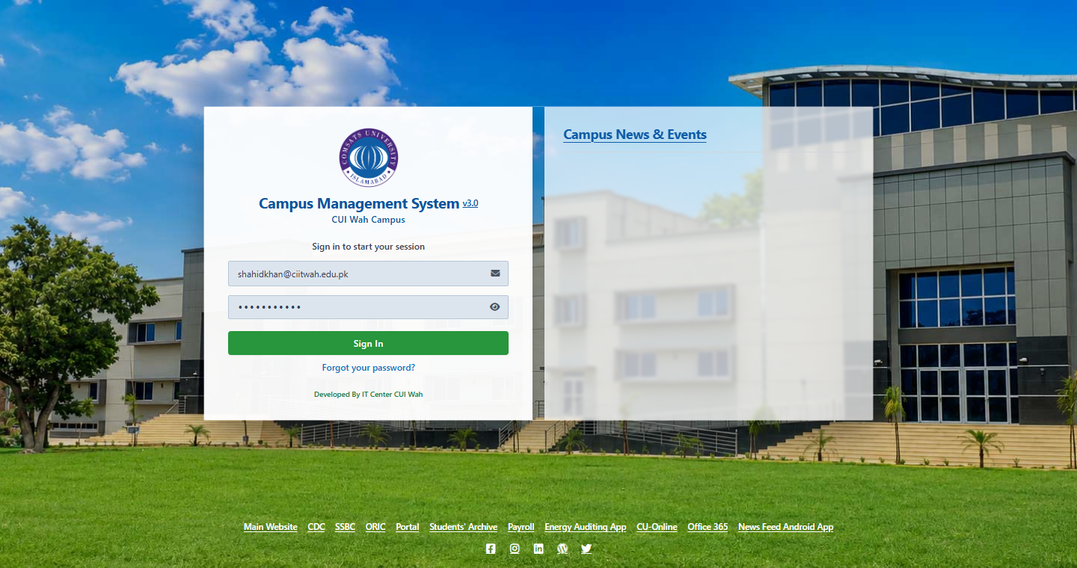
Figure 1 — The Campus Management System login screen over the campus photograph.
QUESTION 2

Sidebar, Google Fonts and Horizontal Navigation

Objective
This question has three separate parts:
- Part A — Create a sidebar with a different background colour, width, padding and border.
- Part B — Create a webpage with different fonts for the heading and paragraph using Google Fonts.
- Part C — Make a navigation list display horizontally.

Approach
The three parts are demonstrated together on one page — a departmental Campus Portal — rather than as three isolated snippets. This shows each technique in a realistic context and lets the parts contrast with one another: the horizontal navigation in the header sits directly above a deliberately vertical menu inside the sidebar, which makes the difference between the two list treatments immediately visible.
The page is laid out as a flex row: a fixed-width sidebar that does not shrink, beside a content column that takes the remaining space.
.layout {
max-width: 1180px;
margin: 32px auto;
padding: 0 32px;
display: flex;
align-items: flex-start;
gap: 28px;
}
The page shell: a fixed sidebar beside a fluid content column.

Part A — A sidebar with its own background, width, padding and border
The sidebar is given each of the four required properties explicitly. Its measurements are declared as custom properties on :root so the width, padding and colours can be adjusted from one place. flex-shrink: 0 is important — without it, flexbox would squeeze the sidebar narrower than its stated width when the content column grew.
:root {
--sidebar-bg: #123c53; /* sidebar background colour */
--sidebar-border: #0c2a3b; /* sidebar border colour */
--sidebar-width: 280px; /* sidebar width */
--sidebar-pad: 28px; /* sidebar padding */
}

.sidebar {
width: var(--sidebar-width); /* width */
flex-shrink: 0; /* never squashed */
padding: var(--sidebar-pad); /* padding */
background-color: var(--sidebar-bg); /* background */
border: 3px solid var(--sidebar-border); /* border */
border-radius: 12px;
color: #e7eff4;
box-shadow: 0 8px 24px -8px rgba(18, 60, 83, 0.18);
}
Part A — all four required properties, applied to the sidebar.
<aside class="sidebar">
<h2>Student Panel</h2>

<h3>Quick Links</h3>
<ul class="sidebar-menu">
<li><a href="#">Dashboard</a></li>
<li><a href="#">My Courses</a></li>
<li><a href="#">Attendance Record</a></li>
<li><a href="#">Fee Challan</a></li>
<li><a href="#">Transcript</a></li>
<li><a href="#">Library Account</a></li>
</ul>
...
</aside>
The sidebar markup. Its own menu stays vertical, contrasting with the header navigation.

Part B — Different Google Fonts for headings and paragraphs
Two families are requested from Google Fonts in a single stylesheet link, which is more efficient than two separate requests. Merriweather, a serif, is applied to every heading; Open Sans, a humanist sans-serif, is applied to body copy. Pairing a serif with a sans-serif gives an obvious visual hierarchy without needing to change colour or size.
The two preconnect links are a performance detail: they open the connection to the Google Fonts servers before the stylesheet is requested, so the fonts arrive sooner.
<!-- Both families requested in one stylesheet link -->
<link rel="preconnect" href="https://fonts.googleapis.com">
<link rel="preconnect" href="https://fonts.gstatic.com" crossorigin>
<link rel="stylesheet" href="https://fonts.googleapis.com/css2?family=Merriweather:wght@400;700;900&family=Open+Sans:wght@400;600;700&display=swap">
Part B — requesting both Google Fonts in one HTTP request.
/* Paragraph text uses Open Sans (sans-serif) */
body {
font-family: 'Open Sans', Arial, Helvetica, sans-serif;
font-size: 15px;
line-height: 1.7;
color: var(--ink);
}

/* Every heading uses Merriweather (serif) */
h1, h2, h3, h4 {
font-family: 'Merriweather', Georgia, 'Times New Roman', serif;
line-height: 1.3;
color: var(--ink);
}
Part B — a serif for headings and a sans-serif for body copy, each with fallbacks.
Each declaration ends with generic fallbacks, so the page still renders sensibly if the Google Fonts request fails. The page also includes a side-by-side specimen panel showing both faces with the CSS that produces them.

Part C — A navigation list displayed horizontally
By default, list items are block-level, so each one starts on a new line. Turning the <ul> into a flex container lays its children out along a row instead. flex-wrap: wrap allows the links to drop onto a second line on narrow screens rather than overflowing.
Each link is then made display: block so its padding becomes a full clickable target — a detail that matters for usability, since an inline <a> would only respond to clicks on the text itself.
/* The horizontal list itself */
.main-nav ul {
display: flex; /* lay the list items out in a row */
flex-wrap: wrap; /* wrap onto a second line if needed */
align-items: center;
gap: 6px;
}

.main-nav li {
display: inline-block; /* each item sits inline, not on its own line */
}

.main-nav a {
display: block; /* padding becomes the clickable area */
padding: 9px 16px;
font-size: 14px;
font-weight: 600;
color: #d8e6ee;
border-radius: 6px;
transition: background-color 0.2s ease, color 0.2s ease;
}

.main-nav a:hover {
background-color: rgba(255, 255, 255, 0.12);
color: #ffffff;
}

.main-nav a.active {
color: var(--accent-ink);
background-color: var(--accent); /* the current page */
}
Part C — display: flex on the <ul> turns a vertical list into a horizontal navigation bar.
<nav class="main-nav">
<ul>
<li><a class="active" href="#">Home</a></li>
<li><a href="#">Courses</a></li>
<li><a href="#">Faculty</a></li>
<li><a href="#">Notices</a></li>
<li><a href="#">Results</a></li>
<li><a href="#">Contact</a></li>
</ul>
</nav>
The navigation markup is an ordinary unordered list — only the CSS makes it horizontal.
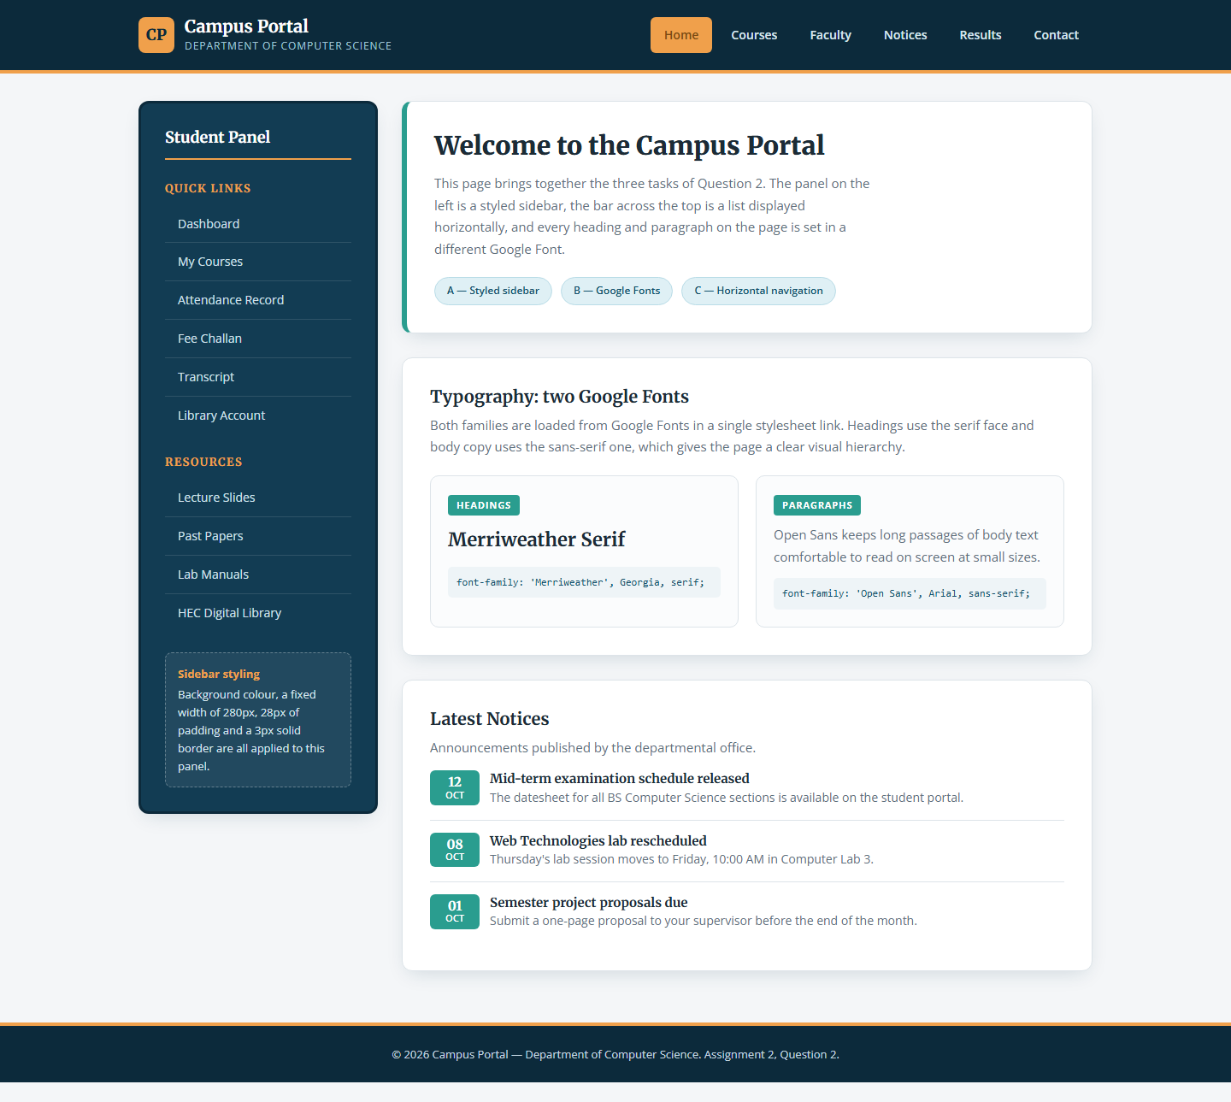
Figure 2 — All three parts on one page: styled sidebar (A), paired Google Fonts (B) and horizontal navigation (C).
QUESTION 3

Contact Form Page

Objective
Build a two-column contact page: an introduction with a circular profile photograph and a LinkedIn link on the left, and an enquiry form on the right containing name, job title, email, a budget dropdown, a message textarea and a send button — all set on a patterned teal background.

Approach
The layout is a CSS Grid split 5fr / 7fr, which gives the form the wider column it needs. The patterned background is generated entirely in CSS: nine layered gradients — three radial for soft lighting and six linear at 30°, 150° and 60° — combine into a subtle geometric watermark, so the page needs no background image file at all.
Requirement | How it was implemented
Two columns | display: grid with grid-template-columns: 5fr 7fr and a 56px gap
Background | Nine layered CSS gradients producing a hexagonal watermark
Avatar frame | border-radius: 50% with a 5px white ring and object-fit: cover
Form controls | One .form-input-white class shared by inputs, select and textarea
Focus state | A translucent white ring via box-shadow rather than the default outline
Custom select | appearance: none removes the native arrow; an inline SVG replaces it
Send button | border-radius: 9999px for a pill, with a subtle scale on :active
Responsive | Below 900px the grid collapses to a single column and the avatar shrinks

Key code
/* The teal watermark, built entirely from layered gradients */
body {
background-color: #5abdbd;
background-image:
radial-gradient(circle at 85% 60%, rgba(255, 255, 255, 0.08) 0%, transparent 40%),
radial-gradient(circle at 10% 80%, rgba(255, 255, 255, 0.07) 0%, transparent 45%),
radial-gradient(circle at 45% 40%, rgba(0, 0, 0, 0.03) 0%, transparent 50%),
linear-gradient(30deg, rgba(255,255,255,0.04) 12%, transparent 12.5%,
transparent 87%, rgba(255,255,255,0.04) 87.5%),
linear-gradient(150deg, rgba(255,255,255,0.04) 12%, transparent 12.5%,
transparent 87%, rgba(255,255,255,0.04) 87.5%),
/* ... four further linear gradients ... */;
background-size:
100% 100%, 100% 100%, 100% 100%,
80px 140px, 80px 140px, 80px 140px, 80px 140px, 80px 140px, 80px 140px;
}
Nine gradient layers replace what would otherwise be a background image.
/* Two-column layout: the form gets the wider track */
.layout {
display: grid;
grid-template-columns: 5fr 7fr; /* 5/12 and 7/12 split */
gap: 56px;
align-items: start;
}

/* One class styles every white control on the teal background */
.form-input-white {
width: 100%;
font-family: inherit;
font-size: 14px;
background-color: #ffffff;
border: 1px solid #ffffff;
border-radius: 4px;
color: #333333;
box-shadow: 0 1px 2px rgba(0, 0, 0, 0.04);
outline: none;
}

.form-input-white:focus {
box-shadow: 0 0 0 2px rgba(255, 255, 255, 0.5); /* visible focus ring */
}

/* Shared class, different sizing per control type */
input.form-input-white,
select.form-input-white { height: 44px; padding: 0 14px; }

textarea.form-input-white { padding: 14px; min-height: 140px; resize: vertical; }
The grid split and the single class that styles every form control.
/* Custom select: the native arrow is removed and replaced with an SVG */
select.form-input-white {
padding-right: 32px;
cursor: pointer;
appearance: none;
-webkit-appearance: none;
}

.select-chevron {
position: absolute;
top: 0; right: 0; bottom: 0;
display: flex;
align-items: center;
padding: 0 12px;
color: #4b5563;
pointer-events: none; /* clicks pass through to the select beneath */
}
pointer-events: none lets the chevron sit above the select without blocking it.
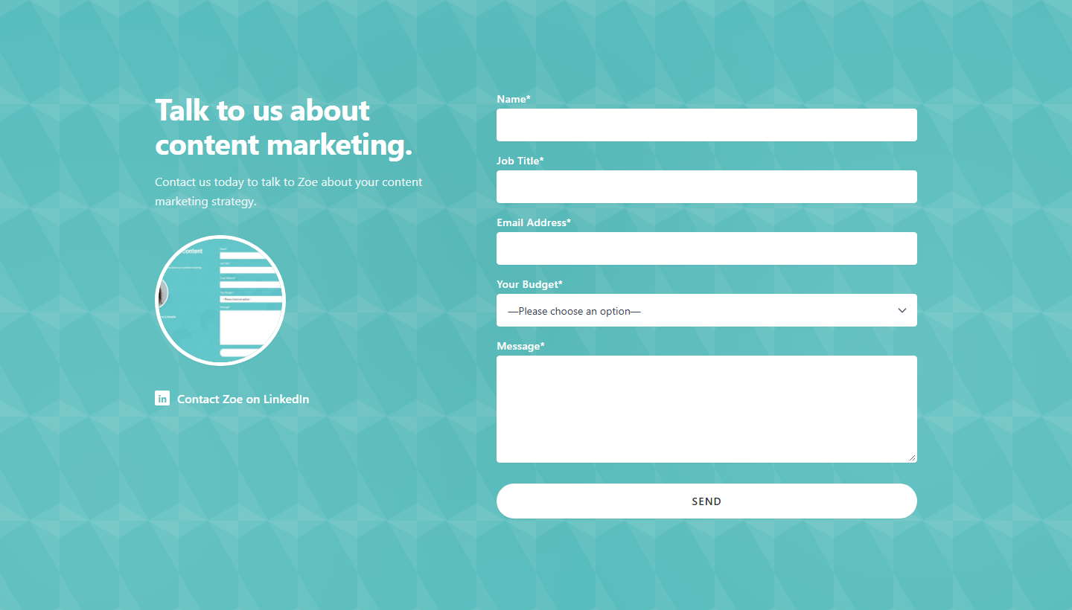
Figure 3 — The contact page: a two-column layout on a CSS-generated teal pattern.

Conclusion
All three questions of Assignment 2 were completed as responsive webpages written in plain HTML5 and CSS3. Question 2 was treated as one integrated page rather than three fragments, which let the three techniques be compared against one another directly — most clearly in the contrast between the horizontal header navigation and the vertical sidebar menu sitting immediately beneath it.
The main points learned were:
- Flexbox controls list direction — a navigation bar is an ordinary <ul>; display: flex on the list is the single declaration that makes it horizontal
- flex-shrink: 0 protects fixed widths — without it a flex item will be compressed below its stated width when its sibling grows
- Font pairing creates hierarchy — a serif for headings against a sans-serif for body copy separates the two levels without any change of size or colour
- Always declare font fallbacks — a generic family at the end of the stack keeps the page readable if the web font fails to load
- Gradients can replace images — a layered background-image of gradients produces texture with no network request and no file to maintain
- Styling native form controls — appearance: none plus pointer-events: none on the overlay is the reliable way to replace a select's dropdown arrow
- Never remove focus indicators — replacing the default outline with a box-shadow ring keeps keyboard navigation usable while matching the design
All three pages are published and can be viewed live at https://areeshakhan25.github.io/web-assignments/

