WEB TECHNOLOGIES
Assignment 1
HTML & CSS — Components, Layout and Page Composition
Five webpages built from scratch with semantic HTML5 and hand-written CSS3. Each question is documented with its objective, the techniques applied, annotated code snippets and a screenshot of the finished interface.
Submitted by | Areesha Khan
Registration number | SP24-BSE-006
Course | Web Technologies
Submission date | 24 September 2026
Questions covered | Q1 – Q5 (five questions)
Technologies | HTML5, CSS3 (hand-written, no framework)
Live site | https://areeshakhan25.github.io/web-assignments/
Source repository | https://github.com/AreeshaKhan25/web-assignments

Contents
1. Question 1 — Practical Questions Showcase
2. Question 2 — University Admission Webpage
3. Question 3 — Product Advertisement Page
4. Question 4 — Faculty Portal Login Interface
5. Question 5 — Restaurant Menu Website
6. Conclusion

Introduction
This report documents five webpages produced for Assignment 1. Every page is written in plain HTML5 and CSS3: there is no CSS framework, no utility-class library and no build step. All styling lives in a single commented <style> block inside each file, so every rule can be read and traced directly.
The following techniques are demonstrated across the five questions:
- Box model — margin, padding, border, outline, width/height and the min-/max- constraints
- Modern layout — CSS Grid for two-dimensional layouts and Flexbox for one-dimensional rows
- Visual design — border-radius, box-shadow, linear and radial gradients, and layered backgrounds
- Design tokens — CSS custom properties declared once on :root and reused throughout
- Typography — Google Fonts paired to separate display headings from body copy
- Responsiveness — media queries that reflow each layout for tablet and phone widths
- Interaction — hover, focus and active states on every link, button and form control
Project structure
site/
├── index.html Landing page with routing to every question
├── assignment-1/
│ ├── question-1/index.html Practical questions showcase
│ ├── question-2/index.html University admission webpage
│ ├── question-3/index.html Product advertisement page
│ ├── question-4/index.html Faculty portal login interface
│ └── question-5/index.html Restaurant menu website
├── assignment-2/
│ ├── question-1/index.html Campus management system login
│ ├── question-2/index.html Sidebar, Google Fonts & horizontal nav
│ └── question-3/index.html Contact form page
└── docs/ These assignment reports
Every question folder also holds a screenshot.png of the rendered page.
QUESTION 1

Practical Questions Showcase
Live page: https://areeshakhan25.github.io/web-assignments/assignment-1/question-1/

Objective
Build a single page that presents eight independent user-interface components side by side, each inside its own labelled panel. The eight components are a student profile card, a row of product cards, a college notice box, a login form, a college website header, an about-us section, a faculty section and a full website footer.

Approach
The page is a two-column CSS Grid of eight panels. Every panel shares the same shell — a tinted title bar above a white body — so the eight very different components read as one consistent catalogue. Colours are declared once as custom properties on :root, which keeps the blue accent, border colour and shadow identical across all eight components.
Requirement | How it was implemented
Panel grid | display: grid with grid-template-columns: repeat(2, 1fr) and a 24px gap
Shared shell | A .panel-head title bar and .panel-body content area reused eight times
Profile card | Flexbox row; the detail rows use a 130px fixed label column via CSS Grid
Product cards | A three-column grid; each card is a flex column so the buttons align
Notice box | A 2px dashed border with a warm background and a Font Awesome megaphone
Login form | A white card centred on a three-stop linear-gradient background
Website header | A background photo with an absolutely positioned gradient scrim for contrast
Footer | A three-column grid on a dark background with branded social-icon tiles

Key code
/* ---------- Design tokens ---------- */
:root {
--page-bg: #f0f5fa;
--panel-head: #d9e9f9;
--panel-title: #1e3a8a;
--blue: #1a73e8;
--border: #e2e8f0;
--shadow-sm: 0 1px 2px rgba(0, 0, 0, 0.05);
}

/* ---------- Showcase grid: two panels per row ---------- */
.showcase {
max-width: 1280px;
margin: 0 auto;
display: grid;
grid-template-columns: repeat(2, 1fr);
gap: 24px;
}

/* ---------- Panel shell shared by all eight questions ---------- */
.panel-head {
padding: 8px 16px;
font-weight: 600;
color: var(--panel-title);
background-color: var(--panel-head);
border-bottom: 1px solid #bfdbfe;
border-radius: 6px 6px 0 0;
}

.panel-body {
flex: 1;
display: flex;
align-items: center;
justify-content: center;
padding: 20px;
background-color: #ffffff;
border: 1px solid var(--border);
border-radius: 0 0 6px 6px;
}
The grid and the reusable panel shell that wraps all eight components.
<!-- The profile card: a flex row of photo column + detail column -->
<div class="profile-card">
<div class="profile-photo-col">
<img src="..." alt="Muhammad Shahid Khan">
<button class="btn-blue profile-badge">BS Computer Science</button>
</div>
<div class="profile-info">
<h2>Muhammad Shahid Khan</h2>
<div class="profile-row">
<span class="label">Registration No:</span>
<span class="value">FA23-CS-001</span>
</div>
...
</div>
</div>
HTML for component 1. The .profile-row grid keeps every label aligned on a 130px column.
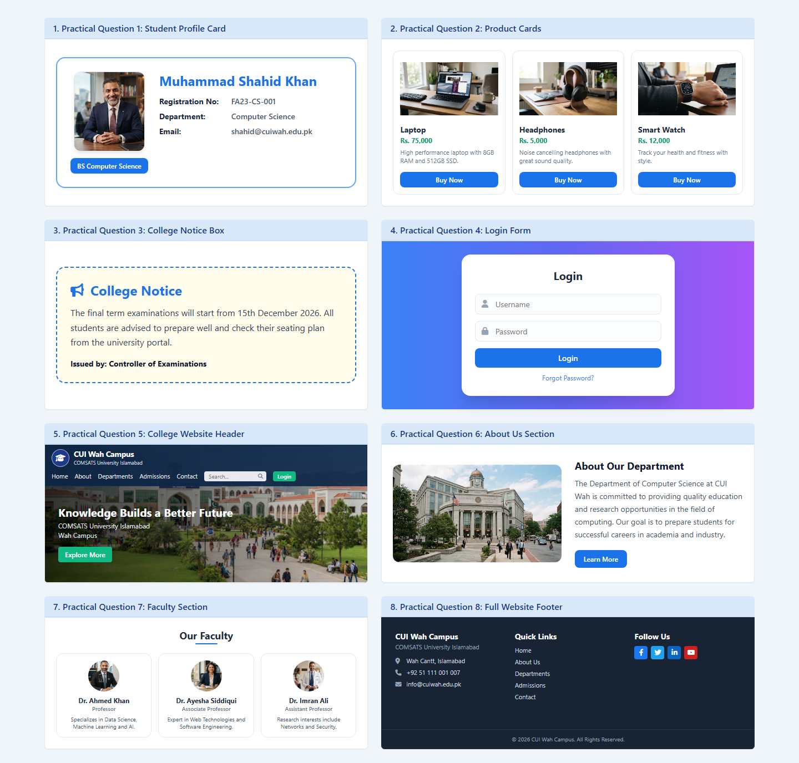
Figure 1 — All eight practical components rendered on one page.
QUESTION 2

University Admission Webpage
Live page: https://areeshakhan25.github.io/web-assignments/assignment-1/question-2/

Objective
Create a university admission webpage containing a header with the university name and admission title, an admission-information area covering undergraduate programs, graduate programs, admission requirements and important dates, and an application section built around a visually highlighted application box.
The application box had to apply background colours, text colours, borders, padding, margins, width and height, border-radius, box-shadow and an outline, and it had to be constrained by both a minimum and a maximum width.

Approach
The page opens with a sticky brand header, then a gradient hero holding a frosted-glass frame, a dark statistics band, a 2x2 grid of admission-information cards, a campus-life banner, and finally the application section. The four information cards map one-to-one onto the four topics the brief lists, and each is colour-coded with a pastel icon badge.
Requirement | How it was implemented
Header | A sticky translucent bar carrying the university name and admission title
Hero | A 135° linear-gradient panel behind a backdrop-filter: blur frosted frame
Stats band | A three-column grid on the deep-forest brand colour with divider rules
Information grid | grid-template-columns: repeat(2, 1fr) — the four required topics
Application box | Its own background, border, outline, spacing and size constraints
Form | Labelled inputs and selects with a shared .custom-input focus ring
Footer | A four-column grid over a darkened campus photograph

Key code — the highlighted application box
This single rule carries every property the question asks for. The outline sits 8px outside the 3px navy border, which produces the double-framed effect, and the clay-orange offset shadow gives the box a printed, card-like edge.
.app-box {
background-color: var(--warm-white); /* background colour */
color: var(--ink); /* text colour */
border: 3px solid var(--navy); /* border */
outline: 4px solid #ffffff; /* outline */
outline-offset: 8px; /* outline sits clear */
padding: 40px; /* internal spacing */
margin: 12px auto; /* external spacing */
width: 100%; /* width */
min-width: 300px; /* minimum width */
max-width: 520px; /* maximum width */
min-height: 520px; /* height */
border-radius: 28px; /* rounded corners */
box-shadow: 0 24px 48px -12px rgba(27, 42, 115, 0.16),
0 6px 0 0 var(--clay); /* box shadow */
}
Every property required by the brief, applied to the application box.
/* Shared styling for the form controls inside the application box */
.custom-input {
width: 100%;
padding: 12px 16px;
font-family: inherit;
font-size: 14px;
color: var(--ink);
background-color: #ffffff;
border: 1.5px solid #d8dde8;
border-radius: 12px;
transition: all 0.2s ease;
}

.custom-input:focus {
outline: none;
border-color: var(--navy);
box-shadow: 0 0 0 3px rgba(27, 42, 115, 0.12); /* visible focus ring */
}
One class styles every text input and select, including the accessible focus state.
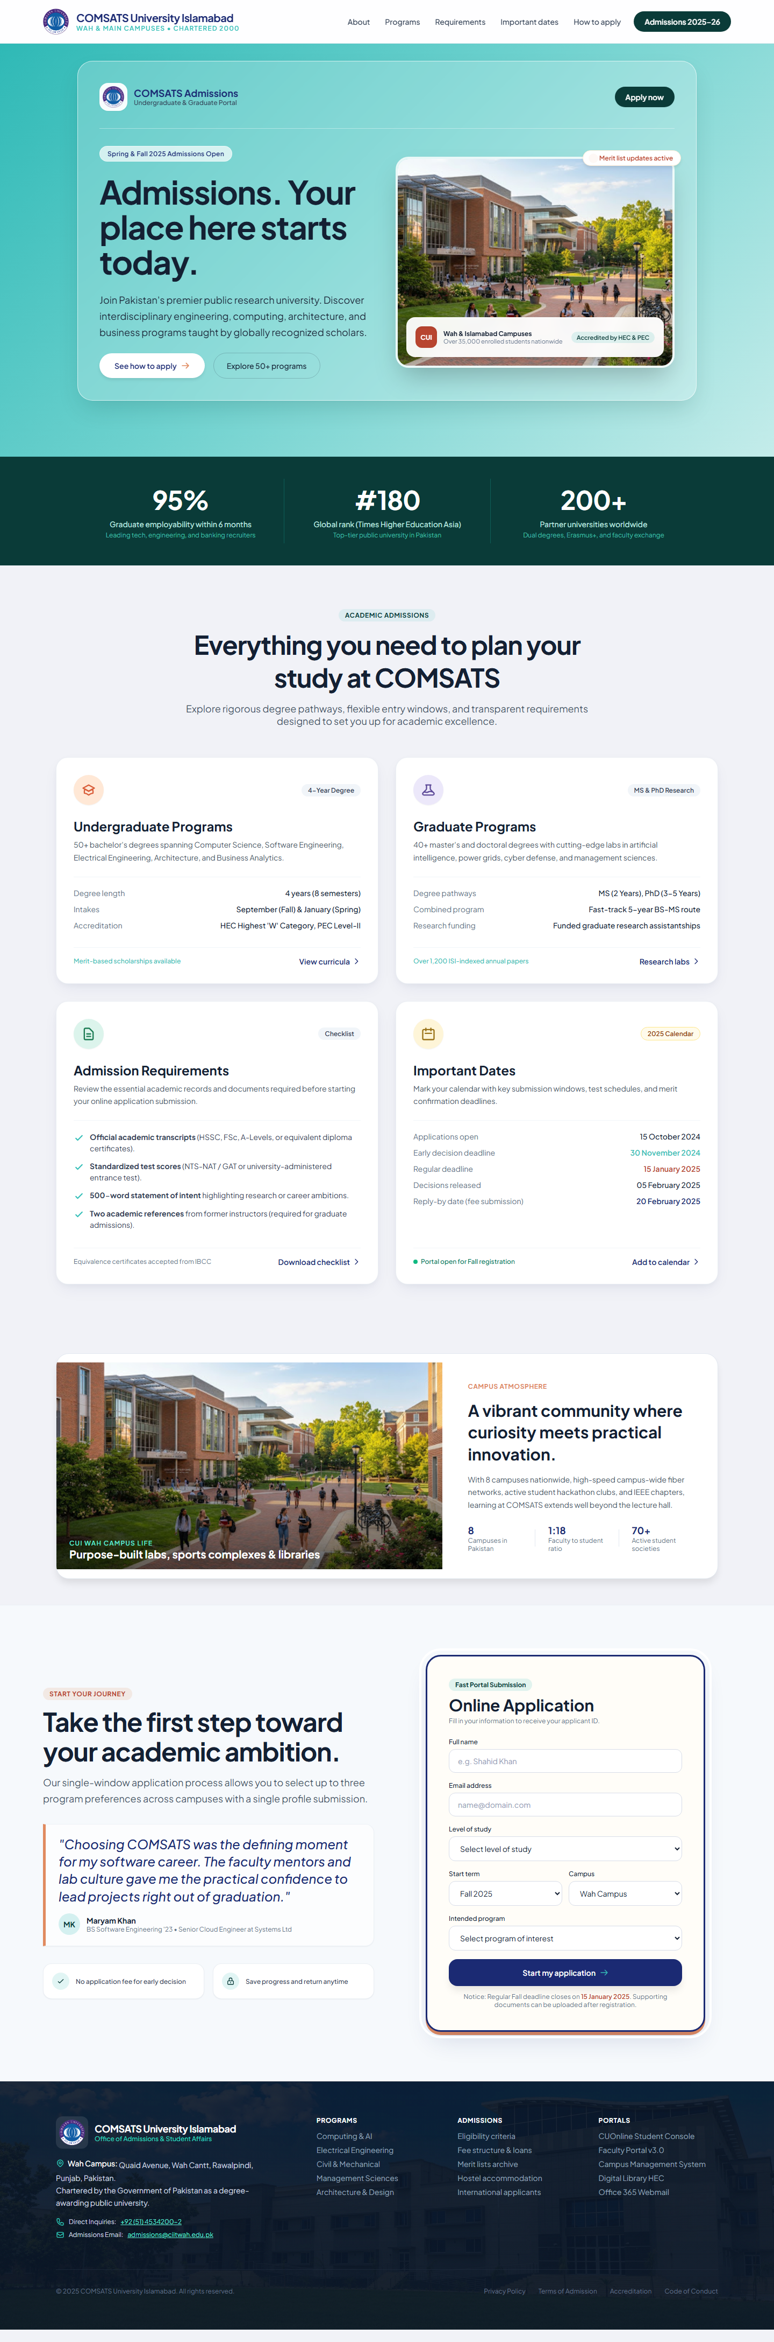
Figure 2 — The admission webpage: header, information cards and application box.
QUESTION 3

Product Advertisement Page
Live page: https://areeshakhan25.github.io/web-assignments/assignment-1/question-3/

Objective
Build a webpage advertising laptops and mobile phones. Each product must show an image, name, description, price, a feature list and a “Buy Now” button. The product card itself had to be 300–400px wide, carry a border and rounded corners, use padding for internal spacing and margin for external spacing, apply a box-shadow, give the price section a different background colour, place an outline around the Buy Now area, fit the image inside the card using width constraints, and use classes for repeated styling.

Approach
Three product cards sit in a responsive grid: two laptops and one smartphone. Every card is built from the same set of classes, so adding a fourth product needs no new CSS — only a pastel tint class on the image tile. The surrounding page gives the cards context with a gradient hero, a partner strip, a benefits panel, a statistics grid and a trade-in banner.
Requirement | How it was implemented
Card width | max-width: 380px — inside the 300–400px band the brief specifies
Border & radius | border: 2px solid; border-radius: 22px
Internal spacing | padding: 20px on the card itself
External spacing | margin: 16px, plus a 32px grid gap between cards
Box shadow | A two-layer --shadow-card token for a soft, realistic lift
Price section | A deep-navy .price-box panel — a different background from the card
Buy Now outline | A coral border plus an offset outline that appears on hover
Image fitting | width: 100%; height: 100%; object-fit: contain inside a fixed tile
Repeated styling | Shared .product-card, .feature-list, .tick and .btn-buy classes

Key code — the product card
/* Card: 300–400px wide, border + rounded corners, padding, margin, shadow */
.product-card {
width: 100%;
max-width: 380px; /* card width band */
margin: 16px; /* external spacing */
padding: 20px; /* internal spacing */
display: flex;
flex-direction: column;
justify-content: space-between;
background-color: #ffffff;
border: 2px solid rgba(226, 232, 240, 0.9); /* border */
border-radius: 22px; /* rounded */
box-shadow: var(--shadow-card); /* shadow */
transition: border-color 0.2s ease;
}

/* The image is constrained by the tile, never overflowing the card */
.product-media {
width: 100%;
height: 224px;
padding: 12px;
display: flex;
align-items: center;
justify-content: center;
overflow: hidden;
border-radius: 16px;
}

.product-media img {
width: 100%;
height: 100%;
object-fit: contain; /* fits inside without distortion */
}
The reusable product-card class and the width-constrained image tile.
/* Price section — a different background colour from the rest of the card */
.price-box {
display: flex;
align-items: center;
justify-content: space-between;
padding: 14px;
color: #ffffff;
background-color: var(--navy);
border-radius: 12px;
}

/* "Buy Now" — a coral border plus a second outline revealed on hover */
.btn-buy {
width: 100%;
padding: 12px 16px;
color: var(--coral);
background-color: #ffffff;
border: 2.5px solid var(--coral);
border-radius: 12px;
outline: 2px solid transparent;
outline-offset: 3px;
transition: all 0.2s ease;
}

.btn-buy:hover {
outline-color: var(--coral); /* the outline appears, offset from the border */
transform: translateY(-1px);
}
The contrasting price panel and the outlined Buy Now control.
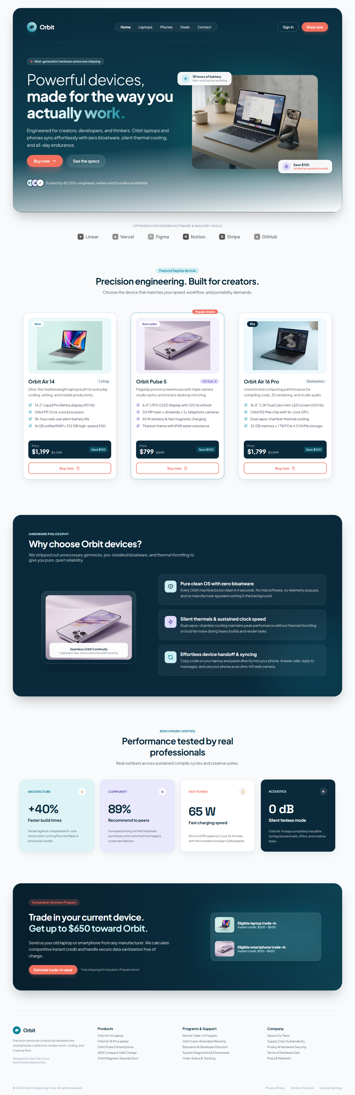
Figure 3 — The product advertisement page with three fully styled product cards.
QUESTION 4

Faculty Portal Login Interface
Live page: https://areeshakhan25.github.io/web-assignments/assignment-1/question-4/

Objective
Reproduce the CUOnline Faculty Portal sign-in screen: a split-screen layout with a dark branded marketing panel on one side and a white authentication card on the other, including validated field states, a distorted security code and a working password toggle.

Approach
The screen is a flex row split 58/42. The left panel layers three radial gradients over a forest-green base and adds two soft glow circles for depth. The right panel centres a rounded white card. The captcha box is drawn entirely in CSS — the two crossing noise strokes are ::before and ::after pseudo-elements, so no image file is needed.
Requirement | How it was implemented
Split layout | display: flex with the panels at 58% and 42% width
Brand gradient | Three layered radial-gradient() stops over a #075239 base colour
Ambient glows | Absolutely positioned circles with a radial-gradient fill
Login card | A 430px max-width card with a two-layer shadow and a 16px radius
Validated fields | An emerald border plus an inline tick icon positioned with inset
Captcha | A dark box whose ::before and ::after draw rotated coloured strike lines
Password toggle | A small script that swaps the input type between password and text
Responsive | Below 1024px the flex direction becomes a column and the panels stack

Key code
/* Deep forest gradient field built from three radial gradients */
.brand-panel {
width: 58%;
padding: 56px 80px;
display: flex;
flex-direction: column;
justify-content: space-between;
position: relative;
overflow: hidden;
background-color: #075239;
background-image:
radial-gradient(circle at 100% 0%, rgba(16, 120, 80, 0.45) 0%, transparent 45%),
radial-gradient(circle at 10% 95%, rgba(13, 98, 66, 0.50) 0%, transparent 40%),
radial-gradient(circle at -5% 45%, rgba(6, 68, 46, 0.30) 0%, transparent 35%);
}
The layered gradient background of the branding panel.
/* The security-code box, drawn without any image */
.captcha-box {
position: relative;
overflow: hidden;
background: #0d0a14;
border-radius: 8px;
box-shadow: inset 0 1px 3px rgba(0, 0, 0, 0.6);
}

/* Two crossing noise strokes over the code */
.captcha-box::before {
content: '';
position: absolute;
top: 30%; left: 10%;
width: 80%; height: 2px;
background: rgba(217, 70, 239, 0.55);
transform: rotate(-12deg);
}

.captcha-box::after {
content: '';
position: absolute;
top: 55%; left: 20%;
width: 65%; height: 1.5px;
background: rgba(56, 189, 248, 0.45);
transform: rotate(8deg);
}
Pseudo-elements produce the captcha distortion lines entirely in CSS.
/* Show / hide the password when the eye button is clicked */
var toggleBtn = document.getElementById('togglePassword');
var passwordInput = document.getElementById('faculty-password');

if (toggleBtn && passwordInput) {
toggleBtn.addEventListener('click', function () {
var isPassword = passwordInput.getAttribute('type') === 'password';
passwordInput.setAttribute('type', isPassword ? 'text' : 'password');
});
}
The only JavaScript on the page — the password visibility toggle.
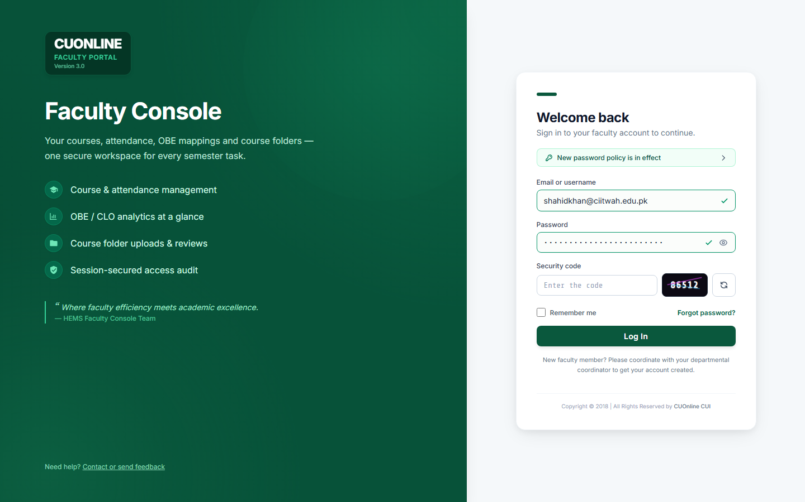
Figure 4 — The Faculty Console split-screen sign-in interface.
QUESTION 5

Restaurant Menu Website
Live page: https://areeshakhan25.github.io/web-assignments/assignment-1/question-5/

Objective
Build a complete restaurant website: a branded header with horizontal navigation, a hero banner, a menu divided into four categories each holding three dishes, and a footer with contact details and social links.

Approach
The whole site sits inside a rounded, shadowed container so it reads as a finished product. The four menu categories — Starters, Main Course, Desserts and Drinks — share one .category class and differ only by a modifier class. Each theme is defined once in :root as four custom properties, so a category can be recoloured by editing a single line.
Requirement | How it was implemented
Colour themes | Four variables per category declared on :root and applied by modifier class
Header | A flex row with the logo on the left and a horizontal nav on the right
Active page | The current nav link becomes a yellow pill via an .nav-active class
Hero banner | A flex row of cream text panel and photograph, joined by a gradient fade
Menu grid | A two-column grid of categories; each holds a three-column dish grid
Dish cards | Flex columns with a 16:9 aspect-ratio thumbnail so the prices align
Price button | The price doubles as the order button, tinted by the category theme
Typography | Playfair Display for display headings, Poppins for interface text

Key code — theming four categories from one class
:root {
--starters: #3b8744;
--starters-hover: #327339;
--starters-light: #eef8ef;
--starters-border: #a2cf9c;

--main: #e06d26;
--main-hover: #cb5c18;
--main-light: #fdf3ec;
--main-border: #facdb3;
/* ... desserts and drinks follow the same four-token pattern ... */
}

/* One shared structure for every category panel */
.category {
display: flex;
flex-direction: column;
justify-content: space-between;
border-radius: 12px;
overflow: hidden;
box-shadow: 0 1px 2px rgba(0, 0, 0, 0.05);
}

/* Each theme only needs four lines */
.cat-starters { background-color: var(--starters-light);
border: 1px solid var(--starters-border); }
.cat-starters .category-head { background-color: var(--starters); }
.cat-starters .price-btn { background-color: var(--starters); }
.cat-starters .price-btn:hover{ background-color: var(--starters-hover); }
Four categories, one structure — the colour scheme is swapped by a modifier class.
<!-- Horizontal navigation; the current page carries .nav-active -->
<nav class="main-nav">
<a class="nav-active" href="#">Home</a>
<a href="#">Menu</a>
<a href="#">About Us</a>
<a href="#">Contact</a>
</nav>
The header navigation markup.
/* Dish thumbnails hold a fixed 16:9 ratio so every card lines up */
.item-thumb {
width: 100%;
aspect-ratio: 16 / 9;
border-radius: 4px;
overflow: hidden;
}

.item-thumb img {
width: 100%;
height: 100%;
object-fit: cover;
}
aspect-ratio keeps all twelve dish cards on a consistent grid.
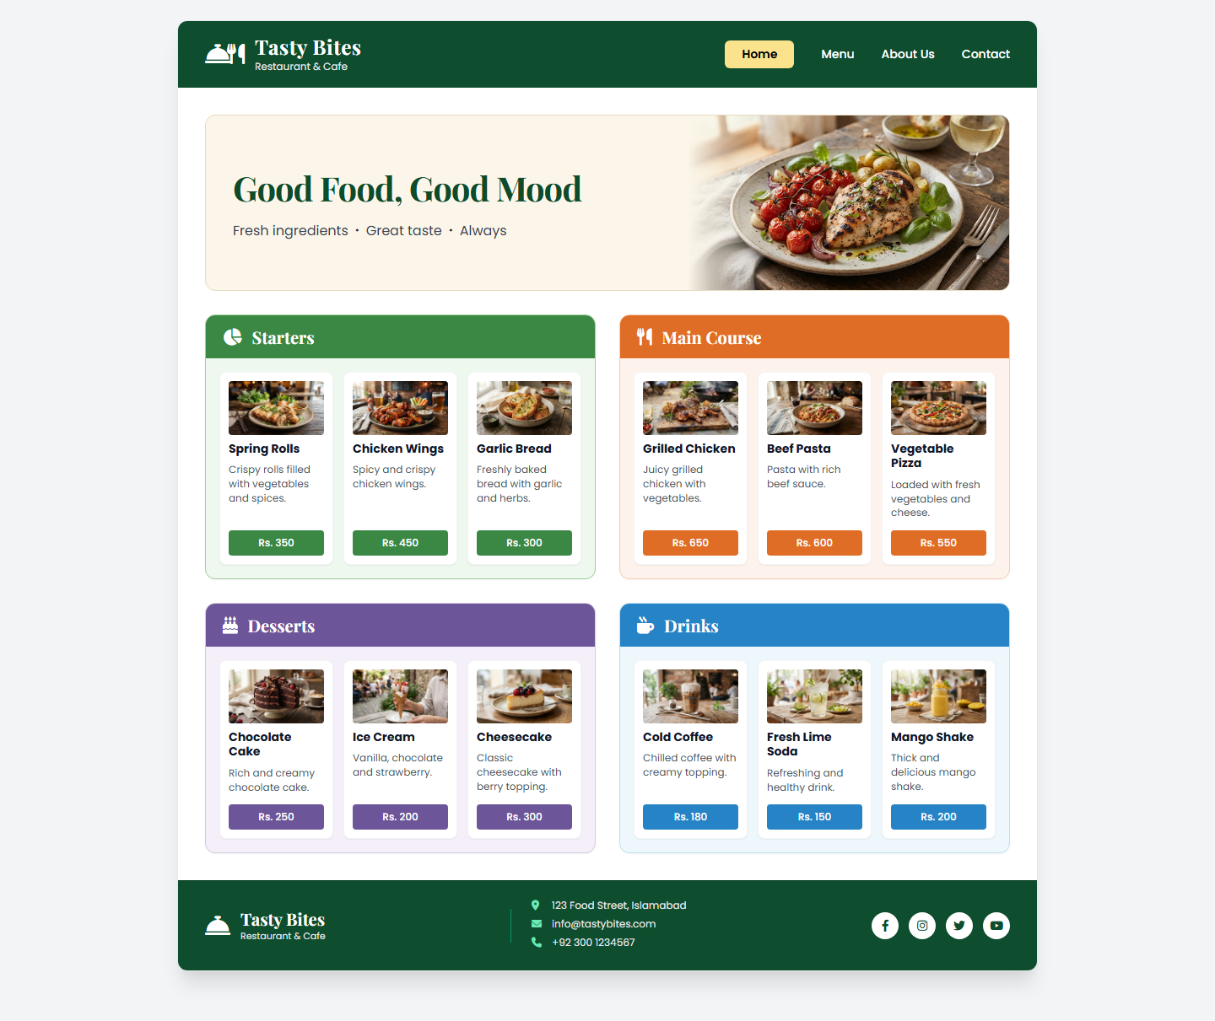
Figure 5 — The Tasty Bites restaurant website with four themed menu categories.

Conclusion
All five questions of Assignment 1 were completed as fully responsive webpages written in plain HTML5 and CSS3. Working without a framework meant every border, shadow, gradient and grid track had to be declared explicitly, which is exactly what made the box model and the cascade concrete rather than abstract.
The most useful techniques learned across the five pages were:
- Custom properties — declaring a palette once on :root removed every duplicated hex value and made recolouring a whole section a one-line change
- Grid versus Flexbox — Grid for page-level two-dimensional layouts, Flexbox for rows and for pushing a card's footer to the bottom with justify-content: space-between
- Border against outline — a border occupies layout space while an outline does not, which is what makes the double-framed application box in Question 2 possible
- object-fit and aspect-ratio — images of different dimensions can be made to fill a fixed tile cleanly without distortion
- Pseudo-elements — ::before and ::after can draw decorative detail, such as the captcha noise lines, with no extra markup and no image files
- Mobile-first thinking — a small number of well-chosen breakpoints is enough to reflow even a complex multi-section page
All five pages are published and can be viewed live at https://areeshakhan25.github.io/web-assignments/

