The Babylonians

• “Babylonian” is used without chronological restrictions to refer to those peoples who, many thousands of years ago, occupied the alluvial plain between the twin rivers, the Tigris and the Euphrates
• The Greeks called this land “Mesopotamia,” meaning “the land between the rivers.”
• The early history of Mesopotamia is largely the story of incessant invaders who, attracted by the richness of the land, conquered their decadent predecessors, absorbed their culture, and then settled into a placid enjoyment of wealth until they were themselves overcome by the next wave of intruders
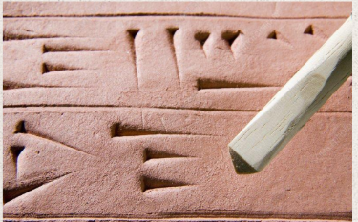
• Shortly after 3000 B.C., the Babylonians
developed a system of writing from “pictographs”
• The choice of material imposed special limitations
of their own, which soon robbed the pictographs
of any resemblance to the object they stood for
• They made impressions (rather than scratches)
in moist clay. Clay dries quickly, so documents had to be relatively short and written all at one time
• Because the Latin word for “wedge” is cuneus, the resulting style of writing has become known as “cuneiform
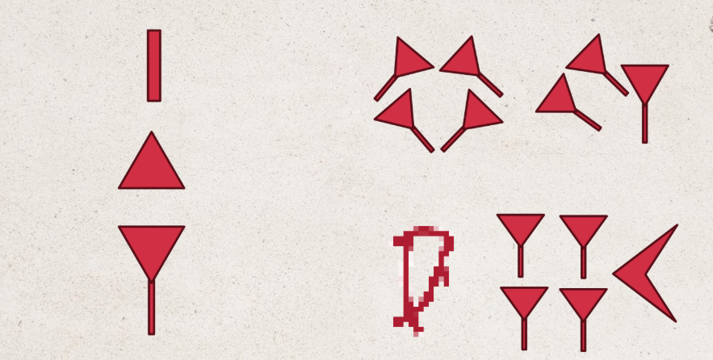

Deciphering Cuneiform: Grotefend and
Rawlinson
• There were no colossal temples or monuments to capture the archeological imagination (the land is practically devoid of building stone), excavation came later to this part of the
ancient world than to Egypt.
• There are at least 400,000 Babylonian clay tablets, generally the size of a hand, scattered among the museums of various countries. Of these, some 400 tablets or tablet fragments have been identified as having mathematical content.

Georg Friedrich Grotefend

• Grotefend wagered that he could decipher a certain cuneiform inscription from Persepolis provided that they would supply him with the previously
published literature on the subject
• He assumed that the language’s characters were alphabetic;
• picked out those characters that occurred with the greatest
frequency and postulated that these were vowels.
• The most recurrent sign group was assumed to represent the word for “king.” Thus, the decipherment of “King of Kings” Darius, Xerxes, and Hystapes.
• produced a translation that, although it contained numerous errors,
• In 1802 (27 years old), he had his investigations presented to the Academy of Science in Gottingen (Grotefend was not allowed to read his own paper).
• He only evoked ridicule from the learned body. • Yet Champollion, the original translator of hieroglyphics, won an international reputation

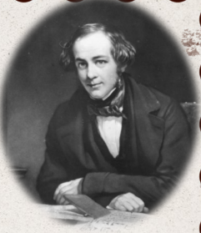
Henry Creswicke Rawlinson
• was an officer in the Indian Army, became interested in
cuneiform inscriptions when posted to Persia in 1835 as an
advisor to the shah’s troops
• Rawlinson’s attention was soon turned to Behistun, where
a towering rock cliff, the “Mountain of the Gods,” rises dramatically

The Behistun
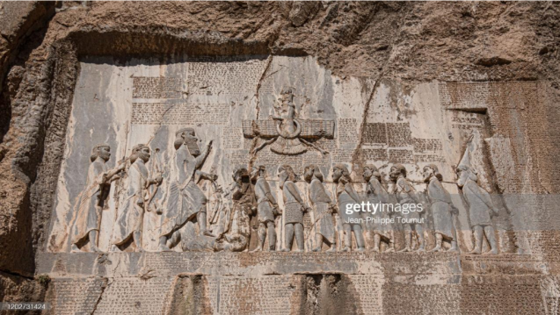

• The first difficulty lay in copying the long inscription. It is cut 400 feet above the ground on the face of a rock mass that itself rises 1700 feet above the plain
• By the end of 1837, he had copied approximately half the 414 lines of Persian text and, he had translated the first two paragraphs
• In 1843, he came back as British consul, eager to continue to copy, decipher, and interpret the remainder of the Behistun inscription
• His complete translation of the Old Persian part of the text, along with a copy of all the 263 lines of the Elamite, was published in 1846.
• Next he tackled the third class of cuneiform writing on the monument, the Babylonian
• Thanks to Rawlinson’s remarkable efforts, the cuneiform enigma was penetrated, and the vast records of Mesopotamian civilization were now an open book
• With the help of the already translated Persian text, which contained numerous proper names, he assigned correct values to a total of 246 characters.
• During this work, he discovered an important feature of Babylonian writing, the principle of “polyphony”; that is, the same sign could stand for different consonantal sounds, depending on the vowel that followed.
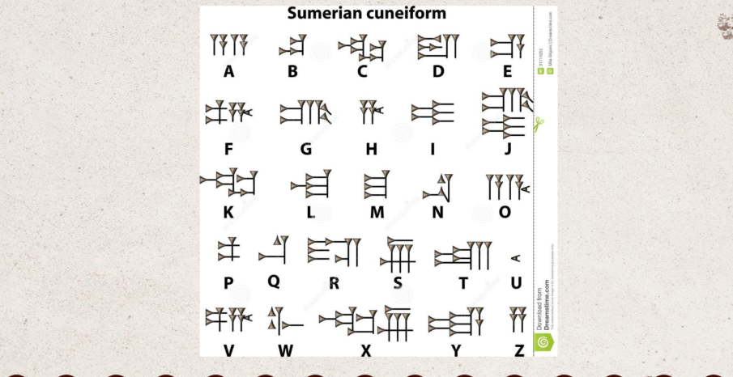

The Babylonian Positional Number System
• Their immense advantage over other systems is that a limited set of symbols suffices to express numbers, no matter how large or small.
• The Babylonian scale of enumeration was not decimal, but sexagesimal (60 as a base), so that every place a “digit” is moved to the left increases its value by a factor of 60
• When whole numbers are represented in the sexagesimal system, the last space is reserved for the numbers from 1 to 59, the next-to-last space for the multiples of 60, preceded by multiples of 602, and so on. For example, the Babylonian 3 25 4 might stand for the number:
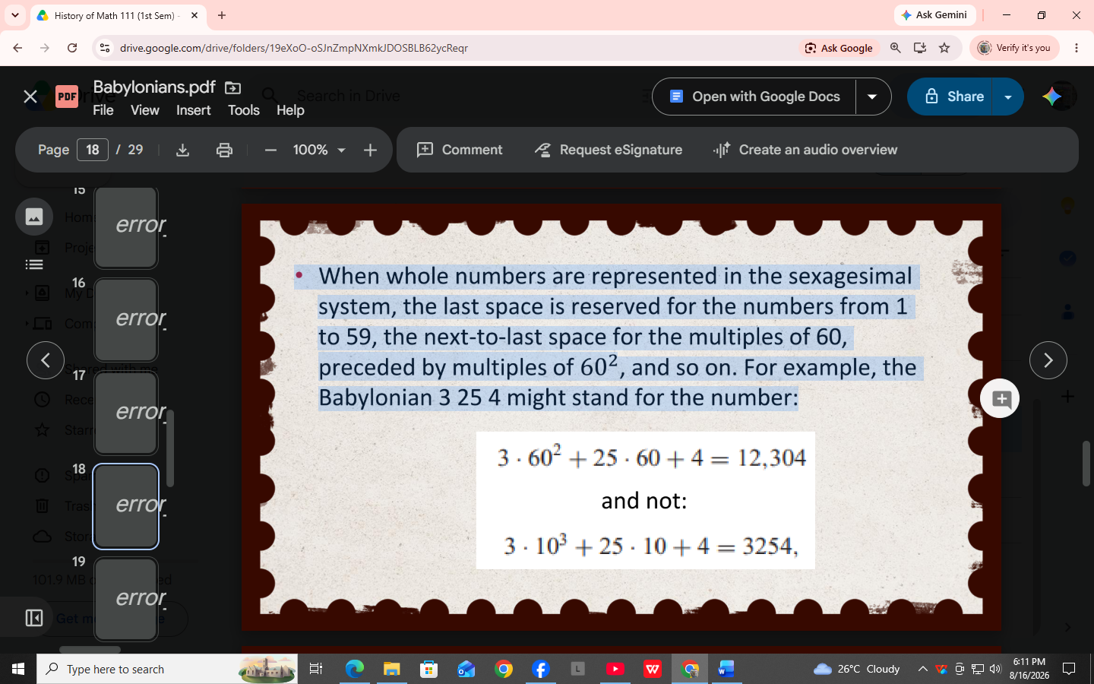

• The Babylonian use of the sexagesimal place-value notation was confirmed by two tablets found in 1854 at Senkerah on the Euphrates by the English geologist W. K. Loftus. These tablets, which probably date from the period of Hammurabi (2000 B.C.), give the squares of all integers from 1 to 59 and their cubes as far as that of 32.
• Where we should expect to find 8² =64, the tablet gives 1 4;
• 9² = 81 is listed as 1 21
• The last entry is 58 1
• The Egyptian hieroglyphic numeration necessitates relatively many symbols (to represent 999, no less than 27 hieroglyphs were required); and with each new power of 10, a new symbol had to be invented.
• By contrast, the numerical notation of the Babylonians emphasized two-wedge characters. The simple upright wedge had the value 1 and could be used nine times, while the broad sideways wedge stood for 10 and could be used up to five times
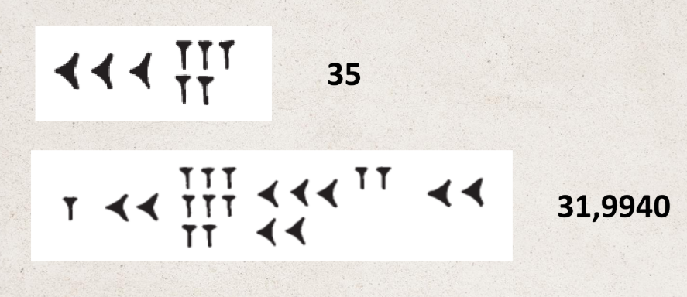
• Those indicating tens appeared to the left of those for ones

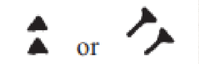
• called a divider, was introduced to serve as a
placeholder, thus indicating an empty space between two
digits inside a number
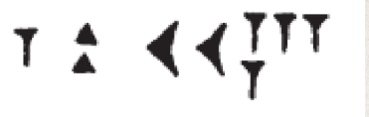

• With this, the number 84 was readily distinguishable
from 3624, the latter being represented by

Why Sexagesimal?
• “natural” origin- the theory was that the early Babylonians reckoned the year at 360 days, and a higher base of 360 was chosen first, then lowered to 60
• it evolved from the merger between two peoples of whom one had adopted the decimal system, whereas the other brought with them a 6-system, affording the advantage of being divisible by 2 and by 3
• The advantages of the Babylonian place-value system over the Egyptian additive computation with unit fractions were so apparent that this method became the principal instrument of calculation among astronomers.
• We see this numerical notation in full use in Ptolemy’s outstanding work, the Megale Syntaxis (The Great Collection).
• Ptolemy announced that he would be carrying out all his calculations in the sexagesimal system to avoid “the embarrassment of [Egyptian] fractions

Exercises
Express each of the given numbers in Babylonian cuneiform notation
A. 1000
B. 12345
C. 650.50
D. 120.33
E. 45.25

Convert each of the given numbers into decimal notation.
A. 1000
B. 12345
C. 650.50
D. 120.33
E. 45.25

Translate each of these into a number in our system
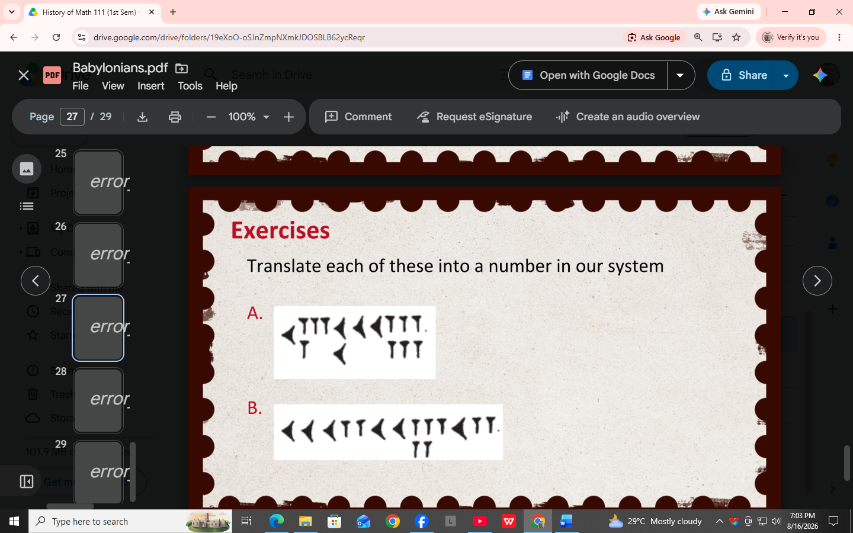
A.

B.

Quiz
Express each of the given numbers in Babylonian cuneiform notation
A. 10000
B. 100000
C. 654000

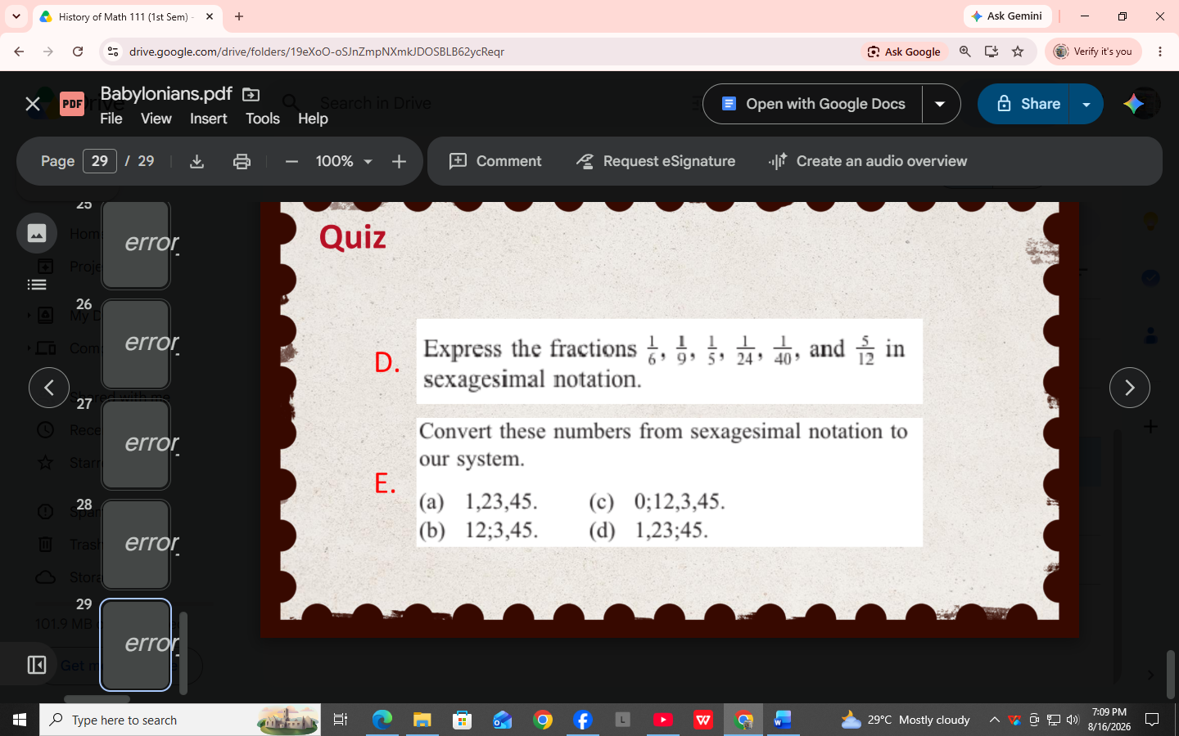
D.

E.

