General observation:

1. I observe that when I SEARCH, the result is usually from a single page not from the whole resources on the website.

**Page 1:**

**Page 2:**

**WORD FORMATION GUIDELINES**

**NOTE:** Please help correct the red highlighted letters in their correct spellings.

i. Ohùn ìsàlẹ̀ **(dò)**

ii. Ohùn àárín **(re)**

iii. Ohùn òkè **(mí)**

**NOTE: FORMING THREE LETTER WORDS**

The spelling of **"ìmọ̀**" is correct but the **audio** is mixed up for **“èmi” which already exist up.**

NOTE: **READING ALPHABET WITH PICTURES**

I just realized that **READING ALPHABET WITH PICTURES** does not feature the actual alphabets (Aa, Bb, Cc…etc) as contained in the image below. Please help adjust.

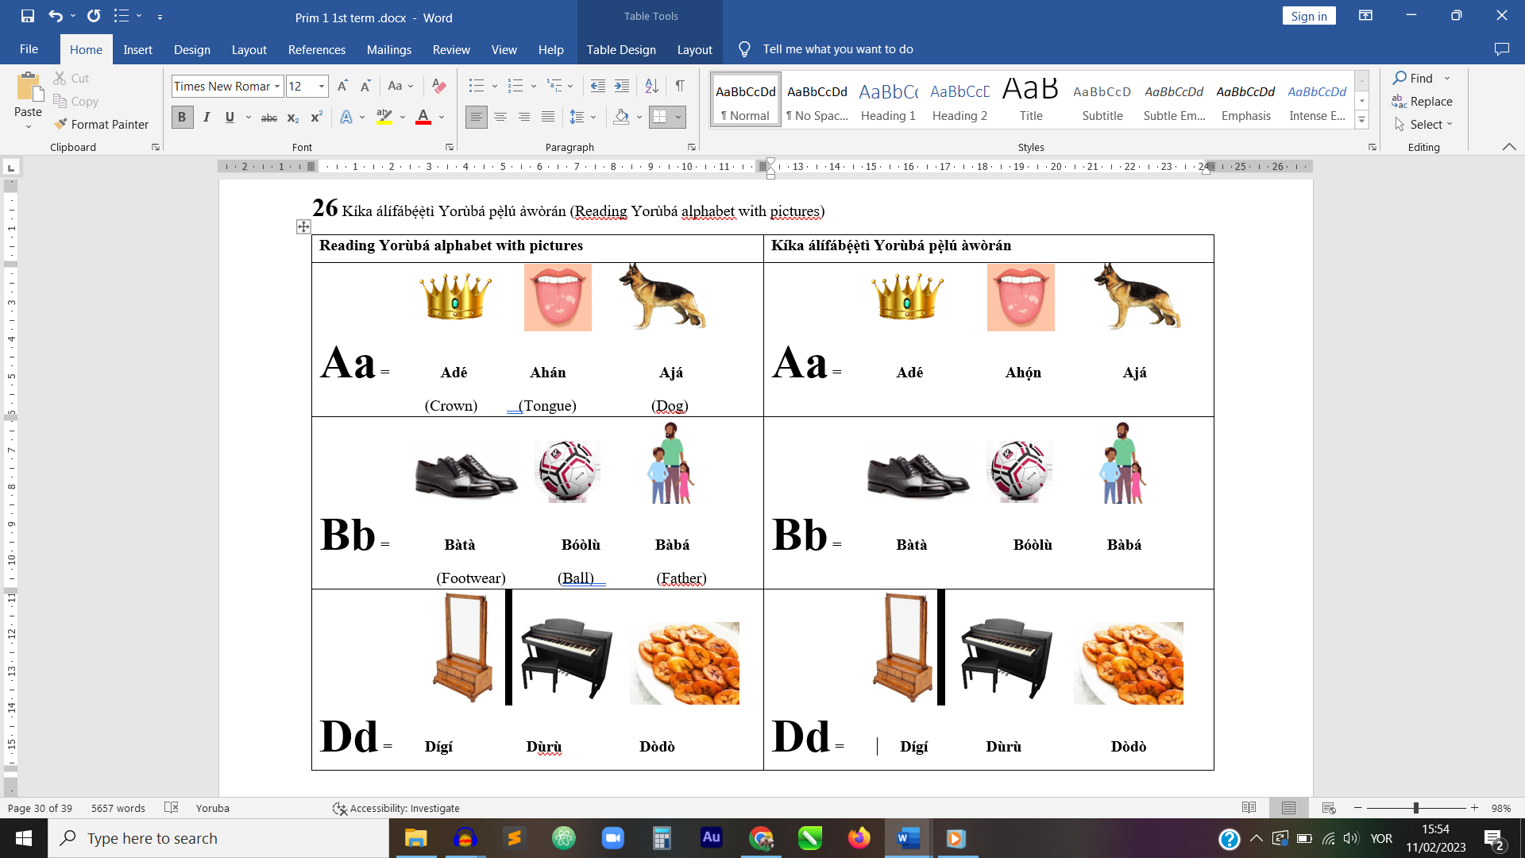

B: **YES** is just realized the audio for **"O - owó"** is mixing. Please delete the audio of **"Ọ - ọ̀wọ̀" attached to it until I provide the actual one.**

**PAGE 3**

NOTE: **COUNTING FROM 0 to 20**:

**A:** **please some of the àmì on the letters in the body of Kíyèsí (Note) after 15 are wrong. Please replace the body of texts with the one below.**

Nípasẹ̀ ìyọkúrò (-) àwọn nọ́mbà 5, 4, 3, 2, àti 1 lẹ́sẹẹsẹ

láti ara nọ́mbà ogún (20) ni a ṣe máa ń ṣe ẹ̀dá àwọn

nọ́mbà tí ó wà láti orí 15 sí 19.

**B: Please make the fonts and sizes of:**

**6 – Ẹẹ́fà**

**9 - Ẹẹ́sàn-án**

**13 – Ẹẹ́tàlá**

**14 – Ẹẹ́rìnlá**

**16 – Ẹẹ́rìndínlógún**

**That you edited to look the same as the rest.**

The **audio for FIFTEEN "Aárùndínlógún**" has been sent to you.

NOTE: **DELETE COUNTING MONEY ON THE LAST ITEM**

**PAGE 4:**

**NOTE: DELETE COUNTING MONEY ON THE FIRST ITEM**

NOTE: **WORDS AND OPPOSITE WITH PICTURES:** Please, let the difference between **big ball and small ball** pronounce; **MAKE THE SMALL BALL EVEN SMALLER.**

**PAGE 5:**

**NOTE:** **TWO LETTER WORDS FORMATION**

1. The audio for **DO "ṣe"** is mixed-up with that of **OFFEND "ṣẹ̀".**  Please insert the correct audio.