**Frequency Sweep Test Report**

Setup:

* OpenMote

listens on one channel all the time.

Prints out the payload of any packet it receives and the frequency offset reader from FREQEST register.

* SCuM:

Send 3 packet at each frequency settings of coarse, middle and fine.

Packet payload starts with test.xx.yy.zz, where xx.yy.zz indicates “coarse.middle.fine”

Result:

Y: frequency offset (read value of FREQEST register)

X: frequency settings (**from 00.00.00 to 31.31.31**)

Questions:

1. Why the result on channel 11 and 26 shows that OpenMote received packets from two coarse settings with 10 difference in between?
2. Why in the result on majority of channels, OpenMote received packets on two different frequency settings with 15-17 middle difference in between?

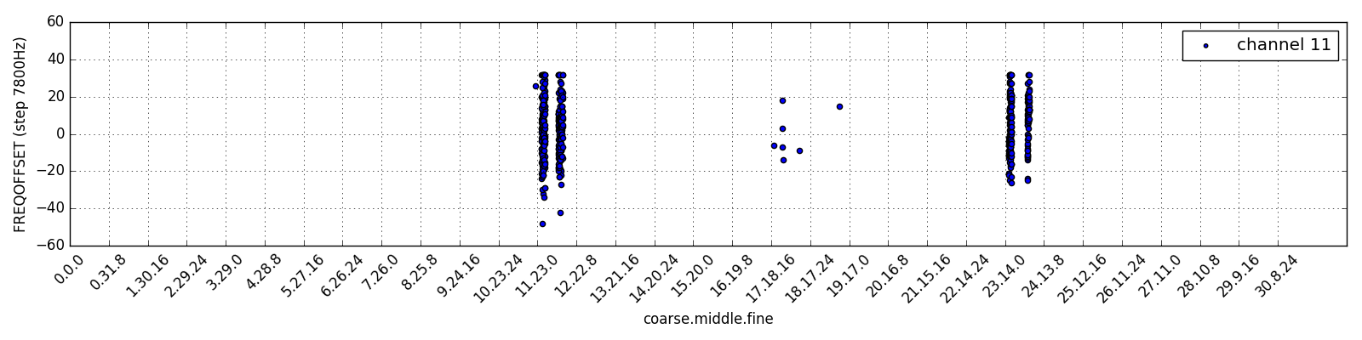

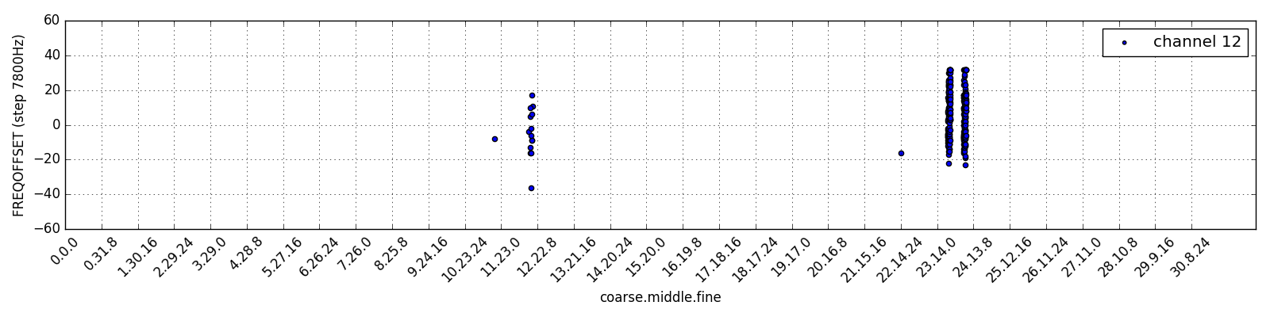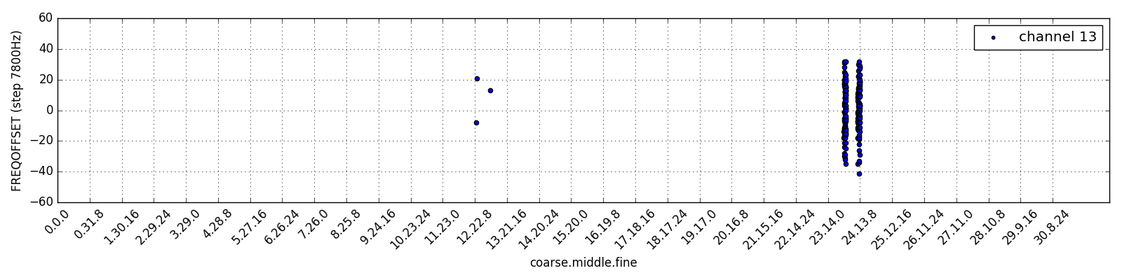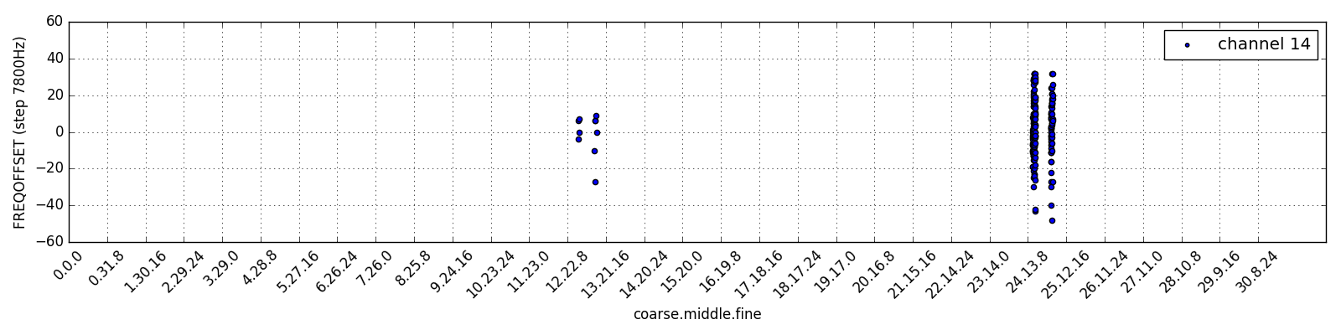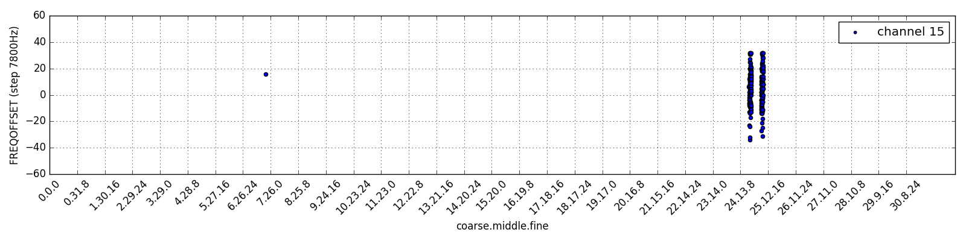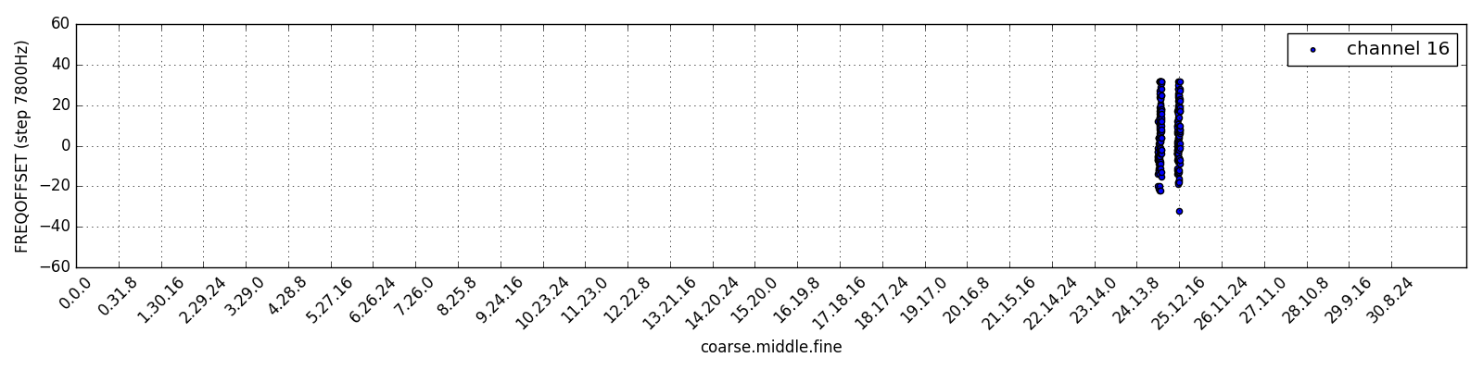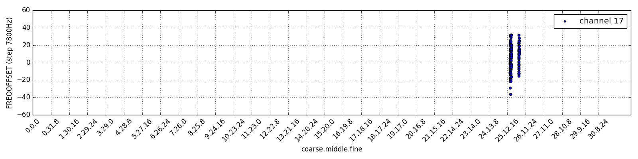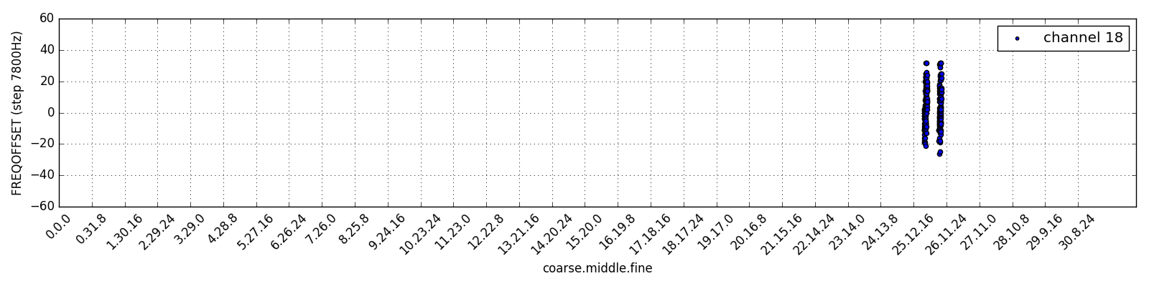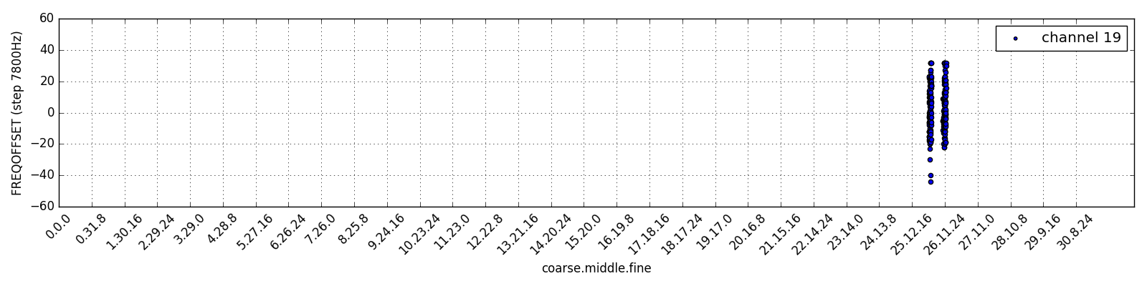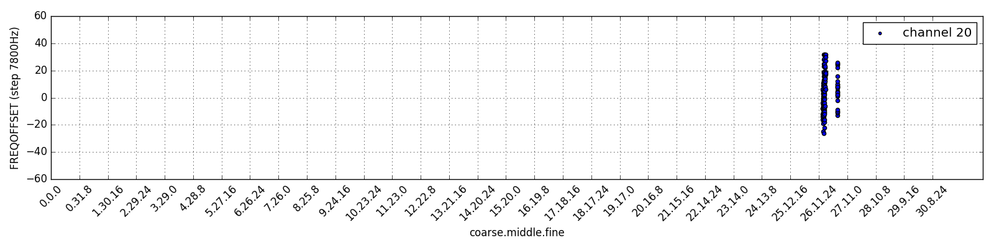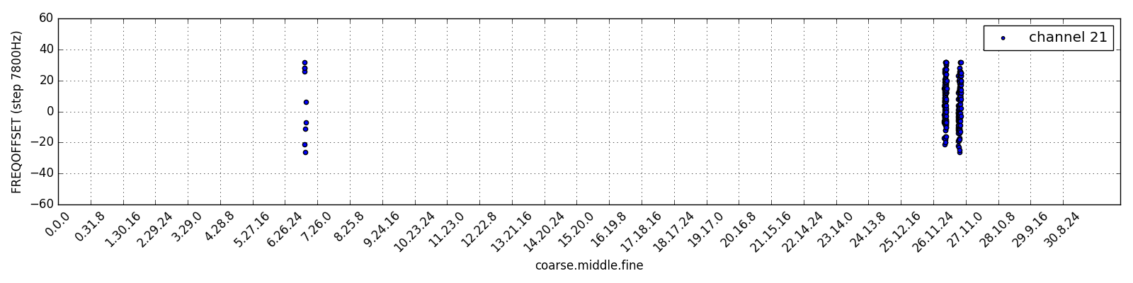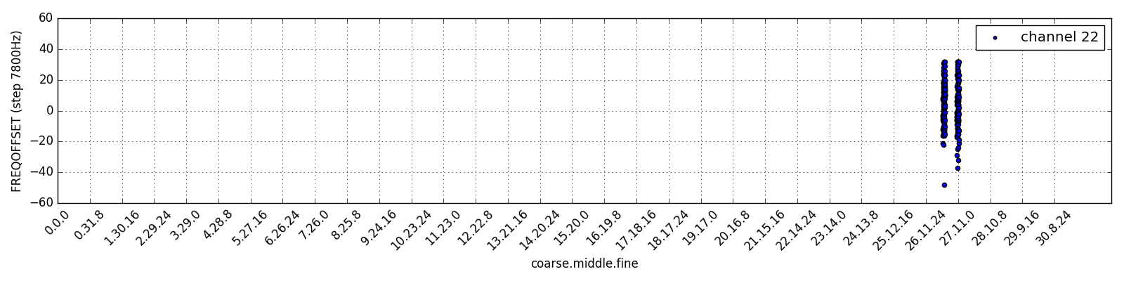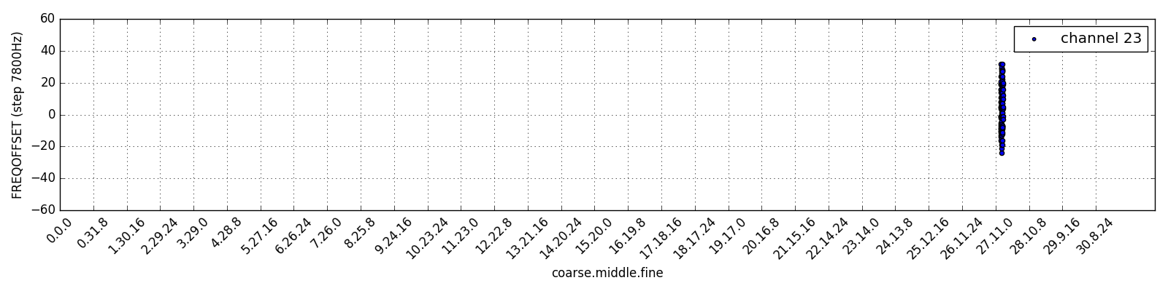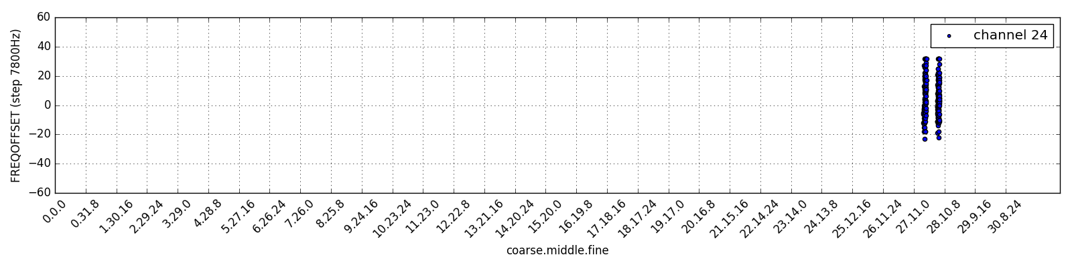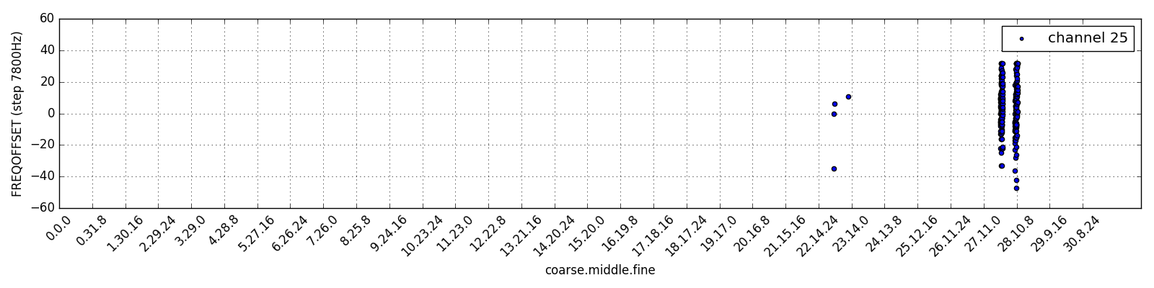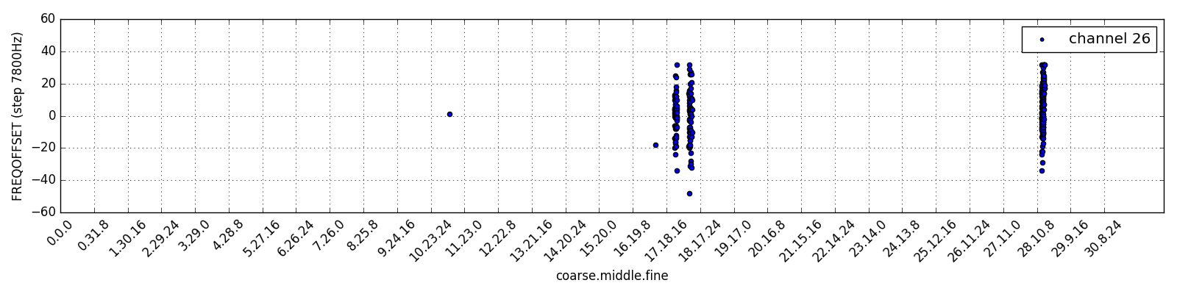

Result: (same result but zoom in between coarse **23 and 29**)

Y: frequency offset (read value of FREQEST register)

X: frequency settings (**from** **23.00.00 to 29.00.00**)

Question:

1. Why the results of two adjacent channels cross each (NOT overlapping)?

