# 연도별 논문 분석 결과

## 연도별 논문 키워드

### 2020 Year Top 30 Keyword & Count

|  |  |
| --- | --- |
| deep neural networks | 1984 |
| convolutional neural networks | 1154 |
| convolutional neural network | 961 |
| deep neural network | 946 |
| paper propose novel | 692 |
| deep learning models | 634 |
| natural language processing | 581 |
| neural network cnn | 461 |
| generative adversarial networks | 447 |
| machine learning models | 446 |
| graph neural networks | 416 |
| deep convolutional neural | 341 |
| recurrent neural networks | 321 |
| stochastic gradient descent | 319 |
| deep learning methods | 318 |
| recurrent neural network | 298 |
| adversarial networks gans | 292 |
| neural architecture search | 286 |
| neural network models | 265 |
| generative adversarial network | 251 |
| neural network model | 243 |
| partial differential equations | 237 |
| graph neural network | 236 |
| neural network architecture | 231 |
| in this paper propose | 230 |
| finite element method | 223 |
| deep learning model | 221 |
| automatic speech recognition | 220 |
| long shortterm memory | 218 |
| neural machine translation | 215 |

### 2016 Year Top 30 Keyword & Count

|  |  |
| --- | --- |
| convolutional neural networks | 378 |
| deep neural networks | 297 |
| convolutional neural network | 267 |
| paper propose novel | 167 |
| deep convolutional neural | 166 |
| recurrent neural networks | 160 |
| recurrent neural network | 150 |
| deep neural network | 148 |
| channel state information | 137 |
| neural network cnn | 119 |
| natural language processing | 107 |
| stochastic gradient descent | 91 |
| long shortterm memory | 79 |
| wireless sensor networks | 75 |
| neural machine translation | 69 |
| paper present novel | 67 |
| principal component analysis | 61 |
| paper present new | 58 |
| state information csi | 57 |
| neural network architecture | 55 |
| neural network model | 54 |
| polynomial time algorithm | 54 |
| artificial neural networks | 53 |
| support vector machines | 53 |
| paper new method | 52 |
| support vector machine | 52 |
| markov decision process | 50 |
| paper new approach | 48 |
| online social networks | 48 |
| present novel approach | 47 |

### 2017 Year Top 30 Keyword & Count

|  |  |
| --- | --- |
| convolutional neural networks | 627 |
| deep neural networks | 601 |
| convolutional neural network | 520 |
| deep neural network | 297 |
| deep convolutional neural | 267 |
| recurrent neural networks | 260 |
| paper propose novel | 251 |
| neural network cnn | 246 |
| recurrent neural network | 218 |
| natural language processing | 177 |
| generative adversarial networks | 161 |
| channel state information | 152 |
| stochastic gradient descent | 134 |
| neural machine translation | 132 |
| long shortterm memory | 122 |
| deep learning models | 111 |
| neural network architecture | 99 |
| support vector machine | 92 |
| neural network model | 92 |
| paper present novel | 91 |
| principal component analysis | 86 |
| paper present new | 84 |
| adversarial networks gans | 82 |
| neural network models | 82 |
| neural network rnn | 82 |
| artificial neural networks | 82 |
| state information csi | 74 |
| markov decision process | 71 |
| paper new approach | 68 |
| direction method multipliers | 68 |

### 2015 Year Top 30 Keyword & Count

|  |  |
| --- | --- |
| convolutional neural networks | 171 |
| deep neural networks | 141 |
| convolutional neural network | 137 |
| channel state information | 132 |
| paper propose novel | 98 |
| deep convolutional neural | 91 |
| wireless sensor networks | 78 |
| stochastic gradient descent | 69 |
| recurrent neural networks | 69 |
| deep neural network | 66 |
| mean square error | 66 |
| principal component analysis | 63 |
| natural language processing | 60 |
| neural network cnn | 54 |
| recurrent neural network | 53 |
| white gaussian noise | 48 |
| state information csi | 48 |
| long shortterm memory | 47 |
| additive white gaussian | 45 |
| online social networks | 45 |
| support vector machine | 44 |
| polynomial time algorithm | 44 |
| paper present novel | 43 |
| stochastic block model | 41 |
| paper new approach | 41 |
| necessary sufficient conditions | 40 |
| paper novel approach | 39 |
| paper present new | 38 |
| paper new method | 35 |
| massive mimo systems | 34 |

### 2013 Year Top 30 Keyword & Count

|  |  |
| --- | --- |
| channel state information | 114 |
| wireless sensor networks | 94 |
| paper propose novel | 52 |
| paper present new | 49 |
| state information csi | 48 |
| paper new approach | 48 |
| white gaussian noise | 40 |
| online social networks | 39 |
| bit error rate | 38 |
| additive white gaussian | 37 |
| orthogonal frequency division | 37 |
| polynomial time algorithm | 35 |
| wireless sensor network | 35 |
| support vector machine | 32 |
| mean square error | 32 |
| natural language processing | 27 |
| necessary sufficient conditions | 27 |
| markov decision process | 27 |
| paper novel approach | 25 |
| signal noise ratio | 25 |
| optimal power allocation | 24 |
| principal component analysis | 23 |
| necessary sufficient condition | 23 |
| chain monte carlo | 22 |
| quantum key distribution | 22 |
| achievable rate region | 22 |
| last few years | 22 |
| paper new method | 22 |
| signaltonoise ratio snr | 21 |
| division multiple access | 21 |

### 2014 Year Top 30 Keyword & Count

|  |  |
| --- | --- |
| channel state information | 95 |
| wireless sensor networks | 91 |
| paper propose novel | 62 |
| convolutional neural networks | 60 |
| natural language processing | 53 |
| wireless sensor network | 42 |
| state information csi | 42 |
| principal component analysis | 40 |
| mean square error | 37 |
| online social networks | 37 |
| white gaussian noise | 36 |
| support vector machine | 36 |
| polynomial time algorithm | 35 |
| paper present novel | 32 |
| necessary sufficient conditions | 31 |
| paper present new | 31 |
| bit error rate | 31 |
| markov decision process | 30 |
| last few years | 29 |
| additive white gaussian | 29 |
| support vector machines | 28 |
| convolutional neural network | 28 |
| deep convolutional neural | 27 |
| cognitive radio networks | 27 |
| in this paper propose | 26 |
| convex optimization problem | 26 |
| orthogonal frequency division | 26 |
| deep neural networks | 26 |
| quality service qos | 25 |
| past few years | 25 |

### 2019 Year Top 30 Keyword & Count

|  |  |
| --- | --- |
| deep neural networks | 1641 |
| convolutional neural networks | 1105 |
| convolutional neural network | 876 |
| deep neural network | 755 |
| paper propose novel | 591 |
| neural network cnn | 440 |
| deep learning models | 429 |
| natural language processing | 420 |
| generative adversarial networks | 403 |
| recurrent neural networks | 371 |
| deep convolutional neural | 354 |
| machine learning models | 308 |
| recurrent neural network | 285 |
| stochastic gradient descent | 270 |
| generative adversarial network | 251 |
| adversarial networks gans | 242 |
| neural network models | 224 |
| neural machine translation | 220 |
| deep learning methods | 213 |
| neural network architecture | 213 |
| long shortterm memory | 213 |
| neural network model | 207 |
| markov decision process | 185 |
| support vector machine | 184 |
| graph neural networks | 183 |
| paper present novel | 178 |
| neural architecture search | 171 |
| artificial neural networks | 170 |
| partial differential equations | 170 |
| neural network architectures | 155 |

### 2018 Year Top 30 Keyword & Count

|  |  |
| --- | --- |
| deep neural networks | 1153 |
| convolutional neural networks | 918 |
| convolutional neural network | 797 |
| deep neural network | 536 |
| paper propose novel | 422 |
| deep convolutional neural | 337 |
| neural network cnn | 332 |
| recurrent neural networks | 318 |
| generative adversarial networks | 312 |
| recurrent neural network | 259 |
| natural language processing | 238 |
| deep learning models | 220 |
| stochastic gradient descent | 214 |
| neural machine translation | 210 |
| adversarial networks gans | 188 |
| machine learning models | 185 |
| neural network models | 175 |
| long shortterm memory | 172 |
| generative adversarial network | 154 |
| neural network architecture | 153 |
| deep learning methods | 150 |
| paper present novel | 140 |
| neural network model | 136 |
| channel state information | 132 |
| support vector machine | 128 |
| artificial neural networks | 123 |
| paper present new | 108 |
| in this paper propose | 107 |
| deep learning model | 105 |
| neural network dnn | 101 |

## 연도별 논문 키워드 시각화 - Word Cloud

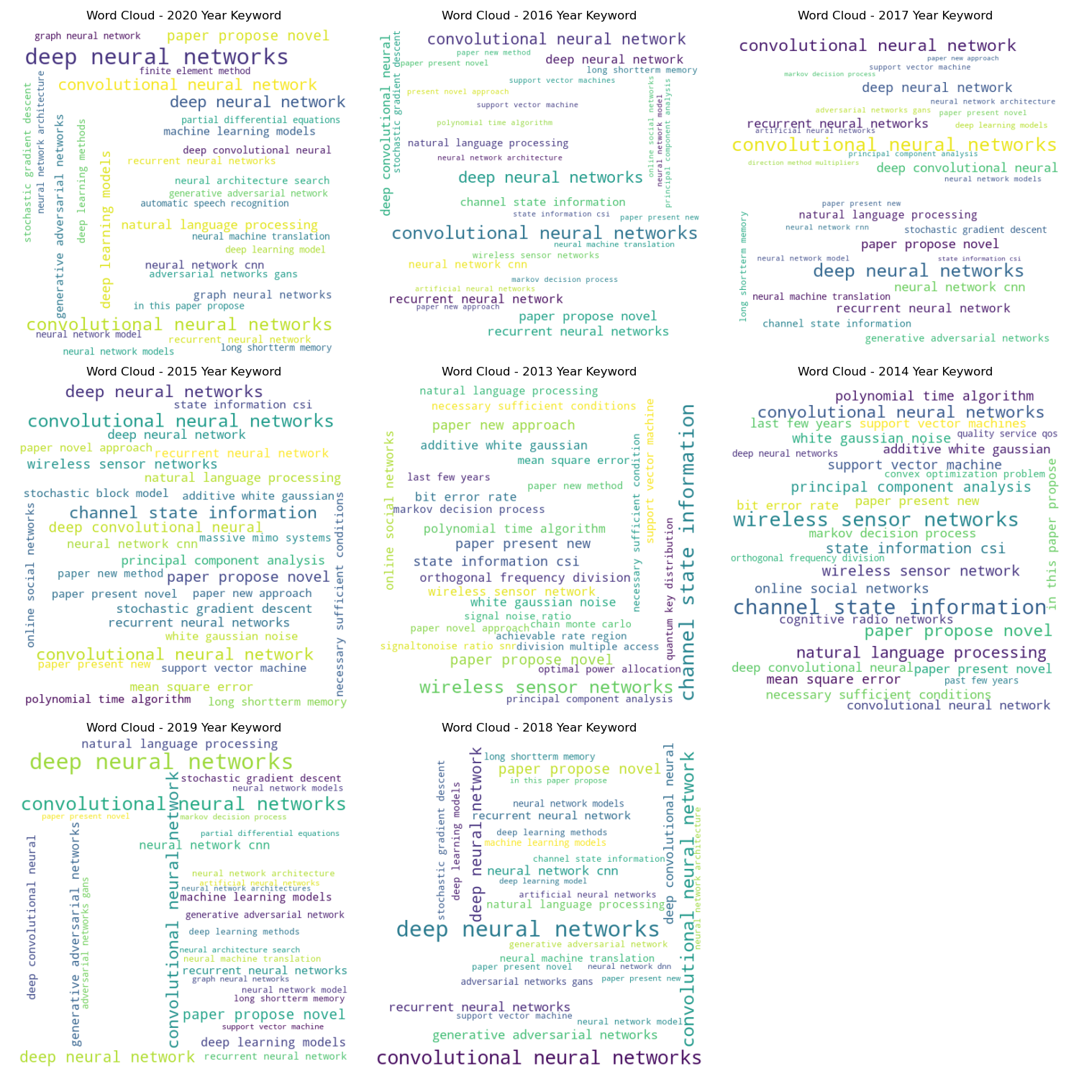

## 연도별 논문 게시 수

