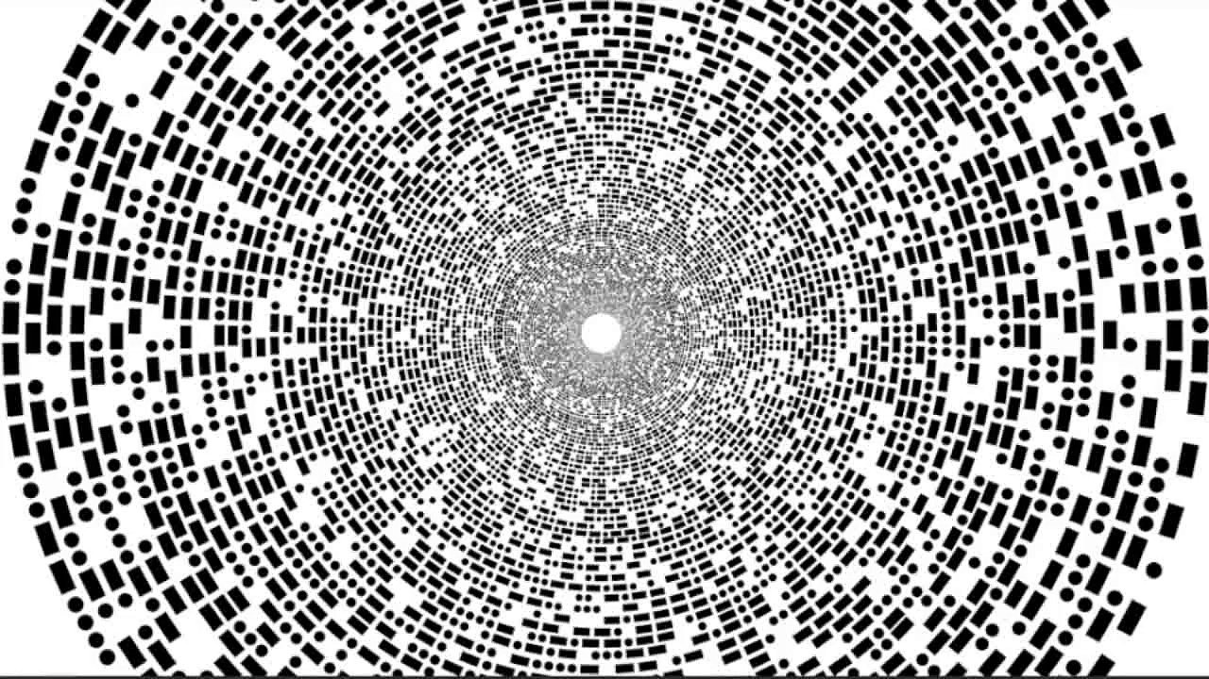

Morse Code Converter

cpe 426/526

group 1:

Prawar Poudel

nipuna Rupasinghe

Mathew Pittenger

Kyle ray

April 28, 2017

Contents

Introduction 2

Preliminary Design 2

Abstract 2

Team 2

Requirements 2

Design and Implementation 2

Project GUI 2

Receiver Module 2

Morse Code Converter Module 2

Hex Display Module 2

Speaker Module 2

Testing? 2

Lessons Learned 2

Conclusion 2

# Introduction

KRR – Talk about morse code and why we wanted to do this project.

## Preliminary Design

KRR – Include the diagram that we came up with, either the hand drawn or the diagram that Prawar has drawn up.

# Abstract

# Team

# Requirements

# Design and Implementation

## Project GUI

## Receiver Module

## Morse Code Converter Module

## Hex Display Module

## Speaker Module

# Testing?

# Lessons Learned

# Conclusion