Yongjia (Ephrem) Yuan Resume

ephremyuan

2024-07-10T23:32:35+00:00

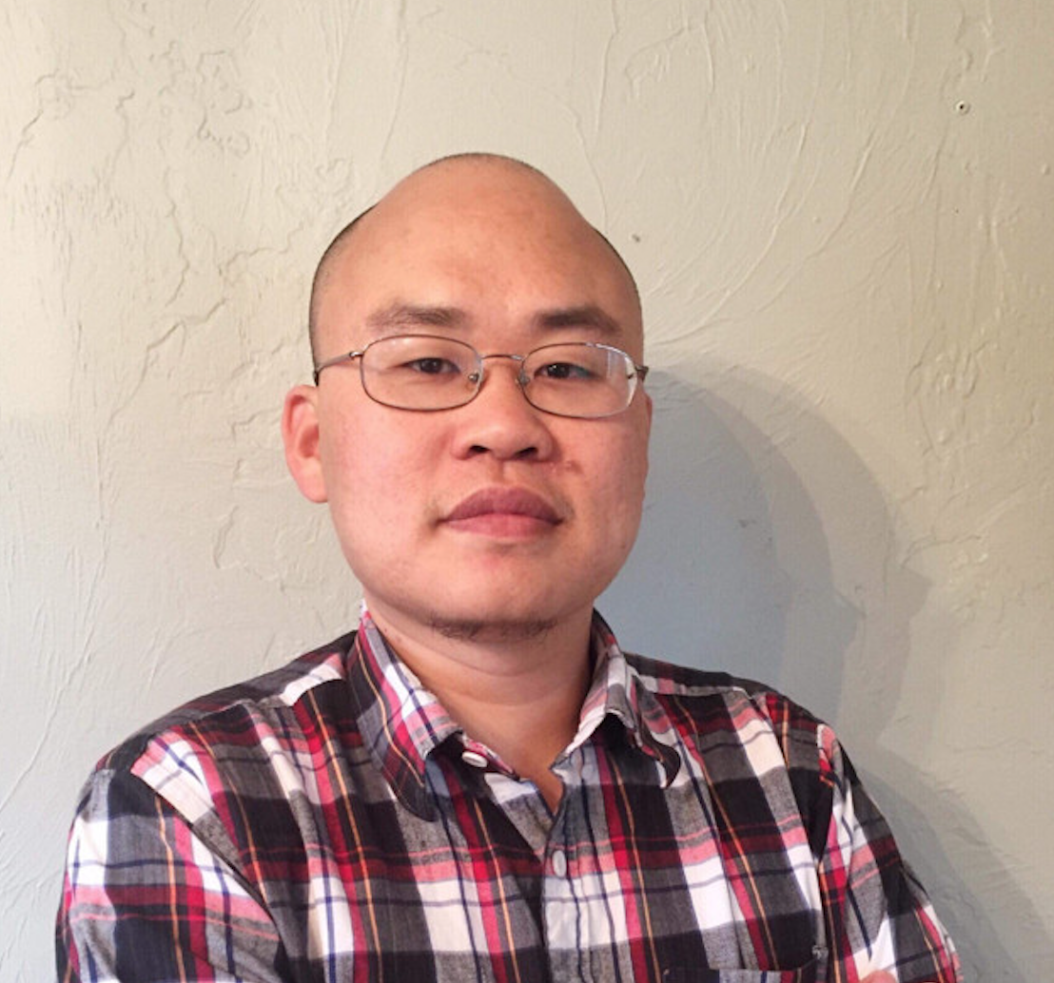 For more information about my updated resume see: [ajiacloud.org](https://www.ajiacloud.org/). If you are interested in my experiences, Please send my email: areopagusworkshop@gmail.com, if you are interested in my experiences.

## Summary

* Founder (November 2021 - Present) of two non-profit project GCDFL (introducing Eastern Churches through academic lectures to Chinese Speakers) and CTCFOL (Chinese Translation of Church Fathers from Original Languages).
* Teacher of Ancient Greek, Syriac languages, Church History, the spirituality of Eastern Churches for over 200 hours.
* Translator of the works of Church Fathers for over 300k words.
* Phd Candidate in SOAS, focusing on the Church of the East in Turfan area (7-9 centuries)
* Lover of DevOps and Web application through Linux, docker, Git, python, javascript.”

## Education

| Time | Degree | School | focusing |
| --- | --- | --- | --- |
| 2021 Sep. -Now | Phd Candidate | SOAS | The Church of the East in Turfan area |
| 2019 Apr. - 2021 Nov. | Master of Studies in Theology | Boston College School of Theology and Ministry | Syriac Churches |
| 2015 Aug.- 2018 Nov. | Master of Theology | Hellenic College Holy Cross | the Spiritual of Greek Fathers Greek Tradition |

**Language ability** > Ancient Languages: Chinese, Ancient Greek, Syriac, Latin, Coptic, Sogdian, Old Turkish, Middle Persian

Modern Lauanages: Chinese, English, French, German, Japanese.

## Public Lectures

over 200 hours of experience, All of them are in Mandarin, of course I can offer the same content with English.

### Introdoctory of Bishop Ware’s Book *Eastern Orthodox*

based on (London: Peguins, Second edition, 2015), teaching from **June 2024**, to be continue… > - [The Introduction of Bishop Ware’s Book *Eastern Orthodox* session 3 维尔主教《东正教会》导读第三课](https://www.gcdfl.org/2024/07/05/Ware-Orthodox-Church-3/) > - [The Introduction of Bishop Ware’s Book *Eastern Orthodox* session 2 维尔主教《东正教会》导读第二课](https://www.gcdfl.org/2024/06/28/Ware-Orthodox-Church-2/) > - [The Introduction of Bishop Ware’s Book *Eastern Orthodox* session 1 维尔主教《东正教会》导读第一课](https://www.gcdfl.org/2024/06/21/Ware-Orthodox-Church-1/)

### The Church History Season 2

**Greek Tradition, 10 sessions, Jan-May 2014** > - [The Introduction of the Great St. Anthony 圣安东尼传导读](https://www.gcdfl.org/2024/06/14/圣安东尼传导读/) > - [The Introduction of St. Gregory the Theologian 神学家列高里利](https://www.gcdfl.org/2024/03/29/%E7%A5%9E%E5%AD%A6%E5%AE%B6%E6%A0%BC%E5%88%97%E9%AB%98%E5%88%A9/) > - [The Introduction of St. Gregory of Nyssa on resurrection 尼撒的格列高利论肉体复活](https://www.gcdfl.org/2024/04/19/尼撒的格列高利论肉体复活/) > - [The lifes of St. John Chrysostom 金口约翰生平](/2024/04/26/阿甲-金口约翰生平/) > - [Constantine and Nicene creed 君士坦丁，米兰赦令与尼西亚会议](https://www.gcdfl.orghttps://www.gcdfl.org/2024/03/01/%E5%90%9B%E5%A3%AB%E5%9D%A6%E4%B8%81%E4%B8%8E%E5%B0%BC%E8%A5%BF%E4%BA%9A/) > - [The Second Ecumenical Council 第二次大公会议之信经与教规](https://www.gcdfl.org/2024/03/08/%E7%AC%AC%E4%BA%8C%E6%AC%A1%E5%A4%A7%E5%85%AC%E4%BC%9A%E8%AE%AE/) > - [St. Basil the Great 大圣巴西尔](https://www.gcdfl.org/2024/03/29/%E5%A4%A7%E5%9C%A3%E5%B7%B4%E8%A5%BF%E5%B0%94/) > - [The Formation of the Biblical Canon 圣经正典的形成](https://www.gcdfl.org/2024/02/02/%E5%9C%A3%E7%BB%8F%E6%AD%A3%E5%85%B8%E7%9A%84%E5%BD%A2%E6%88%90-%E6%95%99%E4%BC%9A%E5%8E%86%E5%8F%B2%E5%B8%8C%E8%85%8A%E7%AF%873/) > - [Origen and the Alexiandrian Tradition 奥利金与亚历山大传统](https://www.gcdfl.org/2024/01/05/%E5%A5%A5%E5%88%A9%E9%87%91%E4%B8%8E%E4%BA%9A%E5%8E%86%E5%B1%B1%E5%A4%A7%E4%BC%A0%E7%BB%9F-%E6%95%99%E4%BC%9A%E5%8E%86%E5%8F%B2%E5%B8%8C%E8%85%8A%E4%BC%A0%E7%BB%9F%E4%B9%8B%E4%B8%80/) > - [Athanasius and Arianism 阿塔纳修与阿里乌主义](https://www.gcdfl.org/2024/01/12/%E9%98%BF%E5%A1%94%E7%BA%B3%E4%BF%AE%E4%B8%8E%E9%98%BF%E9%87%8C%E4%B9%8C%E4%B8%BB%E4%B9%89-%E6%95%99%E4%BC%9A%E5%8E%86%E5%8F%B2%E5%B8%8C%E8%85%8A%E4%BC%A0%E7%BB%9F%E4%B9%8B%E4%BA%8C/)

### Five Lectures about Church History season 1 in 2023

* [Why Jesus Coming? 耶稣为何来？](https://www.gcdfl.org/2023/01/11/%E8%80%B6%E7%A8%A3%E4%B8%BA%E4%BD%95%E6%9D%A5/)
* [I Believe the Apostolic Church 我信使徒的教会](https://www.gcdfl.org/2023/02/15/%E6%88%91%E4%BF%A1%E4%BD%BF%E5%BE%92%E7%9A%84%E6%95%99%E4%BC%9A/)
* [Martyrdom 殉道精神](https://www.gcdfl.org/2023/03/22/%E6%AE%89%E9%81%93%E7%B2%BE%E7%A5%9E/)
* [Apologist Irenaeus 护教士爱任纽](https://gcdfl.org/2023/04/21/%e6%8a%a4%e6%95%99%e5%a3%ab%e7%88%b1%e4%bb%bb%e7%ba%bd/)
* [St. Clement and Greek Philosophy 克莱门特与希腊哲学](https://www.gcdfl.org/2023/09/12/%E5%B8%8C%E8%85%8A%E5%93%B2%E5%AD%A6%E4%B8%8E%E4%BA%9A%E5%8E%86%E5%B1%B1%E5%A4%A7%E7%9A%84%E5%85%8B%E8%8E%B1%E9%97%A8%E7%89%B9/)

### Five Lectures about Spirituality of early Greek and Syriac Tradition in 2023

* [The Formation of St. Basil Rules 巴西尔会规的形成](https://gcdfl.org/2023/04/11/%e5%b7%b4%e8%a5%bf%e5%b0%94%e9%95%bf%e4%bc%9a%e8%a7%84%e7%9a%84%e5%bd%a2%e6%88%90/)
* [The Sayings of the Desert Fathers and the prayer of heart 沙漠教父言行录》与心祷默观传统](https://www.gcdfl.org/2022/10/29/%E6%B2%99%E6%BC%A0%E6%95%99%E7%88%B6%E8%A8%80%E8%A1%8C%E5%BD%95%E4%B8%8E%E5%BF%83%E7%A5%B7%E4%BC%A0%E7%BB%9F/)
* [The early Syriac Spitual Tradition 叙利亚教会早期灵修传统](https://gcdfl.org/2022/12/11/%e5%8f%99%e5%88%a9%e4%ba%9a%e6%95%99%e4%bc%9a%e6%97%a9%e6%9c%9f%e7%81%b5%e4%bf%ae%e4%bc%a0%e7%bb%9f/)
* [The Anthropology Centered in Heart Historical Evidence 以心为中心的人论——史料篇](https://gcdfl.org/2022/12/09/%e4%bb%a5%e5%bf%83%e4%b8%ba%e4%b8%ad%e5%bf%83%e7%9a%84%e4%ba%ba%e8%ae%ba/)
* [The Introdcution of Philokalia 爱神集导读讲座——CIU讲座录音](https://gcdfl.org/2021/12/09/%e8%ae%b2%e5%ba%a7-%e4%b8%9c%e6%ad%a3%e6%95%99%e7%81%b5%e4%bf%ae%e4%bc%a0%e7%bb%9f%e4%b8%8e%e5%8f%99%e5%88%a9%e4%ba%9a%e6%97%a9%e6%9c%9f%e7%81%b5%e4%bf%ae%e4%bc%a0%e7%bb%9f/)

### Greek and Syriac Language classes

* **Syriac Language Class from Jan. 2024 - now, available in** [**Forum**](https://forum.ctcfol.org/t/topic/12/5) **and** [**Youtube**](https://www.youtube.com/watch?v=gda4RjUosQ8&list=PLc2zmiCJjhVuRrhi602FnV7UMiEpW51bJ)
* **Ancient Greek language Class in 2023, available in** [**Forum**](https://forum.ctcfol.org/t/topic/34) **and** [**Youtube**](https://www.youtube.com/playlist?list=PLc2zmiCJjhVuRrhi602FnV7UMiEpW51bJ)

## Paid Course

**All course are in Mandarin, of course, I can teach them in English**

| Class name | How many sessions | teaching time |
| --- | --- | --- |
| **The Introduction of Philokalia** | 10 sessions of 90 minutes each | 5 such sessions in 2022-2023 |
| **The Introduction of Desert Fathers** | 5 sessions of 90 minutes each | 5 such sessions in 2022-2023 |
| **The Introduction of St. Basil Long Rules** | 5 sessions of 90 minutes each | 1 such sessions in 2023 |
| **The Introduction of St. Cassian and St. Benedict** | 5 sessions of 90 minutes each | 1 such sessions in 2023 |

## Translations from Greek and Syriac

Over 300k Chinese words of translations. All my translations of Greek and Syriac sources are partially available in [CTCFOL](https://ctcfol.org/). I will publish them in near future. All of them are Chinese translations.

### Translations Completed from Greek Fathers

* [**Philokalia: The Guided Reader version**](https://www.ctcfol.org/philokalia/), 11 authors works with 180k Chinese translations.
* [**St. Basil the Long Rules,including some letters**](https://www.ctcfol.org/basil/), about 60k Chinese translations.

### Translations Completed from Syriac Fathers

* [**Selections of early Syriac Spirituality**](https://www.ctcfol.org/#%E5%8F%99%E5%88%A9%E4%BA%9A%E6%97%A9%E6%9C%9F%E7%81%B5%E4%BF%AE%E8%AF%91%E4%BD%9C%E8%8A%82%E9%80%89)

### Translations Completed from Modern academic papers

* [译作：圣索弗罗尼《论耶稣祷文的方法》](https://www.ctcfol.org/2022/09/04/%E5%9C%A3%E7%B4%A2%E5%BC%97%E7%BD%97%E5%B0%BC%E8%AE%BA%E8%80%B6%E7%A8%A3%E7%A5%B7%E6%96%87%E7%9A%84%E6%96%B9%E6%B3%95/) > Translated from: Sophrony, Archimandrite. His Life Is Mine (Crestwood, N.Y.: St. Vladimir’s Seminary Press, 1977), 112-120.
* [卡里斯托•维尔主教：圣尼哥底母和《爱神集》（完整版）](https://www.ctcfol.org/2022/03/10/%E5%8D%A1%E9%87%8C%E6%96%AF%E6%89%98%E7%BB%B4%E5%B0%94%E4%B8%BB%E6%95%99%EF%BC%9A%E5%9C%A3%E5%B0%BC%E5%93%A5%E5%BA%95%E6%AF%8D%E5%92%8C%E3%80%8A%E7%88%B1%E7%A5%9E%E9%9B%86%E3%80%8B%EF%BC%88/) > Translated From: Ware, Kallistos. “St. Nikodimos and the Philokalia .” In The Philokalia : A Classic Text of Orthodox Spirituality, edited by Brock Bingaman, Bradley Nassif, and Inc ebrary, 9–35. New York: Oxford University Press, 2012.

### Tranlsation in Progress

* **St. Macarius Homilies**
* **St. Ephrem the Hymns of Paradise**. You can see the [the first hymns](https://www.ctcfol.org/2022/06/22/%E8%AF%91%E4%BD%9C%EF%BC%9A%E5%9C%A3%E8%89%BE%E5%BC%97%E5%86%B7%E3%80%8A%E5%A4%A9%E5%A0%82%E4%B9%8B%E6%AD%8C%E3%80%8B%E7%AC%AC%E4%B8%80%E9%A6%96/).

## publication

[the Exiled John Chrysostom, Suffering as a Bishop of Empire Capital Nikephoros the Solitary On Watchfulness and the Guarding of the Heart: Greek Text, Chinese Translation, and Commentary (in Chinese)](https://www.kosmoschina.org/%E6%B5%81%E6%94%BE%E9%87%91%E5%8F%A3%E7%BA%A6%E7%BF%B0%EF%BC%9A%E4%B8%80%E4%BD%8D%E5%B8%9D%E5%9B%BD%E9%A6%96%E9%83%BD%E4%B8%BB%E6%95%99%E7%9A%84%E9%81%AD%E9%81%87-%EF%BC%8F%E8%A2%81%E6%B0%B8%E7%94%B2/)

[The Heart in Pure Prayer on Aphrahat (in Chinese)](https://www.kosmoschina.org/%E5%8F%99%E5%88%A9%E4%BA%9A%E6%95%99%E7%88%B6%E9%98%BF%E5%BC%97%E5%93%88%E7%89%B9%E8%AE%BA%E5%BF%83%E5%9C%A8%E5%9C%A3%E7%A5%B7%E4%B8%AD%E7%9A%84%E4%BD%9C%E7%94%A8-%E8%A2%81%E6%B0%B8%E7%94%B2/)

## DevOps and web application

### Yaml, Markdown, html, css and javascripts through Hugo, Discourse and Ghost

As a Founder of two non-profit projects [GCDFL](https://gcdfl.org/),introducing the Eastern Churches into Chinese audience by academic lectures and [CTCFOL](https://ctcfol.org/), Chinese Translation of Church Fathers from Original Language. I learned to build these two websites through Hugo. I also made a [docs for CTCFOL](https://doc.ctcfol.org/) through [Hugo](https://gohugo.io/). Hugo is simple and easy to use for a static websites. I learned Yaml, Markdown, and a little bit about html, css and javascripts through building these three websites.

I also build a [Forum](https://forum.ctcfol.org) to teaching ancient Greek and Syriac through [Discourse](https://www.discourse.org/).

I build a personal websites [ephremyuan](https://ephremyuan.com) for sharing my translations through [Ghost](https://ghost.org/).

### Reverse Proxy Servives, [Nginx](https://nginx.org/en/) and [Caddy](https://caddyserver.com/)

About reverse proxy service, I initially used [NGINX proxy manager](https://nginxproxymanager.com/), now I use Caddy. The latter’s characteristic is to automatically add the certificate ssl to the domain name, setup is simple, more convenient.

### Git, Github and Backup tools

For a remote backup: I applied for Yandex-1tb plan, and use rclone + restic to achieve regular backup. I use git and github to backup the following three websites, GCDFL, CTCFOL, and docs for CTCFOL.

### Working flowing: Terminal and Editor

I love terminal, I have used [warp](https://www.warp.dev/), [Iterm2](https://iterm2.com/), alacritty, now I use kitty.

For the editors: I now use [Neovim](https://github.com/neovim/neovim)+[tmux](https://github.com/tmux/tmux)as my IDE. About simple Neovim IDE, I recommend [Nvchad](https://nvchad.com/) and [Lunarvim](https://www.lunarvim.org/).

## blogs

My personal blogs is here all Chinese versions about the Eastern Churches. This post can easily tranlsated into English for English audience.

[**The Question and Answer in 2023**](https://www.gcdfl.org/pdf/#%E8%AF%BB%E8%80%85%E9%97%AE%E7%AD%94) [**Personal notes in 2023**](https://www.gcdfl.org/pdf/#%E9%98%BF%E7%94%B2%E9%9A%8F%E6%83%B32023) [**the Blogs in 2021 and 2022**](https://www.gcdfl.org/pdf/#2021-2022%E7%9B%AE%E5%BD%95)