**Technical Report**

**IDP Project**

**Algorithm-based** **risk scoring analysis.**

**October 2016 - April 2017**

|  |  |
| --- | --- |
| Sergey Nasonov | Andrey Nikiforov |
| sergey.nasonov@tum.de | a.nikiforov@tum.de |

Technische Universität München

**Abstract**

*The project main goal is to extend the current approaches of classification of investments according to their risk position. Broadly speaking, risk is an inherited attribute of any action that will happen in the future, and when this action is connected to financial operations, the measurement and management of the risk becomes a fundamental criterion for success of these operations. Credit scoring methodologies can dramatically help in this sense.*

*To achieve the goal of clever investment and to manage the risk we developed solution that applies the* *risk metrics described by Ambrosio[1], as well as a set of ratios discussed by D. Hillier et al.[2] to get* *the risk matrix. Ultimately, we proceed systematically in the following steps. For each investment that is represented by the company whose stocks and bonds are traded on the German open market we calculate the risk metrics based on their trading prices. We then utilize financial ratios to analyse* *fundamentals of every company – the main financial statements.* *This increases the accuracy of the classification, assess the unsystematic risk and gives the mathematical basis for investment decisions. Overall, we get the consolidated view of the financial shape of every company in the form of the final risk matrix.*

*Next, we classify the investments in relation to the DAX index as the benchmark and follow it up with the segmentation on natural breaks. In our work, we focus on the evaluation of the results to give a recommendation on which investment to choose as to decrease to overall risk of the portfolio of investments. This way we can advise the combination of investment based on if a particular investment will add value to the portfolio and at the same time reduce the overall risk. The classification can help investors, for instance, corporations and individuals* *based on the risk averseness to choose the right opportunity and to plan their financial flows accordingly.*

1. **Introduction**

In the next paragraphs, we give an overview of the different definitions that are essential for the project and see how these drive the assumption making process. This is done to see the explanatory power in the context of risk assessment.

We define risk, using dictionary terms, as “the possibility of loss or injury.” Risk can also be defined as the intentional interaction with uncertainty, it is a consequence of action taken in spite of uncertainty [3].

At the same time, risk awareness is the subjective judgment people make about the rigidity and possibility of a risk, and vary from individual to individual. Most of human aspirations incorporates some risk, however, many aspirations are riskier [2]. We aim at bringing the evaluation of riskiness of an investment to the point where mathematics and financial analysis vanquishes the mere assumptions and can be used to judge how much more risk an investment brings to the house. In this paper, we discuss risk metrics that work as evaluation tools that help to make concrete judgements of the riskiness of every stock as well as portfolio of investments.

Meanwhile, the modern portfolio theory [6] states that risk is divided into two categories: systematic risk and unsystematic risk.

**Systematic risk** – is the risk that is inseparable from the market and is not related to some specific stock or company. This class of risk is almost impossible to predict and fully avoid, it is also cannot be mitigated through diversification of portfolio of other investments.

**Unsystematic risk** – is the investment-specific risk that investors can reduce by owning stocks and securities of different asset providers, thus, balancing the overall risk of specific industries, types of assets, for instance, commodities, also different countries and their political systems. By using portfolio diversification investors manage the risk exposure to their profits by dangerous events or unsmart decision of some executive which can have a severe effect on any single asset.

Benchmark works as is a virtually risk-free asset, for instance indices and government bonds and helps to evaluate and see the price of uncertainty relative to stability and predictability.

1. **Risk Metrics**

Risk metrics are employed to estimate the level of uncertainty and to provide the range of outcomes that can happen. Similarly, to other methods, risk metrics have area where they can be used. There are two main categories of risk measures that asses an investment from the market perspective: Absolute and Relative.

* 1. **Absolute risk metrics**

Absolute risk measures are widely used measures of absolute risk include standard deviation, value-at-risk (VaR), risk of loss. Here we define these measures and illustrate their common uses and most severe limitations.

* + 1. **Standard deviation** of a single stock is a measure that is used to quantify the amount of variation or dispersion of a set of returns. [6] It is a measure of the [volatility](https://en.wikipedia.org/wiki/Volatility_(finance)) of the investment and is used as a measure of the [risk](https://en.wikipedia.org/wiki/Risk#Finance) associated with price-fluctuations of a given asset.
    2. **Portfolio standard deviation** measures variability of the expected returns from a portfolio [6]. One of the main ideas of finance is that diversification of portfolio reduces risk the overall risk if and only if there is no perfect correlation between the returns of investments in that portfolio.

$σ_{Portfolio}= \sqrt{\sum_{a=1}^{n}{ω_{a}^{2}}σ_{a}^{2}+2∙\sum_{a_{1}=1}^{n}{\sum_{a_{2}=1}^{n}{ω_{a_{1}}^{2}}ω_{a_{2}}^{2}r_{a_{1}, a_{2}}}σ_{a_{1}}σ_{a_{2}}}$

Where,

$ω_{A}$ = weight of asset A in the portfolio;

$ω_{B}$ = weight of asset B in the portfolio;

$σ_{A}$ = standard deviation of asset A;

$σ_{B}$ = standard deviation of asset B;

r = correlation coefficient between returns on asset $A$ and asset B.

In our estimation, the initial assumption that the portfolio consists of investments with equal weight.

* + 1. **Value-at-Risk (VaR)** is one of the most important and widely used risk management statistics [7]. It measures the maximum expected loss in the value of a portfolio of assets over a target horizon, subject to a specified confidence level [2]. The higher the portfolio’s VaR, the greater its expected loss and exposure to market risks. The higher the portfolio’s VaR, the greater its expected loss and exposure to market risks.
    2. **Historical VaR** and risk of loss are most useful when they are derived from results over long time periods. Generally, the longer the period, the more negative the worst potential loss could be at any point—something that is true looking either backward or forward in time.
    3. **Risk of loss** is a useful metric to describe how often underperformed results appeared in the past. Broadly speaking, Risk of loss measures the percentage of outcomes below a certain return level, most often this boundary is 0%. Value-at-risk and risk of loss can be used by almost any portfolio as the ultimate test of risk toleration.
  1. **Relative risk metrics.**

Relative risk metrics are widely used measures of relative risk which include excess return, tracking error, Sharpe ratio, information ratio, beta, and Treynor ratio.

Relative risk metrics assume that there exists a value (benchmark), against which the performance is being measured. The main benchmark that we used was the German CDAX from the DAX stock exchange. It is assumed to be of a very low risk (practically, risk-free investment). In case a stock of a company under analysis performs better that the benchmark, it is said that the stock outperforms the benchmark. The goal of the project is to find such investments, that bring as low risk level as possible, preferably, as low as a benchmark and at the same time outperform the benchmark.

* + 1. **Sharpe ratio.** Measures the reward-to-risk efficiency of a portfolio. The Sharpe ratio characterizes how well the return of an asset compensates the investor for the risk taken. The Sharpe ratio is a representation of the risk- adjusted return of a portfolio or security. The Sharpe ratio measures how much return is being obtained for each theoretical unit of risk [8].

When comparing two assets versus a common benchmark, the one with a higher Sharpe ratio provides better return for the same risk. The higher the Sharpe ratio, the better the portfolio’s risk-adjusted performance. The Sharpe ratio has as its principal advantage that it is directly computable from any observed series of returns without need for additional information surrounding the source of profitability.

In our calculations, we use the ex-post way to calculate the Sharpe ratio. It uses realized returns of the asset and benchmark rather than expected returns as in the traditional calculations.

Let $R_{Ft}$ be the return on the fund in period t, $R_{Bt}$ the return on the benchmark portfolio or security in period t, and Dt the differential return in period t:

$$D_{t}≡R_{Ft}-R_{Bt}$$

Let D-bar be the average value of $D_{T}$ over the historic period from t=1 through T:

$$\overline{D}≡\frac{1}{T}\sum_{t=1}^{T}{D_{T}}$$

and $σ_{D}$ be the standard deviation over the period:

$$σ_{D}≡\sqrt{\frac{\sum_{t=1}^{T}{{(D_{t}-\overline{D})}^{2}}}{T-1}}$$

The ex-post, or historic Sharpe Ratio () is:

* + 1. **Beta** measures the volatility of a security or portfolio to market movements. An important concept for evaluating an asset's exposure to systematic risk is Beta. Since Beta indicates the degree to which an asset's expected return is correlated with broader market outcomes, it is simply an indicator of an asset's vulnerability to systematic risk.
* beta smaller than 1,0 indicates likely lower volatility than the market.
* beta bigger than 1,0 shows likely higher volatility than the market.

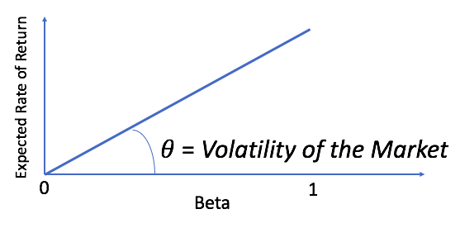

Figure 1 – The illustration of how Beta is affected by the expected RoR.

Firstly, we believe that to make a useful judgement on the riskiness of an investment, beta should be used together with the market prices to measure risk – instead of using fundamentals. Market prices often have nothing to do with the underlying economics of a business.

* 1. **Financial accounting risk metrics.**

In this section, we want to present several risk metrics that are aimed at analysing financial statements of a company that offers the investments. We want to assess the financial position of every company that offers investment opportunities. The importance of analysing of the main financial documents comes from the understanding of the fact that in order to invest into an asset that is represented by a company that offers it, the asset (the company) must be valuable enough to be able to fulfil the obligations to pay back to investors the agreed coupons or some other form of a premium, as well as the principal, in case of a corporate bond.

* + 1. **Current Ratio**. The current ratio is a liquidity ratio that measures a company's ability to pay short-term and long-term obligations. To gauge this ability, the current ratio considers the current total assets of a company (both liquid and illiquid) relative to that company's current total liabilities [9]. A ratio below 1 indicates that a company's liabilities are above its assets and suggests that the company in question would be unable to pay off its debt if they came due at that point.
 $$CR=\frac{Current Assets }{Current Liabilities}$$

   2. **Quick Ratio.** The quick ratio indicates a company’s short-term liquidity, measuring a company’s ability to meet its short-term obligations with its most liquid assets [10].

* + 1. **Debt Ratio.** Debt Ratio is a financial ratio that indicates the percentage of a company's assets that are provided by debt [11]. It is the ratio of total debt (the sum of current and long-term liabilities) and total assets.

* + 1. **Gearing Ratio.** A gearing ratio is a general classification describing a financial ratio that compares some form of owner's equity (or capital) to funds borrowed by the company. Gearing is a measurement of the entity's financial leverage, which demonstrates the degree to which a firm's activities are funded by owner's funds versus creditor's funds. The best-known examples of gearing ratios include the debt-to-equity ratio (total debt / total equity), times interest earned (EBIT / total interest), equity ratio (equity / assets), and debt ratio (total debt / total assets).
 $$GR=\frac{Total Debt}{Total Equity}$$

   2. **Leverage Ratio.** Provides information on the amount of debt within the company on the point of earnings. Large debt can be dangerous for a company and its investors. Uncontrolled debt levels can lead to credit downgrades or worse. On the other hand, too few debts can also raise questions. If a company's operations can generate a higher rate of return than the interest rate on its loans, then the debt is helping to fuel growth in profits. A reluctance or inability to borrow may be a sign that operating margins are simply too tight.

* + 1. **Net Leverage Ratio** is a debt ratio that shows how many years it would take for a company to pay back its debt if net debt and EBITDA are held constant. If a company has more cash than debt, the ratio can be negative. It considers a company's ability to decrease its debt. Ratios higher than 5 typically set off alarm bells because this indicates that a company is less likely to be able to handle its debt burden, and thus is less likely to be able to take on the additional debt required to grow the business. The net debt to EBITDA ratio should be compared to that of a benchmark or the industry average to determine the creditworthiness of a company. Additionally, horizontal analysis could be conducted to determine whether a company has increased or decreased its debt burden over a specified period. In horizontal analysis, ratios or items in the financial statement are compared to those of previous periods to determine how the company has grown over the specified period.

1. **Cluster analysis**

Clustering is the task of bringing a group of data points in a way that items in the same cluster have more attributes in common than to those in other clusters. Clustering in our project is used to score investments based in their level of risk relative to the benchmark(CDAX), as well as to each other.

* 1. **Histogram.**

A histogram is a graphical representation of the distribution of numerical data. It is an estimate of the probability distribution of a continuous variable (quantitative variable) [4]. An instance of a histogram that we created to analyse the standard deviation as a risk metric can be seen on Figure 1.

In a general mathematical sense, a histogram counts the number of observations that fall into each of the intervals, while the graphical representation of a histogram is mean to show how many item fell into the set of bins. Thus, if we let n be the total number of observations and k be the total number of bins, the histogram $m_{i}$  meets the following conditions:

$$n= \sum_{i=1}^{k}{m_{i}}$$

In our calculations of the number of buckets we choose the square-root of the number of data points.

$$k= \sqrt{n}$$

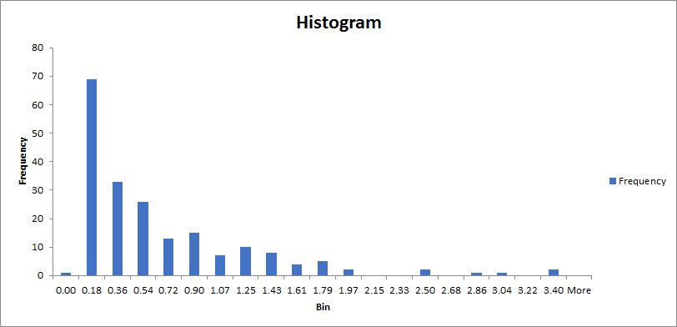

Figure 2 – Diagram for frequency of standard deviation of returns.

* 1. **Expectation maximisation.**

Expectation maximisation assigns a probability distribution to each instance of the data point which indicates the possibility of it belonging to each of the clusters. It decides how many clusters to create using cross validation. The EM iteration alternates between two steps: executing an expectation step, which creates a function for the expectation of the log-likelihood evaluated using the current estimate for the parameters, and a maximization (M) step, which computes parameters maximizing the expected log-likelihood found on the previous step [5]. Following that, these estimated parameters are then employed to define the distribution of the latent variables in the following E step in case the algorithm has not converged yet.

Given the statistical model which generates a set $X$  of observed data, a set of unobserved latent data or missing values $Z$ , and a vector of unknown parameters $θ$, along with a likelihood function $L\left(θ;X\right)=p(X, Z|θ)$ , the maximum likelihood estimate (MLE) of the unknown parameters is determined by the marginal likelihood of the observed data [5]:

$$L\left(θ;X\right)=p\left(X|θ\right)= \sum_{Z}{p(X, Z|θ)}$$

The EM algorithm seeks to find the MLE of the marginal likelihood by iteratively applying these two steps:

*Expectation step* (E step): Calculate the expected value of the log likelihood function, with respect to the conditional distribution of $Z$  given $X$  under the current estimate of the parameters $θ^{(t)}$ :

$$Q\left(θ | θ^{(t)}\right)=E_{Z|{X,θ}^{(t)}}[logL(θ;X, Z)]$$

*Maximization step* (M step): Find the parameter that maximizes this quantity:

$$θ^{\left(t+1\right)}={argmax}_{θ} Q\left(θ | θ^{\left(t\right)}\right)$$

The cross validation performed to determine the number of clusters is performed in the following steps (written in pseudocode):

1. The initial number of clusters is set to 1.

2. Split training set into 10 parts randomly.

3. Perform the algorithm 10 times with the 10 folds.

4. The loglikelihood is equal to the mean of 10 executions.

5. In case loglikelihood has increased the number of clusters is increased then repeat the step 2.

The number of folds is usually equals to 10, however, it can be set equal to any number reasonably close to the number of instances.

* 1. **Farthest-first traversal.**

One more efficient method to choose cluster centres is to select data points of maximal distance from the other, thus maximizing cluster radius (Dasgupta, 2002). Analogously to the famous K-Means algorithm, the Farthest-First works in two stages: selection of a centroid, and cluster assignment.

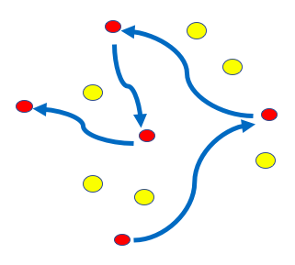

Figure 3 – Illustration of work of Farthest-first traversal algorithm.

The algorithm of Farthest-first traversal method can be described in pseudo-code as follows:

1. The farthest-first traversal of a finite point set may be computed by a greedy algorithm that maintains the distance of each point from the previously selected points, performing the following steps:

2. Initialize the sequence of selected points to the empty sequence, and the distances of each point to the selected points to infinity.

3. While not all points have been selected, repeat:

4. Scan the list of not-yet-selected points to find a point p that has the maximum distance from the selected points.

5. Remove p from the not-yet-selected points and add it to the end of the sequence of selected points.

6. For each remaining not-yet-selected point q, replace the distance stored for q by the minimum of its old value and the distance from p to q.

For a set of n points, this algorithm takes $O$ ($n^{2}$) steps and $O$ ($n^{2}$) distance computations.

1. **Implementation.**

The data subsets of the initial data for the risk metrics can be seen in Tables 1 and 2 were extracted from the data API provided by Thomson Reuters. Specifically, Table 1 contains data for the opening and closing prices of investments, as well as the data for which the prices are relevant. The interring fact that comes to the attention is that the opening price for a given day is not the same as the closing price for the previous day. The reason for that is that after the market closes, there can be performed adjustments to the prices for those transactions that were already in the queue when the market closed. Thus, the opening price is the adjusted closing price for the previous day.

Table 1. Subset of investments.

|  |  |  |  |  |  |  |
| --- | --- | --- | --- | --- | --- | --- |
| ***Date*** | ***.CDAX*** | ***.CDAX*** | ***.STOXX50*** | ***.STOXX50*** | ***.MCAPM*** | ***.MCAPM*** |
| ***Timestamp*** | ***Trade Open*** | ***Trade Close*** | ***Trade Open*** | ***Trade Close*** | ***Trade Open*** | ***Trade Close*** |
| 29/11/2016 | 965,29 | 969,58 | 2806,08 | 2816,25 | 1854,2 | 1860,5 |
| 28/11/2016 | 973,57 | 966,63 | 2830,08 | 2810,98 | 1864,54 | 1855,3 |
| 25/11/2016 | 975,66 | 976,32 | 2825,42 | 2835,82 | 1859,01 | 1866,56 |
| 24/11/2016 | 974,02 | 974,68 | 2824,65 | 2828,14 | 1855,81 | 1857,54 |
| 23/11/2016 | 977,37 | 971,75 | 2821,01 | 2820,97 | 1858,8 | 1849,37 |
| 22/11/2016 | 977,96 | 976,25 | 2832,92 | 2823,77 | 1851,73 | 1854,12 |
| 21/11/2016 | 974,16 | 973,43 | 2818,91 | 2826,09 | 1842,38 | 1845,46 |
| 18/11/2016 | 977,75 | 971,9 | 2841,48 | 2820 | 1845,5 | 1837,79 |
| 17/11/2016 | 970,88 | 973,67 | 2814,96 | 2835,39 | 1829,27 | 1840,64 |
| 16/11/2016 | 980,36 | 971,64 | 2836,71 | 2818,86 | 1837,94 | 1829,57 |

Table 2. Subset of accounting metrics of the companies that offer investments.

|  |  |  |  |  |  |
| --- | --- | --- | --- | --- | --- |
| ***Investment Name*** | ***Normalized EBITDA*** | ***Normalized EBIT*** | ***Normalized Income Before Taxes*** | ***Normalized Income After Taxes*** | ***Total Revenue*** |
| TGTG.DE | 2.314.000,00 € | -€6.112.000,00 | -€5.926.000,00 | -€6.274.100,00 | €53.535.000,00 |
| UUUG.DE | 4.037.000,00 € | €909.000,00 | -€286.000,00 | -€735.000,00 | €50.575.000,00 |
| VSCk.DE | -7.966.000,00 € | -€8.969.000,00 | -€9.242.000,00 | -€9.263.100,00 | €3.266.000,00 |
| HRPKk.F | 21.662.000,00 € | €9.910.000,00 | €4.692.000,00 | €4.072.430,00 | €25.362.000,00 |
| LUMG.F | 245.560,00 € | €243.940,00 | €238.940,00 | €238.940,00 | €12.433.970,00 |
| AAQG.DE | -6.092.000,00 € | -€9.116.000,00 | -€9.261.000,00 | -€9.542.000,00 | €12.280.000,00 |

The solution was implemented in two steps. During the first step we were using high-level programming language Python. Python features a dynamic type system and automatic memory management and supports multiple programming paradigms, including object-oriented, imperative, functional programming, and procedural styles. It has a large and comprehensive standard library [12].

Below we specify the main functions that are used in the Risk Matrix calculation.

**def getFYData_SingleYear(xl, wsName):**

Algorithm performs as follows:

1. Obtaining data from the disk
2. Remapping the columns names to the predefined technical standard to accommodate future extensibility.

**def getTS(xl, startDt , endDt):**

Algorithm performs as follows:

1. Parse the incoming Excel file **xl** and recognise it as a Data Frame.
2. We consider data for the specified date window set by the parameter list, provided by **startDt** and **endDt**.
3. The price of a stock is a close price for a given day. Decrease or Increase in the price for a given day is the closing price for previous day minus the closing price for the given day.
4. Sort the subset on the date column.

**def getRiskMatrix(dictTS, dfFY, begDate, endDate):**

Algorithm performs as follows:

1. Initiate the entire process and execute the calling of methods responsible for opening the data stream, parsing and cleaning, and subsequently, calculating all risk metrics.
2. The result of the work of the function is the Risk Matrix which is outputted to the console, as well as to the csv file.

In the second step, we implemented k-means clustering algorithm which did not show distinct results and which also proved to be relatively slow in compare to other algorithms that we used using the data analysis tool. The reason is that k-means traverses all data points several times and there is a possibility that the algorithm will not converge. To overcome this shortcoming, the fixed maximum number of steps are used. Subsequently, the clustering was implemented using Waikato Environment for Knowledge Analysis (Weka) which is a suite of machine learning software written in Java [13]. Weka provides a User Interface that can be used to retrieve and build the most common and essential charts of the provided data, as well as employ the clustering algorithms.

1. **Results**

We ran three clustering algorithms: Histogram, Estimation Maximisation and Farthest-first traversal. This gave us two results of three that cannot be used for defining which assets are less risky than other, while one result was particularly clear.

The FarthestFirst performed best giving us two clear and distinct clusters, while Jenks, as well as Expectation Maximisation collapsed most of the data points in two clusters, and at the same time more than 98% of all points belonged only to one of this cluster groups.

Based on these results, we can recommend investors the following investment opportunities. For those investors who are more risk averse, we can suggest obtaining investments from that fall into the cluster with more safer investments. For instance, we can recommend Mutual funds managers as well as Pension funds to invest into stocks with the following stickers: BIJG.DE, CSGG.F, FRSG.DE, AGXG.F, CNWKk.DE, FAOGn.DE, ELBG.DE, BIOG.DE, BIOG_p.DE, GMEG.DE, VSCk.DE. A reciprocal conclusion can be made for those investors who prefer more returns and are ready to add additional risk to their portfolio, thus making the overall position less stable. We can also suggest buying Hedge funds to concentrate their efforts on the following list of stocks that are represented by the stickers: DICn.DE, HRPKk.F, HAWG.DE, BTCGk.F, H2Fn.DE, CEAG.DE.

Overall, while our results can suggest investors based on the historical performance of investments suitable efficient options, there are other factors that can affect the resulting income. For instance, inflation, is a bigger danger to bond investors than stock investors. Stocks, on the other hand, face greater liquidity risk.

The Table 3 below shows the resulting data for cluster centroids for the Farthest-first traversal clustering algorithm that work with the best results and can be used to make the most promising recommendations.

Table 3. Resulting cluster centroids.

|  |  |  |  |  |  |  |  |  |
| --- | --- | --- | --- | --- | --- | --- | --- | --- |
| ***Cluster ID*** | ***VaR_95(%)*** | ***StdDev*** | ***Risk of Loss (%)*** | ***Beta*** | ***Sharpe*** | ***Current Ratio*** | ***Quick Ratio*** | ***Net Leverage*** |
| 1 | -5,4 | 3,35E-02 | 40,91 | 3,18E-04 | 6,07E-02 | 3,711 | 5,429 | 8,18E-01 |
| 2 | -4,43 | 2,80E-02 | 31,84 | 2,76E-04 | 1,24E-02 | 3,286 | 4,523 | -1,08 |

The listed metrics in the table above are not all that were assessed and participated in the calculation of the clusters. The short version is for shown for the sake of being concise. Additionally, in Appendix A are shown the histograms and charts of the resulting risk metrics and how they influence each other.

1. **Conclusion**

The designed algorithm for risk scoring showed excellent performance overall, giving us understanding of the risks of underlying stocks and corporate bonds and which now can be used to exercise the arbitrage we discovered. During the project, we gained an impressive knowledge of the literature on risk analysis, derived a taxonomy for the multiple risk metrics, and gained experience in calculations of risk metrics. We also got deep insights and experience in the programming language and libraries of Python and implemented an automatic solution for the analysis of investments.

At the same time, there is a window for further grows, for instance, we could enhance the solution by applying weights to each stock, thus making the portfolio more flexible. Also, we could develop a set of new metrics which is relevant specifically for the German market, and which considers laws and common practises on investing.

Ultimately, every amount of investment resources needs strategy and flexibility, as well as a great enforcement to stick to the plan. The developed algorithm can provide investment advices and can be adopted to achieve the best combination of risk exposure and benefit.

**References**

1. Frank J. Ambrosio, CFA, “An Evaluation of Risk Metrics” Vanguard Investment Counselling & Research, retrieved from www.advisors.vanguard.com
2. Hansson, Sven Ove; Zalta, Edward N. (Spring 2014). "Risk". The Stanford Encyclopedia of Philosophy. Retrieved 9 May 2014.
3. Pearson, K. (1895). "Contributions to the Mathematical Theory of Evolution. II. Skew Variation in Homogeneous Material". Philosophical Transactions of the Royal Society A: Mathematical, Physical and Engineering Sciences. 186: 343–414.
4. A. P. Dempster, N. M. Laird, and D. B. Rubin. Maximum likelihood from incomplete data via the em algorithm. Journal of the royal statistical society, series B, 39(1):1–38, 1977.
5. Dasgupta, S., "Performance guarantees for hierarchical clustering", in Proceedings of the 15th Annual Conference on Computational Learning Theory (COLT ’02), Sydney, Australia, July 8-10, 2002, pp. 351-363.
6. Markowitz, H.M. (March 1952). "Portfolio Selection". The Journal of Finance. 7 (1): 77–91.
7. Jorion, Philippe (2006). Value at Risk: The New Benchmark for Managing Financial Risk (3rd ed.). McGraw-Hill. ISBN 978-0-07-146495-6.
8. Sharpe, William F., 1994. The Sharpe Ratio. Journal of Portfolio Management 21(1):49-58.
9. "Current Ratio | Formula | Example | Analysis | Industry Standards". accounting-simplified.com. Retrieved 2016-10-11.
10. Tracy, John A. (2004). How to Read a Financial Report: Wringing Vital Signs Out of the Numbers. John Wiley and Sons. p. 173.
11. Corporate Finance: European Edition, by D. Hillier, S. Ross, R. Westerfield, J. Jaffe, and B. Jordan. McGraw-Hill, 1st Edition, 2010.
12. Summerfield, Mark. Rapid GUI Programming with Python and Qt. Python is a very expressive language, which means that we can usually write far fewer lines of Python code than would be required for an equivalent application written in, say, C++ or Java”.
13. Ian H. Witten; Eibe Frank; Mark A. Hall (2011). "Data Mining: Practical machine learning tools and techniques, 3rd Edition". Morgan Kaufmann, San Francisco. Retrieved 2011-01-19.
14. G. Holmes; A. Donkin; I.H. Witten (1994). "Weka: A machine learning workbench" (PDF). Proc Second Australia and New Zealand Conference on Intelligent Information Systems, Brisbane, Australia. Retrieved 2007-06-25.
15. **Appendix**

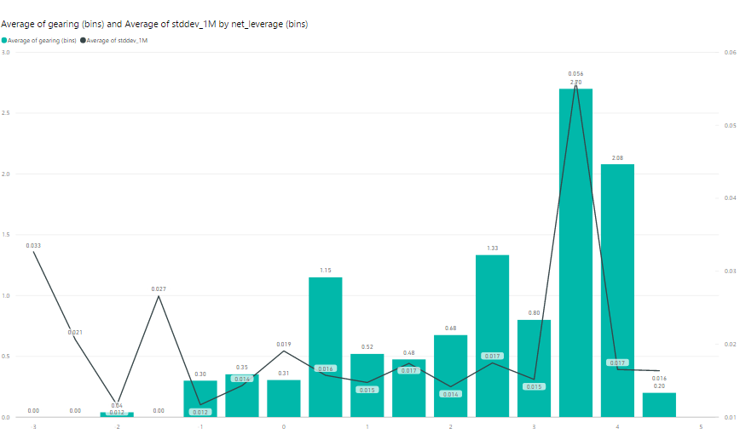

Figure 4 – Average of Gearing (bins) and average of Stadard Deviation by Net Leverage of all investments.

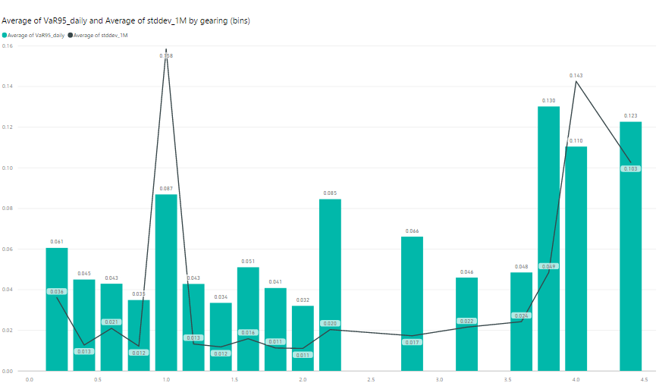

Figure 5 – Average of Variance and Standard Deviation by Gearing of all investments.

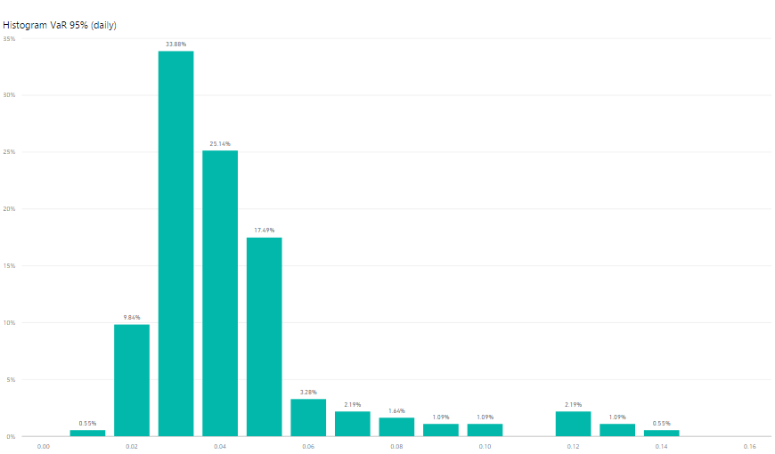

Figure 6 – Histogram for daily Value at Risk of all investments.

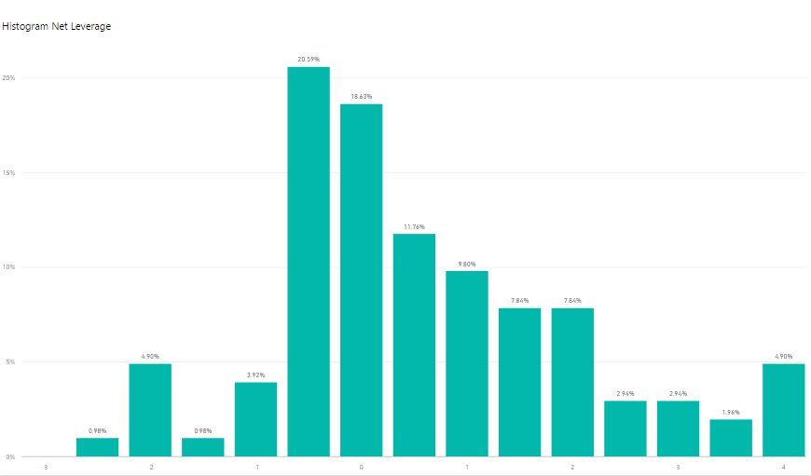

Figure 7 – Histogram of level of Net Leverage of all investments of all analysed comnpanies.

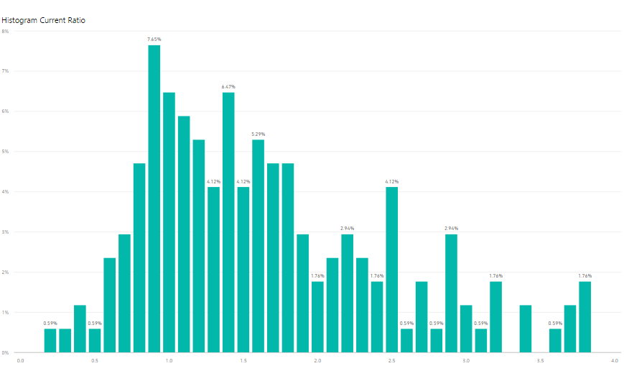

Figure 8 – Histogram of level of Current Ratio of all investments of all analysed companies.

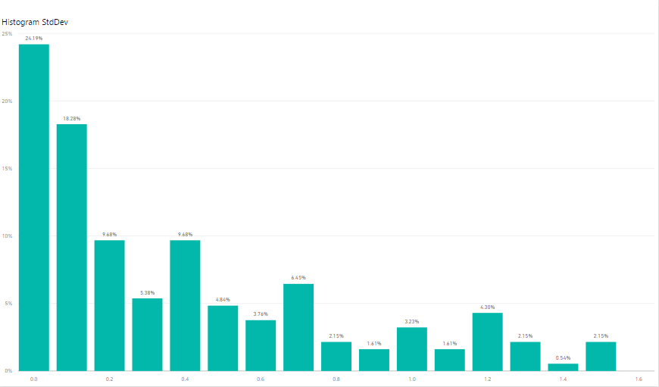

Figure 9 – Histogram of level of Standard Deviation of all investments of all analysed companies.