CMPSCI 187 (Spring 2019) Lab 07: Queue

This lab reviews some topics on the midterm. To work on the assignment:

* Go to ***File -> Make a Copy*** to make an editable copy of this Google Doc for your account
* Follow the instructions to complete the assignment
* When you are done, go to ***File -> Download As -> PDF Document***
* Log in to [Gradescope](https://gradescope.com/) and submit your PDF

1. Suppose we have the following queue implemented as a linked list with head insertion.

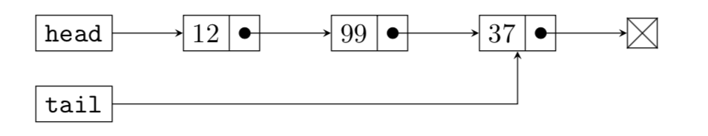

(a) (5 points) Complete the figure below showing the contents of the queue:

Queue - FIFO

|  |  |  |  |  |
| --- | --- | --- | --- | --- |
| 37 | 99 | 12 |  |  |

---------------------------------------------------------------------------->

(b) (5 points) How many dequeue() calls will it take before:

i. 37 is removed?

|  |
| --- |
| 1 |

ii. 12 is removed?

|  |
| --- |
| 3 |

iii. head is null?

|  |
| --- |
| 3 |

iv. isEmpty() returns true?

|  |
| --- |
| 3 |

v. a QueueUnderflowException is thrown?

|  |
| --- |
| 4 |

(c) (5 points) If we insist on using head insertion, what is the O() cost of the following operations on this queue? Note that the tail reference must still be maintained.

i. dequeue()

|  |
| --- |
| O( n ) |

ii. peek()

|  |
| --- |
| O( 1 ) |

iii. enqueue()

|  |
| --- |
| O( 1 ) |

2. (a) (5 points) Draw the array equivalent to the Queue created by the following operations:

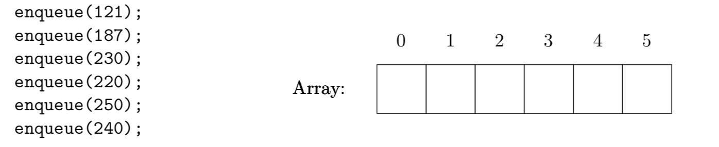

0 1 2 3 4 5

|  |  |  |  |  |  |
| --- | --- | --- | --- | --- | --- |
| 121 | 187 | 230 | 220 | 250 | 240 |

(b) (1 point) What is the O() cost of enqueue(311) after the previous code has been executed?

|  |
| --- |
| O( n ) |

(c) (1 point) What would the O() cost of enqueue(311) be if we were using a linked list with tail insertion like in this week’s project? Justify your answer with a diagram.

|  |
| --- |
| O( 1 ) |

3. Suppose we have the following file system structure:

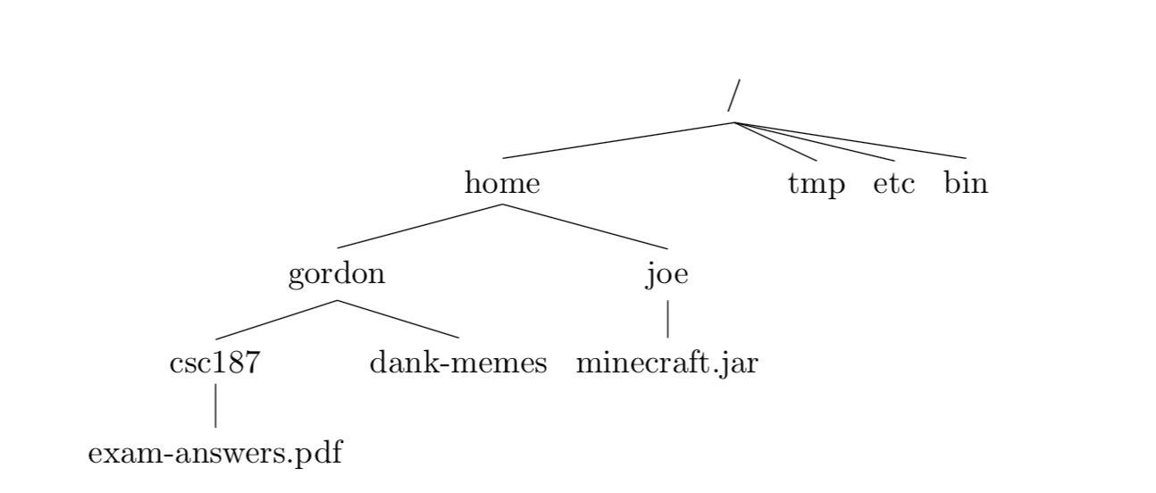

a) (5 points) In what order will a level order traversal visit the files? Assume files are added to the queue from left to right and all subdirectories are immediately enqueued when the parent directory is processed.

|  |
| --- |
| /  /home  /tmp  /etc  /bin  /home/gordon  /home/joe  /home/gordon/csc187  /home/gordon/dank-memes  /home/joe/Minecraft.jar  /home/Gordon/csc187/exam-answers.pdf |

b) (5 points) Now suppose we swapped out our queue for a stack and tried to traverse the file system again. What would the stack look like immediately after minecraft.jar gets pushed?

TOP

|  |
| --- |
|  |
|  |
|  |
|  |
|  |
|  |
|  |
|  |
| Minecraft.jar |
| gordon |

BOTTOM