### Steps to Create Executable JAR file in Eclipse

### Select your project and click on the Export option.

* **In the Export wizard, expand the "Java" folder, select "Runnable JAR file", and click "Next".**A screenshot of a computer

  Description automatically generated
* **In the "Runnable JAR File Export" window, you'll need to select the launch configuration that you want to use to run your program when the JAR file is executed. Choose the appropriate launch configuration from the dropdown menu.**
* **Specify where you want to save the JAR file on your filesystem and provide a name for the JAR file and click "Finish".**

* **Once the export process is complete, you should find the executable JAR file in the location you specified.**

**How to sign java jar  
  
keytool -genkeypair -keystore banor-bpipe.jks -keyalg RSA -keysize 2048 -validity 3650 -alias banor-bpipe**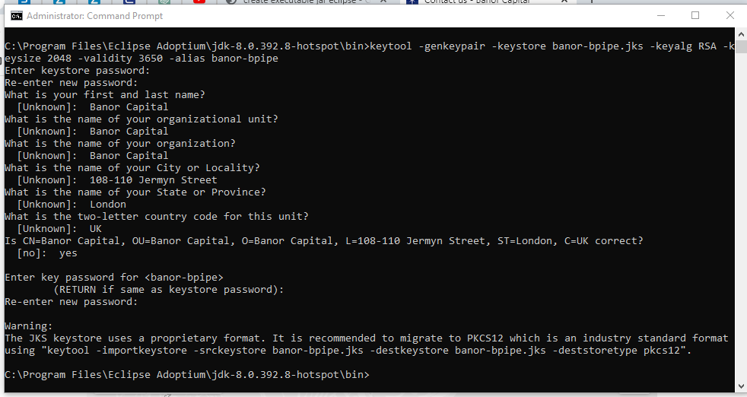

**

**

**jarsigner -verify -keystore banor-bpipe.jks -storepass banor123$ D:\Bpipe\Bpipe-banor\banor.jar**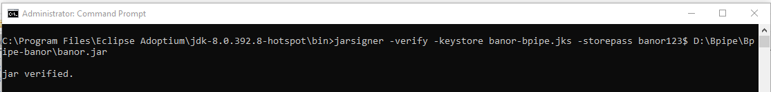

**

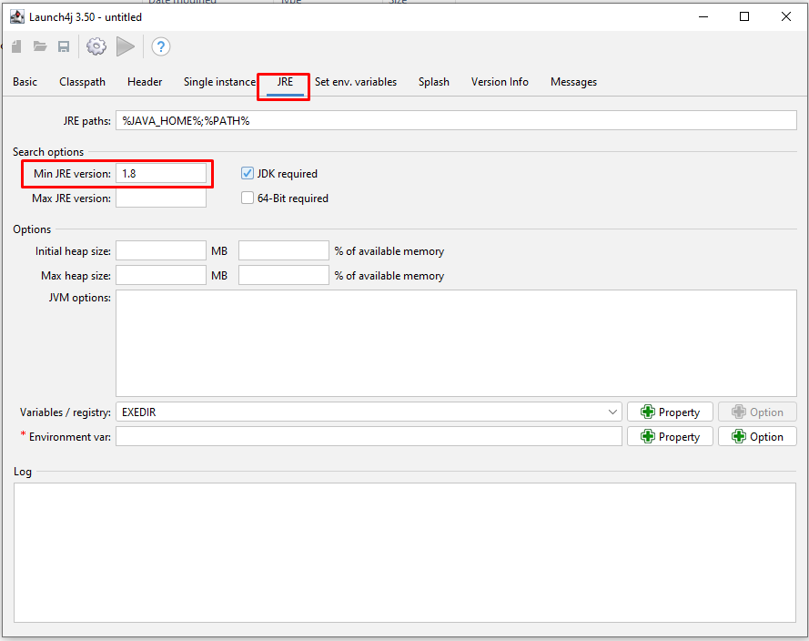

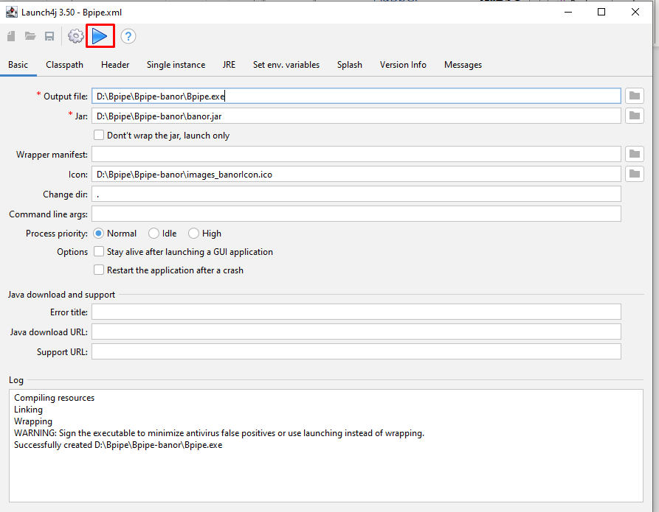 **inno setup**

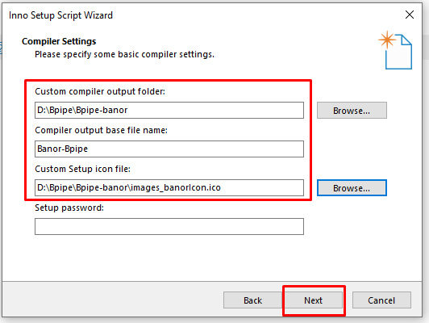

**Name: "{commonstartup}\{#MyAppName}"; Filename: "{app}\{#MyAppExeName}"**

**Name: "{userprograms}\{groupname}\{#MyAppName}"; Filename: "{app}\{#MyAppExeName}"**

**Installation**

