A800040-4.0 Arduino compatible CO2 USB

## Short description

The A800040-4 is a USB based CO2 sensor board for evaluating the SG111A, SG111B, SG112A, SG112B, PSA112ASN and PSA112BSN CO2 sensors. The evaluation board utilizes the Atmega32u4 microprocessor and is compatible with the Arduino IDE when using the Leonardo bootloader. PC Users can use the Arduino Leonardo USB driver.

## Technical / Electrical specifications

|  |  |
| --- | --- |
| Microcontroller | Atmega32u4 |
| Operating Voltage | 5V |
| Input Voltage | USB Bus (5V) |
| Flash Memory | 32KB – 4KB (Bootloader) |
| SRAM | 2.5KB |
| EEPROM | 1KB |
| Clock Speed | 16MHz |
| CO2 Range | 400-5000PPM* or 400-10000PPM |
| GPIO | * PWM Input (SG111A, SG111B) * ALARM Input (SG111A, SG111B) * Programmable ALARM/Piezo output (use Tone library) * Programmable Indicator LED |
| Connectivity | USB 2.0 / UART |

## Block diagram

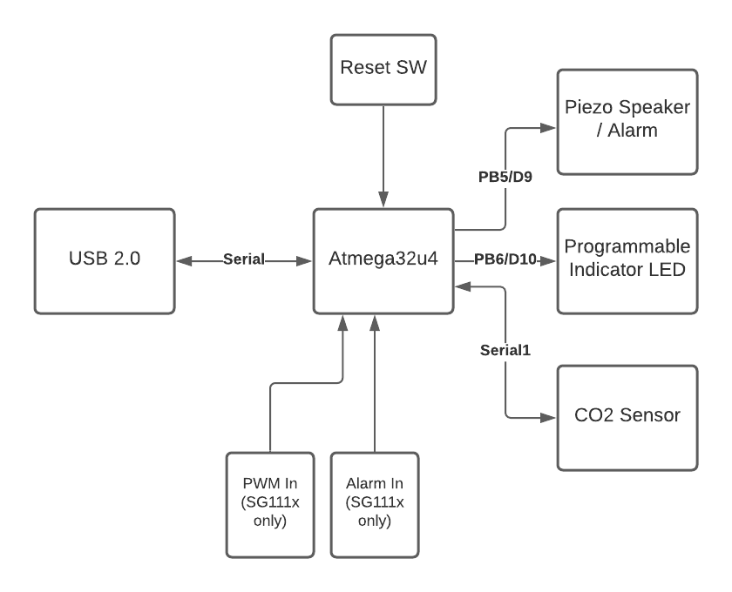

## Schematics

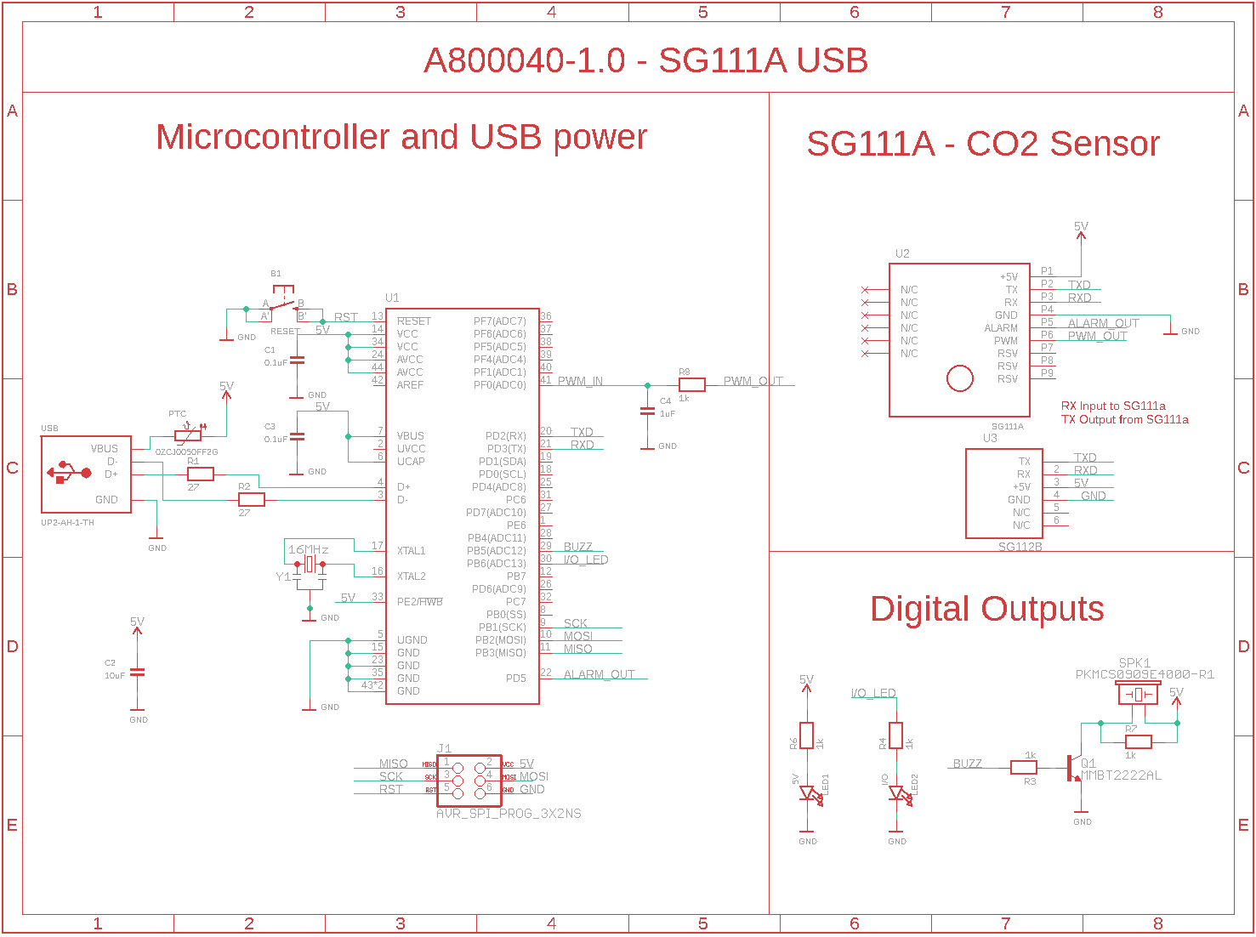

## BOM

|  |  |  |
| --- | --- | --- |
| **Qty** | **Description** | **Parts** |
| 2 | SMD/SMT .1UF 50V 10% 0603 | C1, C3 |
| 1 | PTC RESET FUSE 8V 500MA 1206 | PTC |
| 1 | SMD/SMT 10uF 6.3Volts 20% | C2 |
| 1 | Resonators 16.0000MHz 15pF SMD CHP Resntr | Y1 |
| 5 | RES SMD 1K OHM 1% 1/10W 0603 | R3, R4, R6, R7, R8 |
| 1 | CAP CER 1UF 10V X7R 0603 | C4 |
| 2 | RES SMD 27 OHM 5% 1/4W 0603 | R1, R2 |
| 1 | ATMEGA32U4QFN | U1 |
| 1 | LED RED CLEAR 0603 SMD | LED1 |
| 1 | CONN HEADER VERT 6POS 2.54MM | J1 |
| 1 | LED RED CLEAR 0603 SMD | LED2 |
| 1 | TRANS NPN 40V 0.6A SOT23 | Q1 |
| 1 | AUDIO PIEZO TRANSDUCER 12.5V SMD | SPK1 |
| 1 | SWITCH TACTILE SPST-NO 0.05A 32V | B1 |
| 1 | SG111A_CO2 | U2 |
| 1 | SG112B | U3 |
| 1 | CONN PLUG USB2.0 TYPEA 4POS R/A | USB |

## Description of Arduino Library

Arduino Library and example files can be found here: <https://github.com/AretasSensorNetworks/SG111A>

The library implements the following functions:

|  |  |
| --- | --- |
| getABCMode() | Returns a signed short integer indicating the ABC Mode setting (0 ABC is disabled 1 ABC is enabled) |
| setABCMode(boolean state) | Sets the ABC Mode. If state is true, ABC is enabled, if state is false, ABC is disabled. Returns 1 for success -1 for failure. |
| getABCDuration() | Returns a 16-bit integer indicating the ABC Duration. Returns -1 if failed to get the setting from the sensor. |
| setABCDuration(uint16_t duration) | Sets the ABC Duration (only tested up to 7 days). Returns 1 indicating success and -1 for failure. |
| getCO2aPeriodic() | This function gets the CO2 levels from the sensor on a demand basis. Note that this disables automatic mode on all subsequent calls until the sensor is reset. Returns a 16 bit integer with the CO2 value or -1 for failure. |
| getCO2() | A function to get the CO2 when operating in automatic mode. This function has basic retry logic:   * Will retry if the checksum fails up to 5 times * Will attempt to wait for a valid reading for up to 4 seconds   Returns:   * An 16-bit signed int indicating the CO2 level or * -1 indicates something unexpected happened * -2 indicates timeout reading the serial port * -3 indicates failed checksum after n retries |
| CalcCRC16 | Computes a CRC 16 Checksum, algorithm as provided by the manufacturer |