My program: include 3 parts

Part 1:
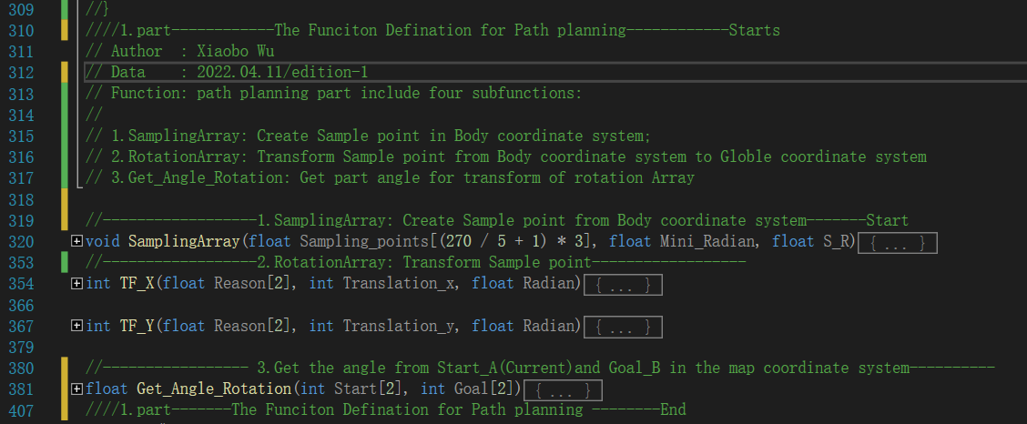
Part 2:
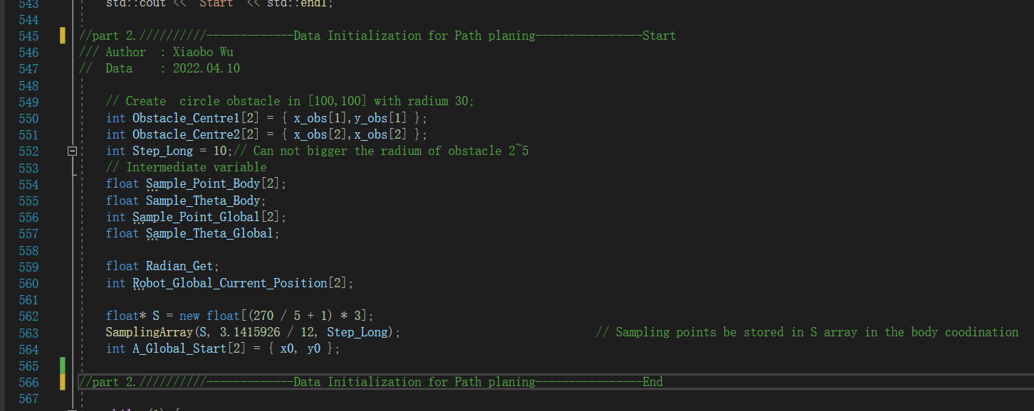
Part 3:

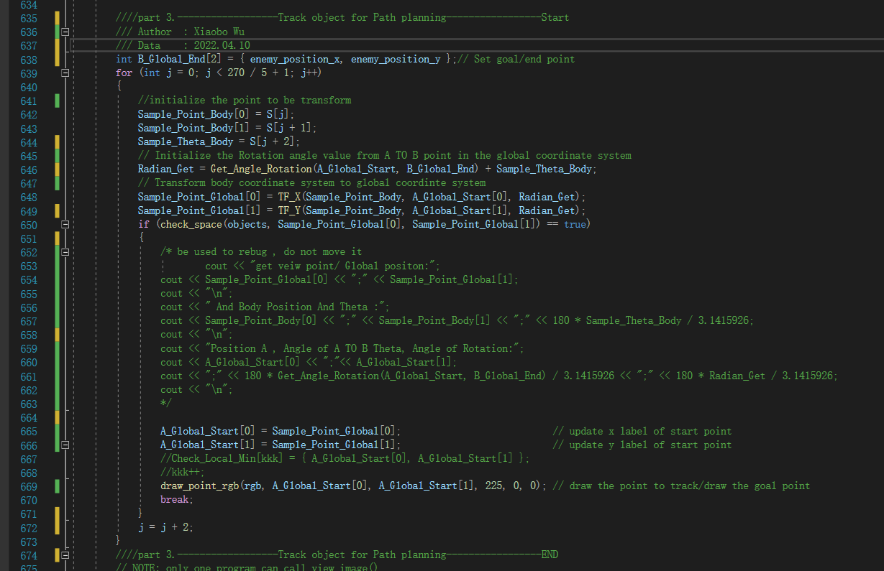

YOU need use my files with the files Player2_keyboard and image_view in the package of ImageProcessing.

Thanks.

