Департамент образования Воронежской области

Государственное бюджетное профессиональное образовательное учреждение

Воронежской области «Борисоглебский техникум промышленных

и информационных технологий»

ОТЧЕТ

по учебной практике

УП.05.01 Проектирование и разработка информационных систем

|  |  |
| --- | --- |
| Выполнил студент __3__ курса  спец. 09.02.07 «Информационные системы и программирование»  Группа 3.2ИСИП__  Юшкин.А.А  (ФИО)  Дата сдачи __31.05.2023 г.____ | Проверил  преподаватель  Пеньков А.С.  (ФИО)  Оценка _______________ |

Борисоглебск

2022 –2023 учебный год

Оглавление

1. ВЫБОР СРЕДСТВ РАЗРАБОТКИ ПРОЕКТА 3

4

ТЕМА 2. РАЗРАБОТКА ТЕХНИЧЕСКОГО ЗАДАНИЯ 5

ТЕМА 3. СИСТЕМА КОНТРОЛЯ ВЕРСИЙ 7

ТЕМА 4. СБОР ДАННЫХ ДЛЯ СОЗДАНИЕ ИНФОРМАЦИОННОЙ СИСТЕМЫ 9

ТЕМА 5. СОЗДАНИЕ МАКЕТА ИНФОРМАЦИОННОЙ СИСТЕМЫ. 11

ТЕМА 7. MATERIAL DESIGN 15

ТЕМА 8. РАБОТА СО СПИСОЧНЫМИ ЭЛЕМАНТАМИ ИНТЕРФЕЙСА 18

ТЕМА 9. ОБЪЕКТО-ОРИЕНТИРОВАННЫЙ ПОДХОД В РАЗРАБОТКЕ КОДА ИНФОРМАЦИОННОЙ СИСТЕМЫ 23

ТЕМА 10. СОЗДАНИЕ ПРОЦЕДУР ОБРАБОТКИ ИНФОРМАЦИИ 33

ТЕМА 11. ОБЕСПЕЧЕНИЕ ДОПОЛНИТЕЛЬНОЙ ФУНКЦИОНАЛЬНОЙ СИСТЕМЫ 39

ТЕМА 12. INTENTS 42

ТЕМА 13. ТЕСТИРОВАНИЕ ПРИЛОЖЕНИЯ 45

ТЕМА 14. ОТЛАДКА ПРИЛОЖЕНИЯ 48

ТЕМА 15. ЗАЩИТА ПРИЛОЖЕНИЯ.ОЦЕНКА КАЧЕСТВА И НАДЕЖНОСТИ ПРИЛОЖЕНИЯ. 50

ТЕМА 16. СОПРОЖДЕНИЕ ПРОГРАММ 52

ТЕМА 17. СОПРОВОЖДЕНИЕ ПРОГРАММ 55

ТЕМА 18. ИТОГОВОЕ ЗАНЯТИЕ 58

# ВЫБОР СРЕДСТВ РАЗРАБОТКИ ПРОЕКТА

1.Определение ОС Android

Открытая ОС для мобильных телефонов, смартфонов, коммуникаторов, планшетных компьютеров, электронных книг, цифровых проигрывателей, наручных часов, нетбуков и смартбуков, основанная на ядре Linux.

2.Что входит в инструментарий Android разработчика

JDK (Java Development Kit), IDE(Integrated Development Environment), SDK(Android Software Development Kit).

3.Перечислите обязательные элементы в структуре приложения

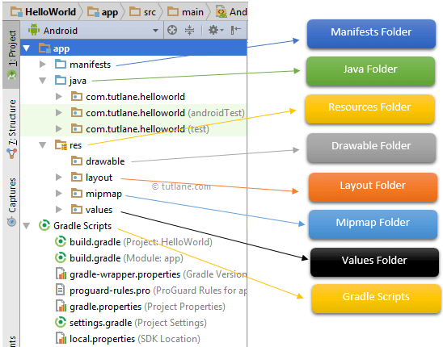

4.Перечислите опциальные элементы в структуре приложения

* src
* gen
* Android Version
* Assets
* libs
* res
  + drawable
  + layout
  + anim
  + values
* AndroidManifest.xml
* default.properties

5. Изобразите жизненный цикл android приложения

# 

# ТЕМА 2. РАЗРАБОТКА ТЕХНИЧЕСКОГО ЗАДАНИЯ

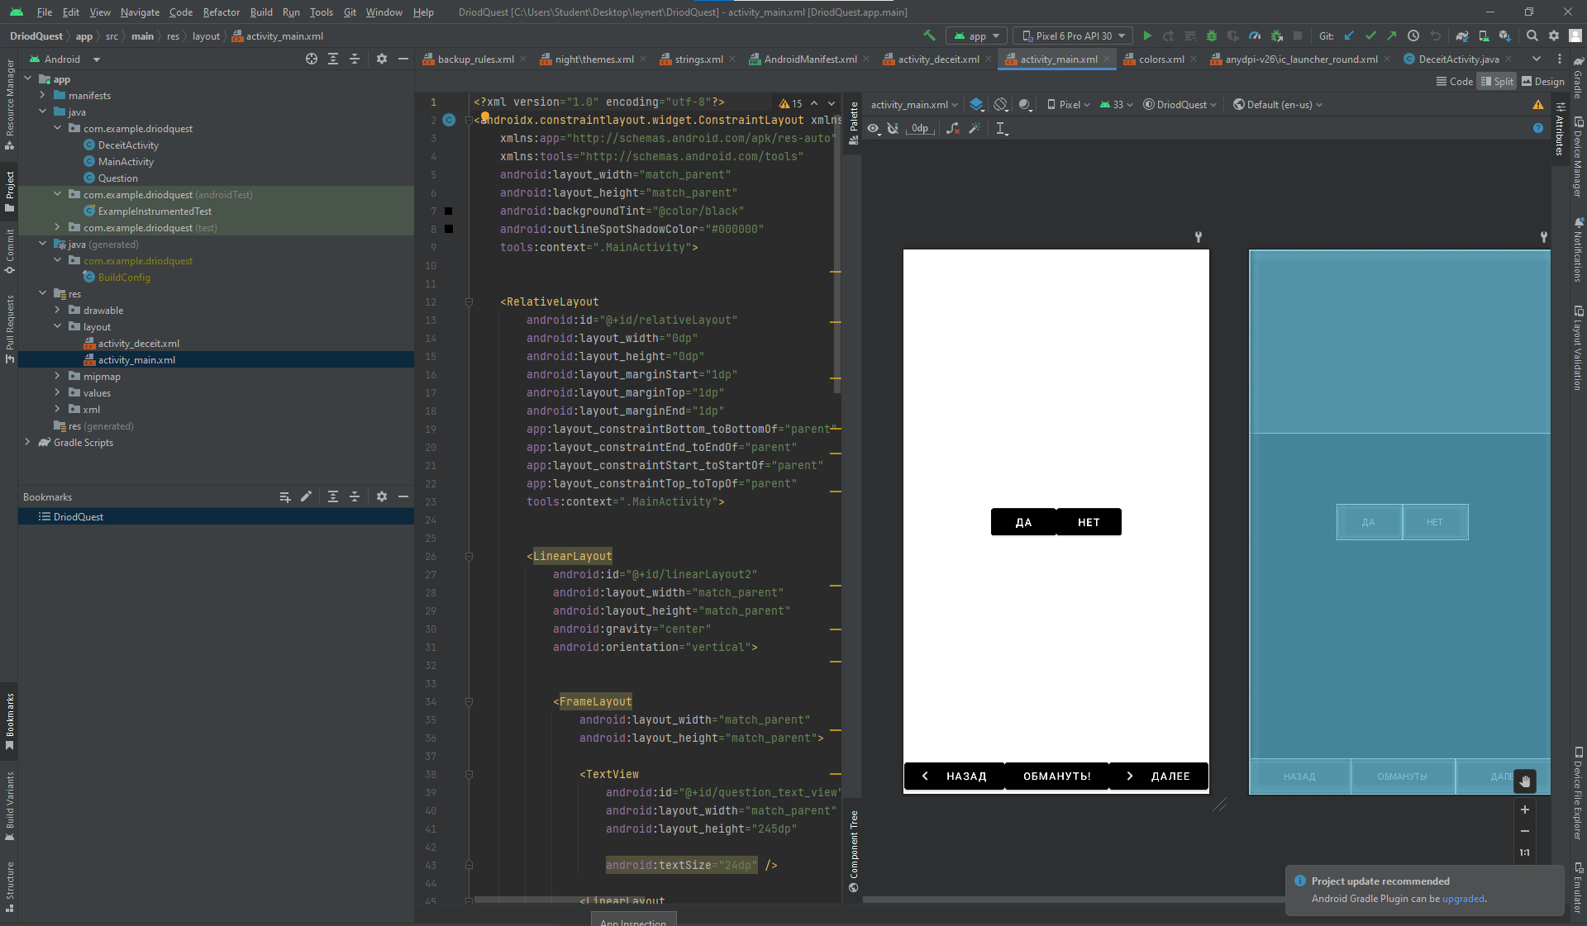

<?xml version="1.0" encoding="utf-8"?>  
<LinearLayout xmlns:android="http://schemas.android.com/apk/res/android"  
 android:layout_width="match_parent"  
 android:layout_height="match_parent"  
 android:gravity="center"  
 android:orientation="vertical">  
  
  
 <TextView  
 android:id="@+id/textView"  
 android:layout_width="347dp"  
 android:layout_height="wrap_content"  
 android:text="ОС Android основана на ядре Linux"  
 android:textSize="20sp" />  
  
 <LinearLayout  
 android:layout_width="wrap_content"  
 android:layout_height="wrap_content"  
 android:orientation="horizontal">  
  
  
 <Button  
 android:id="@+id/true_button"  
 android:layout_width="match_parent"  
 android:layout_height="wrap_content"  
 android:layout_weight="1"  
 android:text="@string/true_button" />  
  
 <Button  
 android:id="@+id/false_button"  
 android:layout_width="wrap_content"  
 android:layout_height="wrap_content"  
 android:layout_marginLeft="20dp"  
 android:layout_weight="1"  
 android:text="@string/false_button" />  
 </LinearLayout>  
</LinearLayout>

Strings.xml

<resources>  
 <string name="app_name">DriodQuest</string>  
  
 <string name="true_button">Да </string>  
 <string name="false_button">Нет </string>  
 <string name="action_setting">Setting </string>  
 <string name="correct_toast">Верно</string>  
 <string name="incorrect_toast">Не верно</string>

</resources>

}

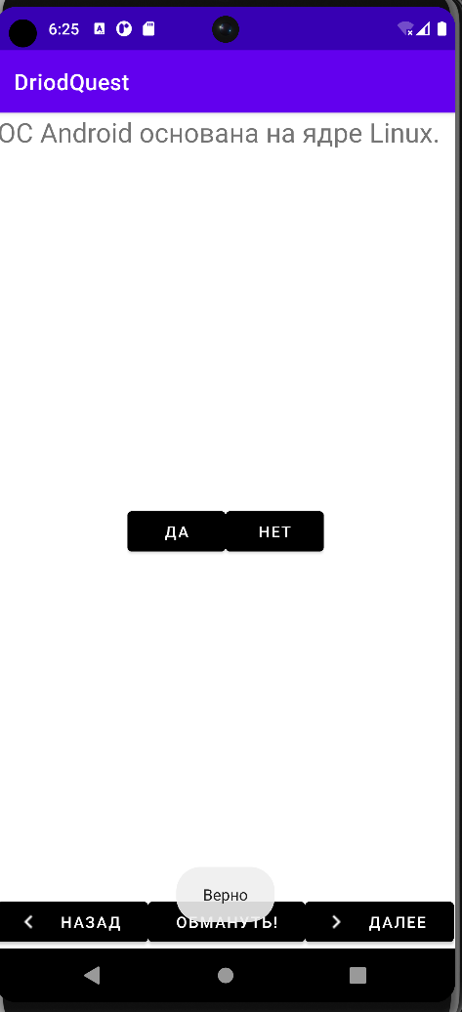

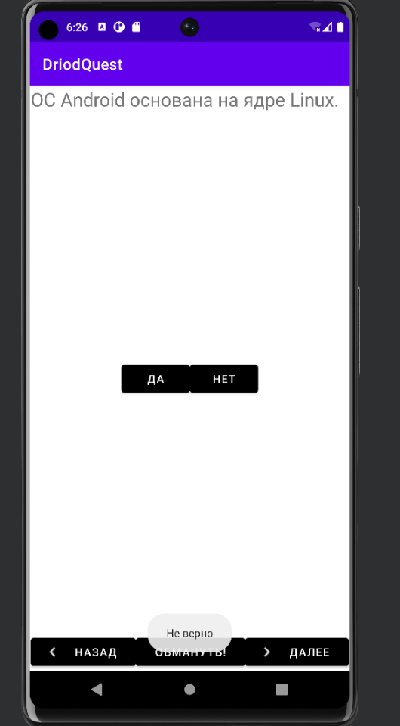

ТЕМА 3. СИСТЕМА КОНТРОЛЯ ВЕРСИЙ

<string name="next_button">Далее</string>  
<string name="back_button">Назад</string>

<TextView  
 android:id="@+id/question_text_view"  
 android:layout_width="match_parent"  
 android:layout_height="245dp"  
  
 android:textSize="24dp" />

<Button  
 android:id="@+id/back_button"  
 android:layout_width="wrap_content"  
 android:layout_height="wrap_content"  
 android:layout_weight="1"  
 android:backgroundTint="@color/black"  
 android:contentDescription="@string/back_button"  
 android:drawableRight="@drawable/baseline_keyboard_arrow_left_black_24dp"  
 android:text="@string/back_button"  
 app:icon="@drawable/baseline_keyboard_arrow_left_black_24dp" />

<Button  
 android:id="@+id/next_button"  
 android:layout_width="wrap_content"  
 android:layout_height="wrap_content"  
 android:layout_weight="1"  
 android:backgroundTint="@color/black"  
 android:contentDescription="@string/next_button"  
 android:drawableRight="@drawable/baseline_keyboard_arrow_right_black_24dp"  
 android:text="@string/next_button"  
 android:drawablePadding="4dp"  
 android:gravity="center"

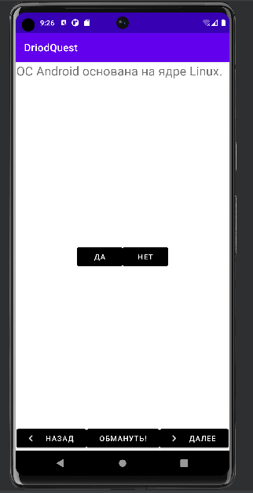 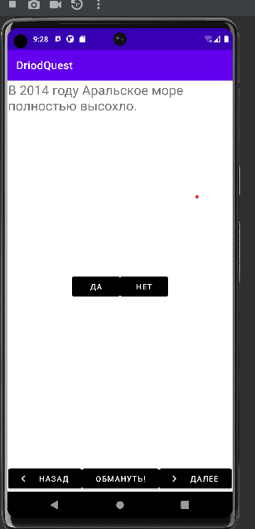 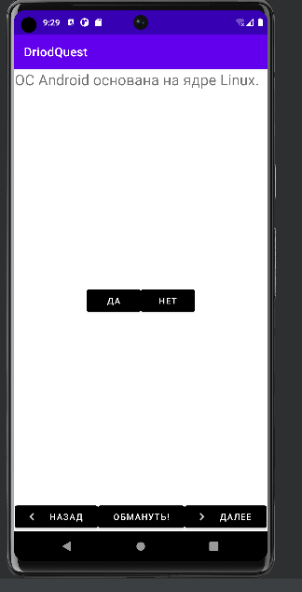

# 

# ТЕМА 4. СБОР ДАННЫХ ДЛЯ СОЗДАНИЕ ИНФОРМАЦИОННОЙ СИСТЕМЫ

Log.*d*(*TAG*, "onCreate(Bundle) вызван");

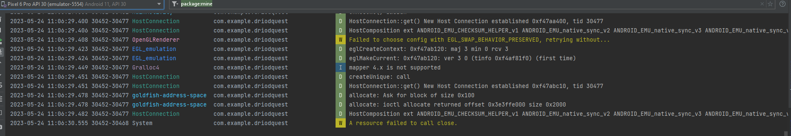@Override  
public void onStart() {  
 super.onStart();  
 Log.*d*(*TAG*, "onStart() вызван");  
}  
  
@Override  
public void onPause() {  
 super.onPause();  
 Log.*d*(*TAG*, "onPause() вызван");  
}  
  
@Override  
public void onResume() {  
 super.onResume();  
 Log.*d*(*TAG*, "onResume() вызван");  
}  
  
@Override  
public void onStop() {  
 super.onStop();  
 Log.*d*(*TAG*, "onStop() вызван");  
}  
  
@Override  
public void onDestroy() {  
 super.onDestroy();  
 Log.*d*(*TAG*, "onDestroy() вызван");  
}

# Сделала альбомную ориентацию

# 

# ТЕМА 5. СОЗДАНИЕ МАКЕТА ИНФОРМАЦИОННОЙ СИСТЕМЫ.

Создаем кнопуку «Обмануть!»

MainActivity.java

<Button  
 android:id="@+id/deceit_button"  
 android:layout_width="wrap_content"  
 android:layout_height="wrap_content"  
 android:layout_weight="1"  
 android:backgroundTint="@color/black"  
 android:outlineAmbientShadowColor="@color/black"  
 android:outlineSpotShadowColor="@color/black"  
 android:text="@string/deceit_button"  
 app:rippleColor="@color/black" />

private Button mDeceitButton;

mDeceitButton = (Button)findViewById(R.id.*deceit_button*);   
mDeceitButton.setOnClickListener(new View.OnClickListener() {  
 @Override  
 public void onClick(View view) {  
 boolean answerIsTrue = mQuestionBank[mCurrentIndex]  
 .isAnswerTrue();  
 Intent i = DeceitActivity.*newIntent*(MainActivity.this, answerIsTrue);  
 startActivityForResult(i, *REQUEST_CODE_DECEIT*);  
 }  
});

boolean answerIsTrue = mQuestionBank[mCurrentIndex]  
 .isAnswerTrue();  
Intent i = DeceitActivity.*newIntent*(MainActivity.this, answerIsTrue);

DeceitActivity.java

private boolean mAnswerIsTrue;  
private TextView mAnswerTextView;  
private Button mShowAnswer;

protected void onCreate(Bundle savedInstanceState) {  
 super.onCreate(savedInstanceState);  
 setContentView(R.layout.*activity_deceit*);  
 mAnswerIsTrue = getIntent().getBooleanExtra(*EXTRA_ANSWER_IS_TRUE*, false);  
 mAnswerTextView = (TextView) findViewById(R.id.*answer_text_view*);  
 mShowAnswer = (Button) findViewById(R.id.*show_answer_button*);  
 mShowAnswer.setOnClickListener(new View.OnClickListener() {

Получение результата от дочерней активности

private static final int *REQUEST_CODE_DECEIT* = 0;

startActivityForResult(i, *REQUEST_CODE_DECEIT*);

Возвращение интента

public static final String *EXTRA_ANSWER_SHOWN* = "com.example.my_practica.answer_shown";

setAnswerShownResult(true);  
 }  
 });  
  
  
 }  
  
 private void setAnswerShownResult(boolean isAnswerShown) {  
 Intent data = new Intent();  
 data.putExtra(*EXTRA_ANSWER_SHOWN*, isAnswerShown);  
 setResult(*RESULT_OK*, data);  
 }  
}

public static boolean wasAnswerShown(Intent result) {  
 return result.getBooleanExtra(*EXTRA_ANSWER_SHOWN*, false);  
}

# Обработка результата

private boolean mIsDeceiter;

@Override  
protected void onActivityResult(int requestCode, int resultCode, Intent data) {  
 super.onActivityResult(requestCode, resultCode, data);  
 if (resultCode != Activity.*RESULT_OK*) {  
 return;  
 }  
 if (requestCode == *REQUEST_CODE_DECEIT*) {  
 if (data == null) {  
 return;  
 }  
  
 mIsDeceiter = DeceitActivity.*wasAnswerShown*(data);  
 }

# Изменение уведомления в зависимости от значения mIsDeceiter (QuestActivity.java)

if (mIsDeceiter) {  
 messageResId = R.string.*judgment_toast*;  
} else {  
 if (userPressedTrue == answerIsTrue) { messageResId = R.string.*correct_toast*;  
 } else {  
 messageResId = R.string.*incorrect_toast*;  
 }

@Override  
public void onClick(View view) {  
 mCurrentIndex = (mCurrentIndex + 1) % mQuestionBank.length;  
 mIsDeceiter = false;  
 updateQuestion();  
  
}

# Результат

# 

# Если мы нажем кнопку нет

# 

# ТЕМА 7. MATERIAL DESIGN

Activity_main.xml

<FrameLayout xmlns:android="http://schemas.android.com/apk/res/android"  
 android:id="@+id/fragmentContainer"  
 android:layout_width="match_parent"  
 android:layout_height="match_parent"  
 >  
  
 <LinearLayout  
 android:layout_width="match_parent"  
 android:layout_height="match_parent"  
 android:orientation="vertical">  
  
 <EditText  
 android:id="@+id/book_title"  
 android:layout_width="match_parent"  
 android:layout_height="wrap_content"  
 android:hint="@string/book_title_hint" />  
 </LinearLayout>  
</FrameLayout>

fragment_book.xml

<?xml version="1.0" encoding="utf-8"?>  
<LinearLayout  
 xmlns:android="http://schemas.android.com/apk/res/android"  
 android:layout_width="match_parent"  
 android:layout_height="match_parent"  
 android:orientation="vertical">  
 <EditText  
 android:id="@+id/book_title"  
 android:layout_width="match_parent"  
 android:layout_height="wrap_content"  
 android:hint="@string/book_title_hint"  
 />  
</LinearLayout>

strings.xml

<resources>  
 <string name="app_name">BookDepository</string>  
 <string name="menu_settings">Settings</string>  
 <string name="title_activity_book">BookActivity</string>  
 <string name="book_title_hint">Введите название книги.</string>  
 <!-- TODO: Remove or change this placeholder text -->  
 <string name="hello_blank_fragment">Hello blank fragment</string>  
  
</resources>

BookFragment2.java

package com.example.bookdepository;  
  
import androidx.appcompat.app.AppCompatActivity;  
  
import android.os.Bundle;  
import android.support.v4.app.Fragment;  
import android.text.Editable;  
import android.text.TextWatcher;  
import android.view.LayoutInflater;  
import android.view.View;  
import android.view.ViewGroup;  
import android.widget.EditText;  
  
public class BookFragment2 extends Fragment {  
  
 private Book mBook;  
 private EditText mTitleField;  
 @Override  
 public View onCreateView(LayoutInflater inflater, ViewGroup container, Bundle savedInstanceState) {  
 View v = inflater.inflate(R.layout.*activity_main*, container, false);  
 mTitleField = (EditText) v.findViewById(R.id.*book_title*);  
 mTitleField.addTextChangedListener(new TextWatcher() {  
 @Override  
 public void beforeTextChanged(CharSequence s, int start, int count, int after) {  
  
 }  
  
 @Override  
 public void onTextChanged(CharSequence s, int start, int before, int count) {  
 mBook.setTitle(s.toString());  
 }  
  
 @Override  
 public void afterTextChanged(Editable c) {  
  
 }  
 });  
 return v;  
 }  
  
}

BookActivity.java

package com.example.bookdepository;  
  
import androidx.appcompat.app.AppCompatActivity;  
  
import android.os.Bundle;  
import android.support.v4.app.Fragment;  
import android.support.v4.app.FragmentActivity;  
import android.support.v4.app.FragmentManager;  
  
public class BookActivity extends FragmentActivity {  
  
 @Override  
 protected void onCreate(Bundle savedInstanceState) {  
 super.onCreate(savedInstanceState);  
 setContentView(R.layout.*activity_main*);  
 FragmentManager fm = getSupportFragmentManager();  
 Fragment fragment = fm.findFragmentById(R.id.*fragmentContainer*);  
 if (fragment == null) {  
 fragment = new BookFragment2();  
 fm.beginTransaction()  
 .add(R.id.*fragmentContainer*, fragment)  
 .commit();  
 }  
 }  
}

Book.java

package com.example.bookdepository;  
  
import java.util.UUID;  
  
public class Book {  
 private UUID mId; private  
 String mTitle;  
 public Book() {  
 mId = UUID.*randomUUID*(); //Генерирование уникального идентификатора  
 }  
 public UUID getId() {  
 return mId;  
 }  
 public String getTitle() {  
 return mTitle;  
 }  
 public void setTitle(String title) {  
 mTitle = title;  
 }  
}

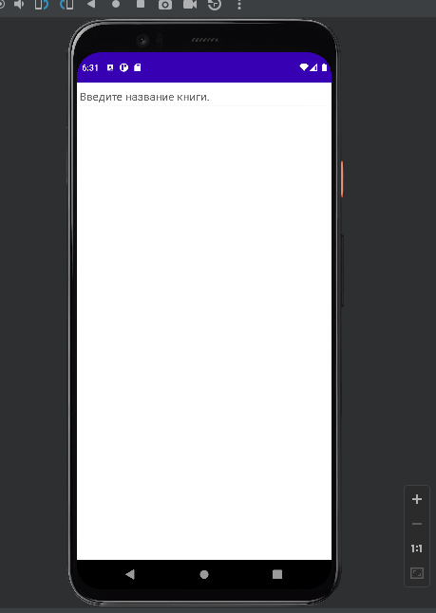

ТЕМА 8. РАБОТА СО СПИСОЧНЫМИ ЭЛЕМАНТАМИ ИНТЕРФЕЙСА

Book.java

package com.example.bookdepository;  
  
import java.util.Date;  
import java.util.UUID;  
  
public class Book {  
 private UUID mId; private  
 String mTitle;  
 private Date mDate;  
 private boolean mReaded;  
 public Book() {  
 mId = UUID.*randomUUID*(); //Генерирование уникального идентификатора  
 mDate = new Date();  
 }  
  
 public Date getDate() {  
 return mDate;  
 }  
 public void setDate(Date date) {  
 mDate = date;  
 }  
 public boolean isReaded() {  
 return mReaded;  
 }  
  
 public void setReaded(boolean readed) {  
 mReaded = readed;  
 }  
  
 public UUID getId() {  
 return mId;  
 }  
 public String getTitle() {  
 return mTitle;  
 }  
 public void setTitle(String title) {  
 mTitle = title;  
 }  
}

BookActivity.java

package com.example.bookdepository;  
  
import java.util.Date;  
import java.util.UUID;  
  
public class Book {  
 private UUID mId; private  
 String mTitle;  
 private Date mDate;  
 private boolean mReaded;  
 public Book() {  
 mId = UUID.*randomUUID*(); //Генерирование уникального идентификатора  
 mDate = new Date();  
 }  
  
 public Date getDate() {  
 return mDate;  
 }  
 public void setDate(Date date) {  
 mDate = date;  
 }  
 public boolean isReaded() {  
 return mReaded;  
 }  
  
 public void setReaded(boolean readed) {  
 mReaded = readed;  
 }  
  
 public UUID getId() {  
 return mId;  
 }  
 public String getTitle() {  
 return mTitle;  
 }  
 public void setTitle(String title) {  
 mTitle = title;  
 }  
}

BookFragment2.java

package com.example.bookdepository;  
  
import java.util.Date;  
  
import android.os.Bundle;  
import android.support.v4.app.Fragment;  
import android.text.Editable;  
import android.text.TextWatcher;  
import android.view.LayoutInflater;  
import android.view.View;  
import android.view.ViewGroup;  
import android.widget.Button;  
import android.widget.CheckBox;  
import android.widget.CompoundButton;  
import android.widget.EditText;  
  
public class BookFragment2 extends Fragment {  
  
 private Book mBook;  
 private EditText mTitleField;  
 private Button mDateButton;  
 private CheckBox mReadedCheckBox;  
 @Override  
 public void onCreate(Bundle savedInstanceState) {  
 super.onCreate(savedInstanceState);  
 mBook = new Book();  
 }  
 @Override  
 public View onCreateView(LayoutInflater inflater, ViewGroup container, Bundle savedInstanceState) {  
 View v = inflater.inflate(R.layout.*fragment_book*, container, false);  
 mTitleField = (EditText) v.findViewById(R.id.*book_title*);  
 mTitleField.addTextChangedListener(new TextWatcher() {  
 @Override  
 public void beforeTextChanged(CharSequence s, int start, int count, int after) {  
  
 }  
  
 @Override  
 public void onTextChanged(CharSequence s, int start, int before, int count) {  
 mBook.setTitle(s.toString());  
 }  
  
 @Override  
 public void afterTextChanged(Editable c) {  
  
 }  
 });  
 mDateButton = (Button) v.findViewById(R.id.*book_date*);  
 mDateButton.setText(mBook.getDate().toString());  
 mDateButton.setEnabled(false);  
mReadedCheckBox = (CheckBox)v.findViewById(R.id.*book_readed*);  
mReadedCheckBox.setOnCheckedChangeListener(new CompoundButton.OnCheckedChangeListener() {  
 @Override  
 public void onCheckedChanged(CompoundButton buttonView, boolean isChecked) {  
 mBook.setReaded(isChecked);  
 }  
});  
 return v;  
 }  
  
}

activity_main.xml

<FrameLayout xmlns:android="http://schemas.android.com/apk/res/android"  
 android:id="@+id/fragmentContainer"  
 android:layout_width="match_parent"  
 android:layout_height="match_parent"  
 >  
  
  
</FrameLayout>

fragment_book.xml

<?xml version="1.0" encoding="utf-8"?>  
<LinearLayout  
 xmlns:android="http://schemas.android.com/apk/res/android"  
 android:layout_width="match_parent"  
 android:layout_height="match_parent"  
 android:orientation="vertical">  
 <TextView  
 android:layout_width="match_parent"  
 android:layout_height="wrap_content"  
 android:text="@string/book_title_label"  
 style="?android:listSeparatorTextViewStyle"  
 />  
 <EditText  
 android:id="@+id/book_title"  
 android:layout_width="match_parent"  
 android:layout_height="wrap_content"  
 android:layout_marginLeft="16dp"  
 android:layout_marginRight="16dp"  
 android:hint="@string/book_title_hint"  
 />  
 <TextView  
 android:layout_width="match_parent"  
 android:layout_height="wrap_content"  
 android:text="@string/book_details_label"  
 style="?android:listSeparatorTextViewStyle"  
 />  
 <Button android:id="@+id/book_date"  
 android:layout_width="match_parent"  
 android:layout_height="wrap_content"  
 android:layout_marginLeft="16dp"  
 android:layout_marginRight="16dp"  
 android:padding="80dp"  
 />  
 <CheckBox  
 android:id="@+id/book_readed"  
 android:layout_width="match_parent"  
 android:layout_height="wrap_content"  
 android:layout_marginLeft="16dp"  
 android:layout_marginRight="16dp"  
 android:text="@string/book_readed_label"  
 />  
  
</LinearLayout>

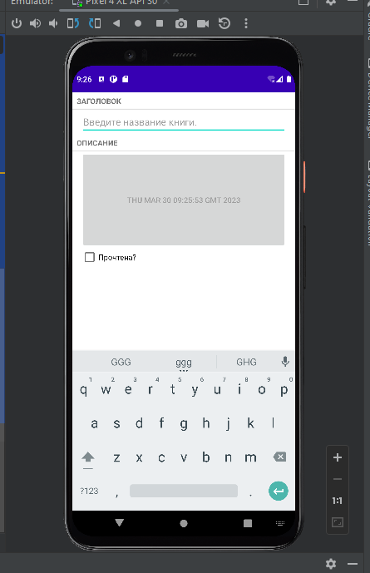

ТЕМА 9. ОБЪЕКТО-ОРИЕНТИРОВАННЫЙ ПОДХОД В РАЗРАБОТКЕ КОДА ИНФОРМАЦИОННОЙ СИСТЕМЫ

Book.java

package ru.rsue.leynert.bookdepository;

import java.util.Date;  
import java.util.UUID;  
  
public class Book {  
 private UUID mId; private  
 String mTitle;  
 private Date mDate;  
 private boolean mReaded;  
 public Book() {  
 mId = UUID.*randomUUID*(); //Генерирование уникального идентификатора  
 mDate = new Date();  
 }  
  
 public Date getDate() {  
 return mDate;  
 }  
 public void setDate(Date date) {  
 mDate = date;  
 }  
 public boolean isReaded() {  
 return mReaded;  
 }  
  
 public void setReaded(boolean readed) {  
 mReaded = readed;  
 }  
  
 public UUID getId() {  
 return mId;  
 }  
 public String getTitle() {  
 return mTitle;  
 }  
 public void setTitle(String title) {  
 mTitle = title;  
 }  
}

BookActivity

package ru.rsue.leynert.bookdepository;

import android.os.Bundle;  
import android.support.v4.app.Fragment;  
import android.support.v4.app.FragmentActivity;  
import android.support.v4.app.FragmentManager;  
  
public class BookActivity extends SingleFragmentActivity{  
 @Override  
 protected Fragment createFragment() {  
  
 return new BookFragment2();  
 }  
  
}

BookFragment2

package ru.rsue.leynert.bookdepository;

import java.util.Date;  
  
import android.os.Bundle;  
import android.support.v4.app.Fragment;  
import android.text.Editable;  
import android.text.TextWatcher;  
import android.view.LayoutInflater;  
import android.view.View;  
import android.view.ViewGroup;  
import android.widget.Button;  
import android.widget.CheckBox;  
import android.widget.CompoundButton;  
import android.widget.EditText;  
  
public class BookFragment2 extends Fragment {  
  
 private Book mBook;  
 private EditText mTitleField;  
 private Button mDateButton;  
 private CheckBox mReadedCheckBox;  
 @Override  
 public void onCreate(Bundle savedInstanceState) {  
 super.onCreate(savedInstanceState);  
 mBook = new Book();  
 }  
 @Override  
 public View onCreateView(LayoutInflater inflater, ViewGroup container, Bundle savedInstanceState) {  
 View v = inflater.inflate(R.layout.*fragment_book*, container, false);  
 mTitleField = (EditText) v.findViewById(R.id.*book_title*);  
 mTitleField.addTextChangedListener(new TextWatcher() {  
 @Override  
 public void beforeTextChanged(CharSequence s, int start, int count, int after) {  
  
 }  
  
 @Override  
 public void onTextChanged(CharSequence s, int start, int before, int count) {  
 mBook.setTitle(s.toString());  
 }  
  
 @Override  
 public void afterTextChanged(Editable c) {  
  
 }  
 });  
 mDateButton = (Button) v.findViewById(R.id.*book_date*);  
 mDateButton.setText(mBook.getDate().toString());  
 mDateButton.setEnabled(false);  
mReadedCheckBox = (CheckBox)v.findViewById(R.id.*book_readed*);  
mReadedCheckBox.setOnCheckedChangeListener(new CompoundButton.OnCheckedChangeListener() {  
 @Override  
 public void onCheckedChanged(CompoundButton buttonView, boolean isChecked) {  
 mBook.setReaded(isChecked);  
 }  
});  
 return v;  
 }  
  
}

BookLab.java

package ru.rsue.leynert.bookdepository;

import android.content.Context;  
  
import java.util.ArrayList;  
import java.util.List;  
import java.util.UUID;  
  
public class BookLab {  
 private static BookLab *sBookLab*;  
 private List<Book> mBooks;  
 public static BookLab get(Context context) {  
 if (*sBookLab* == null) {  
 *sBookLab* = new BookLab(context);  
  
 }  
 return *sBookLab*;  
 }  
 private BookLab(Context context) {  
 mBooks = new ArrayList<>();  
 for (int i = 0; i < 100; i++) {  
 Book book = new Book();  
 book.setTitle("Book #" + i);  
 book.setReaded(i % 2 == 0); // Для каждого второго объекта  
 mBooks.add(book);  
 }  
 }  
 public List<Book> getBooks(){  
 return mBooks;  
 }  
 public Book getBook(UUID id) {  
 for (Book book : mBooks) {  
 if (book.getId().equals(id)) {  
 return book;  
 }  
 }  
 return null;  
 }  
}

BookListActivity.java

package ru.rsue.leynert.bookdepository;

import android.support.v4.app.Fragment;  
  
  
public class BookListActivity extends SingleFragmentActivity {  
 @Override  
 protected Fragment createFragment() {  
 return new BookListFragment();  
  
 }  
}

BookListFragment.java

package ru.rsue.leynert.bookdepository;

import android.os.Bundle;  
import android.support.v4.app.Fragment;  
import android.view.LayoutInflater;  
import android.view.View;  
import android.view.ViewGroup;  
import android.widget.CheckBox;  
import android.widget.TextView;  
import android.widget.Toast;  
  
import androidx.annotation.NonNull;  
import androidx.recyclerview.widget.LinearLayoutManager;  
import androidx.recyclerview.widget.RecyclerView;  
  
import java.util.List;  
  
public class BookListFragment extends Fragment {  
 private RecyclerView mBookRecyclerView;  
 private BookAdapter mAdapter;  
 @Override  
 public View onCreateView(LayoutInflater inflater, ViewGroup container, Bundle savedInstanceState) {  
 View view = inflater.inflate(R.layout.*fragment_book_list*, container, false);  
 mBookRecyclerView = (RecyclerView) view  
 .findViewById(R.id.*book_recycler_view*);  
 mBookRecyclerView.setLayoutManager(new LinearLayoutManager(getActivity()));  
 updateUI();  
 return view;  
 }  
 private void updateUI() {  
 BookLab bookLab = BookLab.*get*(getActivity());  
 List<Book> books = bookLab.getBooks();  
 mAdapter = new BookAdapter(books);  
 mBookRecyclerView.setAdapter(mAdapter);  
 }  
  
 private class BookHolder extends RecyclerView.ViewHolder implements View.OnClickListener {  
 private TextView mTitleTextView;  
 private TextView mDateTextView;  
 private Book mBook;  
 private CheckBox mReadedCheckBox;  
  
 public void bindBook(Book book) { mBook = book;  
 mTitleTextView.setText(mBook.getTitle());  
 mDateTextView.setText(mBook.getDate().toString());  
 mReadedCheckBox.setChecked(mBook.isReaded());  
 }  
 public BookHolder(View itemView) {  
 super(itemView);  
 itemView.setOnClickListener(this);  
 mTitleTextView = (TextView)  
 itemView.findViewById(R.id.*list_item_book_title_text_view*); mDateTextView = (TextView)  
 itemView.findViewById(R.id.*list_item_book_date_text_view*); mReadedCheckBox = (CheckBox)  
 itemView.findViewById(R.id.*list_item_book_readed_check_box*);  
  
 }  
  
 public void onClick(View v) { Toast.*makeText*(getActivity(),  
 mBook.getTitle() + " clicked!", Toast.*LENGTH_SHORT*)  
 .show();  
 }  
}  
  
  
  
 private class BookAdapter extends RecyclerView.Adapter<BookHolder> {  
 private List<Book> mBooks;  
 public BookAdapter(List<Book> books) {  
 mBooks = books;  
 }  
  
 @Override  
 public BookHolder onCreateViewHolder( ViewGroup parent, int viewType) {  
 LayoutInflater layoutInflater = LayoutInflater.*from*(getActivity());  
 View view = layoutInflater.inflate(R.layout.*list_item_book*, parent, false);  
 return new BookHolder(view);  
  
 }  
  
 @Override  
 public void onBindViewHolder(BookHolder holder, int position) {  
 Book book = mBooks.get(position);  
 holder.bindBook(book);  
 }  
  
 @Override  
 public int getItemCount() {  
  
 return mBooks.size();  
 }  
 }  
  
}

SingleFragmentActivity.java

package ru.rsue.leynert.bookdepository;

import android.os.Bundle;  
import android.support.v4.app.Fragment;  
import android.support.v4.app.FragmentActivity;  
import android.support.v4.app.FragmentManager;  
  
public abstract class SingleFragmentActivity extends FragmentActivity {  
 protected abstract Fragment createFragment();  
  
 @Override  
 public void onCreate(Bundle savedInstanceState) {  
 super.onCreate(savedInstanceState);  
 setContentView(R.layout.*activity_fragment*);  
 FragmentManager fm = getSupportFragmentManager();  
 Fragment fragment = fm.findFragmentById(R.id.*fragmentContainer*);  
 if (fragment == null) {  
 fragment = new BookListFragment();//BookFragment2  
 fm.beginTransaction()  
 .add(R.id.*fragmentContainer*, fragment)  
 .commit();  
 }  
 }  
}

activity_fragment.xml

<FrameLayout xmlns:android="http://schemas.android.com/apk/res/android"  
 android:id="@+id/fragmentContainer"  
 android:layout_width="match_parent"  
 android:layout_height="wrap_content"  
 >  
  
  
</FrameLayout>

fragment_book.xml

<?xml version="1.0" encoding="utf-8"?>  
<LinearLayout xmlns:android="http://schemas.android.com/apk/res/android"  
 android:layout_width="match_parent"  
 android:layout_height="match_parent"  
 xmlns:tools="http://schemas.android.com/tools"  
 android:orientation="vertical">  
 <TextView  
 android:layout_width="match_parent"  
 android:layout_height="wrap_content"  
 android:text="@string/book_title_label"  
 style="?android:listSeparatorTextViewStyle"  
 />  
 <EditText  
 android:id="@+id/book_title"  
 android:layout_width="match_parent"  
 android:layout_height="wrap_content"  
 android:layout_marginLeft="16dp"  
 android:layout_marginRight="16dp"  
 android:hint="@string/book_title_hint"  
 />  
 <TextView  
 android:layout_width="match_parent"  
 android:layout_height="wrap_content"  
 android:text="@string/book_details_label"  
 style="?android:listSeparatorTextViewStyle"  
 />  
 <Button android:id="@+id/book_date"  
 android:layout_width="match_parent"  
 android:layout_height="wrap_content"  
 android:layout_marginLeft="16dp"  
 android:layout_marginRight="16dp"  
 android:padding="80dp"  
 />  
 <CheckBox  
 android:id="@+id/book_readed"  
 android:layout_width="match_parent"  
 android:layout_height="wrap_content"  
 android:layout_marginLeft="16dp"  
 android:layout_marginRight="16dp"  
 android:text="@string/book_readed_label"  
 />  
  
</LinearLayout>

land\fragment_book.xml

<?xml version="1.0" encoding="utf-8"?>  
<LinearLayout  
 xmlns:android="http://schemas.android.com/apk/res/android"  
 android:layout_width="match_parent"  
 android:layout_height="match_parent"  
 android:orientation="vertical">  
 <TextView  
 android:layout_width="match_parent"  
 android:layout_height="wrap_content"  
 android:text="@string/book_title_label"  
 style="?android:listSeparatorTextViewStyle"  
 />  
 <EditText  
 android:id="@+id/book_title"  
 android:layout_width="match_parent"  
 android:layout_height="wrap_content"  
 android:layout_marginLeft="16dp"  
 android:layout_marginRight="16dp"  
 android:hint="@string/book_title_hint"  
 />  
 <TextView  
 android:layout_width="match_parent"  
 android:layout_height="wrap_content"  
 android:text="@string/book_details_label"  
 style="?android:listSeparatorTextViewStyle"  
 />  
 <Button android:id="@+id/book_date"  
 android:layout_width="match_parent"  
 android:layout_height="wrap_content"  
 android:layout_marginLeft="16dp"  
 android:layout_marginRight="16dp"   
 android:padding="80dp"  
 />  
 <CheckBox  
 android:id="@+id/book_readed"  
 android:layout_width="match_parent"  
 android:layout_height="wrap_content"  
 android:layout_marginLeft="16dp"  
 android:layout_marginRight="16dp"  
 android:text="@string/book_readed_label"  
 />  
  
</LinearLayout>

fragment_book_list.xml

<?xml version="1.0" encoding="utf-8"?>  
<androidx.recyclerview.widget.RecyclerView android:id="@+id/book_recycler_view"  
 xmlns:android="http://schemas.android.com/apk/res/android"  
 android:layout_width="match_parent"  
 android:layout_height="match_parent"  
 xmlns:tools="http://schemas.android.com/tools">  
</androidx.recyclerview.widget.RecyclerView>

list_item_book.xml

<?xml version="1.0" encoding="utf-8"?>  
<RelativeLayout xmlns:android="http://schemas.android.com/apk/res/android"  
 android:layout_width="match_parent"  
 android:layout_height="wrap_content"  
  
 xmlns:tools="http://schemas.android.com/tools">  
 <CheckBox  
 android:id="@+id/list_item_book_readed_check_box"  
 android:layout_width="wrap_content"  
 android:layout_height="wrap_content"  
 android:layout_alignParentRight="true" android:padding="4dp"/>  
  
 <TextView  
 android:id="@+id/list_item_book_title_text_view"  
 android:layout_width="match_parent"  
 android:layout_height="wrap_content"  
 android:layout_toLeftOf= "@id/list_item_book_readed_check_box"  
 android:textStyle="bold"  
 android:padding="4dp"  
 android:text="Заголовок книги"/>  
  
 <TextView  
 android:id="@+id/list_item_book_date_text_view"  
 android:layout_width="match_parent" android:layout_height="wrap_content"  
 android:layout_toLeftOf= "@id/list_item_book_readed_check_box"  
 android:layout_below="@id/list_item_book_title_text_view"  
 android:text="Дата прочтения книги"  
 />  
  
  
</RelativeLayout>

Результат

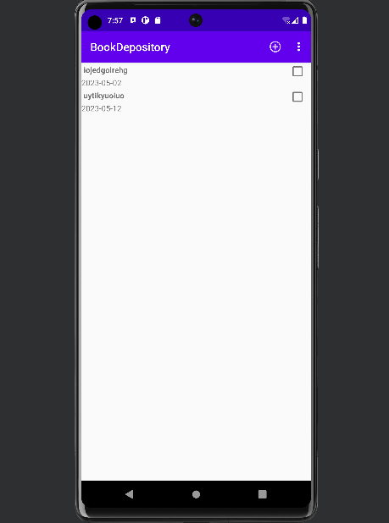

ТЕМА 10. СОЗДАНИЕ ПРОЦЕДУР ОБРАБОТКИ ИНФОРМАЦИИ

Book.java, BookLab.java, BookListActivity остались без изменений в том числе и макеты xml.

BookActivity.java

package ru.rsue.leynert.bookdepository;

import android.content.Context;  
import android.content.Intent;  
import android.os.Bundle;  
import android.support.v4.app.Fragment;  
import android.support.v4.app.FragmentActivity;  
import android.support.v4.app.FragmentManager;  
  
import java.util.UUID;  
  
public class BookActivity extends SingleFragmentActivity{  
 private static final String *EXTRA_BOOK_ID* = "com.example.bookdepository.book_id";  
 public static Intent newIntent(Context packageContext, UUID bookId) {  
 Intent intent = new Intent(packageContext, BookActivity.class); intent.putExtra(*EXTRA_BOOK_ID*, bookId);  
 return intent;  
  
 }  
  
 @Override  
 protected Fragment createFragment() {  
  
 UUID bookId = (UUID) getIntent()  
 .getSerializableExtra(*EXTRA_BOOK_ID*);  
 return BookFragment2.*newInstance*(bookId);  
  
 }  
  
}

BookFragment.java

package ru.rsue.leynert.bookdepository;

import java.util.Date;  
import java.util.UUID;  
  
import android.os.Bundle;  
import android.support.v4.app.Fragment;  
import android.text.Editable;  
import android.text.TextWatcher;  
import android.view.LayoutInflater;  
import android.view.View;  
import android.view.ViewGroup;  
import android.widget.Button;  
import android.widget.CheckBox;  
import android.widget.CompoundButton;  
import android.widget.EditText;  
  
public class BookFragment2 extends Fragment {  
 private static final String *ARG_BOOK_ID* = "book_id";  
 private Book mBook;  
 private EditText mTitleField;  
 private Button mDateButton;  
 private CheckBox mReadedCheckBox;  
 public static BookFragment2 newInstance(UUID bookId) {  
 Bundle args = new Bundle();  
 args.putSerializable(*ARG_BOOK_ID*, bookId);  
 BookFragment2 fragment = new BookFragment2();  
 fragment.setArguments(args);  
 return fragment;  
 }  
  
 @Override  
 public void onCreate(Bundle savedInstanceState) {  
 super.onCreate(savedInstanceState);  
 UUID bookId = (UUID) getArguments().getSerializable(*ARG_BOOK_ID*);  
 mBook = BookLab.*get*(getActivity()).getBook(bookId);  
  
 }  
 @Override  
 public View onCreateView(LayoutInflater inflater, ViewGroup container, Bundle savedInstanceState) {  
 View v = inflater.inflate(R.layout.*fragment_book*, container, false);  
 mTitleField = (EditText) v.findViewById(R.id.*book_title*);  
 mTitleField.setText(mBook.getTitle());  
 mTitleField.addTextChangedListener(new TextWatcher() {  
 @Override  
 public void beforeTextChanged(CharSequence s, int start, int count, int after) {  
  
 }  
  
 @Override  
 public void onTextChanged(CharSequence s, int start, int before, int count) {  
 mBook.setTitle(s.toString());  
 }  
  
 @Override  
 public void afterTextChanged(Editable c) {  
  
 }  
 });  
 mDateButton = (Button) v.findViewById(R.id.*book_date*);  
 mDateButton.setText(mBook.getDate().toString());  
 mDateButton.setEnabled(false);  
mReadedCheckBox = (CheckBox)v.findViewById(R.id.*book_readed*);  
 mReadedCheckBox.setChecked(mBook.isReaded());  
 mReadedCheckBox.setOnCheckedChangeListener(new CompoundButton.OnCheckedChangeListener() {  
 @Override  
 public void onCheckedChanged(CompoundButton buttonView, boolean isChecked) {  
 mBook.setReaded(isChecked);  
 }  
});  
 return v;

BookListFragment.java

package ru.rsue.leynert.bookdepository;

import android.content.Intent;  
import android.os.Bundle;  
import android.support.v4.app.Fragment;  
import android.view.LayoutInflater;  
import android.view.View;  
import android.view.ViewGroup;  
import android.widget.CheckBox;  
import android.widget.TextView;  
import android.widget.Toast;  
  
import androidx.annotation.NonNull;  
import androidx.recyclerview.widget.LinearLayoutManager;  
import androidx.recyclerview.widget.RecyclerView;  
  
import java.util.List;  
  
public class BookListFragment extends Fragment {  
 private RecyclerView mBookRecyclerView;  
 private BookAdapter mAdapter;  
 @Override  
 public View onCreateView(LayoutInflater inflater, ViewGroup container, Bundle savedInstanceState) {  
 View view = inflater.inflate(R.layout.*fragment_book_list*, container, false);  
 mBookRecyclerView = (RecyclerView) view  
 .findViewById(R.id.*book_recycler_view*);  
 mBookRecyclerView.setLayoutManager(new LinearLayoutManager(getActivity()));  
 updateUI();  
 return view;  
 }  
 @Override  
 public void onResume() {  
 super.onResume();  
 updateUI();  
 }  
  
 private void updateUI() {  
 BookLab bookLab = BookLab.*get*(getActivity());  
 List<Book> books = bookLab.getBooks();  
 if (mAdapter == null) {  
 mAdapter = new BookAdapter(books);  
 mBookRecyclerView.setAdapter(mAdapter);  
 } else {  
 mAdapter.notifyDataSetChanged();  
 }  
  
 }  
  
 private class BookHolder extends RecyclerView.ViewHolder implements View.OnClickListener {  
 private TextView mTitleTextView;  
 private TextView mDateTextView;  
 private Book mBook;  
 private CheckBox mReadedCheckBox;  
  
 public void bindBook(Book book) { mBook = book;  
 mTitleTextView.setText(mBook.getTitle());  
 mDateTextView.setText(mBook.getDate().toString());  
 mReadedCheckBox.setChecked(mBook.isReaded());  
 }  
 public BookHolder(View itemView) {  
 super(itemView);  
 itemView.setOnClickListener(this);  
 mTitleTextView = (TextView)  
 itemView.findViewById(R.id.*list_item_book_title_text_view*); mDateTextView = (TextView)  
 itemView.findViewById(R.id.*list_item_book_date_text_view*); mReadedCheckBox = (CheckBox)  
 itemView.findViewById(R.id.*list_item_book_readed_check_box*);  
  
 }  
 @Override  
 public void onClick(View v) {  
 Intent intent = BookActivity.*newIntent*(getActivity(), mBook.getId());  
 startActivity(intent);  
 }  
}  
  
  
  
 private class BookAdapter extends RecyclerView.Adapter<BookHolder> {  
 private List<Book> mBooks;  
 public BookAdapter(List<Book> books) {  
 mBooks = books;  
 }  
  
 @Override  
 public BookHolder onCreateViewHolder( ViewGroup parent, int viewType) {  
 LayoutInflater layoutInflater = LayoutInflater.*from*(getActivity());  
 View view = layoutInflater.inflate(R.layout.*list_item_book*, parent, false);  
 return new BookHolder(view);  
  
 }  
  
 @Override  
 public void onBindViewHolder(BookHolder holder, int position) {  
 Book book = mBooks.get(position);  
 holder.bindBook(book);  
 }  
  
 @Override  
 public int getItemCount() {  
  
 return mBooks.size();  
 }  
 }  
  
}

SingleFragmentActivity.java

package ru.rsue.leynert.bookdepository;

import android.os.Bundle;  
import android.support.v4.app.Fragment;  
import android.support.v4.app.FragmentActivity;  
import android.support.v4.app.FragmentManager;  
  
public abstract class SingleFragmentActivity extends FragmentActivity {  
 protected abstract Fragment createFragment();  
  
 @Override  
 public void onCreate(Bundle savedInstanceState) {  
 super.onCreate(savedInstanceState);  
 setContentView(R.layout.*activity_fragment*);  
 FragmentManager fm = getSupportFragmentManager();  
 Fragment fragment = fm.findFragmentById(R.id.*fragmentContainer*);  
 if (fragment == null) {  
 fragment = createFragment();//BookFragment2  
 fm.beginTransaction()  
 .add(R.id.*fragmentContainer*, fragment)  
 .commit();  
 }  
 }  
}

Результат

У нас есть список книг, выбираем любую из них и смотрим подробную информацию.



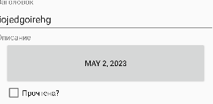

ТЕМА 11. ОБЕСПЕЧЕНИЕ ДОПОЛНИТЕЛЬНОЙ ФУНКЦИОНАЛЬНОЙ СИСТЕМЫ

Создал новый класс

BookPagerActivity.java

package com.example.bookdepository;  
  
import android.content.Context;  
import android.content.Intent;  
import android.os.Bundle;  
import android.support.v4.app.Fragment;  
import android.support.v4.app.FragmentActivity;  
import android.support.v4.app.FragmentManager;  
import android.support.v4.app.FragmentStatePagerAdapter;  
import android.support.v4.view.ViewPager;  
  
import java.util.List;  
import java.util.UUID;  
  
public class BookPagerActivity extends FragmentActivity {  
 private static final String *EXTRA_BOOK_ID* = "com.example.bookdepository.book_id";  
 private ViewPager mViewPager;  
 private List<Book> mBooks;  
 public static Intent newIntent(Context packageContext, UUID bookId)  
 {  
 Intent intent = new Intent(packageContext, BookPagerActivity.class);  
 intent.putExtra(*EXTRA_BOOK_ID*, bookId); return intent;  
 }  
  
 @Override  
 protected void onCreate(Bundle savedInstanceState) {  
 super.onCreate(savedInstanceState);  
 setContentView(R.layout.*activity_book_pager*);  
 UUID bookId = (UUID) getIntent()  
 .getSerializableExtra(*EXTRA_BOOK_ID*);  
 mViewPager = (ViewPager) findViewById( R.id.*activity_book_pager_view_pager*);  
 mBooks = BookLab.*get*(this).getBooks();  
 FragmentManager fragmentManager = getSupportFragmentManager();  
 mViewPager.setAdapter(new FragmentStatePagerAdapter(fragmentManager) {  
 @Override  
 public Fragment getItem(int position) {  
 Book book = mBooks.get(position);  
 return BookFragment2.*newInstance*(book.getId());  
  
 }  
  
 @Override  
 public int getCount() {  
 return mBooks.size();  
 }  
 });  
 for (int i = 0; i < mBooks.size(); i++) {  
 if (mBooks.get(i).getId().equals(bookId)) {  
 mViewPager.setCurrentItem(i);  
 break;  
 }  
 }  
  
 }

Удалил класс BookActivity.java

Добавила макет activity_book_pager.xml

<?xml version="1.0" encoding="utf-8"?>  
<android.support.v4.view.ViewPager xmlns:android="http://schemas.android.com/apk/res/android"  
 android:id = "@+id/activity_book_pager_view_pager"  
 android:layout_width="match_parent"  
 android:layout_height="match_parent">  
  
</android.support.v4.view.ViewPager>

Результат стал список книг, по которым мы выбираем какую-либо книгу и можем перелистывать с одной книги, с помощью продвижение экрана влево или вправо.

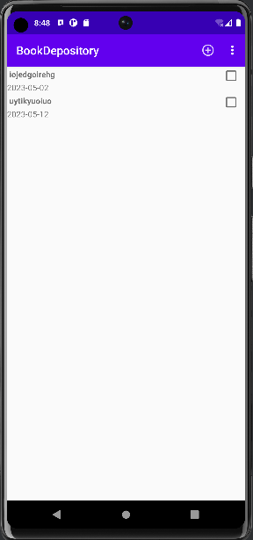

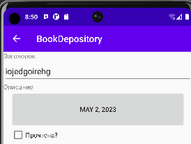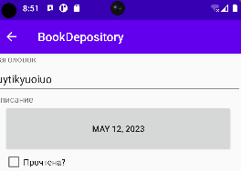

ТЕМА 12. INTENTS

<string name="book_readed_label">Прочтена?</string>  
<string name="date_picker_title">Дата начала прочтения:</string>

DatePickerFragment.java

package ru.rsue.leynert.bookdepository;  
  
import android.app.Activity;  
import android.app.AlertDialog;  
import android.app.Dialog;  
import android.content.DialogInterface;  
import android.content.Intent;  
import android.os.Bundle;  
import android.view.LayoutInflater;  
import android.view.View;  
import android.widget.DatePicker;  
  
import androidx.fragment.app.DialogFragment;  
  
import java.util.Calendar;  
import java.util.Date;  
import java.util.GregorianCalendar;  
  
  
  
public class DatePickerFragment extends DialogFragment {  
  
 private static final String *ARG_DATE* = "date";  
 private DatePicker mDatePicker;  
 public static final String *EXTRA_DATE* =  
 "ru.rsue.bugakovnikita.bookdepository.date";  
 public static DatePickerFragment newInstance(Date date) {  
 Bundle args = new Bundle();  
 args.putSerializable(*ARG_DATE*, date);  
  
 DatePickerFragment fragment = new DatePickerFragment();  
 fragment.setArguments(args);  
 return fragment;  
 }  
  
  
 @Override  
 public Dialog onCreateDialog(Bundle savedInstanceState) {  
 Date date = (Date) getArguments().getSerializable(*ARG_DATE*);  
 Calendar calendar = Calendar.*getInstance*();  
 calendar.setTime(date);  
 View v = LayoutInflater.*from*(getActivity())  
 .inflate(R.layout.*dialog_date*, null);  
 int year = calendar.get(Calendar.*YEAR*);  
 int month = calendar.get(Calendar.*MONTH*);  
 int day = calendar.get(Calendar.*DAY_OF_MONTH*);  
 mDatePicker = (DatePicker)  
 v.findViewById(R.id.*dialog_date_date_picker*);  
 mDatePicker.init(year, month, day, null);  
 return new AlertDialog.Builder(getActivity())  
 .setView(v)  
 .setTitle(R.string.*date_picker_title*)  
 .setPositiveButton(android.R.string.*ok*,new DialogInterface.OnClickListener() {  
 @Override  
 public void onClick(DialogInterface dialog, int which) {  
 int year = mDatePicker.getYear();  
 int month = mDatePicker.getMonth();  
 int day = mDatePicker.getDayOfMonth();  
 Date date = new GregorianCalendar(year, month, day).  
 getTime();  
 sendResult(Activity.*RESULT_OK*, date);  
 }  
 } ).create();  
  
  
 }  
 private void sendResult(int resultCode, Date date) {  
 if (getTargetFragment() == null) {  
 return;  
 }  
 Intent intent = new Intent();  
 intent.putExtra(*EXTRA_DATE*, date);  
 getTargetFragment()  
 .onActivityResult(getTargetRequestCode(), resultCode,  
 intent);  
 }  
  
}

BookFragment.java

private static final String *DIALOG_DATE* = "DialogDate";

mDateButton.setOnClickListener(new View.OnClickListener() {  
 @Override  
 public void onClick(View v) {  
 FragmentManager manager = getFragmentManager();  
 DatePickerFragment dialog = DatePickerFragment  
 .*newInstance*(mBook.getDate());  
 dialog.setTargetFragment(BookFragment.this,  
 *REQUEST_DATE*);  
 dialog.show(manager, *DIALOG_DATE*);  
 }  
});

Dialog_date.xml

<?xml version="1.0" encoding="utf-8"?>  
<android.widget.DatePicker xmlns:android="http://schemas.android.com/apk/res/android"  
 android:layout_width="match_parent"  
 android:layout_height="match_parent"  
 android:id="@+id/dialog_date_date_picker">  
</android.widget.DatePicker>

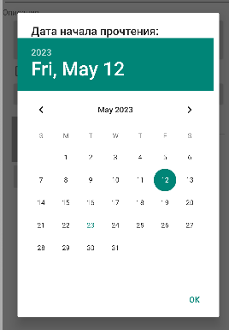

ТЕМА 13. ТЕСТИРОВАНИЕ ПРИЛОЖЕНИЯ

AndroidManifest.xml

<application  
 android:allowBackup="true"  
 android:dataExtractionRules="@xml/data_extraction_rules"  
 android:fullBackupContent="@xml/backup_rules"  
 android:icon="@mipmap/ic_launcher"  
 android:label="@string/app_name"  
 android:supportsRtl="true"  
 android:theme="@style/Theme.BookDepository"

SingleFragmentActivity.java



BookPagerActivity.java



Strings.xml

<string name="date_picker_title">Дата начала прочтения:</string>  
<string name="new_book">Новая книга</string>  
<string name="show_subtitle">Показать подзаголовок</string>  
<string name="hide_subtitle">Скрыть подзаголовок</string>  
<string name="subtitle_format">%1$s books</string>



Menu/fragment_book_list.xml

<?xml version="1.0" encoding="utf-8"?>  
<menu xmlns:android="http://schemas.android.com/apk/res/android"  
 xmlns:app="http://schemas.android.com/apk/res-auto">  
 <item  
 android:id="@+id/menu_item_new_book"  
 android:icon="@drawable/ic_menu_add"  
 android:title="@string/new_book"  
 app:showAsAction="ifRoom|withText"/>  
 <item  
 android:id="@+id/menu_item_show_subtitle"  
 android:title="@string/show_subtitle"  
 app:showAsAction="ifRoom"/>  
</menu>

BookListFragment.java

@Override  
public void onCreateOptionsMenu(Menu menu, MenuInflater inflater) {  
 super.onCreateOptionsMenu(menu, inflater);  
 inflater.inflate(R.menu.*fragment_book_list*, menu);  
  
 MenuItem subtitleItem = menu.findItem(R.id.*menu_item_show_subtitle*);  
 if (mSubtitleVisible) {  
 subtitleItem.setTitle(R.string.*hide_subtitle*);  
 } else {  
 subtitleItem.setTitle(R.string.*show_subtitle*);  
 }  
}

BookListFragment.java

@Override  
public void onCreate(Bundle savedInstanceState) {  
 super.onCreate(savedInstanceState);  
 setHasOptionsMenu(true);  
}

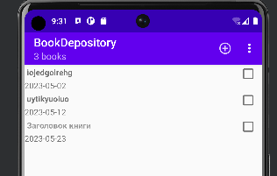

BookListFragment.java

private void updateSubtitle() {  
 BookLab bookLab = BookLab.*get*(getActivity());  
 int bookCount = bookLab.getBooks().size();  
 String subtitle = getString(R.string.*subtitle_format*, bookCount);  
 if (!mSubtitleVisible) {  
 subtitle = null;  
 }  
 AppCompatActivity activity = (AppCompatActivity) getActivity();  
 activity.getSupportActionBar().setSubtitle(subtitle);  
}

@Override  
public boolean onOptionsItemSelected(MenuItem item) {  
 switch (item.getItemId()) {  
 case R.id.*menu_item_new_book*:  
 Book book = new Book(UUID.*randomUUID*());  
 BookLab.*get*(getActivity()).addBook(book);  
 Intent intent = BookPagerActivity  
 .*newIntent*(getActivity(), book.getId());  
 startActivity(intent);  
 case R.id.*menu_item_show_subtitle*:  
 mSubtitleVisible = !mSubtitleVisible;  
 getActivity().invalidateOptionsMenu();  
 updateSubtitle();  
 return true;  
 default:  
 return super.onOptionsItemSelected(item);  
 }  
}

MenuItem subtitleItem = menu.findItem(R.id.*menu_item_show_subtitle*);  
 if (mSubtitleVisible) {  
 subtitleItem.setTitle(R.string.*hide_subtitle*);  
 } else {  
 subtitleItem.setTitle(R.string.*show_subtitle*);  
 }  
}

@Override  
public void onSaveInstanceState(Bundle outState) {  
 super.onSaveInstanceState(outState);  
 outState.putBoolean(*SAVED_SUBTITLE_VISIBLE*, mSubtitleVisible);  
}



ТЕМА 14. ОТЛАДКА ПРИЛОЖЕНИЯ

BookBaseWrapper.java

package ru.rsue.leynert.bookdepository.database;  
  
import android.content.Context;  
import android.database.sqlite.SQLiteDatabase;  
import android.database.sqlite.SQLiteOpenHelper;  
  
  
public class BookBaseHelper extends SQLiteOpenHelper {  
  
 private static final int *VERSION* = 1;  
 private static final String *DATABASE_NAME* = "bookBase.db";  
  
 public BookBaseHelper(Context context) {  
 super(context, *DATABASE_NAME*, null, *VERSION*);  
 }  
  
 @Override  
 public void onCreate(SQLiteDatabase db) {  
 db.execSQL("create table " + BookDbSchema.BookTable.*NAME* + "(" +  
 " _id integer primary key autoincrement, " +  
 BookDbSchema.BookTable.Cols.*UUID* + ", " +  
 BookDbSchema.BookTable.Cols.*TITLE* + ", " +  
 BookDbSchema.BookTable.Cols.*DATE* + ", " +  
 BookDbSchema.BookTable.Cols.*READED* + ")"  
 );  
 }  
 @Override  
 public void onUpgrade (SQLiteDatabase db,int i, int i1){  
  
 }  
  
}

BookCursorWrapper.java

package ru.rsue.leynert.bookdepository.database;  
  
import android.database.Cursor;  
import android.database.CursorWrapper;  
  
import java.sql.Date;  
import java.util.UUID;  
  
import ru.rsue.leynert.bookdepository.Book;  
  
  
public class BookCursorWrapper extends CursorWrapper {  
 public BookCursorWrapper(Cursor cursor) {  
 super(cursor);  
 }  
 public Book getBook() {  
 String uuidString =  
 getString(getColumnIndex(BookDbSchema.BookTable.Cols.*UUID*));  
 String title = getString(getColumnIndex(BookDbSchema.BookTable.Cols.*TITLE*));  
 long date = getLong(getColumnIndex(BookDbSchema.BookTable.Cols.*DATE*));  
 int isReaded = getInt(getColumnIndex(BookDbSchema.BookTable.Cols.*READED*));  
 Book book = new Book(UUID.*fromString*(uuidString));  
 book.setTitle(title);  
 book.setDate(new Date(date));  
 book.setReaded(isReaded != 0);  
 return book;  
 }  
}

BookDbSchema.java

package ru.rsue.leynert.bookdepository.database;  
  
import android.database.Cursor;  
import android.database.CursorWrapper;  
  
import java.sql.Date;  
import java.util.UUID;  
  
import ru.rsue.leynert.bookdepository.Book;  
  
  
public class BookCursorWrapper extends CursorWrapper {  
 public BookCursorWrapper(Cursor cursor) {  
 super(cursor);  
 }  
 public Book getBook() {  
 String uuidString =  
 getString(getColumnIndex(BookDbSchema.BookTable.Cols.*UUID*));  
 String title = getString(getColumnIndex(BookDbSchema.BookTable.Cols.*TITLE*));  
 long date = getLong(getColumnIndex(BookDbSchema.BookTable.Cols.*DATE*));  
 int isReaded = getInt(getColumnIndex(BookDbSchema.BookTable.Cols.*READED*));  
 Book book = new Book(UUID.*fromString*(uuidString));  
 book.setTitle(title);  
 book.setDate(new Date(date));  
 book.setReaded(isReaded != 0);  
 return book;  
 }  
}

ТЕМА 15. ЗАЩИТА ПРИЛОЖЕНИЯ.ОЦЕНКА КАЧЕСТВА И НАДЕЖНОСТИ ПРИЛОЖЕНИЯ.

Strings.xml

<string name="book_report_text">Отправить отчет о прочтении</string>  
<string name="book_report">%1$s Книга была запланирована к прочтению %2$s и %3$s</string>  
<string name="book_report_readed">Книга прочитана</string>  
<string name="book_report_unreaded">Книга не прочитана</string>  
<string name="book_report_subject">BookDepository отчет о прочтении</string>  
<string name="send_report">Отправить отчет о прочтении через</string>

Fragment_book.xml

<Button  
 android:id="@+id/book_report"  
 android:layout_width="match_parent"  
 android:layout_height="wrap_content"  
 android:layout_marginLeft="16dp"  
 android:layout_marginRight="16dp"  
 android:hint="@string/book_report_text" />

BookFragment.java

private Button mReportButton;

mReportButton = (Button)v.findViewById(R.id.*book_report*);  
mReportButton.setOnClickListener(new View.OnClickListener() {  
 public void onClick(View v) {  
 Intent i = new Intent(Intent.*ACTION_SEND*);  
 i.setType("text/plain");  
 i.putExtra(Intent.*EXTRA_TEXT*, getBookReport());  
 i.putExtra(Intent.*EXTRA_SUBJECT*,  
 getString(R.string.*book_report_subject*));  
 i = Intent.*createChooser*(i, getString(R.string.*send_report*));  
 startActivity(i);  
 }  
});

private String getBookReport() {  
 String readedString = null;  
 if (mBook.isReaded()){  
 readedString = getString(R.string.*book_report_readed*);  
 }else {  
 readedString = getString(R.string.*book_report_unreaded*);  
 }  
 String dateFormat = "EEE, MMM dd";  
 String dateString = DateFormat  
 .*getDateInstance*(DateFormat.*MEDIUM*).format(mBook.getDate());  
 String report = getString(R.string.*book_report*,  
 mBook.getTitle(), dateString, readedString);  
 return report;  
}

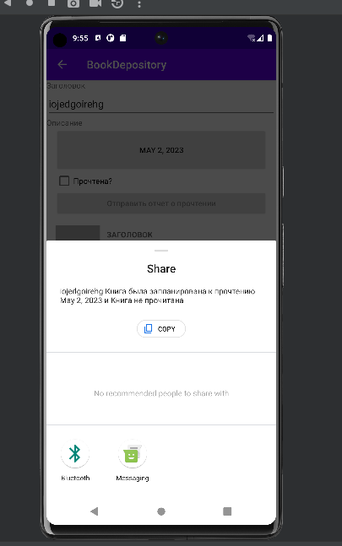

ТЕМА 16. СОПРОЖДЕНИЕ ПРОГРАММ

View_camera_and_title.xml

<?xml version="1.0" encoding="utf-8"?>  
<LinearLayout  
 xmlns:android="http://schemas.android.com/apk/res/android"  
 android:layout_width="match_parent"  
 android:layout_height="wrap_content"  
 android:layout_marginLeft="16dp"  
 android:layout_marginRight="16dp"  
 android:layout_marginTop="16dp">  
 <LinearLayout  
 android:layout_width="wrap_content"  
 android:layout_height="wrap_content"  
 android:orientation="vertical"  
 android:layout_marginRight="4dp">  
 <ImageView  
 android:id="@+id/book_photo"  
 android:layout_width="80dp"  
 android:layout_height="80dp"  
 android:scaleType="centerInside"  
 android:background="@android:color/darker_gray"  
 android:cropToPadding="true"/>  
 <ImageButton  
 android:id="@+id/book_camera"  
 android:layout_width="match_parent"  
 android:layout_height="wrap_content"  
 android:src="@android:drawable/ic_menu_camera"/>  
 </LinearLayout>  
 <LinearLayout  
 android:layout_width="wrap_content"  
 android:layout_height="wrap_content"  
 android:orientation="vertical"  
 android:layout_weight="1">  
 <TextView  
 android:layout_width="match_parent"  
 android:layout_height="wrap_content"  
 android:text="@string/book_title_label"  
 style="?android:listSeparatorTextViewStyle"/>  
 <EditText  
 android:layout_width="match_parent"  
 android:layout_height="wrap_content"  
 android:id="@+id/book_title"  
 android:layout_marginRight="16dp"  
 android:hint="@string/book_title_hint"/>  
</LinearLayout>  
</LinearLayout>

Fragment_book.xml

<include  
 layout="@layout/view_camera_and_title"/>

Book.java

public String getPhotoFilename() {  
 return "IMG_" + getId().toString() + ".jpg";  
}

BookLab.java

public File getPhotoFile(Book book) {  
 File externalFilesDir = mContext  
 .getExternalFilesDir(Environment.*DIRECTORY_PICTURES*);  
 if (externalFilesDir == null) {  
 return null;  
 }  
 return new File(externalFilesDir, book.getPhotoFilename());  
}

BookFragment.java

private File mPhotoFile;

private ImageButton mPhotoButton;  
private ImageView mPhotoView;  
  
private static final int *REQUEST_DATE* = 0;  
private static final int *REQUEST_PHOTO* = 1;

@Override  
public void onCreate(Bundle savedInstanceState) {  
 super.onCreate(savedInstanceState);  
 UUID bookId = (UUID) getArguments().getSerializable(*ARG_BOOK_ID*);  
 mBook = BookLab.*get*(getActivity()).getBook(bookId);  
 mPhotoFile = BookLab.*get*(getActivity()).getPhotoFile(mBook);  
}

mPhotoButton = (ImageButton) v.findViewById(R.id.*book_camera*);  
 final Intent captureImage =  
 new Intent(MediaStore.*ACTION_IMAGE_CAPTURE*);  
 PackageManager packageManager = getActivity().getPackageManager();  
 boolean canTakePhoto = mPhotoFile != null ||  
 captureImage.resolveActivity(packageManager) != null;  
 if (canTakePhoto) {  
 Uri uri;  
 if (Build.VERSION.*SDK_INT*<24)  
 uri = Uri.*fromFile*(mPhotoFile);  
 else  
 uri = FileProvider.*getUriForFile*(getActivity(),  
 BuildConfig.*APPLICATION_ID* + ".provider", mPhotoFile);  
 captureImage.putExtra(MediaStore.*EXTRA_OUTPUT*, uri);  
 mPhotoButton.setOnClickListener(new View.OnClickListener() {  
 @Override  
 public void onClick(View v) {  
 startActivityForResult(captureImage, *REQUEST_PHOTO*);  
 }  
 });  
 mPhotoView = (ImageView) v.findViewById(R.id.*book_photo*);  
 updatePhotoView();  
 }

AndroidManifest.java

<provider  
 android:name="androidx.core.content.FileProvider"  
 android:authorities="${applicationId}.provider"  
 android:exported="false"  
 android:grantUriPermissions="true">  
 <meta-data  
 android:name="android.support.FILE_PROVIDER_PATHS"  
 android:resource="@xml/provider_paths"/>  
</provider>

Provider_paths.xml

<?xml version="1.0" encoding="utf-8"?>  
<paths xmlns:android="http://schemas.android.com/apk/res/android">  
 <external-path name="external_files" path="."/>  
</paths>

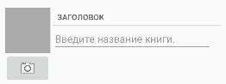

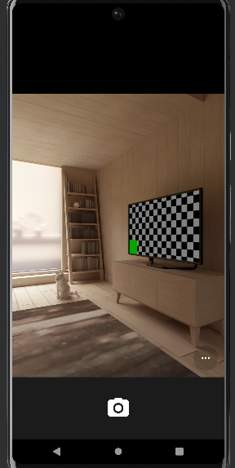

ТЕМА 17. СОПРОВОЖДЕНИЕ ПРОГРАММ

Drawable/sun.xml

<?xml version="1.0" encoding="utf-8"?>  
<shape  
 xmlns:android="http://schemas.android.com/apk/res/android"  
 android:dither="true"  
 android:shape="oval" >  
  
 <gradient  
 android:endColor="#ffff6600"  
 android:gradientRadius="150"  
 android:startColor="#ffffcc00"  
 android:type="radial"  
 android:useLevel="false" />  
  
 <size  
 android:height="150dp"  
 android:width="150dp" />  
  
</shape>

Drawable/sky.xml

<?xml version="1.0" encoding="utf-8"?>  
<shape  
 xmlns:android="http://schemas.android.com/apk/res/android"  
 android:dither="true"  
 android:shape="rectangle" >  
  
 <gradient  
 android:angle="90"  
 android:endColor="#ff000033"  
 android:startColor="#ff0000ff" />  
  
</shape>

Drawable/grass.xml

<?xml version="1.0" encoding="utf-8"?>  
<shape  
 xmlns:android="http://schemas.android.com/apk/res/android"  
 android:dither="true"  
 android:shape="rectangle" >  
  
 <gradient  
 android:angle="90"  
 android:endColor="#ff003300"  
 android:startColor="#ff009900" />  
  
</shape>

Layout/activity_main.xml

<?xml version="1.0" encoding="utf-8"?>  
<RelativeLayout xmlns:android="http://schemas.android.com/apk/res/android"  
 xmlns:tools="http://schemas.android.com/tools"  
 android:layout_width="match_parent"  
 android:layout_height="match_parent"  
 tools:context=".MainActivity" >  
  
 <ImageView  
 android:id="@+id/sky"  
 android:layout_width="fill_parent"  
 android:layout_height="fill_parent"  
 android:contentDescription="@string/sky"  
 android:src="@drawable/sky" />  
  
 <ImageView  
 android:id="@+id/sun"  
 android:layout_width="wrap_content"  
 android:layout_height="wrap_content"  
 android:layout_centerHorizontal="true"  
 android:contentDescription="@string/sun"  
 android:scaleType="fitCenter"  
 android:src="@drawable/sun" />  
  
 <ImageView  
 android:id="@+id/grass"  
 android:layout_width="fill_parent"  
 android:layout_height="150dp"  
 android:layout_alignParentBottom="true"  
 android:contentDescription="@string/grass"  
 android:src="@drawable/grass" />  
  
</RelativeLayout>

Anim/sun_rise.xml

<?xml version="1.0" encoding="utf-8"?>  
<set  
 xmlns:android="http://schemas.android.com/apk/res/android"  
 android:duration="5000"  
 android:fillAfter="true"  
 android:interpolator="@android:anim/accelerate_decelerate_interpolator"  
 android:shareInterpolator="false" >  
 <scale  
 android:fromXScale="1.0"  
 android:fromYScale="1.0"  
 android:pivotX="50%"  
 android:pivotY="50%"  
 android:toXScale="1.5"  
 android:toYScale="1.5" />  
 <translate android:fromYDelta="80%p"  
 android:toYDelta="10%p" />  
 <alpha  
 android:fromAlpha="0.3"  
 android:toAlpha=" 1.0" />  
</set>

MainActivity.java

package ru.rsue.dop;  
  
import android.os.Bundle;  
import android.view.animation.Animation;  
import android.view.animation.AnimationUtils;  
import android.widget.ImageView;  
  
import androidx.appcompat.app.AppCompatActivity;  
  
public class MainActivity extends AppCompatActivity {  
 @Override  
 protected void onCreate(Bundle savedlnstanceState) {  
 super.onCreate(savedlnstanceState);  
 setContentView(R.layout.*activity_main*);  
// Получаем ссылку на изображение солнца  
 ImageView sunImageView = (ImageView)  
 findViewById(R.id.*sun*);  
// Анимация для восхода солнца Animation  
 Animation sunRiseAnimation = AnimationUtils.*loadAnimation*(this, R.anim.*sun_rise*);  
 // Подключаем анимацию к нужному View  
 sunImageView.startAnimation(sunRiseAnimation);  
 }  
}

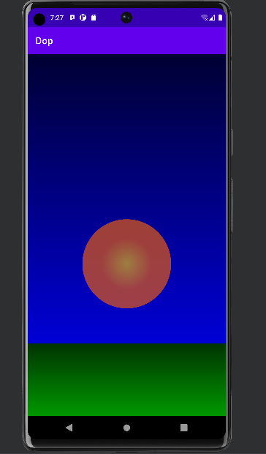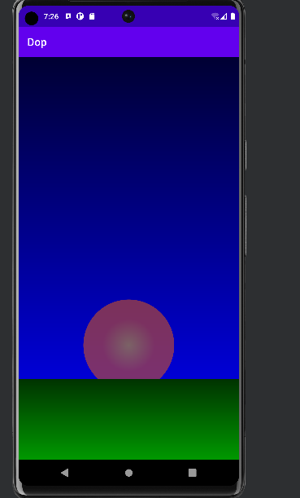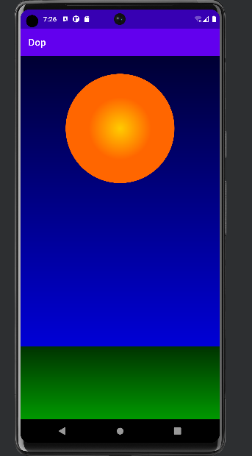

ТЕМА 18. ИТОГОВОЕ ЗАНЯТИЕ

Layout/activity_main.xml

<?xml version="1.0" encoding="utf-8"?>  
<androidx.constraintlayout.widget.ConstraintLayout  
 xmlns:android="http://schemas.android.com/apk/res/android"  
 xmlns:app="http://schemas.android.com/apk/res-auto"  
 android:layout_width="match_parent"  
 android:layout_height="match_parent">  
 <EditText  
 android:id="@+id/editor"  
 android:layout_width="0dp"  
 android:layout_height="0dp"  
 android:textSize="18sp"  
 android:gravity="start"  
 app:layout_constraintLeft_toLeftOf="parent"  
 app:layout_constraintRight_toRightOf="parent"  
 app:layout_constraintBottom_toTopOf="@id/save_text"  
 app:layout_constraintTop_toTopOf="parent" />  
 <Button  
 android:id="@+id/save_text"  
 android:layout_width="wrap_content"  
 android:layout_height="wrap_content"  
 android:onClick="saveText"  
 android:text="Сохранить"  
 app:layout_constraintLeft_toLeftOf="parent"  
 app:layout_constraintRight_toRightOf="parent"  
 app:layout_constraintBottom_toTopOf="@id/text"  
 app:layout_constraintTop_toBottomOf="@id/editor" />  
 <TextView  
 android:id="@+id/text"  
 android:layout_width="0dp"  
 android:layout_height="0dp"  
 android:gravity="start"  
 android:textSize="18sp"  
 app:layout_constraintLeft_toLeftOf="parent"  
 app:layout_constraintRight_toRightOf="parent"  
 app:layout_constraintBottom_toTopOf="@+id/open_text"  
 app:layout_constraintTop_toBottomOf="@+id/save_text"  
 />  
 <Button  
 android:id="@+id/open_text"  
 android:layout_width="wrap_content"  
 android:layout_height="wrap_content"  
 android:onClick="openText"  
 android:text="Открыть"  
 app:layout_constraintLeft_toLeftOf="parent"  
 app:layout_constraintRight_toRightOf="parent"  
 app:layout_constraintBottom_toBottomOf="parent"  
 app:layout_constraintTop_toBottomOf="@+id/text" />  
</androidx.constraintlayout.widget.ConstraintLayout>

MainActivity.java

package ru.rsue.docs;  
  
import androidx.appcompat.app.AppCompatActivity;  
import android.os.Bundle;  
import android.view.View;  
import android.widget.EditText;  
import android.widget.TextView;  
import android.widget.Toast;  
import java.io.FileInputStream;  
import java.io.FileOutputStream;  
import java.io.IOException;  
public class MainActivity extends AppCompatActivity {  
 private final static String *FILE_NAME* = "content.txt";  
 @Override  
 protected void onCreate(Bundle savedInstanceState) {  
 super.onCreate(savedInstanceState);  
 setContentView(R.layout.*activity_main*);  
 }  
 // сохранение файла  
 public void saveText(View view){  
 FileOutputStream fos = null;  
 try {  
 EditText textBox = (EditText)  
 findViewById(R.id.*editor*);  
 String text = textBox.getText().toString();  
 fos = openFileOutput(*FILE_NAME*, *MODE_PRIVATE*);  
 fos.write(text.getBytes());  
 Toast.*makeText*(this, "Файл сохранен",  
 Toast.*LENGTH_SHORT*).show();  
 }  
 catch(IOException ex) {  
 Toast.*makeText*(this, ex.getMessage(),  
 Toast.*LENGTH_SHORT*).show();  
 }  
 finally{  
 try{  
 if(fos!=null)  
 fos.close();  
 }  
 catch(IOException ex){  
  
 Toast.*makeText*(this, ex.getMessage(),  
 Toast.*LENGTH_SHORT*).show();  
 }  
 }  
 }  
 // открытие файла  
 public void openText(View view){  
 FileInputStream fin = null;  
 TextView textView = (TextView)  
 findViewById(R.id.*text*);  
 try {  
 fin = openFileInput(*FILE_NAME*);  
 byte[] bytes = new byte[fin.available()];  
 fin.read(bytes);  
 String text = new String (bytes);  
 textView.setText(text);  
 }  
 catch(IOException ex) {  
 Toast.*makeText*(this, ex.getMessage(),  
 Toast.*LENGTH_SHORT*).show();  
 }  
 finally{  
 try{  
 if(fin!=null)  
 fin.close();  
 }  
 catch(IOException ex){  
 Toast.*makeText*(this, ex.getMessage(),  
 Toast.*LENGTH_SHORT*).show();  
 }  
 }  
 }  
}

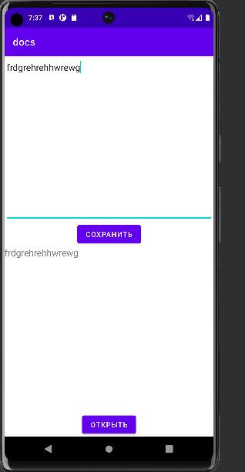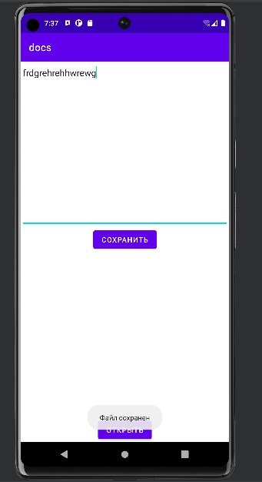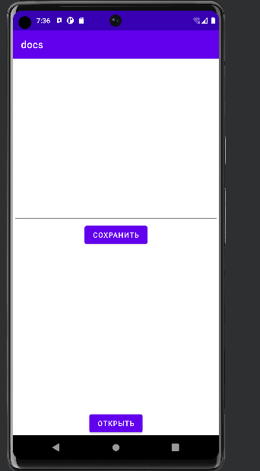

DroidQuest

<https://github.com/rixie13/DroidQuest.git>

BookDepository

<https://github.com/rixie13/BookDepository.git>

Sunrise

<https://github.com/rixie13/sunrise.git>

Docs

<https://github.com/rixie13/docs.git>