Andrei Arevalo

January 22nd, 2021

Foundations of Programming, Python

Assignment03

House Inventory

# **Introduction**

In this assignment we are tasked with taking user input in the form of an item name and estimated value, and then taking that data and storing it in a text file. This program goes above and beyond the program requirements as this program allows multiple lines of data to be stored in the text file. The assignment specifies only one line of data to be entered. This program will accomplish those goals using loops including the “while” loop and “if” loop. The program will also include elements of calling a file from a file path and writing data to that file. This program is useful for circumstances that involve writing data to files.

# **Key Questions and Definitions**

## **Q: What are conditional statements?**

Conditional statements are useful for situations where different sequences of code are needed for different situations. For example, in a program a user might specify what option to select from a menu of options. Depending on their selection, the proper sequence of code needs to be followed. The most common version of this conditional statement is the “if” and “elif” loop. The “if” statement sets a condition which needs to be met for the code to be followed. The “elif” translates to else if, which is useful for multiple types of situations or different inputs.

## **Comparison Operators**

|  |  |  |
| --- | --- | --- |
| **Operator** | **Description** | **Example** |
| < | Something is less than another | 3 < 7 |
| <= | Something is less than or equal to another | 3 <= 7 |
| > | Something is greater than another | 7 >3 |
| >= | Something is greater than or equal to another | 7>= 3 |
| == | Something is equal to another | 3 == 3 |
| != | Something is not equal to another | 3 != 7 |
| is | Something is the same object | objectX is objectY |
| Is not | Something is not the same object | object is not objectY |

# **Creating the Script**

1. The main script is composed of one main section which is all contained in a “while” loop. This loop is kept open for data to be entered and stored until the user specifies that they want to exit. This goes above and beyond the assignment requirements as this is a loop that allows multiple lines of data to be stored in the text file. The assignment specifies only one line of data to be entered. (figure 1)

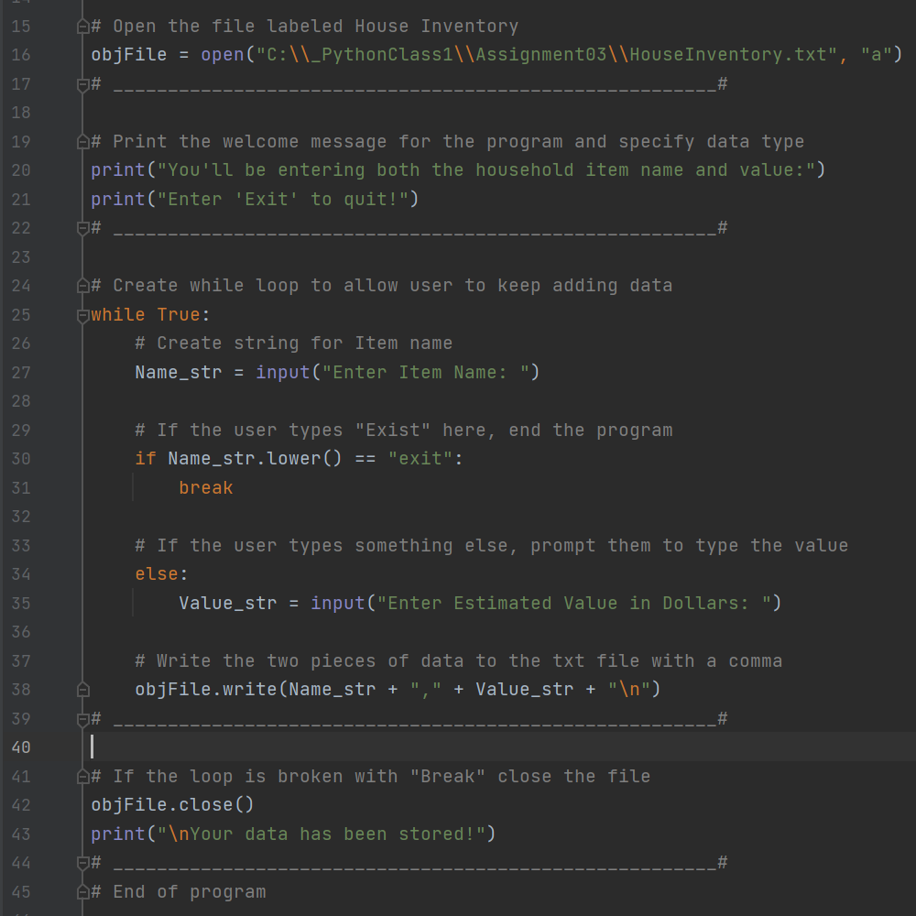

***Figure 1: The main script***

1. At the top of the script is the title block, which shows information about the script and keeps track of revision history in case the file needs to be revised in the future. The author and date are also included in this title block. In addition below the title block is a summary of the assignment with the task outlined. (Figure 2)

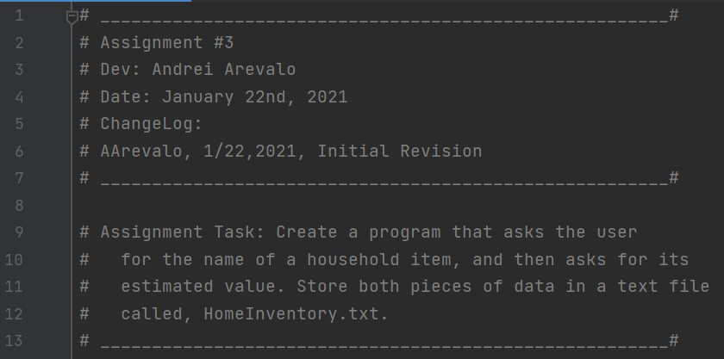

***Figure 2: Title block of the script***

1. This part of the script uses the “open” function to search the file path specified for a file type with the name “HomeInventory.txt.” It’s important here that the file path is correct because otherwise the program will be searching for the file in the wrong folder. (Figure 3)

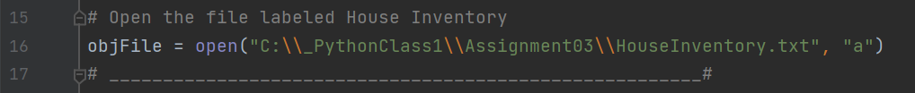

***Figure 3: Create or open file called “HomeInventory.txt”***

1. The next part of the script uses the “print” function to show the user what program they are using. It also lets the user know how to exit the program once they have entered all the data. (Figure 4)

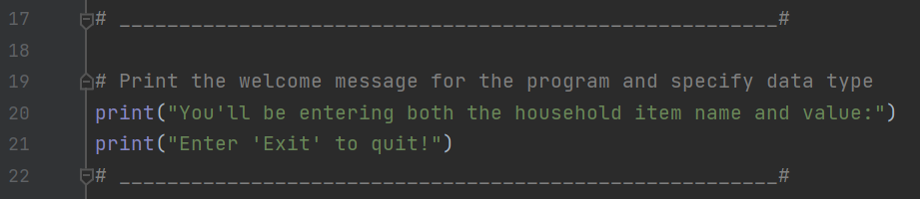

***Figure 4: Main screen of program***

1. The next part of the script is the most important part to the program. A “while” loop is initialized to start looking for entered data. At this point, the “Name_str” (line 27) is created which is based on input from the user on the name of the object. An “if” loop is opened at this point which looks for the word “exit” to be entered. If “exit” is typed into the input, the program ends. If the entered data is not “exit,” the name is stored as the item name. The user is then asked to input the value of the object in dollars. (line 35) At this point both pieces of data are stored together, separated with a comma. As each pair of item name and value are entered, the text file starts a new line. Once the user enters exit, “break” is used to bring the program out of the “while” loop. (Figure 5)

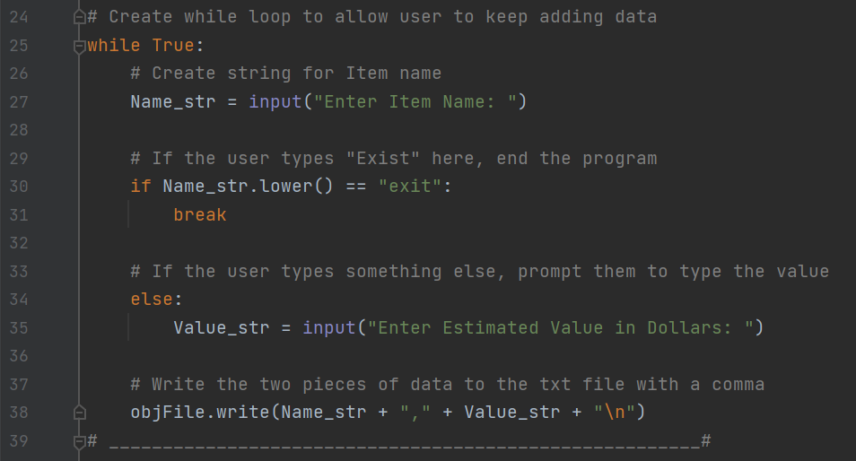***Figure 5: Collecting data from the user***

1. In the last bit of the code, the file is closed and the screen prints that the data is stored. (Figure 6)

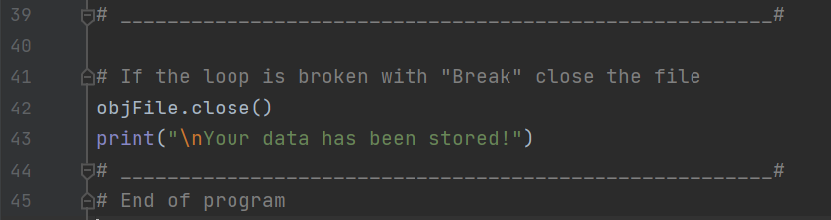***Figure 6: Processing the data***

1. The output of the program is a txt file that has both the item number and the estimated value of that item. The name and the value are separate with a comma, and each item and value pair is separate by a new line in the text file. (Figure 7)

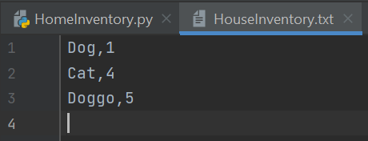

***Figure 7: Example of data being stored and opened using Pycharm***

# **Summary**

In this assignment we are tasked with taking user input in the form of an item name and estimated value, and then taking that data and storing it in a text file. This program goes above and beyond the program requirements as this program allows multiple lines of data to be stored in the text file. The assignment specifies only one line of data to be entered. This is useful for situations when multiple lines of data needed to be stored in a file, and it’s unknown upfront how much data will need to be stored. This program is the first example in this class of using a loop to evaluate True/False conditions. These are really powerful functions that enable different sequences of code to be followed depending on the situation. This program also has nested loops which are useful for additional requirements to delineate and store data.