Architectural Document
ESP32 Blockchain-Powered Attendance System

For Master of Espressif Contest

Version: 1.0.0
Date: December 16, 2025
Submission Deadline: January 21, 2026

1. Executive Summary
The ESP32 Blockchain-Powered Attendance System represents an innovative solution that combines IoT hardware with blockchain technology to create a tamper-proof, automated attendance tracking platform. Built specifically for the Master of Espressif Contest, this project showcases the powerful capabilities of Espressif's ESP32 microcontroller family in creating real-world blockchain-integrated solutions.
This system addresses critical challenges in traditional attendance management: data tampering, manual record-keeping errors, and lack of real-time verification. By leveraging the ESP32-WROOM-32's built-in Wi-Fi capabilities and integrating with Sui blockchain's Move smart contracts, we've created a system that ensures immutable attendance records while maintaining ease of use.

1.1 Key Innovation Highlights
- Espressif ESP32 Core: Uses ESP32-WROOM-32 microcontroller with integrated RC522 RFID reader for contactless attendance capture
- Blockchain Immutability: Every attendance record is permanently stored on Sui blockchain using Move smart contracts
- Subscription Business Model: SaaS-style monthly subscription (10 SUI) with automated access control
- Server-Side Transaction Signing: Platform owner bears gas costs, providing seamless UX for end-users
- Real-Time Verification: Instant feedback via LED and buzzer confirms successful attendance marking
- Multi-Organization Support: Scalable architecture supporting unlimited organizations and students

1.2 Target Users
- Educational Institutions: Universities, colleges, schools requiring automated attendance tracking
- Corporate Organizations: Companies needing employee time-tracking with audit trails
- Training Centers: Professional development centers tracking course participation
- Event Management: Conference and seminar organizers verifying attendee participation

2. System Overview
The ESP32 Attendance Platform is a distributed system comprising four primary architectural layers: Hardware (ESP32 + RFID), Backend (Node.js transaction service), Frontend (React dashboard), and Blockchain (Sui Move smart contracts). This modular design ensures scalability, maintainability, and clear separation of concerns.

2.1 System Context Diagram
The system context diagram illustrates the high-level interactions between external actors and the ESP32 Attendance Platform:
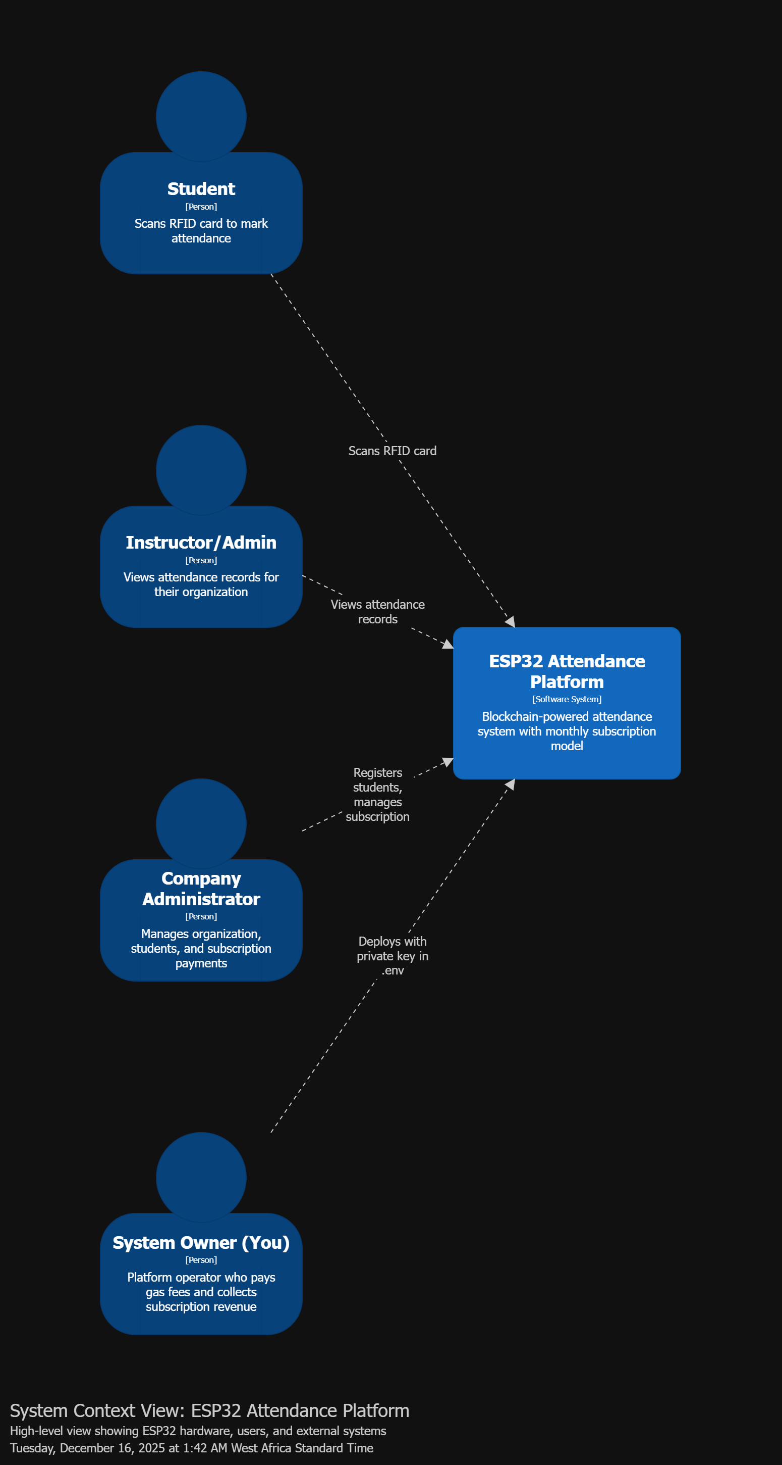
Figure 2.1: System Context Diagram showing external actors and systems

2.1.1 External Actors
- Students: Scan RFID cards at ESP32 devices to mark attendance
- Instructors/Admins: View attendance records and manage students via web dashboard
- Company Administrators: Register organizations, manage subscriptions, and configure system settings
- System Owner: Platform operator who deploys infrastructure and collects subscription revenue

2.1.2 External Systems
- Sui Blockchain Network: Decentralized platform providing immutable storage for attendance records
- Transfer Multisort Electronic: Hardware supplier for ESP32-WROOM-32 modules and electronic components

2.2 Container Architecture
The container diagram shows the high-level technology choices and how they interact:
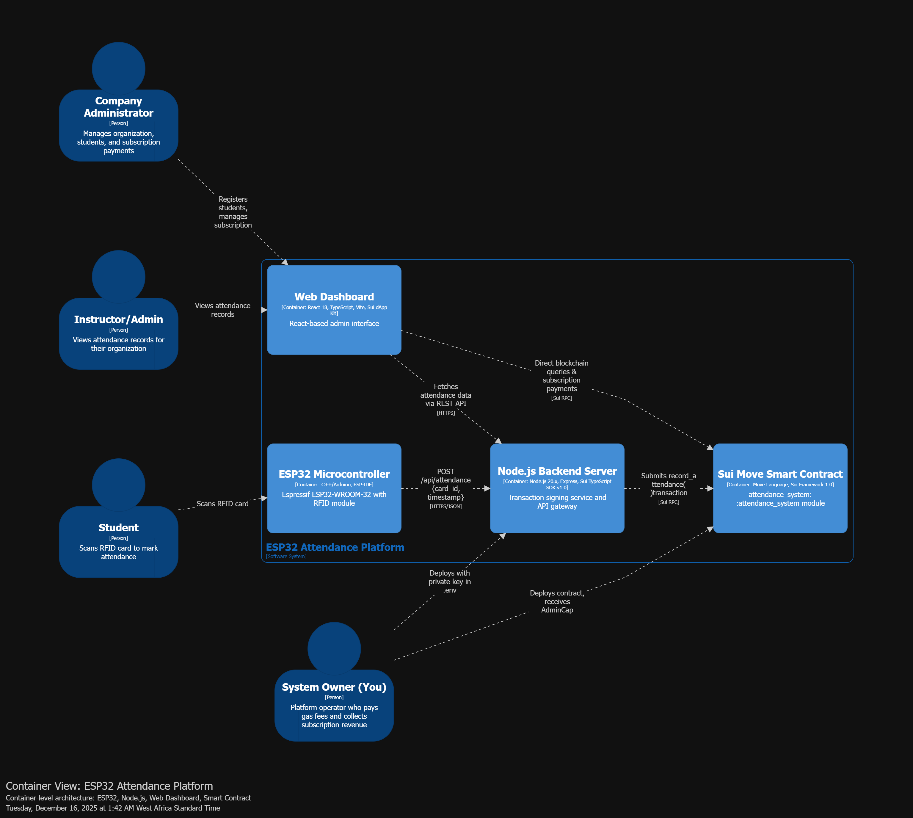
Figure 2.2: Container Architecture showing system components
- ESP32 Microcontroller: Hardware layer running C++/Arduino firmware with RFID reader
- Node.js Backend Server: Transaction signing service and API gateway
- Web Dashboard: React-based admin interface for viewing attendance
- Sui Move Smart Contract: Blockchain layer managing attendance records and subscriptions

3. ESP32 Hardware Architecture
Contest Requirement: This section highlights the Espressif ESP32 component.
The ESP32-WROOM-32 is the core hardware component of this system. It integrates seamlessly with RFID reader modules to capture attendance data and communicates with the backend server via Wi-Fi.
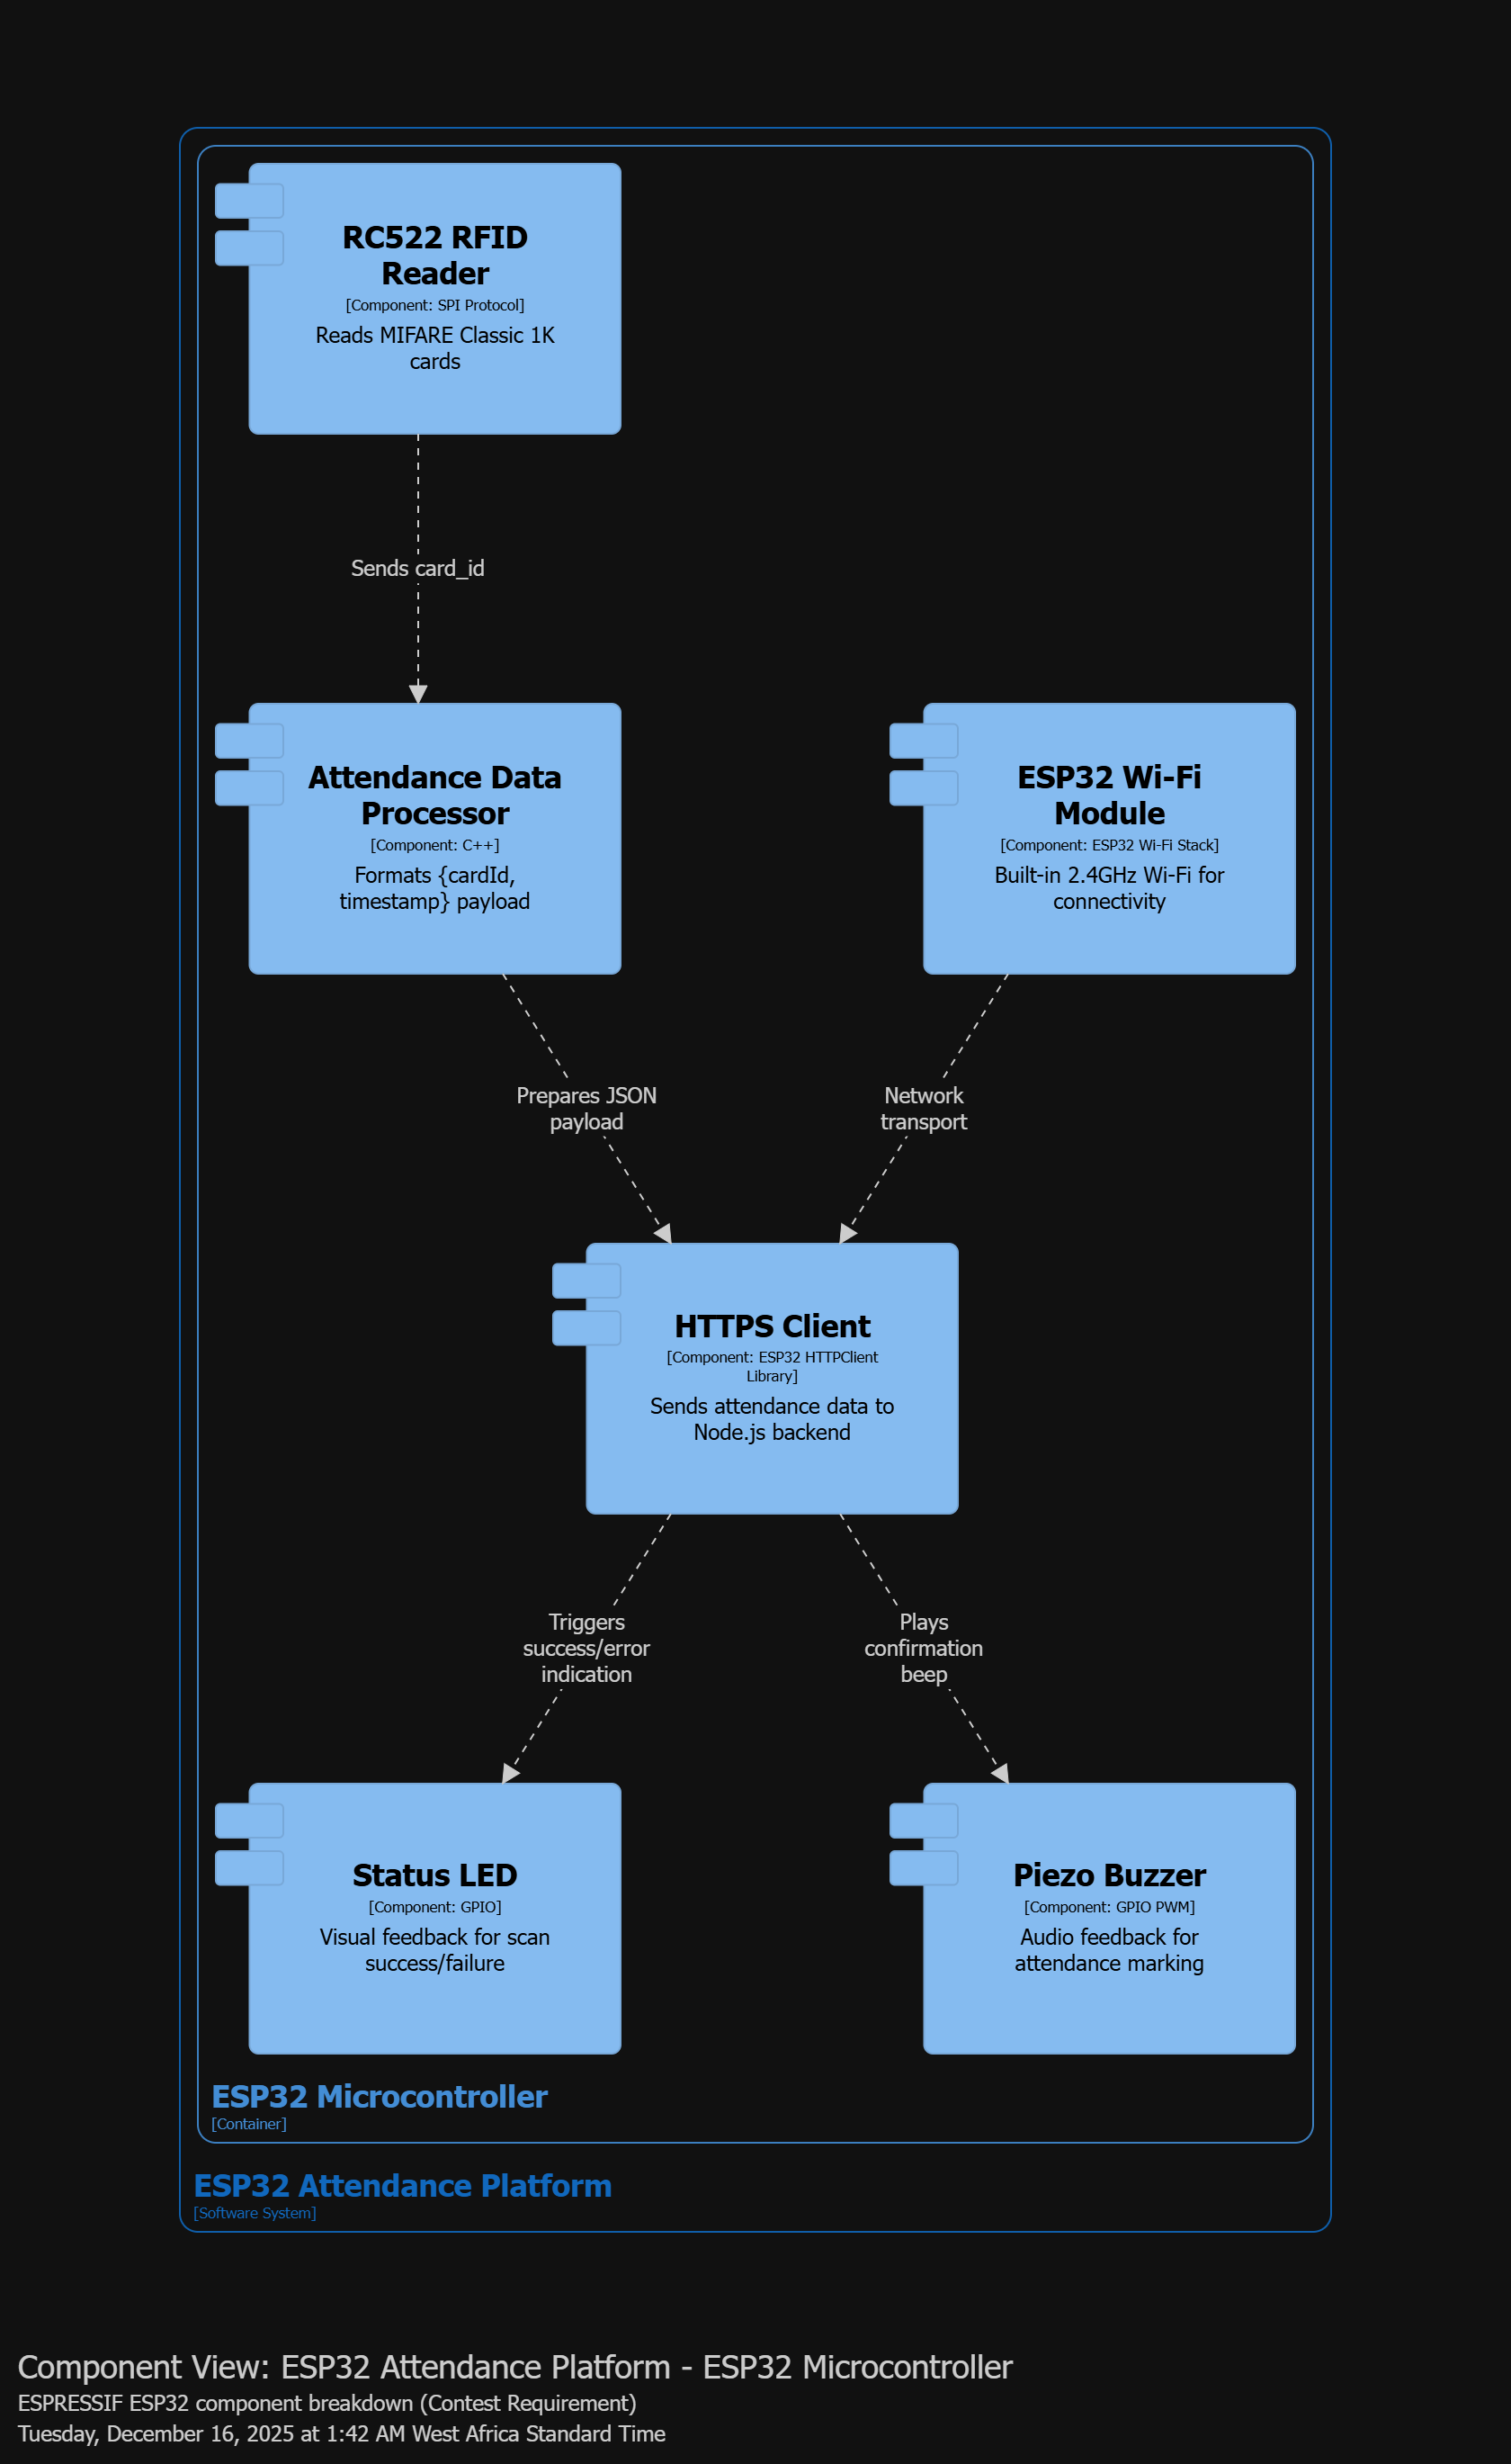
Figure 3.1: ESP32 Hardware Component Breakdown

3.1 Hardware Components
- RC522 RFID Reader: SPI-based module reading MIFARE Classic 1K cards (card_id)
- ESP32 Wi-Fi Module: Built-in 2.4GHz Wi-Fi for network connectivity
- Data Processor: Formats attendance payload with card_id and timestamp
- HTTPS Client: Sends JSON data to Node.js backend via REST API
- Status LED: Visual feedback (green=success, red=error)
- Piezo Buzzer: Audio confirmation for attendance marking

3.2 Hardware Specifications
- Microcontroller: Espressif ESP32-WROOM-32
- CPU: Dual-core Xtensa LX6, 240MHz
- Wi-Fi: 802.11 b/g/n, 2.4GHz
- GPIO Pins: 34 programmable GPIO pins
- SPI Interface: For RC522 RFID reader communication
- Power: 3.3V, ~80mA active, ~10μA deep sleep

4. Node.js Backend Architecture
The Node.js backend serves as the critical middleware between ESP32 hardware and the Sui blockchain. It handles transaction signing, subscription validation, and provides REST API endpoints for both hardware devices and the web dashboard.
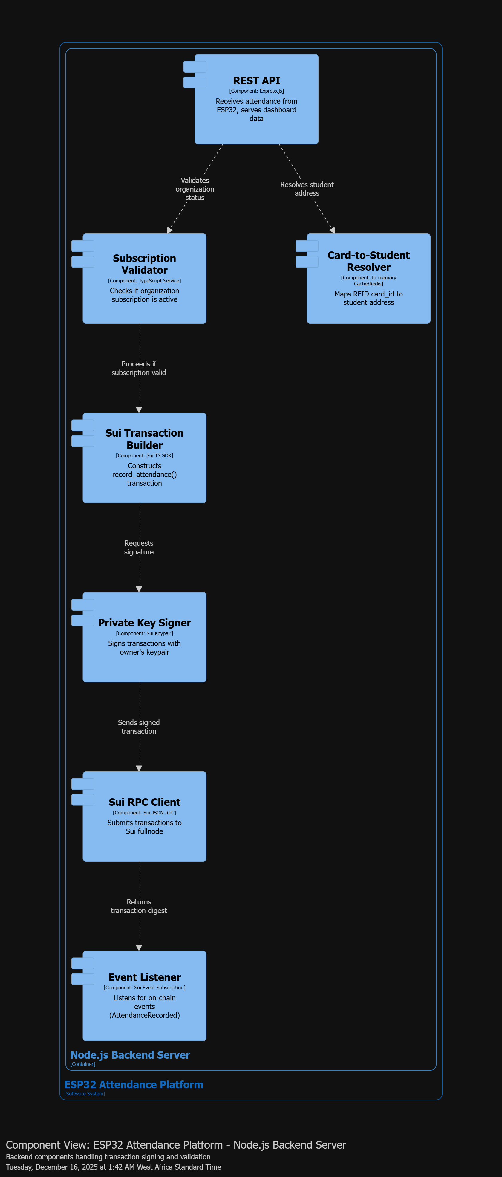
Figure 4.1: Node.js Backend Component Architecture

4.1 Backend Components
- REST API: Express.js server receiving attendance data from ESP32 devices
- Subscription Validator: Checks if organization subscription is active before processing
- Card-to-Student Resolver: Maps RFID card_id to student blockchain address
- Sui Transaction Builder: Constructs record_attendance() transactions
- Private Key Signer: Signs transactions with owner's keypair (stored securely)
- Sui RPC Client: Submits signed transactions to Sui fullnode
- Event Listener: Listens for on-chain events (AttendanceRecordedEvent)

4.2 API Endpoints
- POST /api/attendance: Receives attendance data from ESP32 {card_id, timestamp}
- GET /api/attendance/:orgId: Retrieves attendance records for organization
- GET /api/students/:orgId: Lists all students in an organization
- GET /api/subscription/:orgId: Checks subscription status

5. Web Dashboard Architecture
The React-based web dashboard provides administrators with a comprehensive interface for managing organizations, students, and viewing attendance records. It integrates with Sui wallets for subscription payments.
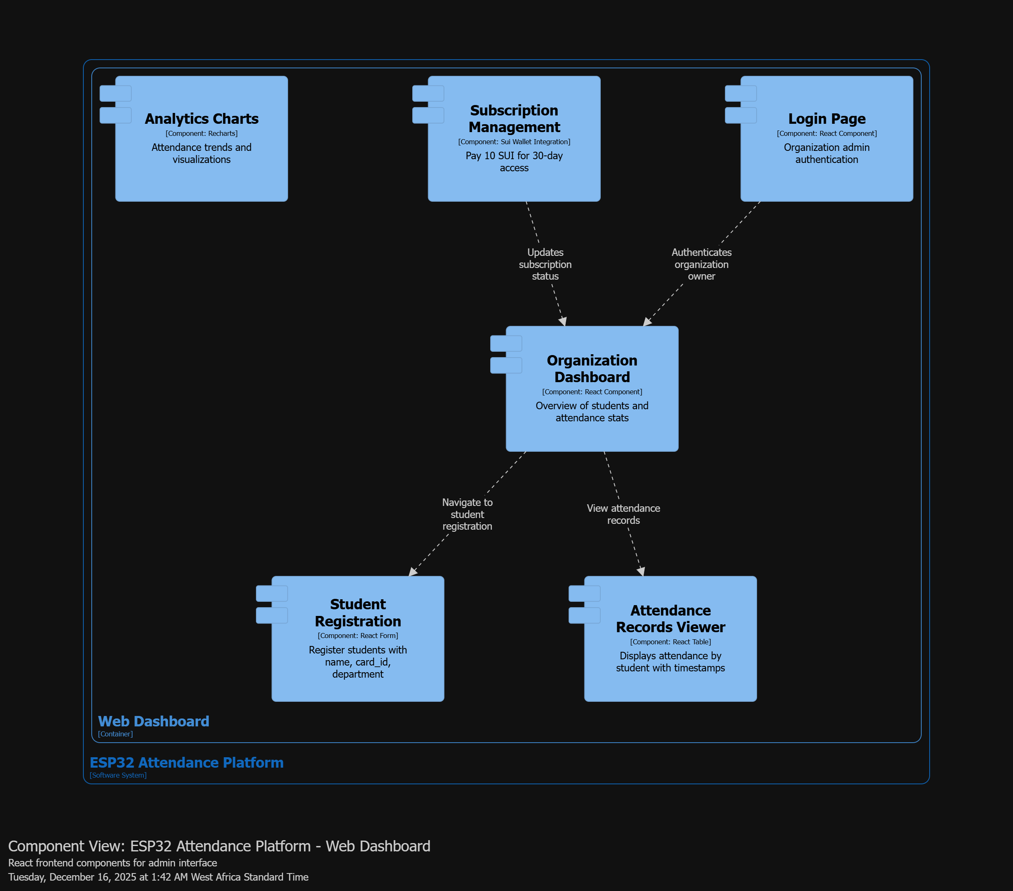
Figure 5.1: Web Dashboard Component Architecture

5.1 Frontend Components
- Login Page: Organization admin authentication
- Organization Dashboard: Overview of students and attendance statistics
- Student Registration: Register students with name, card_id, department
- Attendance Records Viewer: Displays attendance by student with timestamps
- Subscription Management: Pay 10 SUI for 30-day access via Sui wallet
- Analytics Charts: Visualizations of attendance trends and patterns

5.2 Technology Stack
- Framework: React 18 with TypeScript
- Build Tool: Vite
- UI Library: Material-UI or Tailwind CSS
- Blockchain Integration: Sui dApp Kit / Sui Wallet Adapter
- Charts: Recharts or Chart.js
- State Management: React Query / Zustand

6. Sui Smart Contract Architecture
The smart contract layer is implemented in Move language and deployed on Sui blockchain. It manages attendance records, organization data, and subscription logic (to be implemented).
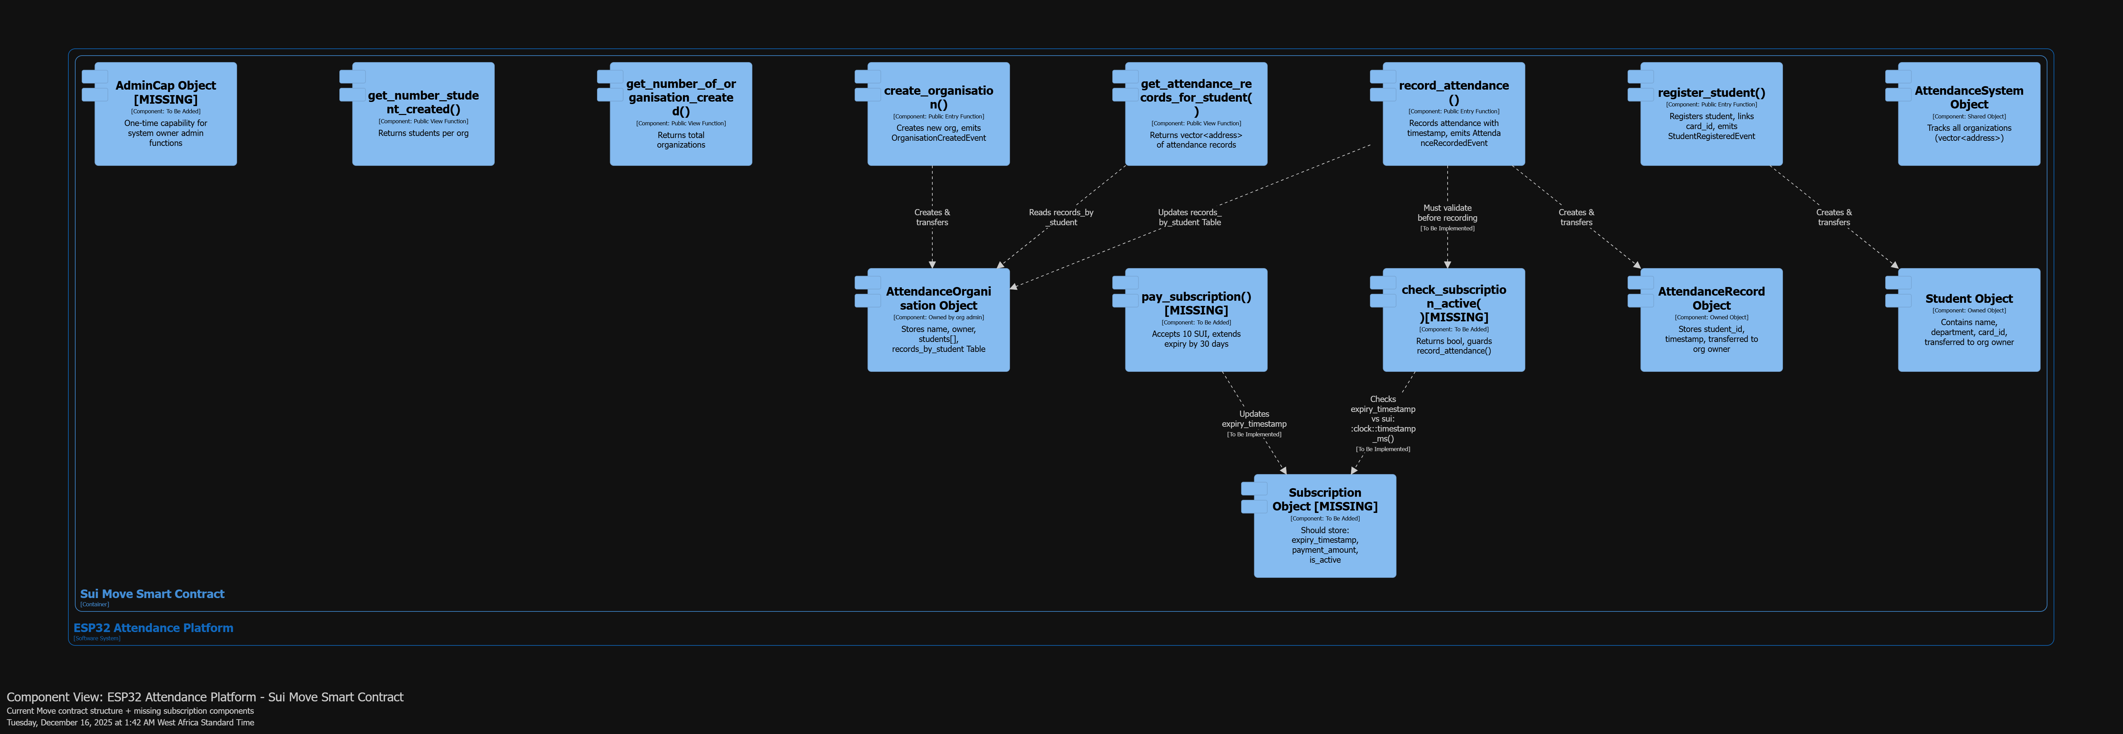
Figure 6.1: Sui Move Smart Contract Architecture

6.1 Smart Contract Objects
- AttendanceSystem: Shared object tracking all organizations (vector<address>)
- AttendanceOrganisation: Owned object storing name, owner, students[], and records_by_student Table
- Student: Owned object containing name, department, and card_id
- AttendanceRecord: Owned object storing student_id and timestamp
- Subscription Object [TO BE IMPLEMENTED]: Should store expiry_timestamp, payment_amount, is_active
- AdminCap Object [TO BE IMPLEMENTED]: One-time capability for system owner admin functions

6.2 Entry Functions
- create_organisation(): Creates new organization, emits OrganisationCreatedEvent
- register_student(): Registers student with card_id, emits StudentRegisteredEvent
- record_attendance(): Records attendance with timestamp, emits AttendanceRecordedEvent
- pay_subscription() [TO BE IMPLEMENTED]: Accepts 10 SUI, extends expiry by 30 days

6.3 View Functions
- get_attendance_records_for_student(): Returns vector<address> of attendance records
- get_number_of_organisation_created(): Returns total organizations
- get_number_student_created(): Returns students per organization
- check_subscription_active() [TO BE IMPLEMENTED]: Returns bool, guards record_attendance()

7. System Workflows

7.1 Attendance Marking Workflow
The complete flow from RFID card scan to blockchain record:
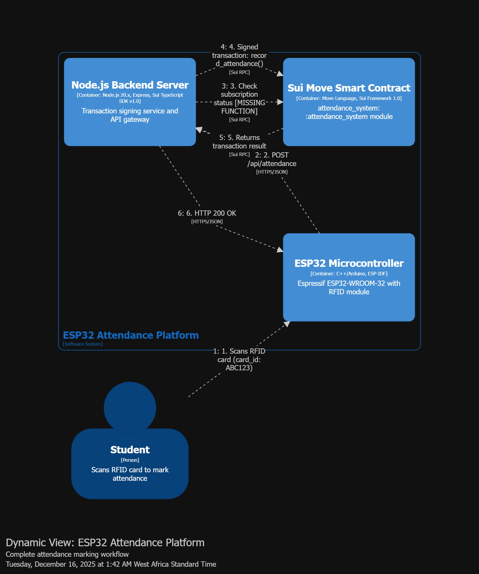
Figure 7.1: Attendance Marking Workflow
- 1. Student scans RFID card at ESP32 device
- 2. ESP32 reads card_id and sends POST /api/attendance to Node.js backend
- 3. Backend validates organization subscription status
- 4. Backend resolves card_id to student blockchain address
- 5. Backend constructs and signs record_attendance() transaction
- 6. Transaction submitted to Sui blockchain via RPC
- 7. Smart contract creates AttendanceRecord object and emits event
- 8. Backend receives transaction confirmation
- 9. Backend sends HTTP 200 OK to ESP32
- 10. ESP32 displays success (green LED, buzzer beep)
- 11. Instructor views updated attendance in web dashboard

7.2 Subscription Payment Workflow
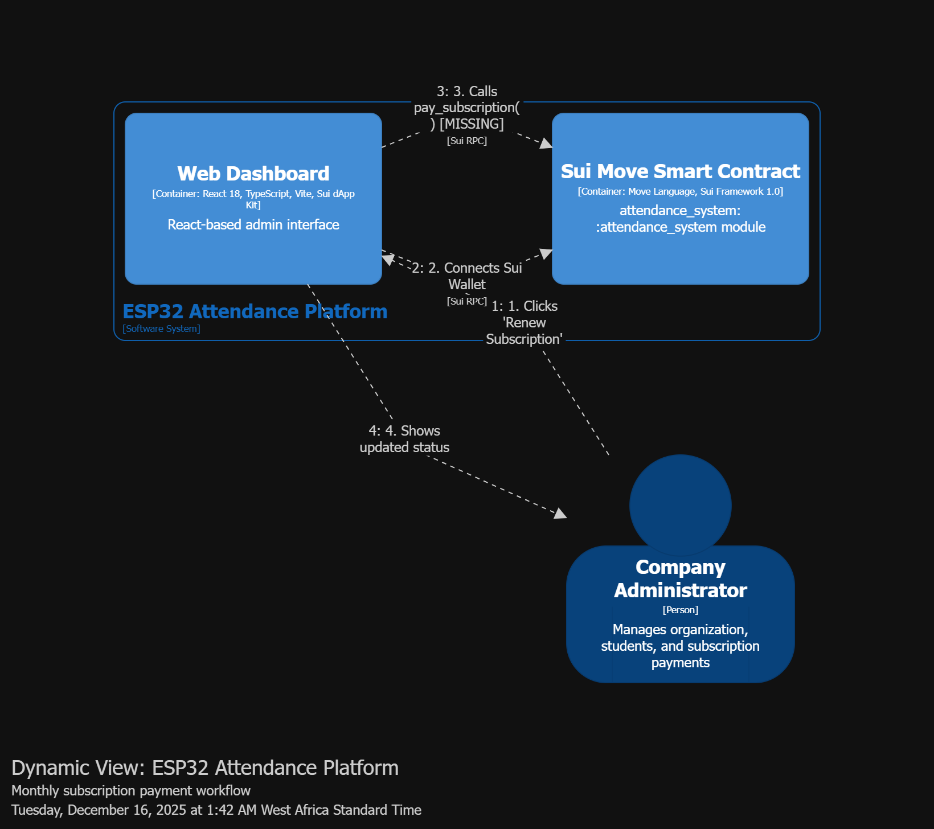
Figure 7.2: Subscription Payment Workflow
- 1. Company admin clicks "Renew Subscription" (10 SUI due)
- 2. Web dashboard connects to Sui wallet (Suiet/Ethos)
- 3. Admin approves payment transaction
- 4. pay_subscription() function called on smart contract
- 5. Contract updates expiry_timestamp (+30 days)
- 6. Contract transfers 10 SUI to system owner address
- 7. SubscriptionRenewedEvent emitted on blockchain
- 8. Dashboard displays updated subscription status

7.3 Expired Subscription Blocking
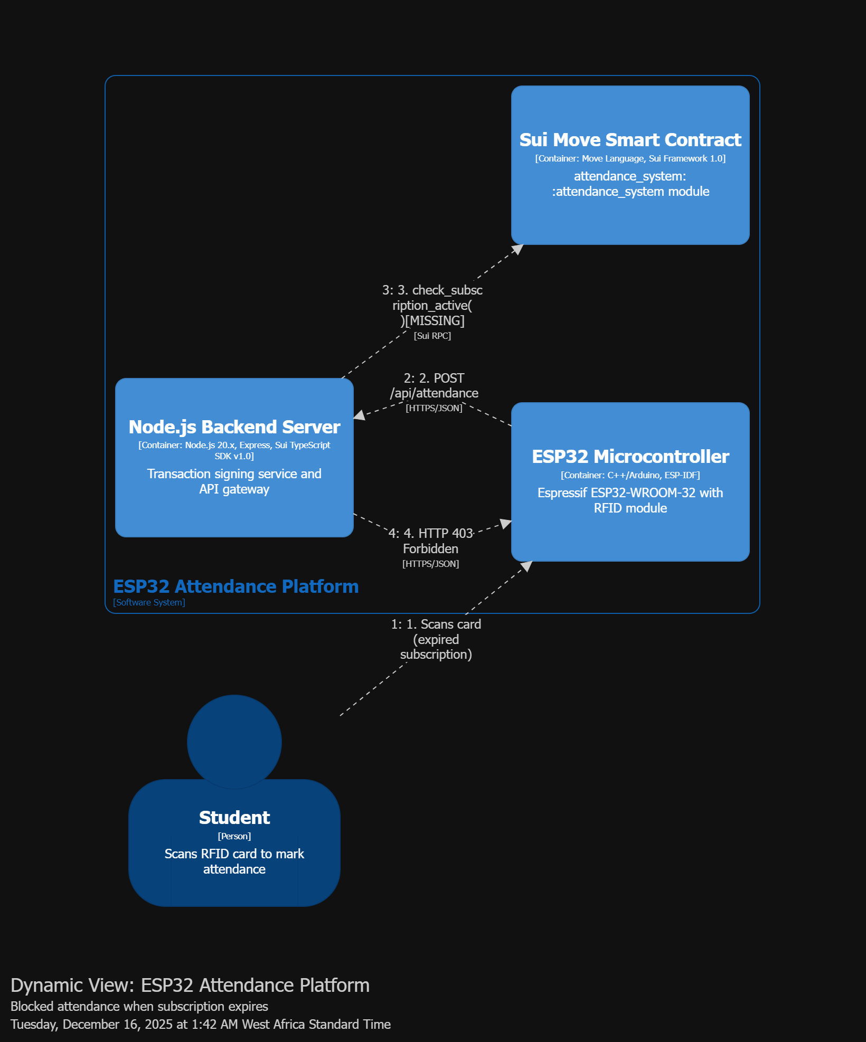
Figure 7.3: Expired Subscription Blocking Flow
- 1. Student scans card (organization subscription expired)
- 2. ESP32 sends attendance request to backend
- 3. Backend calls check_subscription_active() on smart contract
- 4. Contract checks expiry_timestamp vs current timestamp
- 5. Contract returns is_active=false
- 6. Backend returns HTTP 403 Forbidden to ESP32
- 7. ESP32 displays error (red LED, error buzzer tone)
- 8. Dashboard shows "Subscription Expired" banner to admin

8. Deployment Architecture
The system is deployed across multiple environments: physical hardware at organization premises, cloud infrastructure for backend services, and decentralized Sui blockchain network.
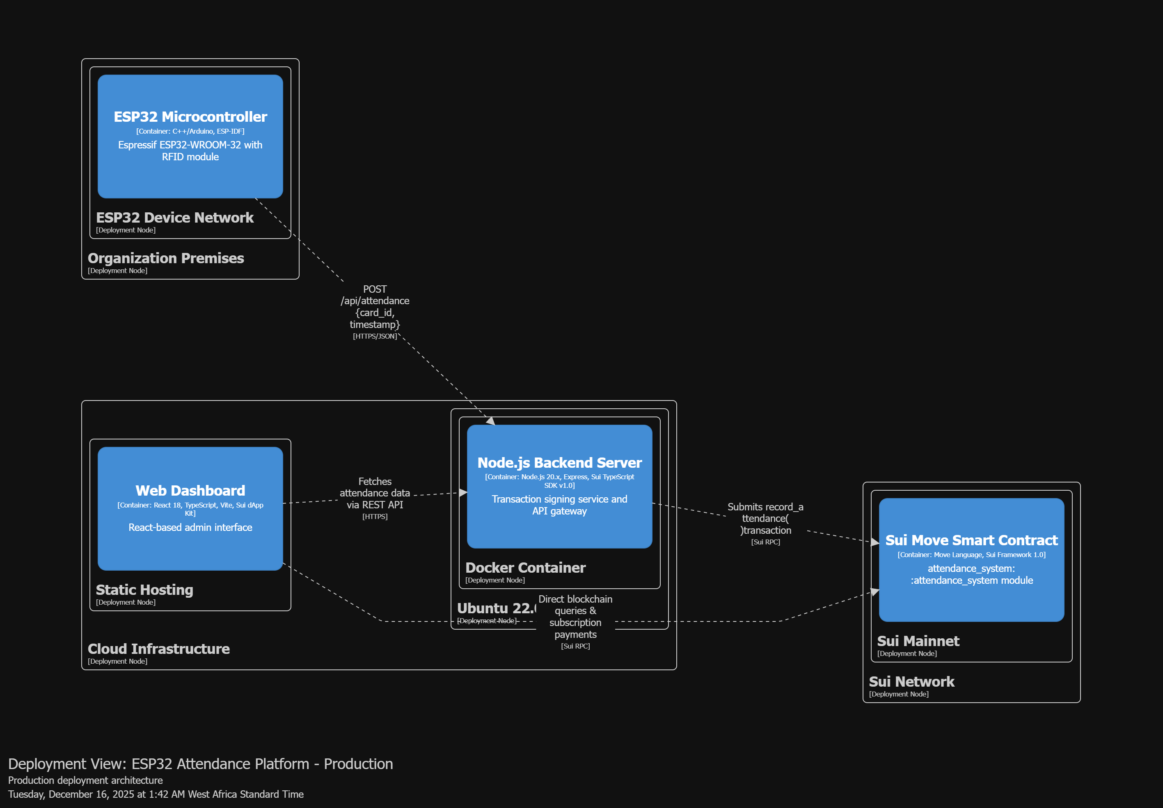
Figure 8.1: Production Deployment Architecture

8.1 Deployment Environments
- Organization Premises: ESP32 devices deployed at physical locations (classrooms, offices)
- Cloud Infrastructure: Node.js backend on Ubuntu 22.04 server (AWS/DigitalOcean)
- Static Hosting: React dashboard on Vercel/Netlify
- Sui Network: Smart contracts deployed on Sui Mainnet/Testnet

8.2 Infrastructure Requirements
- ESP32 Devices: One per attendance station, requires Wi-Fi connectivity
- Backend Server: Minimum 2GB RAM, 1 CPU core, Ubuntu 22.04 LTS
- Database: Optional Redis for card_id caching (in-memory also supported)
- SSL Certificate: Required for HTTPS communication with ESP32 devices
- Sui Fullnode Access: RPC endpoint for blockchain interaction

9. Security Considerations

9.1 Private Key Management
The system owner's private key is stored securely in environment variables on the Node.js backend server. This key is used to sign all attendance transactions, ensuring the platform owner bears gas costs while maintaining transaction authenticity.
- Private key stored in .env file (never committed to version control)
- Environment variables loaded at runtime only
- Consider using hardware security modules (HSM) for production
- Key rotation policy should be established
- Access to backend server restricted via SSH keys

9.2 Blockchain Security
- Smart contracts use Sui's ownership model for access control
- Only organization owners can register students
- Subscription validation prevents unauthorized attendance recording
- All transactions are cryptographically signed
- Immutable audit trail on blockchain

9.3 Network Security
- HTTPS/TLS encryption for all API communications
- ESP32 devices authenticate with backend via API keys
- CORS policies restrict dashboard access
- Rate limiting on API endpoints
- Input validation on all user inputs

10. Future Enhancements
- Subscription Module Implementation: Complete pay_subscription() and check_subscription_active() functions
- AdminCap Pattern: Implement Sui capability pattern for admin-only functions
- Multi-Location Support: Track attendance across multiple physical locations
- Biometric Integration: Add fingerprint or face recognition as alternative to RFID
- Mobile App: Native mobile application for students and instructors
- Analytics Dashboard: Advanced reporting and predictive analytics
- Automated Alerts: Email/SMS notifications for attendance anomalies
- Integration APIs: REST APIs for third-party system integration

11. Conclusion
The ESP32 Blockchain-Powered Attendance System demonstrates the innovative potential of combining Espressif's ESP32 microcontroller with modern blockchain technology. This architecture provides a scalable, secure, and user-friendly solution for attendance tracking while showcasing the capabilities required for the Master of Espressif Contest.
Key architectural strengths include:
- Modular design enabling independent scaling of components
- Blockchain immutability ensuring data integrity
- Hardware-software integration showcasing ESP32 capabilities
- Subscription-based business model for sustainable operation
- Clear separation of concerns across layers
This document serves as the comprehensive architectural reference for the ESP32 Attendance Platform and will be updated as the system evolves.

