**Rock Chalk Rendezvous**

User’s Manual

Version <1.0>

Revision History

| **Date** | **Version** | **Description** | **Author** |
| --- | --- | --- | --- |
| 04/25/2024 | 0.1 | First draft | Shayna Weinstein, Ben Phillips, Dylan Kneidel, Delroy Wright, Andrew Reyes |
| 05/02/2024 | 1.0 | Completed manual | Shayna Weinstein, Ben Phillips, Dylan Kneidel, Delroy Wright, Andrew Reyes |
|  |  |  |  |
|  |  |  |  |

Table of Contents

**1. Purpose 4**

**2. Introduction 4**

**3. Getting Started 4**

**4. Advanced features 5**

**5. Troubleshooting 5**

**6. Examples 5**

**7. Glossary of terms 8**

**8. FAQ 8**

# Purpose

This user manual is an easy-to-understand guide on how to use our software.

# Introduction

The objective of our project is to create a platform for scheduling meetings for a group by compositing schedule information from each member of the group. The purpose is to improve the functionality of existing schedule comparison software to reduce repetitive actions and mitigate the need for active responses from group members for each event. Some features include creating groups (with the name of the group), creating users with names and passwords, getting groups, removing groups, and leaving groups, editing user calendars, and viewing a group’s calendar.

# Getting Started

**Installing**

1. Download the client binary corresponding to your operating system (Windows and Linux currently supported) from: [github.com/delster1/RockChalkRendezvous/releases/tag/release](https://github.com/delster1/RockChalkRendezvous/releases/tag/release)
   1. For Windows, choose “rcr_windows.exe”.
   2. For Linux, choose “rcr_linux”.

**Running**

**Windows**: Double-click or execute the .exe file that was just downloaded.

**Linux**: Double-click or execute the binary file that was just downloaded.

**Controls**

Menu controls in RockChalkRendezvous are directed toward both terminal novices and experts. Use the arrow keys to navigate or J and K to move up and down, respectively. To select, press Enter, and to go back, press backspace. To exit the program at any time, press CTRL+C, or press Q in a menu while not typing.

**Account Creation/Login**

Upon running the binary, an account can be created by selecting “Register” and entering the associated information, pressing Enter to confirm each entry. After the username and password have been created, a server response will confirm your login. If the account already exists, enter its information in the Login option instead to login.

**Calendar** **Navigation**

The selector will clearly highlight which 15-minute block of the calendar is being highlighted using highlighted arrows. The core controls can be used to navigate throughout the calendar with the selector. WASD can be used to pan the screen without using the selector.

**Event List**

To view the list of events, press L. This screen will display information about each task that has been added to the calendar, including the name, time and date, duration, and repetition amount. To go back to the calendar in this screen, press C.

**Event Creation**

To populate your calendar, you must add events! These can be added by pressing N while on either the calendar or list screen, and will take you back to the calendar in a select mode. In this mode, you may select a start and end time to designate the busy time of the event. Then, press Y, M, W, D, or O/N to enter the repeat frequency of year, month, week, day, or none.

**Event Removal**

To remove an event from the calendar, select an event in the events list screen and press backspace. Then, confirm the deletion by pressing Enter.

**Group Calendars**

To join a group calendar, navigate to the “Edit Groups” option in the main menu. Then, you can select group creation, joining, leaving, and view. To join a group, simply paste the group ID and your client will then be added to that group. Then, you can view the group calendar back in the “View Calendar” option in the main menu.

# Advanced features

**Build**

Building any item from source is as easy as running “make” in the given directory of the desired binary. Ensure that the g++ compiler supporting C++17 as well as CMake are installed before running this command.

**Running Your Own Server**

If you would like to run your own RockChalkRendezvous server, the server binaries for Windows and Linux are available at the same webpage ([github.com/delster1/RockChalkRendezvous/releases/tag/release](https://github.com/delster1/RockChalkRendezvous/releases/tag/release)) as the client binaries. Simply create an empty “groups.txt” file and “users” folder in the same location, then after the first run change the number in “config.txt” to the port that you want the server to use. Finally, make sure that your clients are changing their “config.txt” files to match the IP address/hostname and port of your server.

# Troubleshooting

If you experience any difficulties connecting to the main RockChalkRendezvous server, first check that you are connected to the internet. If your network is working properly, then try deleting the “config.txt” file in the same location as the program binary in order to reset the target server address back to the default. If you are still unable to connect, it is likely an issue with the server itself. In this case please contact us by opening an issue on our GitHub repository at <https://github.com/delster1/RockChalkRendezvous>.

If you encounter any other bugs or usability issues, please open an issue on the above repository so that we can correct the problem and release a patch in a timely manner.

# Examples

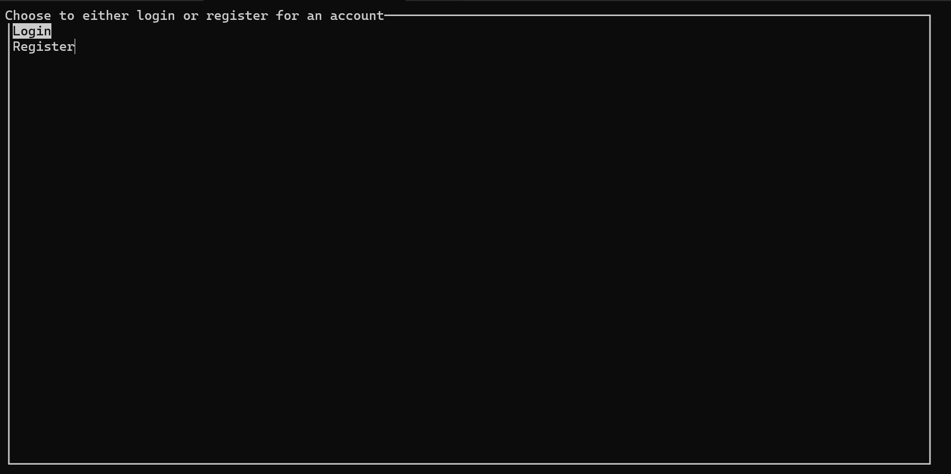

*First screen that is shown to the user*

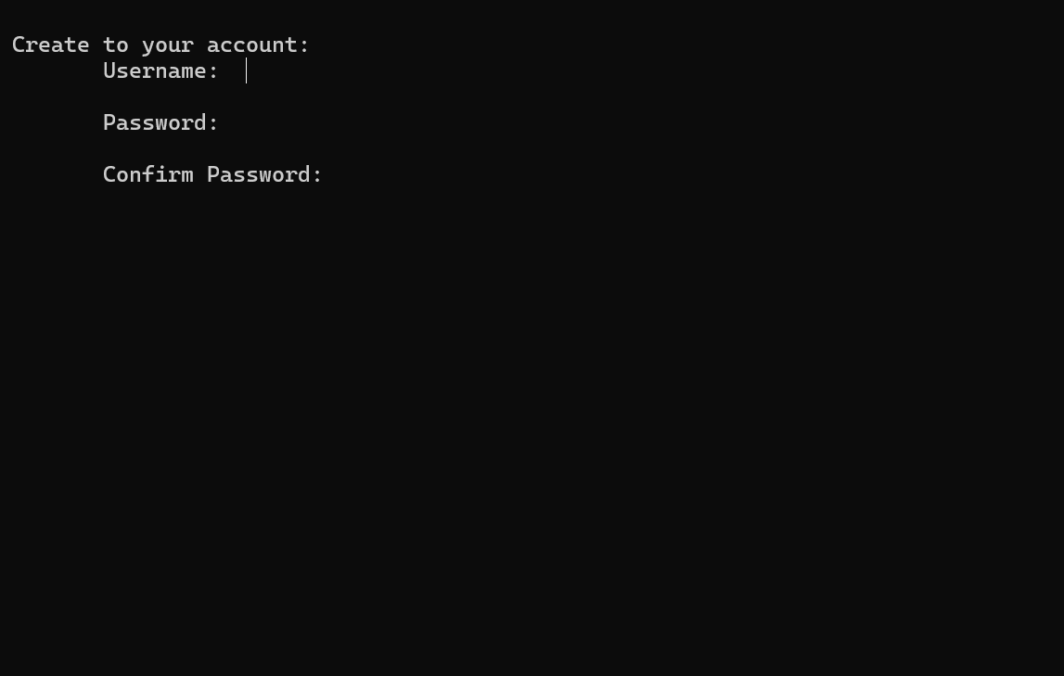

*Registration*

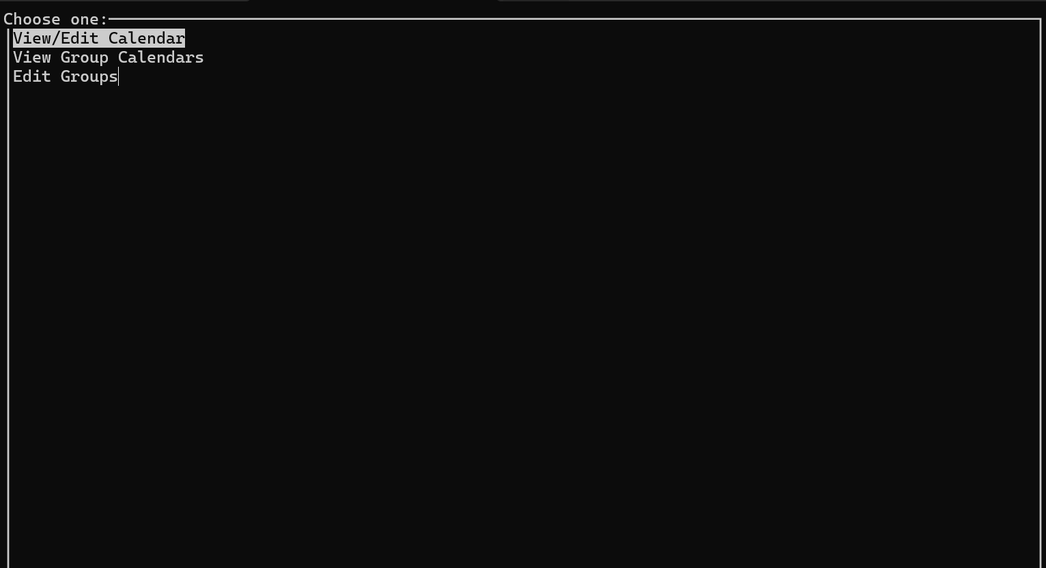

*Main Menu*

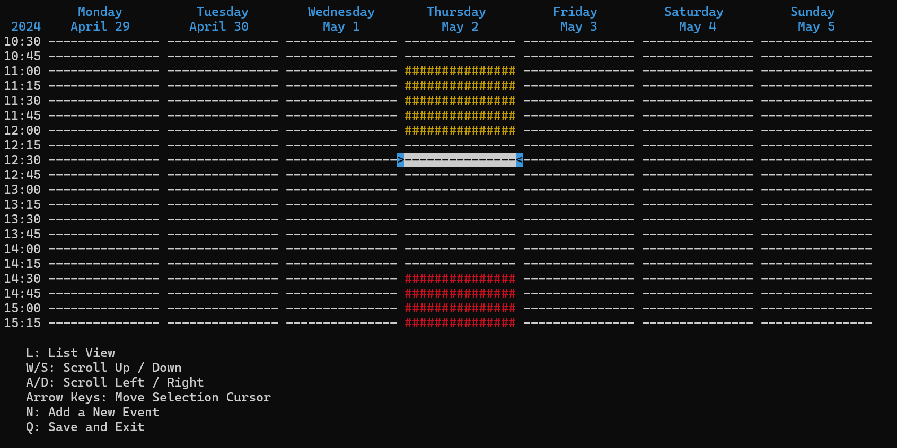

*Calendar View*

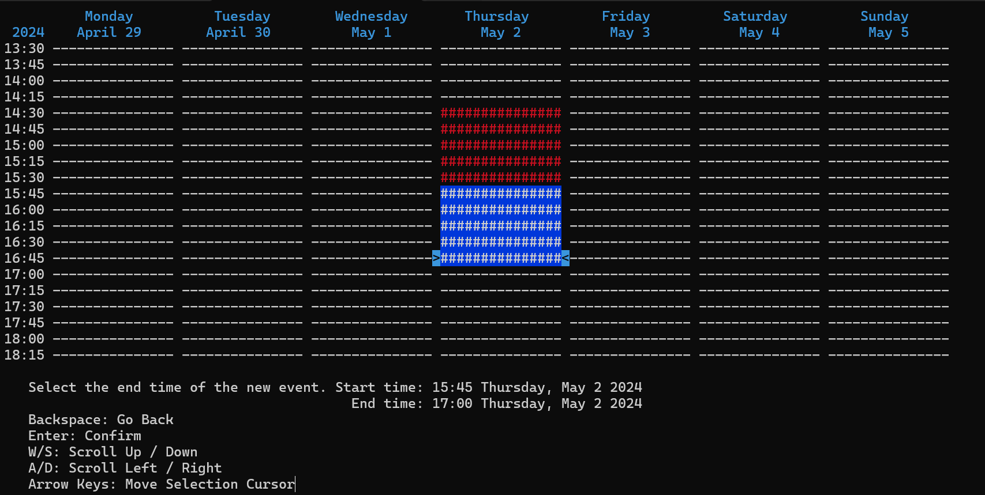

*Event Creation*

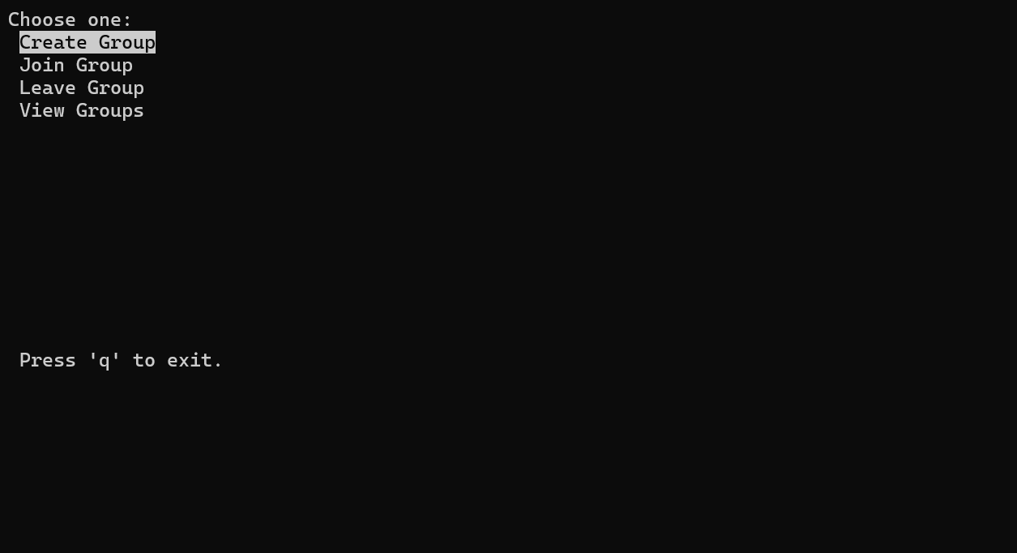

*Group Menu*

# Glossary of terms

See *Glossary of Terms* Document (gloss1) for relevant definitions, acronyms, and abbreviations.

# FAQ

Q: Is this just a better version of the When2Meet scheduling website?

A: Yes, it is!

Q: Can I access this from my computer?

A: You can and this document will tell you how!

Q: Can I change/reset my password?

A: We do not currently have that feature but will keep it in mind for a future release

Q: Is there any upgrades that I should look out for in the future?

A: We are not currently working on any updates, but will adjust this document in the future if that changes.

Q: Can we contact you with bugs or problems?

A: Yes! If you have gone through our troubleshooting section, you will find that you can contact us by opening an issue on our GitHub repository at <https://github.com/delster1/RockChalkRendezvous>.

Q: Do I need a technical background to use Rock Chalk Rendezvous?

A: No, while you have to follow our instructions on how to download our program, we hope that anyone can utilize our project.