
Submitted by:
Arfa Arfan
Roll no:
2024-csre-032
Class/Section:
Computer Science (EVENING)
Submitted to:
Prof. Anees

J.
🔹 General Query
-- Categories Table
CREATE TABLE categories (
category_id SERIAL PRIMARY KEY,
category_name VARCHAR(100) NOT NULL,
description TEXT
);

-- Products Table
CREATE TABLE products (
product_id SERIAL PRIMARY KEY,
product_name VARCHAR(100) NOT NULL,
price DECIMAL(10, 2) NOT NULL,
quantity INT NOT NULL,
discount_percent INT DEFAULT 0,
category_id INT REFERENCES categories(category_id)
);

-- Customers Table
CREATE TABLE customers (
customer_id SERIAL PRIMARY KEY,
name VARCHAR(100) NOT NULL,
phone VARCHAR(15),
email VARCHAR(100) UNIQUE
);

-- Orders Table
CREATE TABLE orders (
order_id SERIAL PRIMARY KEY,
customer_id INT REFERENCES customers(customer_id),
order_date DATE DEFAULT CURRENT_DATE
);

-- Order Details Table
CREATE TABLE order_details (
order_detail_id SERIAL PRIMARY KEY,
order_id INT REFERENCES orders(order_id),
product_id INT REFERENCES products(product_id),
quantity INT,
total_price DECIMAL(10, 2)
);

-- Insert into Categories
INSERT INTO categories (category_name, description) VALUES
('Unstitched', 'Unstitched fabrics for men and women'),
('Ready to Wear', 'Ready-to-wear dresses for all occasions'),
('Accessories', 'Scarves, bags, jewelry'),
('Fragrances', 'Perfumes and mists');

-- Insert into Products
INSERT INTO products (product_name, price, quantity, discount_percent, category_id) VALUES
('Cotton Lawn (3pc)', 3200.00, 150, 10, 1),
('Embroidered Kurta', 4500.00, 80, 15, 2),
('Formal Suit (Men)', 7500.00, 40, 20, 2),
('Chiffon Dupatta', 1200.00, 100, 5, 3),
('Silk Scarf', 950.00, 120, 0, 3),
('Oud Perfume', 3500.00, 60, 10, 4),
('Rose Mist', 1500.00, 90, 5, 4),
('Unstitched Cambric (2pc)', 2200.00, 110, 10, 1),
('Casual Kurti', 2800.00, 70, 0, 2),
('Leather Clutch', 1800.00, 50, 5, 3);

-- Insert into Customers
INSERT INTO customers (name, phone, email) VALUES
('Ayesha Malik', '03112223344', 'ayesha@mail.com'),
('Zain Ali', '03007778899', 'zainali@mail.com'),
('Mehwish Khan', '03219876543', 'mehwish@mail.com'),
('Hamza Tariq', '03451230987', 'hamza@mail.com'),
('Mariam Asif', '03333444555', 'mariam@mail.com');

-- Insert Orders
INSERT INTO orders (customer_id) VALUES
(1), (2), (3), (4), (5);

-- Insert Order Details
INSERT INTO order_details (order_id, product_id, quantity, total_price) VALUES
(1, 1, 2, 5760.00),
(1, 4, 1, 1140.00),
(2, 2, 1, 3825.00),
(2, 6, 1, 3150.00),
(3, 3, 1, 6000.00),
(3, 10, 2, 3420.00),
(4, 5, 3, 2850.00),
(4, 7, 2, 2850.00),
(5, 8, 1, 1980.00),
(5, 9, 1, 2800.00);

Query:
CREATE TABLE categories ;
Explanation:
This table defines product categories like Unstitched, Ready to Wear, etc.
Screenshot:
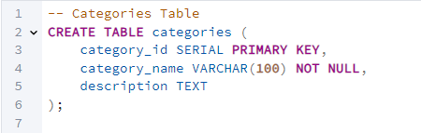
Query:
CREATE TABLE products ;
Explanation:
This table stores product details, including name, price, quantity, discount, and category reference.
Screenshot:
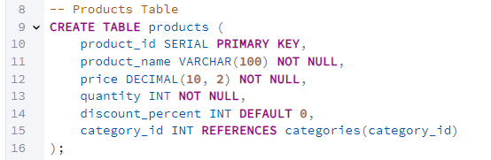
Query:
CREATE TABLE customers ;
Explanation:
This table keeps information about customers such as name, phone, and email.
Screenshot:
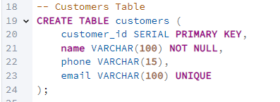
Query:
CREATE TABLE orders ;
Explanation:
This table records customer orders, linking to the customer and storing the order date.
Screenshot:
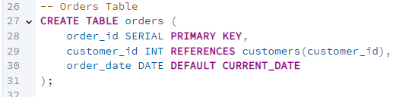
Query:
CREATE TABLE order_details ;
Explanation:
This table contains details of each order, including which products were bought, in what quantity, and their total price.
Screenshot:
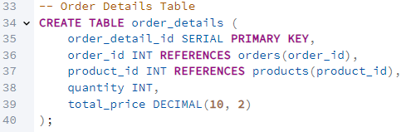
Query:
INSERT INTO categories ...
Explanation:
Insert sample category records for product classification.
Screenshot:
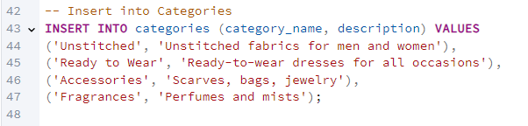
Query:
INSERT INTO products ...
Explanation:
Insert sample products with price, quantity, discount, and linked category.
Screenshot:
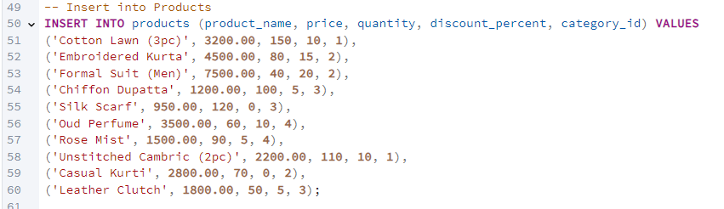
Query:
INSERT INTO customers ...
Explanation:
Insert customer data including name, contact number, and unique email.
Screenshot:
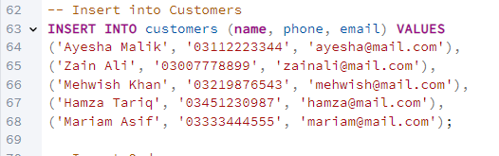
Query:
INSERT INTO orders ...
Explanation:
Insert simple order entries linked with customer IDs.
Screenshot:
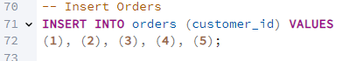
Query:
INSERT INTO order_details ...
Explanation:
Insert detailed line items for each order including quantity and total price.
Screenshot:
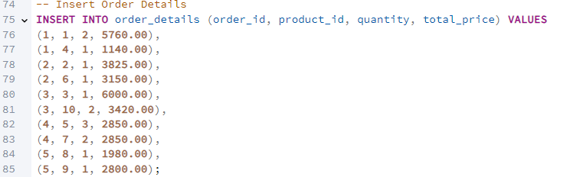
🔹 Basic SELECT Queries
Query:
SELECT product_name FROM products;
Explanation:
Retrieves only the product names from the products table.
Screenshot:
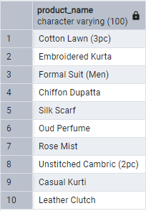

Query:
SELECT product_name, price FROM products;
Explanation:
Fetches both the product name and its price.
Screenshot:
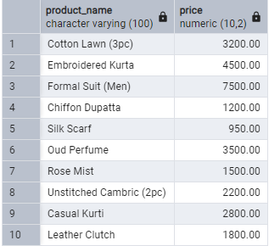

Query:
SELECT * FROM products;
Explanation:
Returns all columns and all records from the products table.
Screenshot:
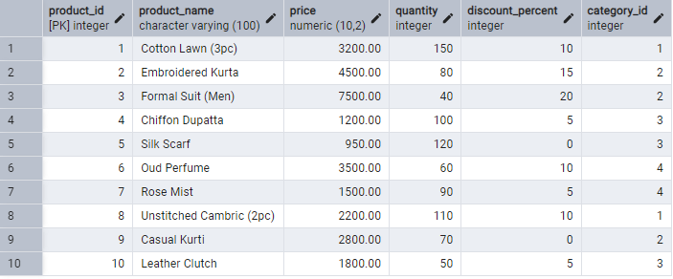

Query:
SELECT DISTINCT category_id FROM products;
Explanation:
Lists unique category IDs that appear in the products table.
Screenshot:
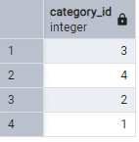

Query:
SELECT DISTINCT name, phone FROM customers;
Explanation:
Fetches unique combinations of customer name and phone number.
Screenshot:
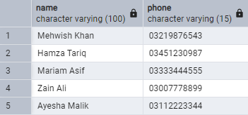

🔹 Aggregate Functions
Query:
SELECT COUNT(*) FROM customers;
Explanation:
Counts the total number of customers.
Screenshot:
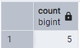

Query:
SELECT COUNT(DISTINCT category_id) FROM products;
Explanation:
Counts how many different categories exist in the products table.
Screenshot:
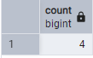

Query:
SELECT MIN(price) FROM products;
Explanation:
Finds the lowest product price.
Screenshot:
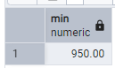

Query:
SELECT MAX(price) FROM products;
Explanation:
Finds the highest product price.
Screenshot:
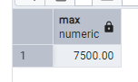

Query:
SELECT AVG(price) FROM products;
Explanation:
Calculates the average price of all products.
Screenshot:
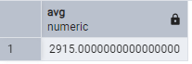

Query:
SELECT SUM(total_price) FROM order_details;
Explanation:
Adds up the total of all order line items (total sales).
Screenshot:
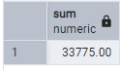

🔹 WHERE Clause Examples
Query:
SELECT name FROM customers WHERE phone LIKE '0311%';
Explanation:
Selects customers whose phone numbers start with “0311”.
Screenshot:
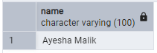

Query:
SELECT * FROM order_details WHERE quantity BETWEEN 1 AND 2;
Explanation:
Selects order lines where quantity is between 1 and 2.
Screenshot:
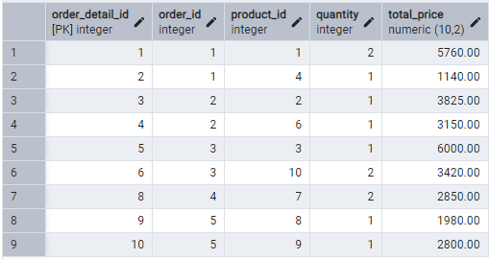

Query:
SELECT * FROM products WHERE price > 2000 AND discount_percent > 0;
Explanation:
Selects expensive discounted products.
Screenshot:
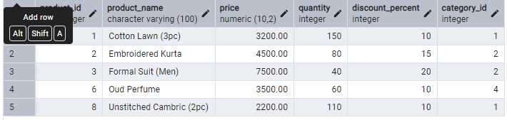

Query:
SELECT * FROM products WHERE quantity < 50 OR discount_percent > 0;
Explanation:
Selects products that are either low in stock or discounted.
Screenshot:
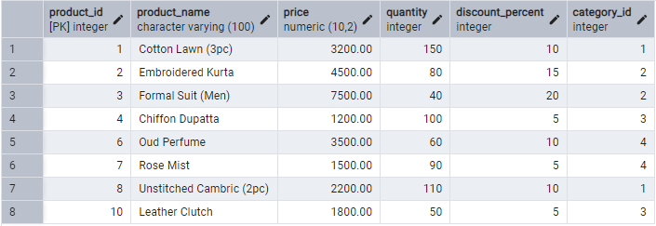

Query:
SELECT * FROM products WHERE NOT discount_percent > 0;
Explanation:
Shows all products without a discount.
Screenshot:
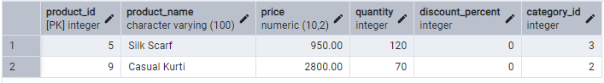

🔹 GROUP BY and HAVING
Query:
SELECT category_id, COUNT(*) AS product_count
FROM products
GROUP BY category_id;
Explanation:
Counts how many products each category has.
Screenshot:
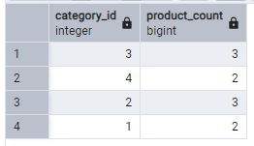

Query:
SELECT category_id, COUNT(*) AS product_count
FROM products
GROUP BY category_id
HAVING COUNT(*) < 2;
Explanation:
Finds categories that have less than two products.
Screenshot:
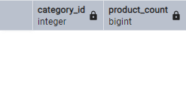

🔹 ORDER BY
Query:
SELECT * FROM products ORDER BY price;
Explanation:
Lists products sorted by price (low to high).
Screenshot:
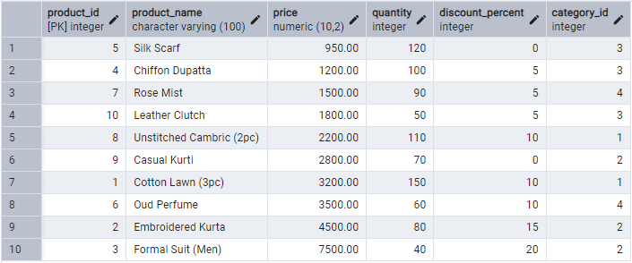

Query:
SELECT * FROM products ORDER BY price DESC;
Explanation:
Lists products sorted by price (high to low).
Screenshot:
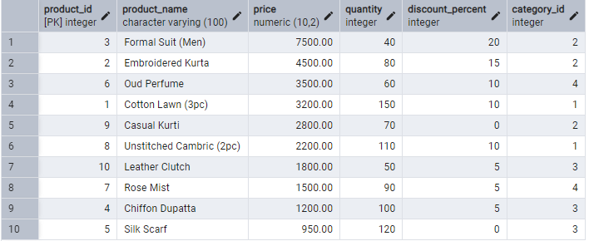

🔹 INSERT Statements
Query:
INSERT INTO customers (name, phone, email)
VALUES ('Bilal Khan', '03004445566', 'bilal@mail.com');
Explanation:
Adds a new customer named Bilal Khan.

Query:
INSERT INTO products (product_name, price, quantity, discount_percent, category_id)
VALUES ('Chiffon Scarf', 1300.00, 90, 5, 3);
Explanation:
Adds a new scarf product under category 3 (Accessories).

🔹 UPDATE Statements
Query:
UPDATE products
SET quantity = quantity + 50
WHERE product_name = 'Silk Scarf';
Explanation:
Restocks 50 more Silk Scarves.

Query:
UPDATE products
SET discount_percent = 20
WHERE category_id = (
SELECT category_id FROM categories WHERE category_name = 'Fragrances'
);
Explanation:
Applies 20% discount to all products in Fragrances.

🔹 DELETE Statements
Query:
DELETE FROM customers WHERE email = 'hamza@mail.com';
Explanation:
Removes the customer Hamza by email.

Query:
DELETE FROM products WHERE quantity < 10 AND discount_percent = 0;
Explanation:
Deletes products that are low stock and not discounted.

🔹 JOIN Queries
Query:
SELECT o.order_id, c.name, o.order_date
FROM orders o
INNER JOIN customers c ON o.customer_id = c.customer_id;
Explanation:
Lists orders alongside the customer who placed them.
Screenshot:
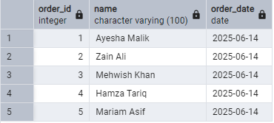

Query:
SELECT p.product_name, c.category_name
FROM products p
LEFT JOIN categories c ON p.category_id = c.category_id;
Explanation:
Displays products and their category names (including those without a category).
Screenshot:
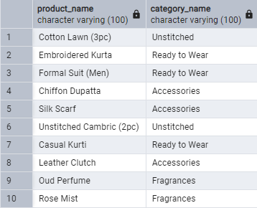

Query:
SELECT c.category_name, p.product_name
FROM categories c
RIGHT JOIN products p ON p.category_id = c.category_id;
Explanation:
Shows all products and their categories, including orphans.
Screenshot:
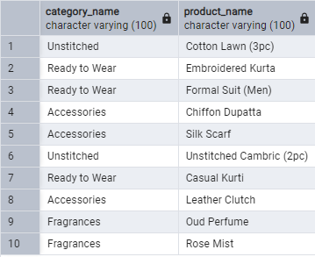

🔹 Nested / Subqueries
Query:
SELECT product_name FROM products
WHERE price > (
SELECT AVG(price) FROM products
);
Explanation:
Fetches products priced above average.
Screenshot:
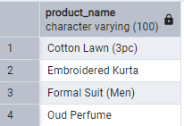

Query:
SELECT name FROM customers WHERE customer_id IN (
SELECT customer_id FROM orders WHERE order_date = CURRENT_DATE
);
Explanation:
Selects customers who placed an order today.
Screenshot:
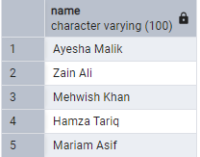

Query:
SELECT * FROM products WHERE category_id IN (
SELECT category_id FROM categories WHERE description LIKE '%fabrics%'
);
Explanation:
Lists products whose category description mentions “fabrics.”
Screenshot:
