DEPARTMENT OF COMPUTER SCIENCE



UNIVERSITY OF VETERINARY & ANIMAL SCIENCES,
RAVI CAMPUS, PATTOKI

NAME: Arfa Arfan
ROLL NO: 2024-Csre-032
Program: BS-CS
Semester: 3rd

Course Name: Data Structures and Algorithms
Instructor Name: Mr. Azeem Aslam
Project Title: Undo / Redo Program using Stack Data Structure

Table of Contents:

- Introduction and Problem Statement ................................... 4
- Objectives of the Project ........................................................ 4
- Tools and Technologies Used ................................................ 4
- System Design ....................................................................... 4
  - 4.1 Data Structure (Stack) ...................................................... 4
  - 4.2 Program Flow ................................................................... 5
- Implementation ....................................................................... 6
- Testing and Sample Outputs ................................................. 6
- Conclusion ............................................................................. 8
- References ............................................................................ 8

1. Introduction and Problem Statement
Introduction:
The Undo/Redo mechanism is a fundamental feature in modern software, allowing users to navigate through their edit history. This project implements a text-based editor that tracks changes across multiple documents simultaneously using the Stack data structure.

Problem Statement:
In standard text manipulation, changes are often destructive; once a character is deleted or replaced, the previous state is lost. To solve this, a system is required that records every state change in a way that allows a user to "step back" (Undo) and "step forward" (Redo) without losing data or creating complex manual indexing.

2. Objectives of the Project
- To implement the Last-In, First-Out (LIFO) principle using Python's list-based stacks.
- To create a robust state-management system where each edit (insert, delete, replace) creates a restorable snapshot.
- To develop a multi-document Command Line Interface (CLI) that avoids manual index handling.

3. Tools and Technologies
- Programming Language: Python 3.x.
- Integrated Development Environment (IDE): Jupyter Notebook (.ipynb).
- Core Libraries: re (for command parsing) and typing (for static type hinting).

4. System Design
4.1 Data Structure (The Stack)
The system utilizes two primary stacks:
- Undo Stack: Stores the string state before an edit occurs.
- Redo Stack: Stores the state after an undo occurs, allowing the user to "undo the undo".

4.2 Program Flow
- State Capture: Before any modification, the current text is pushed to the undo_stack.
- Execution: The text modification (e.g., write, delete) is performed.
- Redo Invalidation: The redo_stack is cleared whenever a new edit is made to ensure linear history.

5. Implementation
The Core Undo/Redo Logic
The UndoRedo class manages the two stacks and the current text state.
Python:
def undo(self) -> bool:
if not self.undo_stack:
return False
prev = self.undo_stack.pop()
self.redo_stack.append(self._text)
self._text = prev
return True

def redo(self) -> bool:
if not self.redo_stack:
return False
nxt = self.redo_stack.pop()
self.undo_stack.append(self._text)
self._text = nxt
return True

Multi-Document Management
The NotebookEditor class handles switching between different named documents, each with its own independent history.

Python:
def use(self, name: str) -> str:
if name not in self.docs:
self.docs[name] = UndoRedo()
self.current = name
return f"using: {name}"

6. Testing and Sample Outputs
- Test Case 1 (Basic help command):
- Undo/Redo CLI
- Type 'help' for commands.
- > help
- Undo/Redo (index-free defaults)
- Commands:
- new <name> # create and switch to a new document
- use <name> # switch to document (creates if missing)
- list # list documents, marking current
- write <text> # append text to the end
- set <text> # replace entire content
- clear # erase entire content
- backspace [n] # delete last n chars (default 1)
- delete [n] # alias of backspace
- insertat <pos> <text> # insert at index (advanced)
- replaceat <pos> <len> <text> # range replace (advanced)
- replaceall <old> <new> # replace all occurrences
- next # show next write index
- show # print current content
- undo # undo last change
- redo # redo last undo
- help # show this help
- exit # quit loop
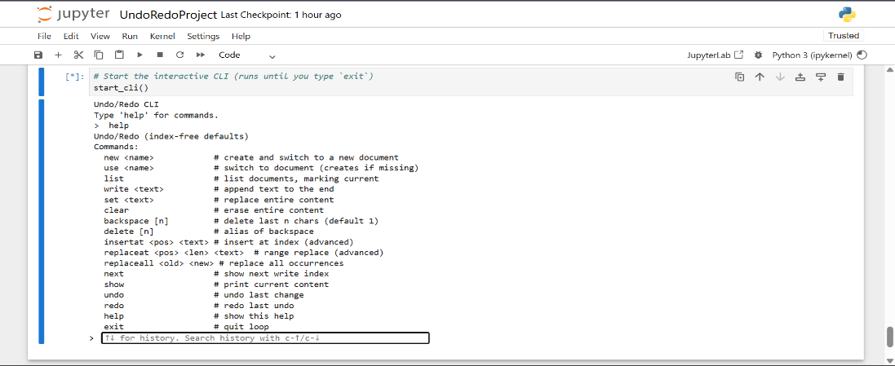

- Test Case 2 (Multi-Doc operations):
- > new Arfa_Arfan
- created and using: Arfa_Arfan
- > use Arfa_Arfan
- using: Arfa_Arfan
- > insertat 0 This is my DSA project.
- This is my DSA project.
- > replaceat 0 4 It
- It is my DSA project.
- > replaceall It This
- This is my DSA project.
- > set My name is Arfa Arfan.
- My name is Arfa Arfan.
- > write This is my DSA project.
- My name is Arfa Arfan. This is my DSA project.
- > show
- My name is Arfa Arfan. This is my DSA project.
- > undo
- My name is Arfa Arfan.
- > redo
- My name is Arfa Arfan. This is my DSA project.
- > next
- 46
- > clear
- > exit
- Bye!
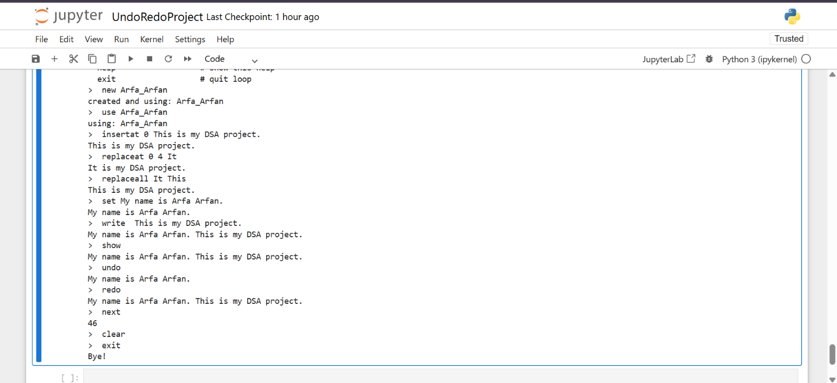

7. Conclusion
Through this project, I learned how the Stack data structure provides an elegant solution for history management. By leveraging the LIFO property, we can efficiently reverse operations in the exact order they were performed. I also gained experience in managing multiple object instances to keep document data separate.

8. References
- Python Software Foundation. Data Structures: Using Lists as Stacks..
- Notebook Implementation: UndoRedoProject.ipynb.

