Assignment-03

Q1. Create a numpy array and populate it with the following data as shown in the picture below and split the array into three different arrays as shown below :

*Hint: You can use array_split method*

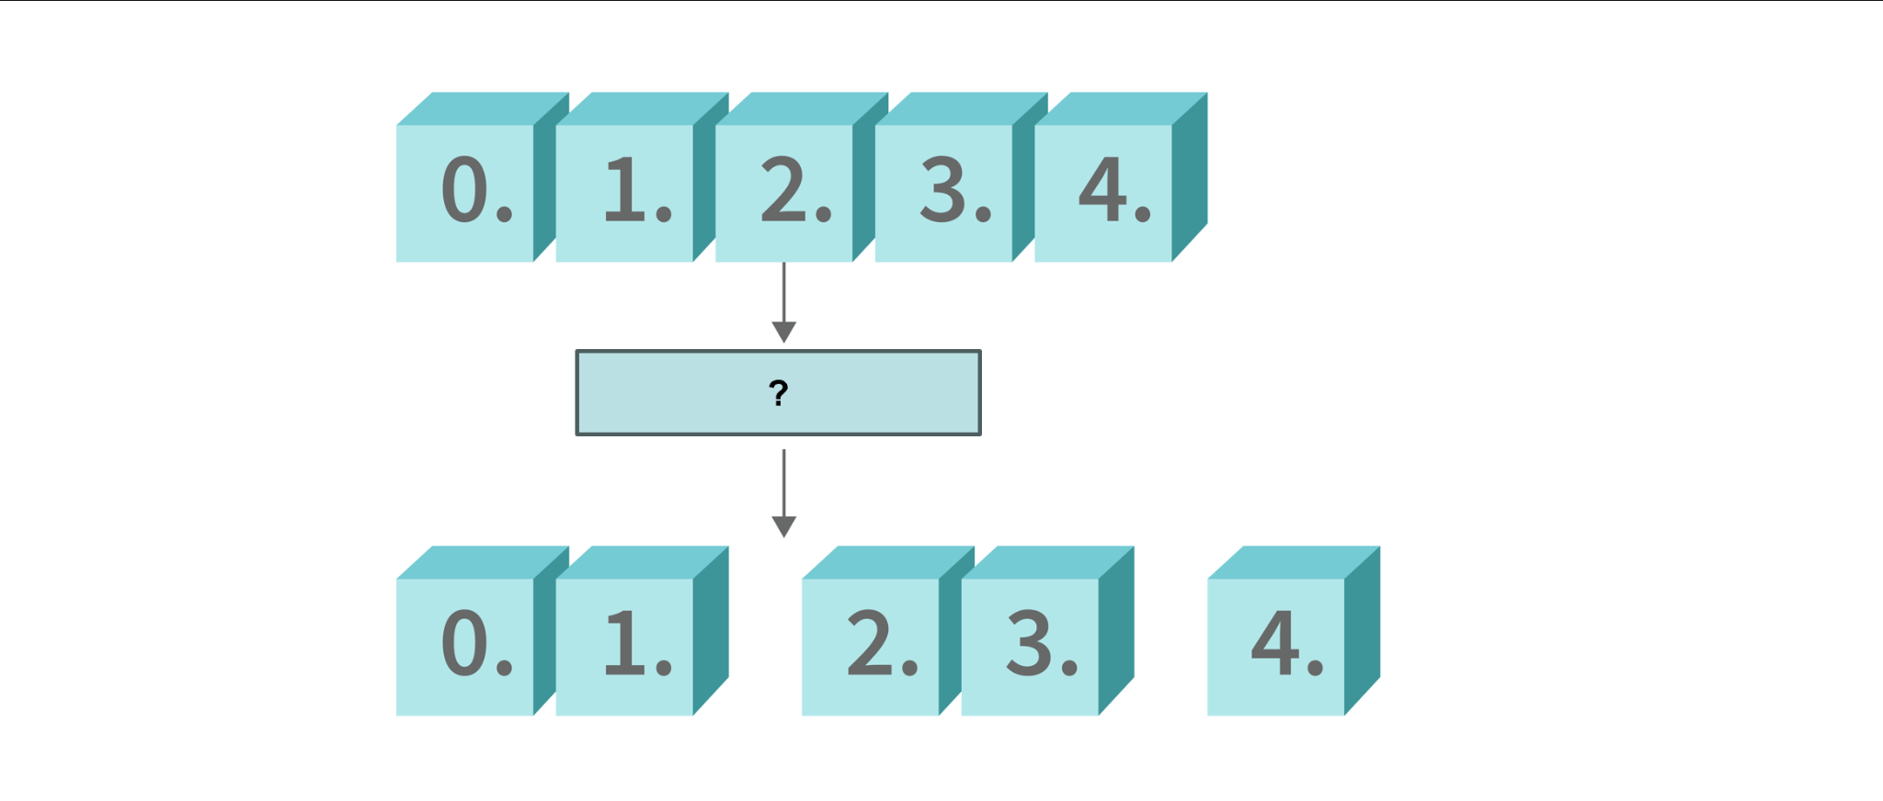

Q2. Create a 2-dimensional numpy array and populate it with the following data as shown in the picture below and flip the array as shown below :

*Hint: You can use the flip method declared in the numpy library*

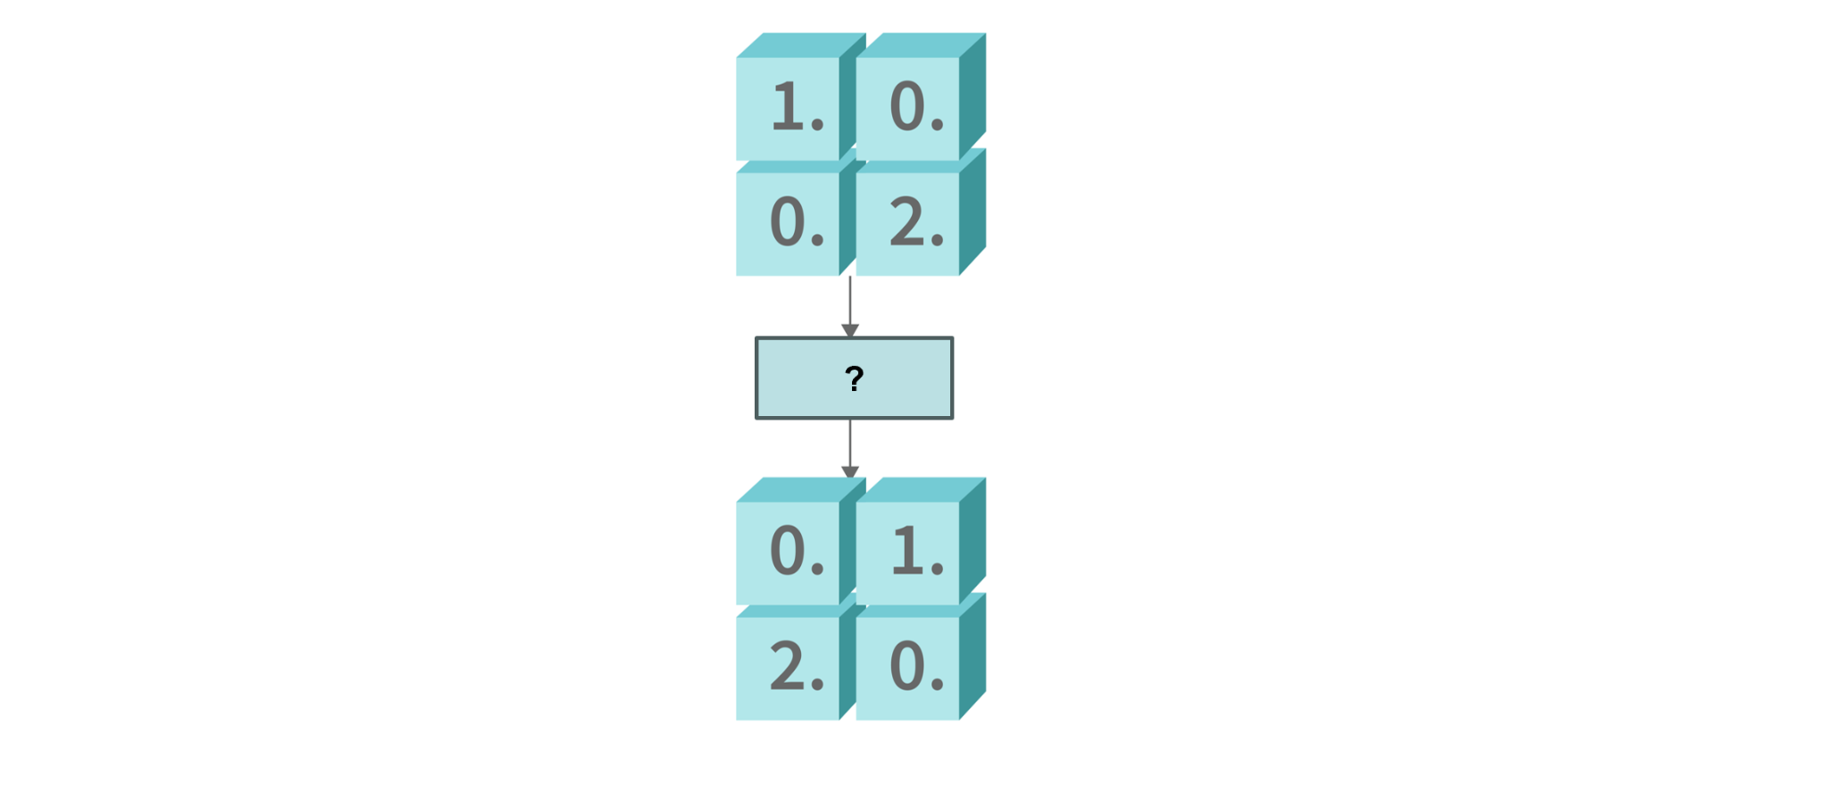

Q3. Create a 2-dimensional numpy array and populate it with the following data as shown in the picture below and add a border of zeros around the existing array :

*Hint: You can use the pad method declared in the numpy library*

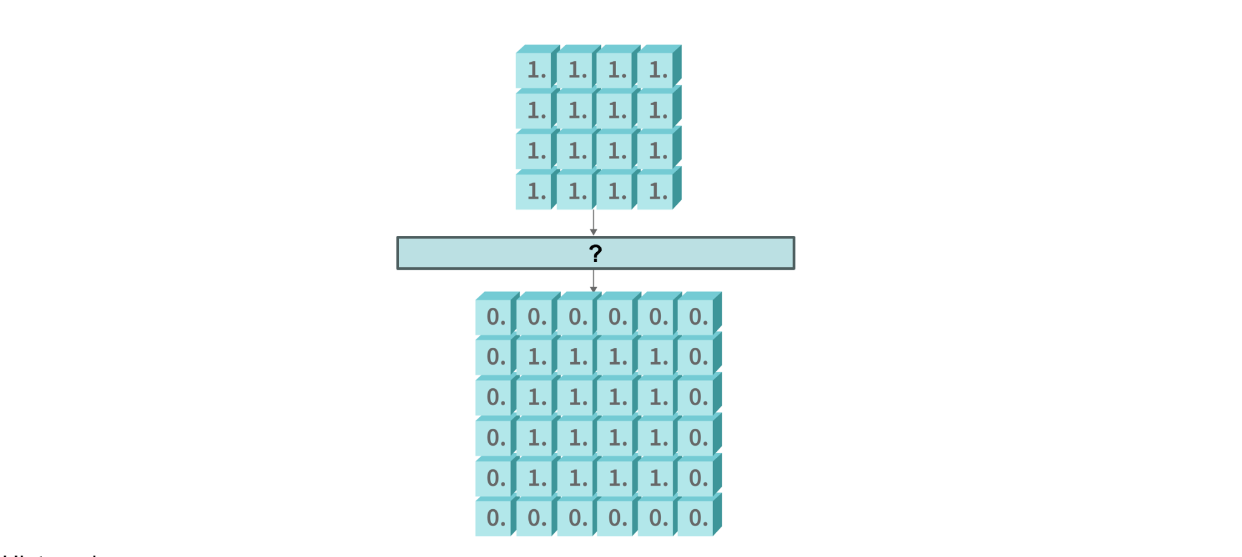

Q4. Create a numpy array and populate it with the following data as shown in the picture below and interchange two axes of the NumPy array :

*Hint: You can use the swapaxes method declared in the numpy library*

