**VISUAL PROGRAMMING**

**LAB-02**

**NAME: ARFA IMRAN**

**ROLL NO: 23356**

**CLASS: BSCS-B**

**1.**

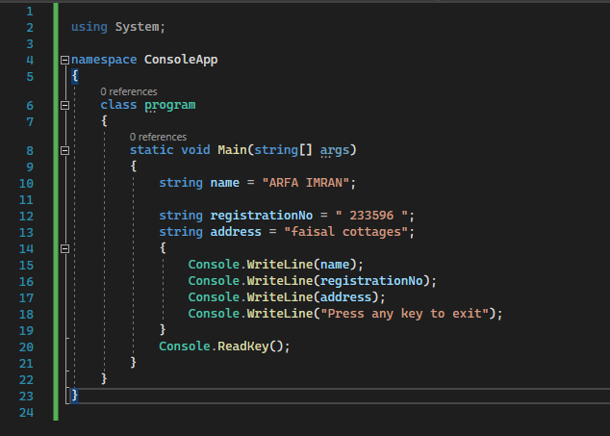

**OUTPUT:**

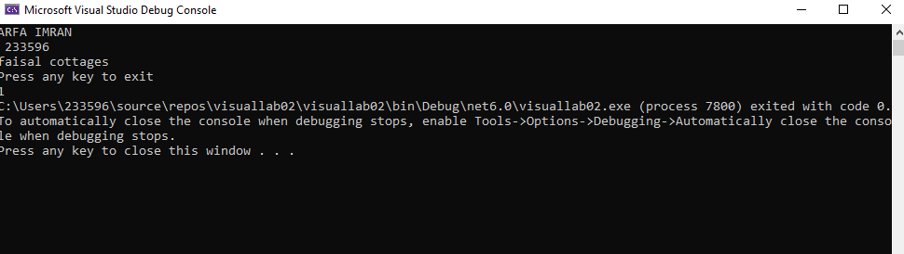

This code is displaying name, registration number, address on the console and wait for the user to press any key before closing the console window.

**2:**

**.**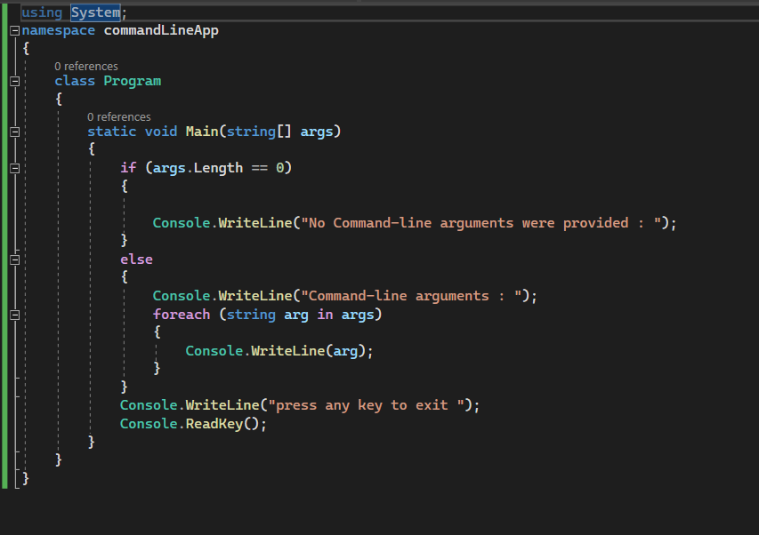

**Output:**

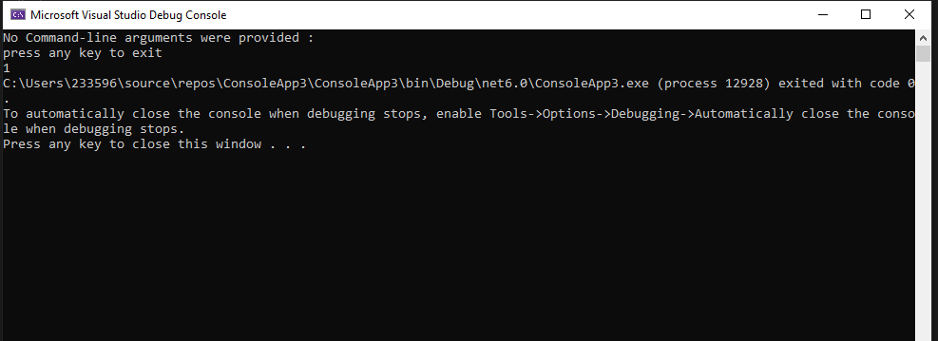

**“ a b c”**

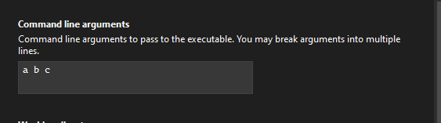

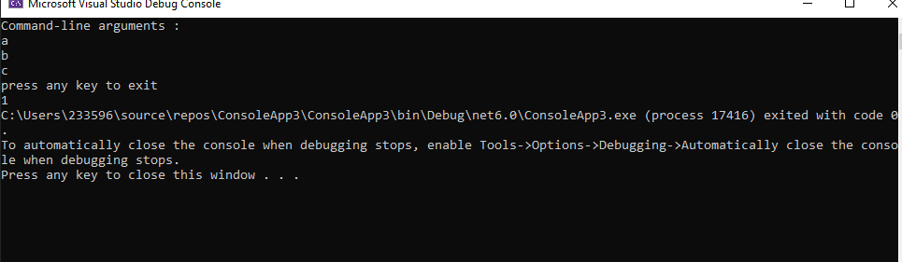

**“ one two”**

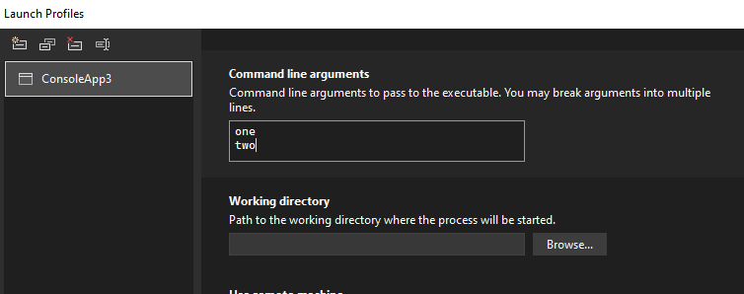

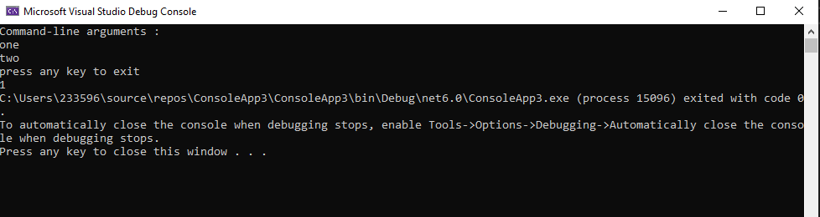

**“one two three”**

