HOSTEL MANAGEMENT SYSTEM

All Diagrams & tables for SRS:

Contents

1. Event response table 2

2. Dialogue Map 3

3. QUESTIONARE 3

4. State Table: 6

5. Decision table and tree 7

6. State transition diagram 7

7. Use case 7

8. User stories 8

9. Dialogue map 8

10. Swim lane diagram 8

11. Activity diagram 8

12. DFD level 0 & 1 8

# Event response table

|  |  |  |  |
| --- | --- | --- | --- |
| **id** | Event | **System State** | **System Response** |
| 1 | Room Reservation | Available rooms, Reservation records | - Checks room availability |
|  |  |  | - Updates reservation status |
| 2 | Check-in | Guest arrival, Room availability, Guest info | - Verifies guest information |
|  |  |  | - Assigns a room to the guest |
|  |  |  | - Updates room availability |
| 3 | Check-out | Guest check-out, Room status, Payment status | - Processes payment |
|  |  |  | - Updates room availability |
|  |  |  | - Issues a payment receipt |
| 4 | Payment Processing | Payment request, Guest account balance | - Confirms payment receipt |
|  |  |  | - Updates guest account balance |
| 5 | Room Maintenance | Reported issues, Room status | - Inspects and addresses reported issues |
|  |  |  | - Updates room status if maintenance is required |
| 6 | Guest Check-in Delay | Guest arrival time, Room availability | - Communicates delay to the guest |
|  |  |  | - Adjusts room availability if necessary |
| 7 | Reservation Cancellation | Reservation records, Room availability | - Cancels reservation |
|  |  |  | - Updates room availability |
| 8 | Guest Inquiry | Guest queries, Reservation records | - Provides information or assistance based on the guest's inquiry |
| 9 | Room Upgrade | Guest request, Room availability | - Checks availability of upgraded rooms |
|  |  |  | - Processes room upgrade if available and requested |
| 10 | Feedback Submission | Guest feedback, System performance | - Records guest feedback |
|  |  |  | - May trigger system improvements based on feedback |

# Dialogue Map

# QUESTIONARE

Multiple-choice questions (MCQs), yes/no questions, and some detailed open-ended questions:

**General Information:**

1. **Organization Details:**
   * Name of the Hostel/Institution:
   * Location:

**System Requirements:**

1. **User Roles:**
   * List the different user roles involved in hostel management (e.g., admin, staff, and residents).
     + Admin
     + Staff
     + Residents
2. **User Interactions:**
   * Describe typical interactions users have with the hostel management system.
   * What tasks do users commonly perform within the system?
3. **Functional Requirements:**
   * What are the essential functions the system should perform?
     + Room Allocation
     + Reservation
     + Check-in/Check-out
     + Other (please specify): _______________
4. **Security Requirements:**
   * What security measures should be implemented to protect user data and system integrity?
     + User Authentication
     + Access Controls
     + Encryption
     + Other (please specify): _______________
5. **Reporting and Analytics:**
   * Are there specific reports or analytics that stakeholders need from the system?
     + Occupancy Reports
     + Financial Reports
     + Other (please specify): _______________

**Room Management:**

1. **Room Allocation:**
   * How rooms are currently allocated to residents?
     + Manual Allocation
     + Automatic Allocation based on criteria
     + Other (please specify): _______________
2. **Room Maintenance:**
   * What kind of maintenance features are needed for rooms?
     + Maintenance Request System
     + Periodic Maintenance Scheduling
     + Other (please specify): _______________
3. **Room Availability:**
   * How should the system display room availability to users?
   * Real-time Availability
   * Daily/Weekly Availability Calendars
   * Other (please specify): _______________

**Reservation and Check-in/Check-out:**

1. **Reservation Process:**
   * Describe the current reservation process.
   * What information is collected during the reservation process?
2. **Check-in/Check-out Procedures:**
   * What are the current procedures for guest check-in and check-out?
   * Are there specific details that need to be captured during these processes?

**Payment and Billing:**

1. **Payment Processing:**
   * How payments currently are processed?
   * Online Payments
   * Manual Payments
   * Other (please specify): _______________
2. **Billing and Invoicing:**
   * What billing and invoicing features are required?
   * Automatic Billing
   * Invoicing System
   * Other (please specify): _______________

**Miscellaneous:**

1. **Guest Communication:**
   * How should the system handle communication with guests (e.g., notifications, updates)?
   * Automated Email Notifications
   * SMS Notifications
   * Other (please specify): _______________
2. **Integration Requirements:**
   * Are there other systems or tools that the hostel management system needs to integrate with?
   * Yes
   * No
   * If yes, please specify: _______________
3. **Regulatory Compliance:**
   * Are there specific regulations or compliance standards that the system must adhere to?
   * Yes
   * No
   * If yes, please specify: _______________

**Future Enhancements:**

1. **Future Features:**
   * Are there any features or functionalities you anticipate needing in the future?
   * If yes, please specify: _______________
2. **Scalability:**
   * How do you envision the system handling growth and an increasing number of users?
   * Easily Scalable
   * Limited Scalability
   * Not Sure

# State Table:

|  |  |  |  |
| --- | --- | --- | --- |
| **Current State** | **Event** | **Next State** | **Action** |
| Idle | System Start | Idle | Initialize system |
| Idle | Student Applies | Pending Approval | Process student registration |
| Pending Approval | Approval Granted | Registered - Single or Shared | Approve registration and assign room |
| Pending Approval | Approval Denied | Not Registered | Deny registration |
| Registered - Single | Student Cancels Registration | Not Registered | Cancel registration and free up the room |
| Registered - Shared | Student Cancels Registration | Not Registered | Cancel registration and adjust occupancy |
| Idle | Limited Availability | Waiting List | Place student on waiting list |
| Waiting List | Room Allocated | Registered - Single or Shared | Assign room to waiting list student |
| Not Registered | Registration Requested | Pending Approval | Process new registration request |

# Decision table and tree

# State transition diagram

# Use case

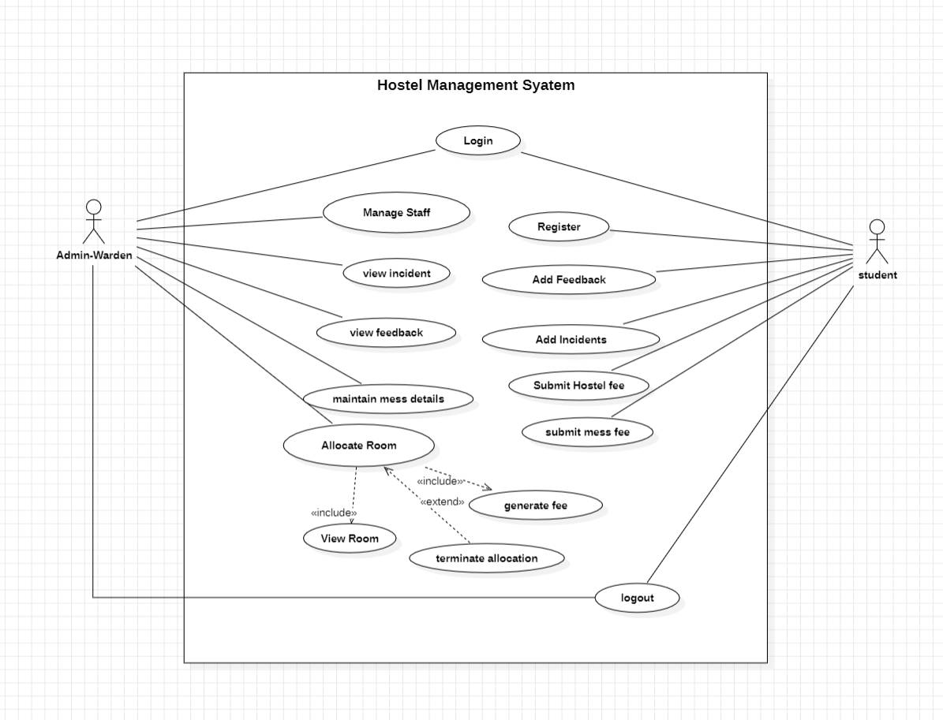

# User stories

# Dialogue map

# Swim lane diagram

# Activity diagram

# DFD level 0 & 1

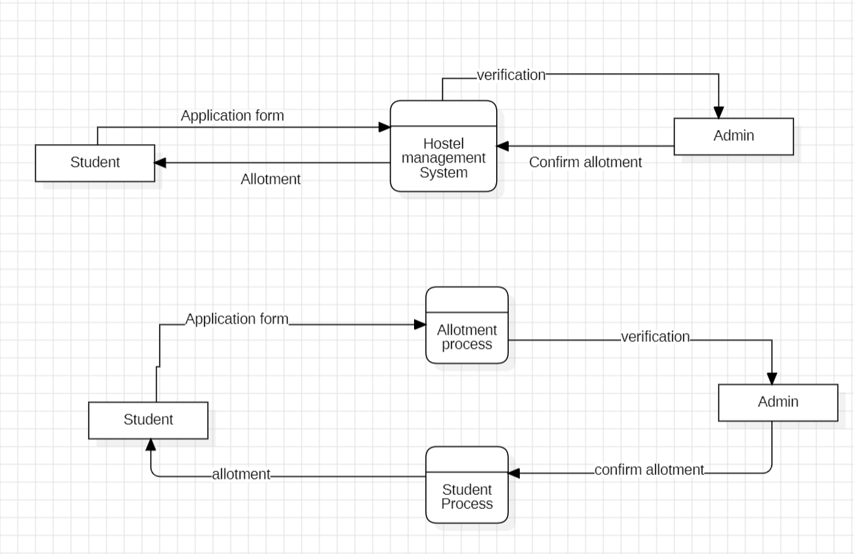

Figure DFD Level 0 and 1

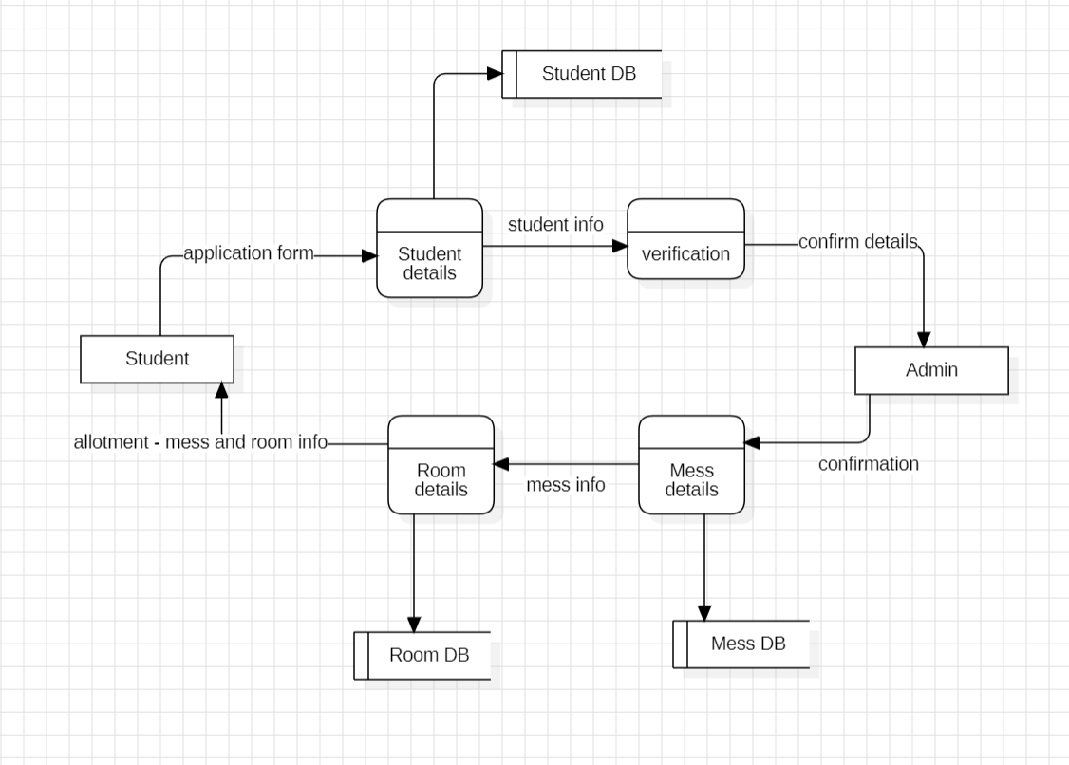

Figure DFD Level 2