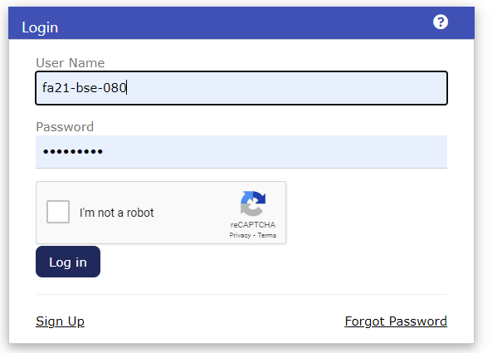

Test Case Description |  | Test Steps | Expected Outcome | Actual Result | Verdict
Functional Test Cases:
1. Valid User Login |  | Entered a valid username and password. | The user is successfully logged in and redirected to the home page or dashboard. | The user successfully logged in and redirected to the home page. | Pass
2. Invalid User ID |  | Enter an invalid user id and a valid password. | The system displays an error message indicating invalid credentials. The user remains on the login page. | Error message displayed: "Username or password is incorrect". The user remains on the login page. | Pass
3. Invalid Password |  | Enter a valid user id and an invalid password. | System displays an error message indicating invalid credentials. The user remains on the login page. | Error message displayed: “Username or password is incorrect ". The user remains on the login page. | Pass
4. Blank User ID |  | Leave the user id field blank and input a valid password. | The system displays an error message indicating the user id is required. The user remains on the login page. | Error message displayed: "Please fill out the field". The user remains on the login page. | Pass
5. Blank Password |  | Enter a valid user id and leave the password field blank. | System displays an error message indicating the password is required. The user remains on the login page. | Error message displayed: "Please fill out the field". The user remains on the login page. | Pass
6. Username Length Validation |  | Input a user id with the maximum length. | The system accepts it and allows the user to log in successfully. | Error message displayed: "username is invalid. Should have 3-15 alphanumeric characters underscore and dash only". The user remains on the login page. | Fail
Interface Test Cases:
1. Layout Verification |  | The layout of the login page with the specified design/layout. | The layout matches the design specifications. | The layout matches the design specifications. | Pass
2. Placeholder Display |  | Verify that placeholders in the user ID and password fields are correctly displayed. | Placeholders are visible within the input fields. | Placeholders are not visible within the input fields. | Fail
3. Mandatory Field Indication |  | Verify that asterisks (*) are displayed next to mandatory fields (user id and password). | Asterisks are displayed next to the user id and password fields. | Asterisks (*) are not displayed next to the user id and password fields. | Fail
4. Field Alignment |  | Verify the alignment of checkboxes, radio buttons, and text fields on the login page. | Fields aligned according to design specifications. | Fields aligned according to design specifications. | Pass
5. Responsiveness Check |  | Test the login page on various devices and screen sizes to ensure responsiveness. | The login page displays and functions correctly on different devices and screen sizes. | The login page displays and functions correctly on different devices and screen sizes. | Pass
Security Test Cases:
1. Session Timeout |  | Log in as a user and wait for the session timeout duration. | The session expires, and the user is logged out. | The session expires after the timeout duration, and the user is automatically logged out. | Pass
2. Back Button Logout |  | Log in as a user, then navigate back using the browser's back button. | The user is logged out and must re-enter credentials to access the secure area. | The user is not logged out upon navigating back. | Fail
3. Direct URL Access |  | Attempt to access the secure area directly by entering its URL without logging in. | The user is redirected to the login page. | The user is redirected to the login page. | Pass
4. Password Encryption |  | Inspect network traffic during login to ensure password transmission is secure. | Password transmitted securely and not stored or transmitted in plaintext. | Password is transmitted securely over HTTPS and not stored or transmitted in plaintext. | Pass

