React.js Component Creation

Name : Shaik Mahammad Kaif

Gmail :shaikkaif.svit@gmail.com

Roll NO : 209F1A05A1

College Name : Sri venkateswara institute of technology,Anantapur

source code :

CARD COMPONENT :

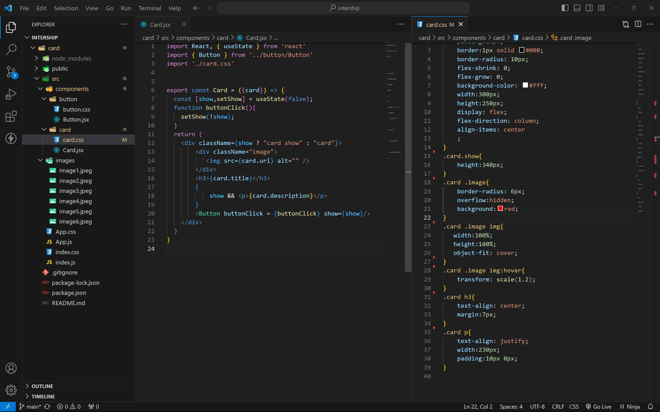

BUTTON COMPONENT :

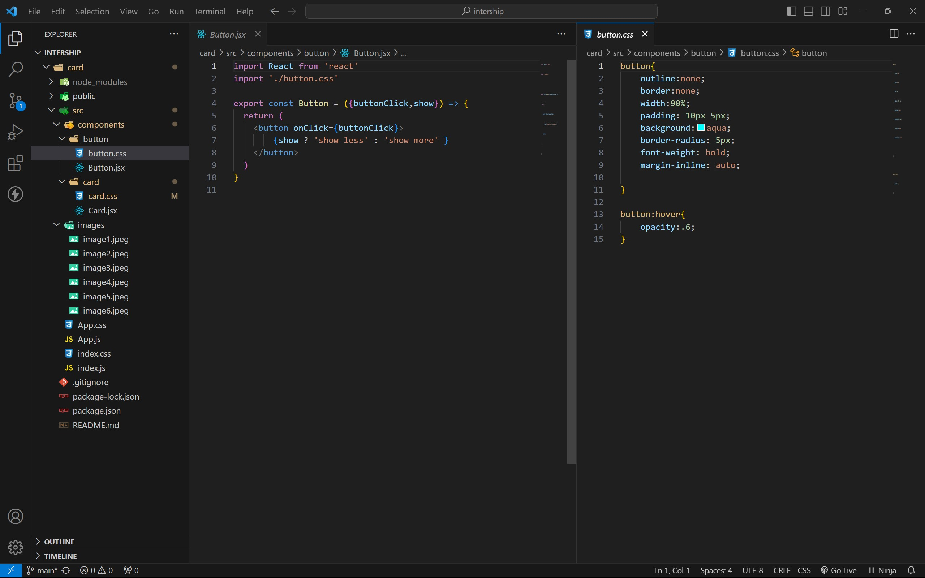

APP COMPONENT :

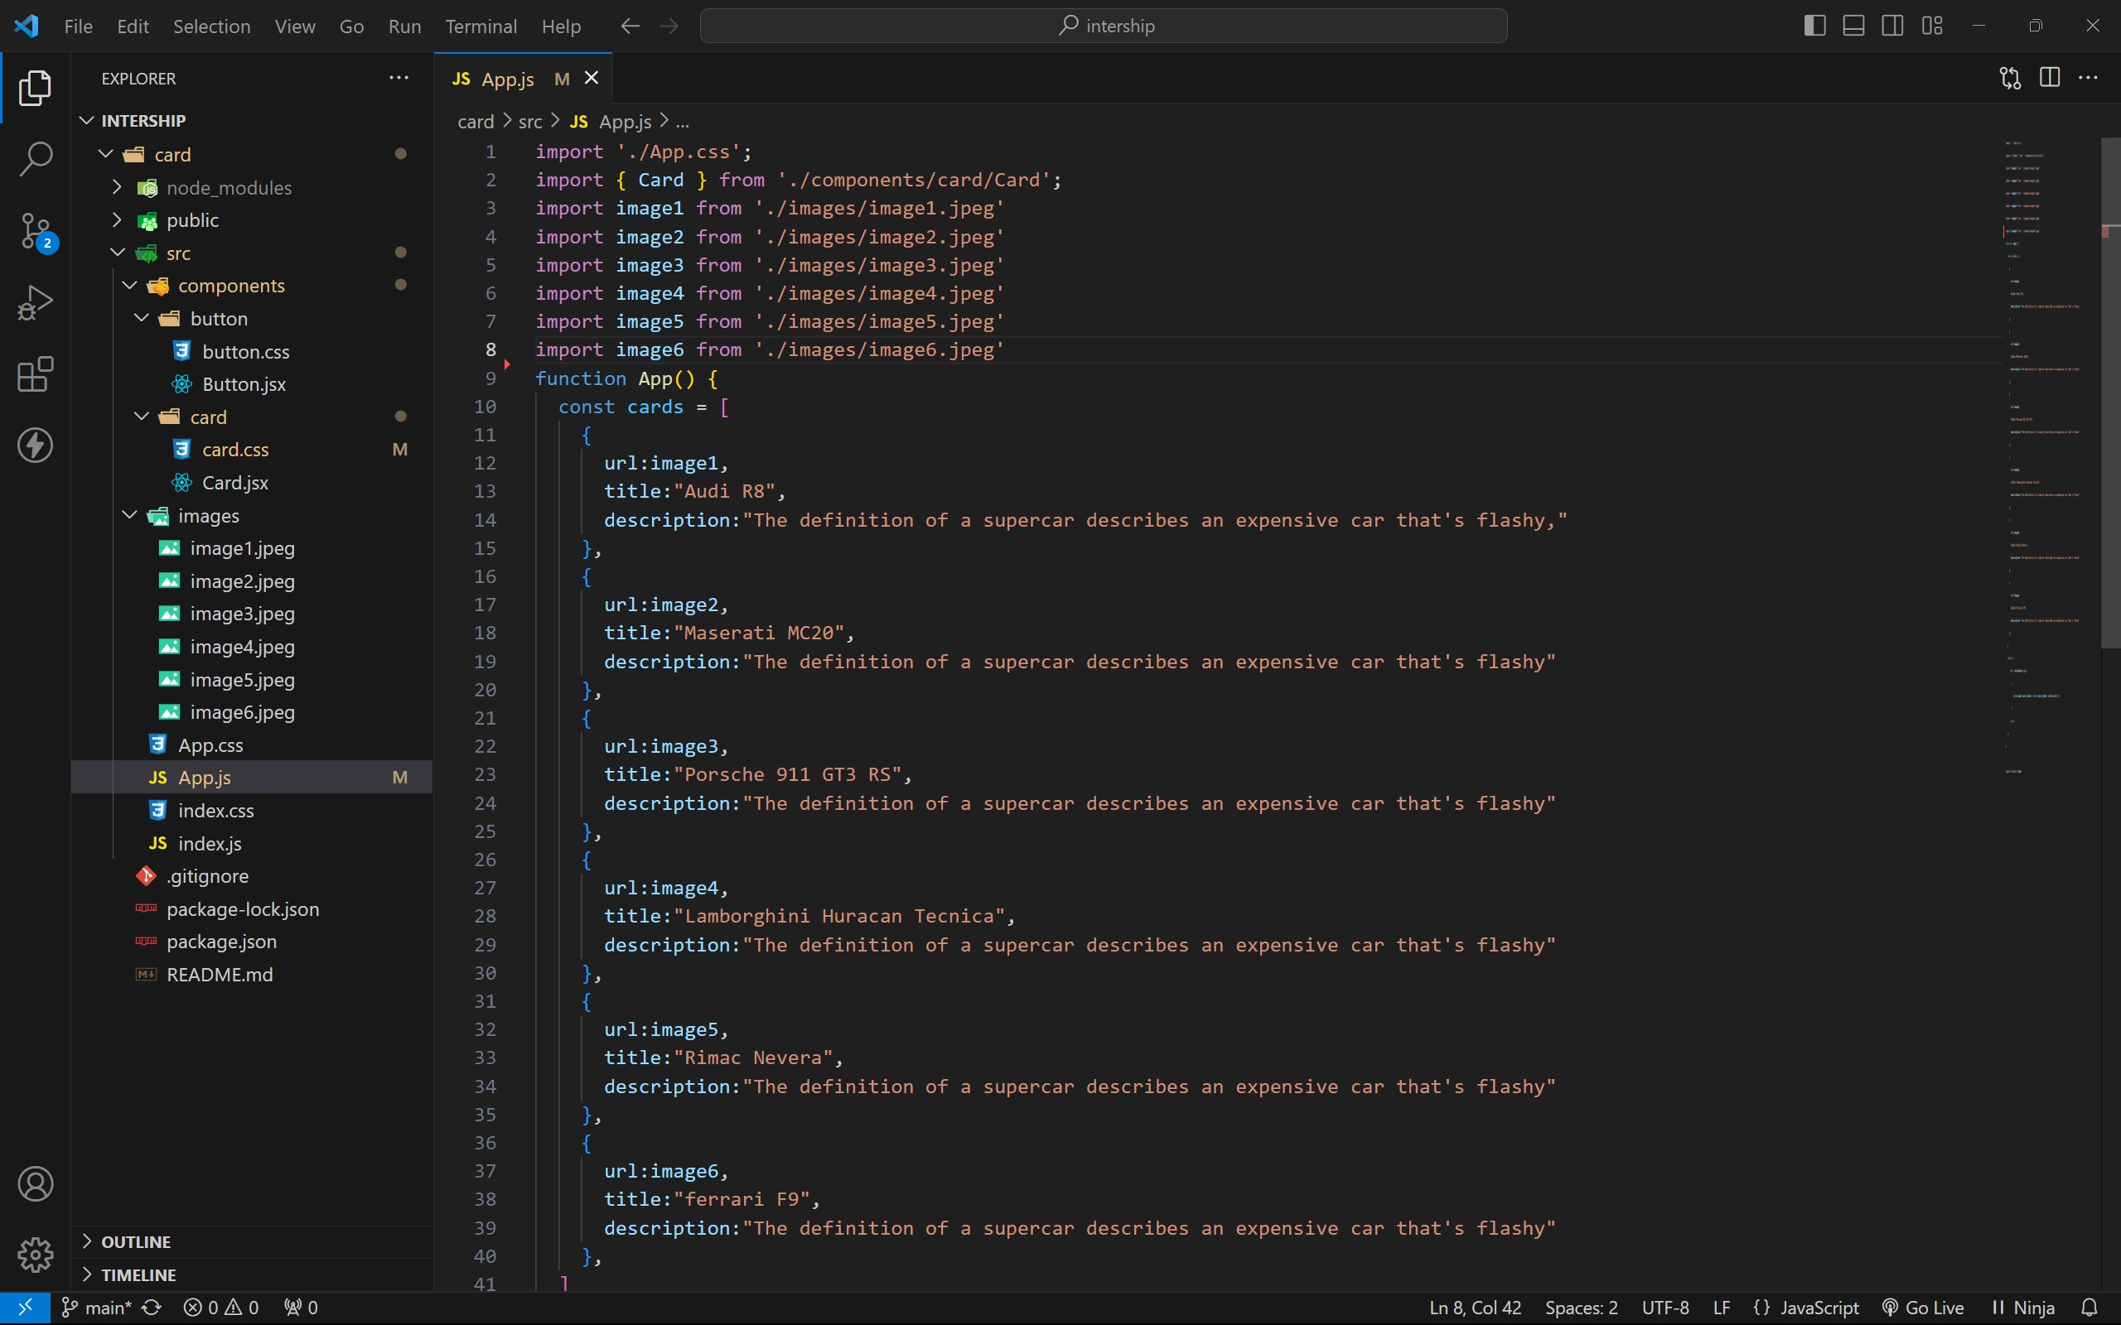

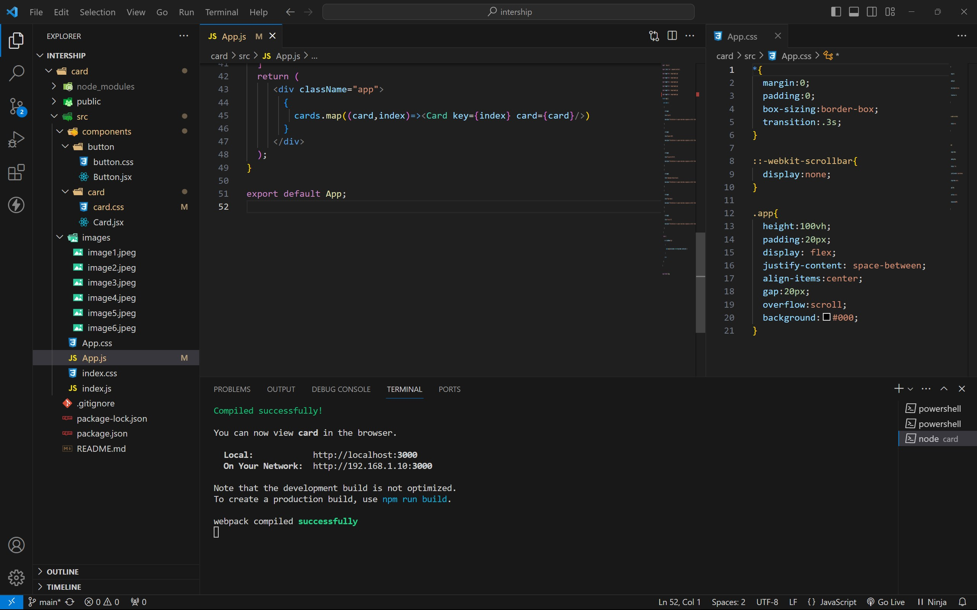

approach :

1. . initially taking an array of objects like below

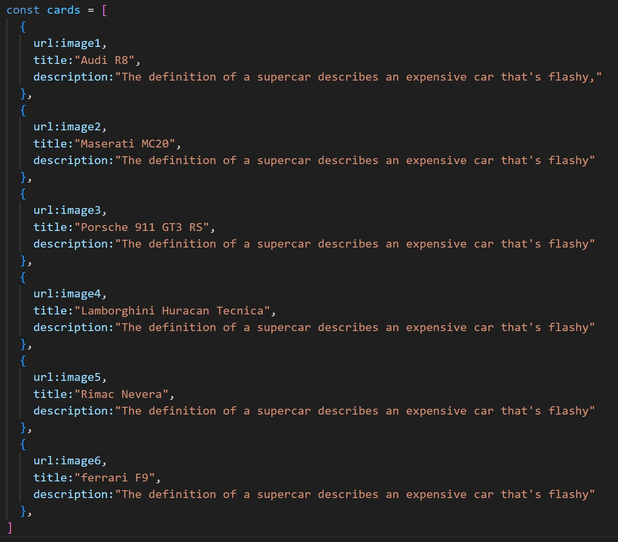

1. . Passing this card array to child (card component) of App component by using props;
2. . getting data as argument like {card} in card component.
3. . in card component i use one state [show, setShow] to get extra info as

description.

1. . When we click the button then show becomes true by assigning set Show (!show) .

OUTPUT :

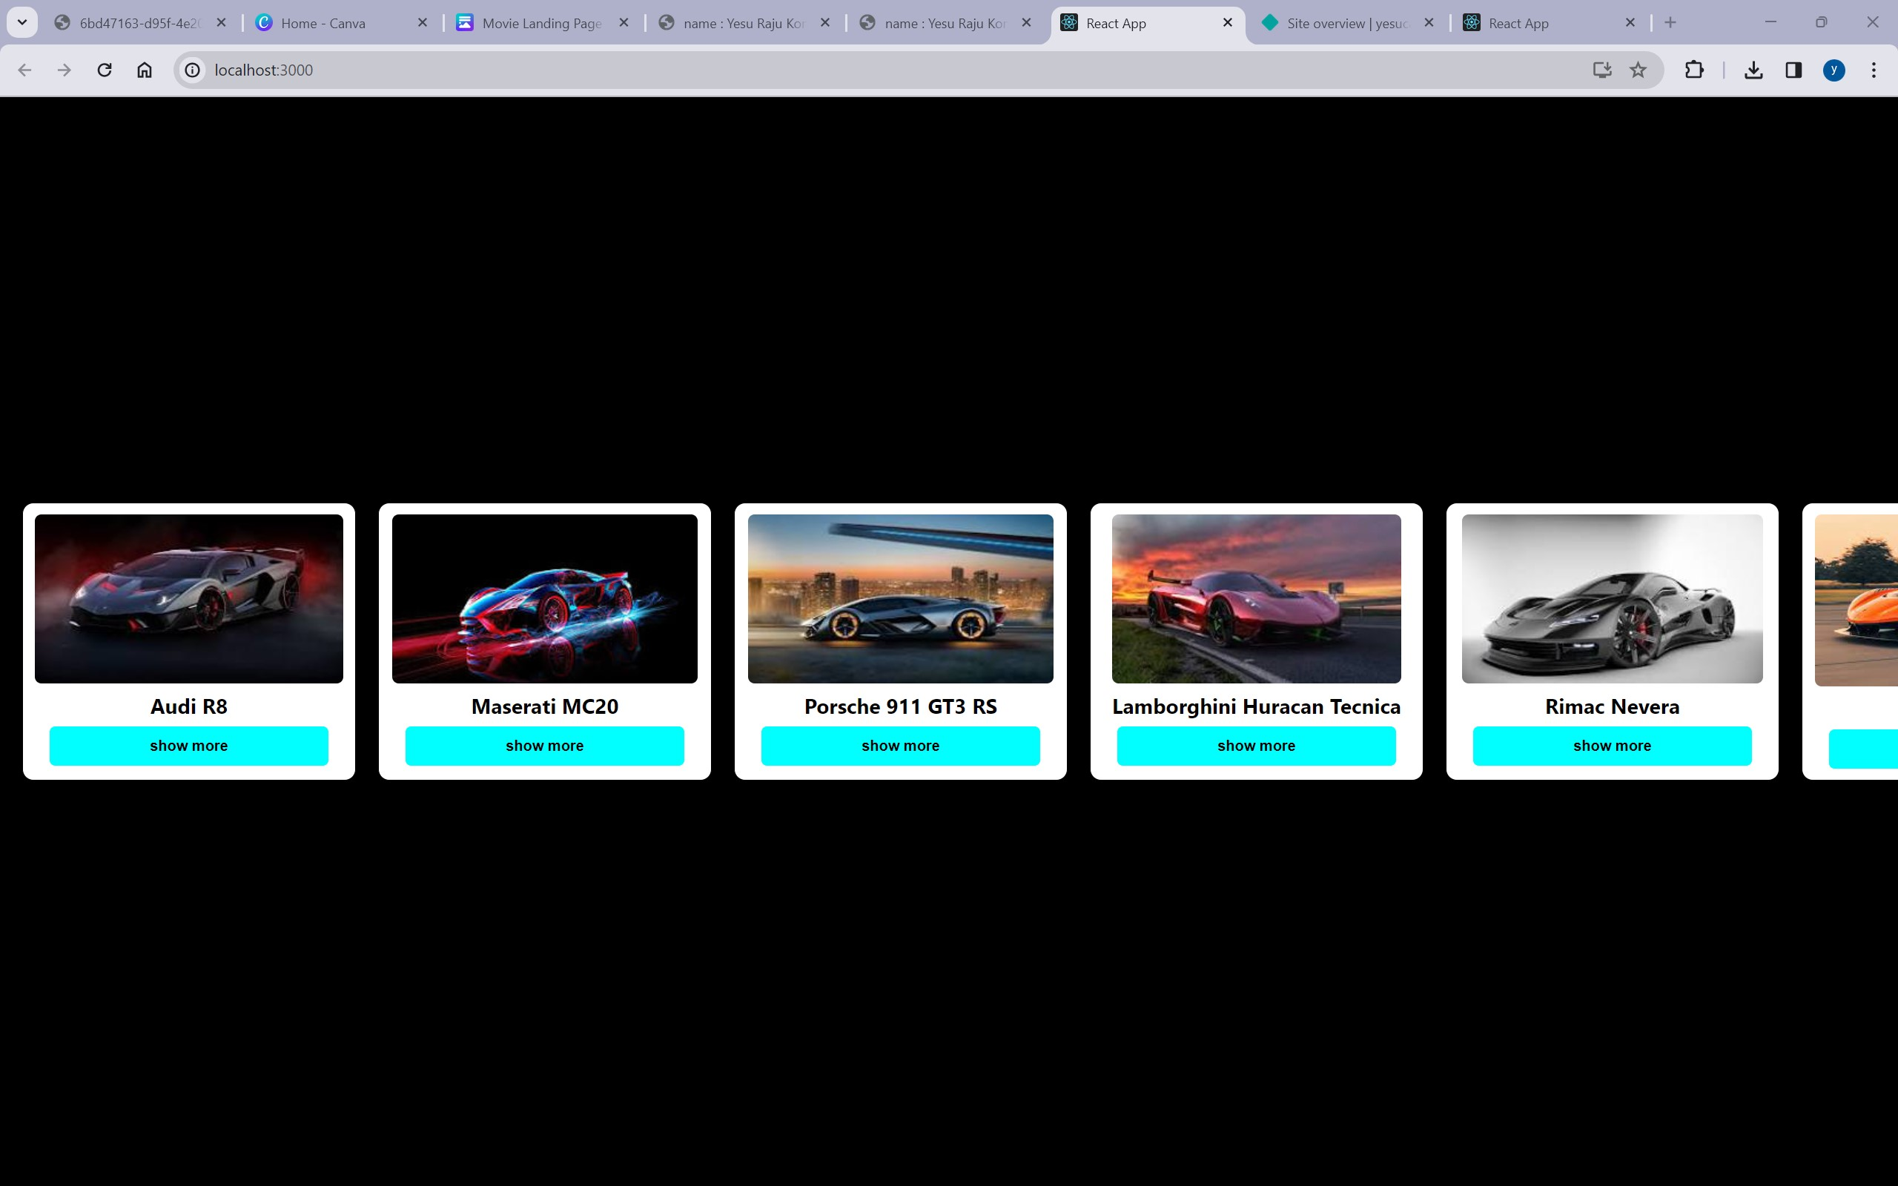

AFTER BUTTON CLICKS :

