Jeffrey Razon

Argenis Jimenez

Professor Venkatesan Muthukumar

CPE 403-1001

December 12th, 2018

CPE 403 Final Project

BeagleBone Black and CC1350 Communication

**Problem Statement:**

Goal/Objective: The main goal is to integrate a temperature sensor by running a “co-processor module” connected between BeagleBone(BBB) and one CC1350 and using a 2nd CC1350 as a transmitter. We also want to display data from the temperature sensor using the “TI 15.4-Stack Collector app”. Our goals have been achieved by programming C code on the CC1350 and interfacing the CC1350 launchpads to collect and transmit data. Another objective is to successfully setup the BeagleBone (BBB) and host system such as Linux for application development.

Project block diagram:

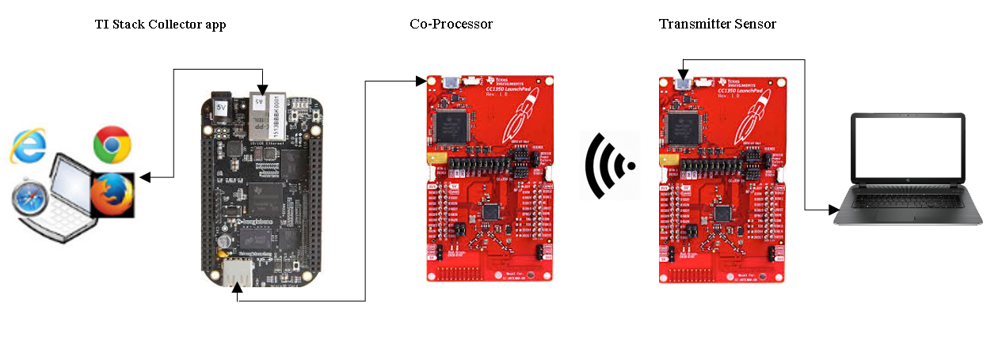

**pre-requisites:**

Components, tools, software used in the design, install steps etc.

Components:

* 2 x Wireless MCU LaunchPad Development kit (LAUNCHXL-CC1350)  
  <http://www.ti.com/tool/LAUNCHXL-CC1350>
* BeagleBone Black  
  <https://beagleboard.org/black>
* Temperature Sensor

Tools:

Software:

* Uniflash Standalone Flash Tool for TI Microcontrollers (MCU)  
  http://www.ti.com/tool/UNIFLASH
* SimpleLink™ Sub-1 GHz CC13x0 Software Development Kit  
  <http://www.ti.com/tool/simplelink-cc13x0-sdk>
* TI 15.4-Stack Gateway Linux Software Development Kit  
  <http://www.ti.com/tool/ti-15.4-stack-gateway-linux-sdk>
* PROCESSOR-SDK-LINUX-AM335X 05_01_00_11

http://software-dl.ti.com/processor-sdk-linux/esd/AM335X/latest/index_FDS.html

* balenaEtcher

<https://www.balena.io/etcher/>

**implementation details:**

1) Flash hex files to CC1350 and flash am335x linux image to the BBB

2) Untarred the tar folder in the Ubuntu Virtual Machine

3) Connected the coprocessor CC1350 to the BBB to create the coprocessor collector

4) Ran the “run_demo.sh” file to obtain url to Stack Collector App

5) Connected the sensor CC1350 to connect to coprocessor in Stack Collector App network

**Photos**

a) Hardware Set-up  
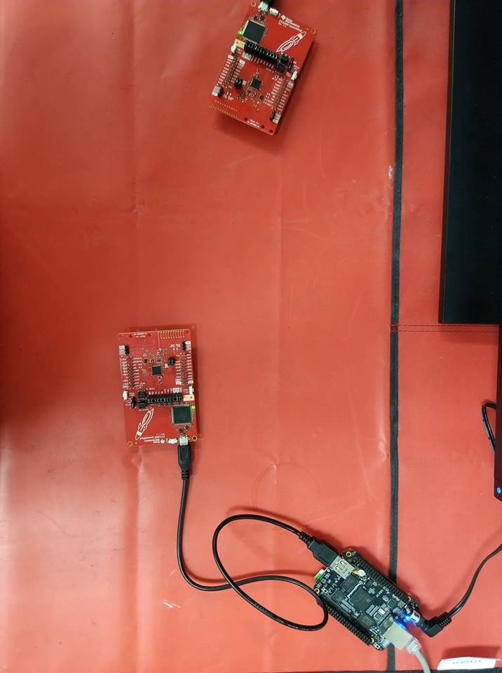

b) Untarring the tar folder

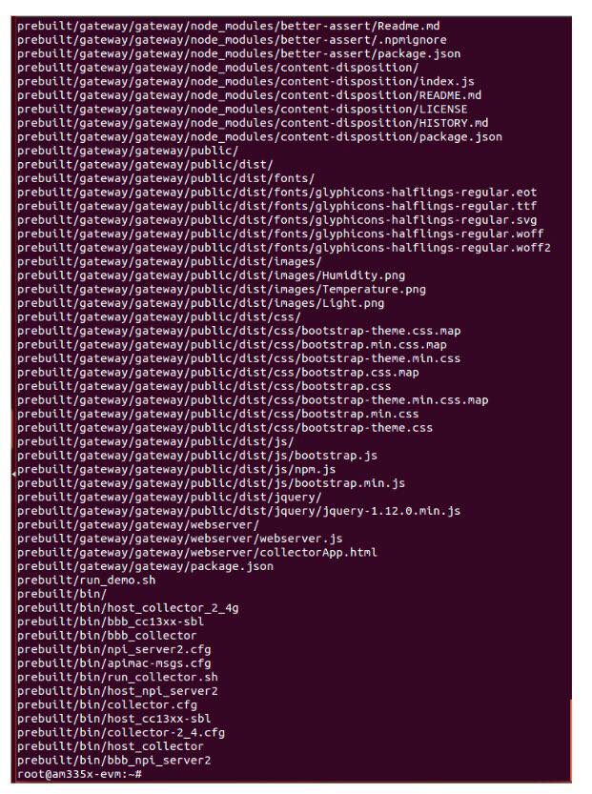

c) Connecting to the Stack Collector App

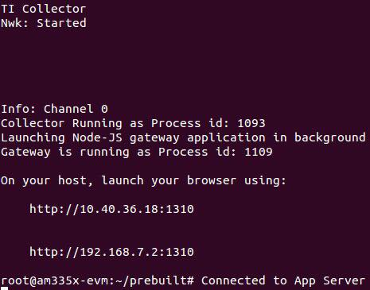

d) Screenshot of working Collector App

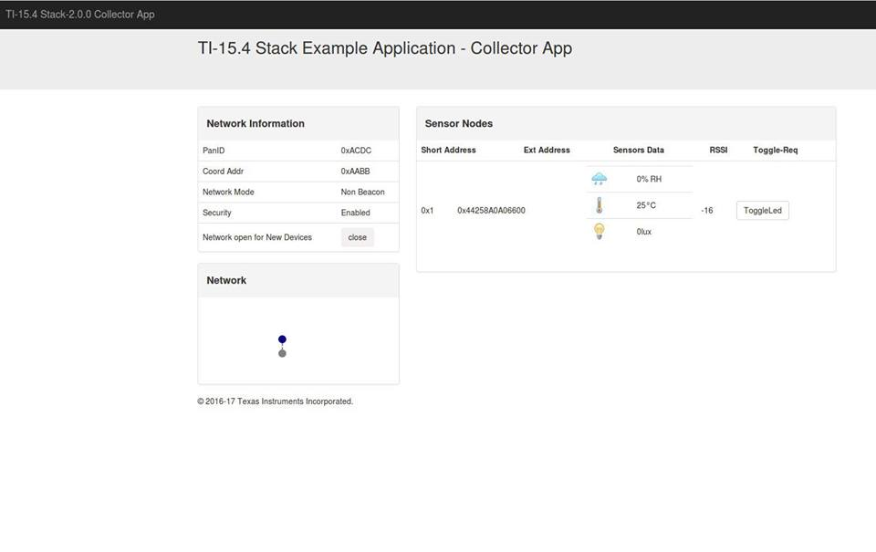

**outcomes, results and conclusions:**

Youtube Link: https://youtu.be/PKAdnBtK_Zg

We have successfully interfaced our temperature sensor. The outcome of our project demonstrates the result of the transmission of the CC1350 launchpad in charge of sending data towards our receiving CC1350 launchpad. The receiving CC1350 launchpad interacts with the BeagleBone Black(BBB) in order for the (BBB) to upload data to the “TI 15.4-Stack Collector app”.

**reference:**

* Official TI Tutorials
* Previous assignments (BBB, CC1350)
* CCS Resource Explorer
* TI Q&A forums
* Stack Overflow