Argenis Jimenez Aguirre

CPE 403

TIVAC LAB 04

Task00: Execute the supplied code, no submission required.

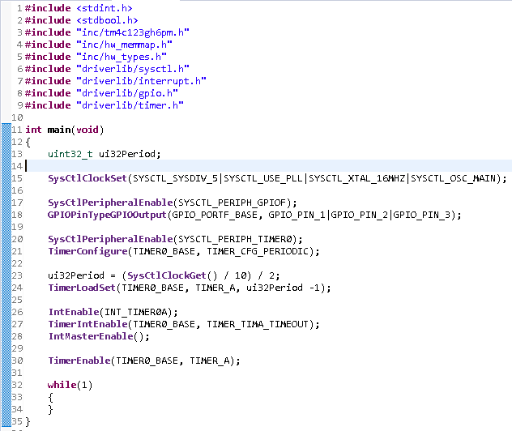

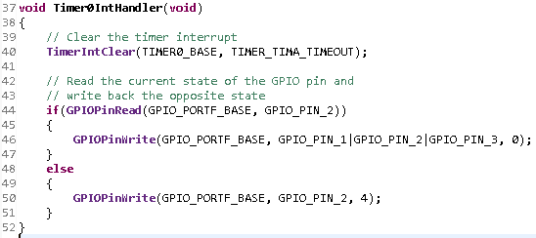

Task 01: Change the toggle of the GPIO at 2 Hz using Timer0 with 75% duty cycle and verify the

waveform generated.

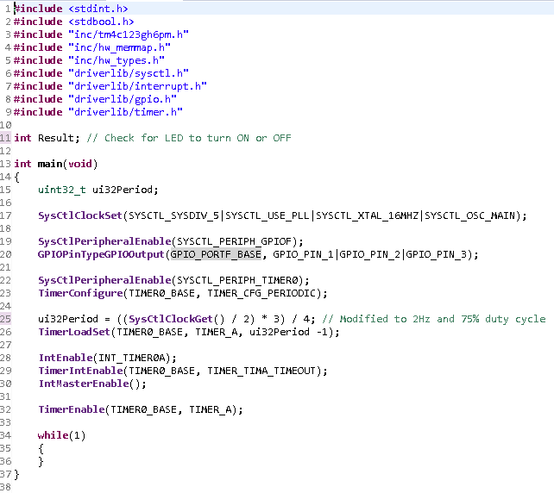

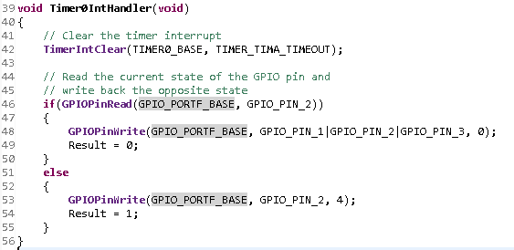

Task 02: Include a GPIO Interrupt to Task 02 from switch SW2 to turn ON and the LED for 1.5

sec. Use a Timer1 to calculate the 1.5 sec delay. The toggle of the GPIO is suspended when executing

the interrupt. I was able to activate the switch but unable to make the delay to light the LED for 1.5 seconds.

