Argenis Jimenez Aguirre

CPE 403

TIVAC LAB 05

Task00: Execute the supplied code, no submission required.

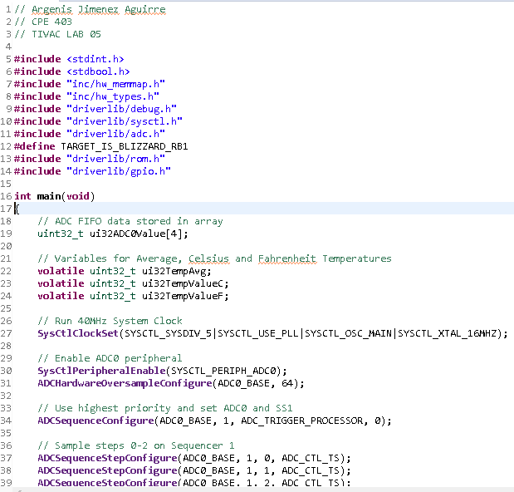

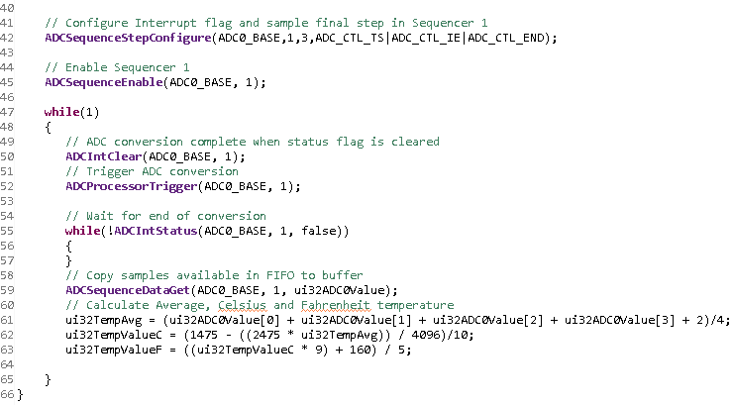

Task 01: Change the ADC Sequencer to SS3. Turn on the LED at PF2 if the temperature is greater

that 72 degF. Use internal temperature sensor for all SS2 sequence. Display the temperature in

the built-in graph tool.

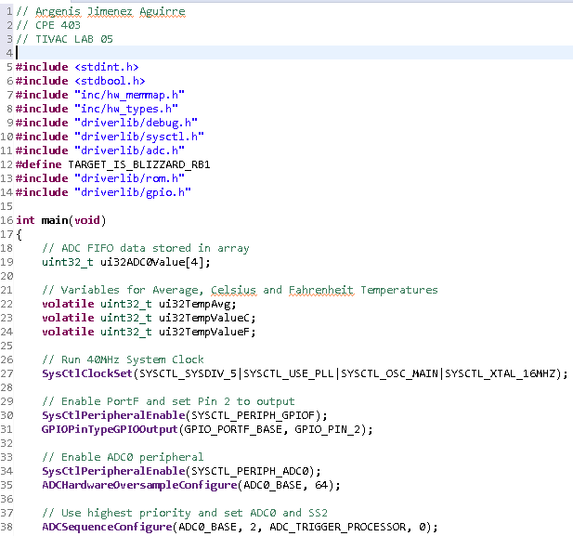

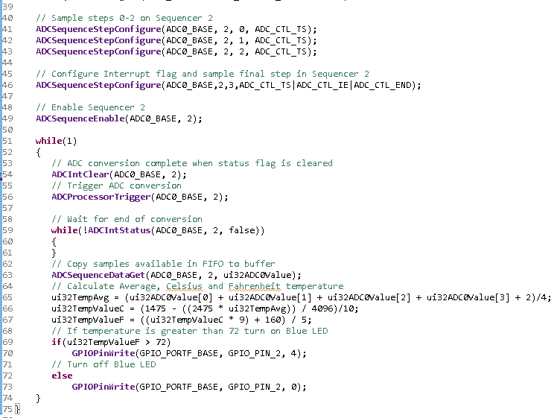

Task 02: Introduce hardware averaging to 32. Using the timer TIMER1A conduct an ADC conversion

on overflow every 0.5 sec. Use the Timer1A interrupt. Display the temperature in the

built-in graph tool.

