Argenis Jimenez Aguirre

CPE 403

TIVAC LAB 07

Task 01: Continuously display the temperature of the device (internal temperature sensor) on the

a) hyperterminal, and b) GUI Composer (Temp Sensor) using a timer interrupt every 0.5 secs.

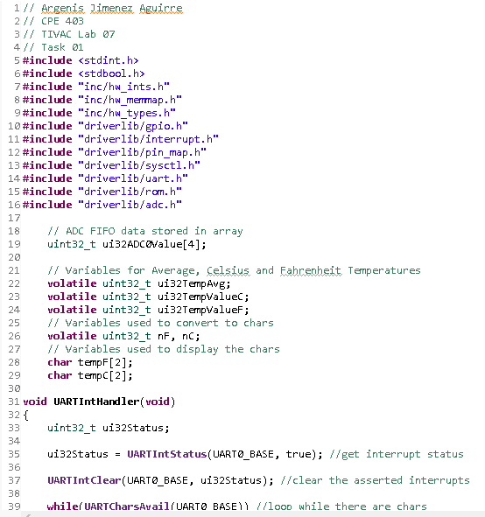

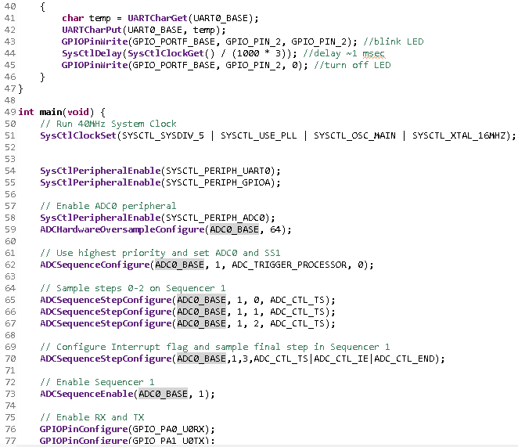

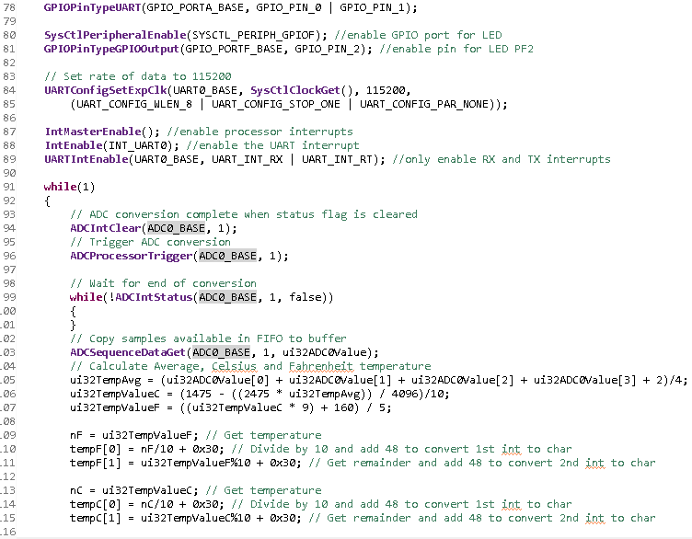

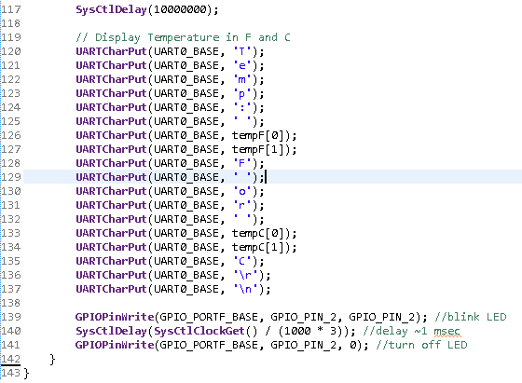

Task 02: Interaction/User Interface: Develop a user interface using UART to perform the following:

Enter the cmd: R: Red LED, G: Green LED, B: Blue LED, T: Temperature:

Based on the command (cmd) the program should turn ON Red LED when R is entered in the

terminal, etc. Command of ‘r’ will turn off the Red LED.

