Argenis Jimenez Aguirre

CPE 403

TIVAC LAB 09

Task01: Submit a comprehensive commented file of the original code.

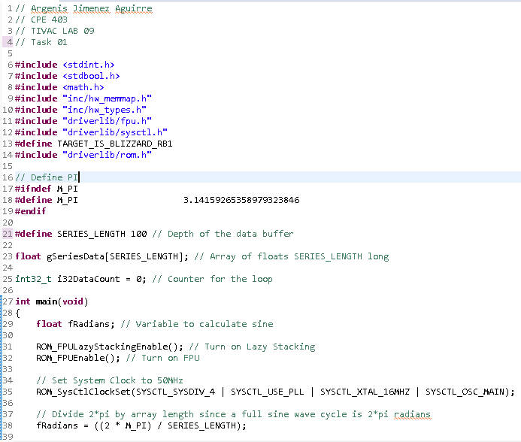

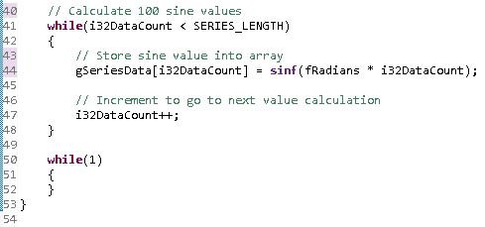

Task 02: Modify the code to implement the below equation to generate a frequency of 5 Hz. Display

the equation for 1 sec.

