**Argenis Jimenez Aguirre**

**CPE 403 FALL 2018**

**TIVAC MIDTERM**

**1) Goal**

The TIVAC Midterm project is conformed of the supplied TSL2561 lux sensor, ESP-01S, TM4C123GXL and FTDI Basic. This project requires the use of the I2C interface for the TSL sensor and UART interface for the ESP8266 WiFi module. The goal for this project will be to be able to display the data collected by the lux sensor.

**2) Detailed Implementation**

The TM4C123GXL Launchpad is used to transmit data to the ESP module from the TSL2961 sensor. The use of the I2C helps with the communication of launchpad and the ESP module. Ports PB0 and PB1 function as Rx and Tx to connect to their respective Rx and Tx on the ESP module. Ports PB2 and PB3 are connected to the SCL and SDA ports of the lux sensor. In order to kickstart the project the ESP module was flashed. Then, modifications were made to the main code and the TSL2591 header file to adjust for the given TSL2561 lux sensor. Lastly, the use of thingSpeak allows for the display of the given data by the TSL2561 sensor. This is possible with AT commands that connect to the wifi and are able to send data to the ESP module.

**3) Schematics**

SDA

SCL

TSL2591

Vin

SCL

PB2

PB3

TM4C123GXL

PB0

PB1

TX

RX

ESP8266

Vin

GND

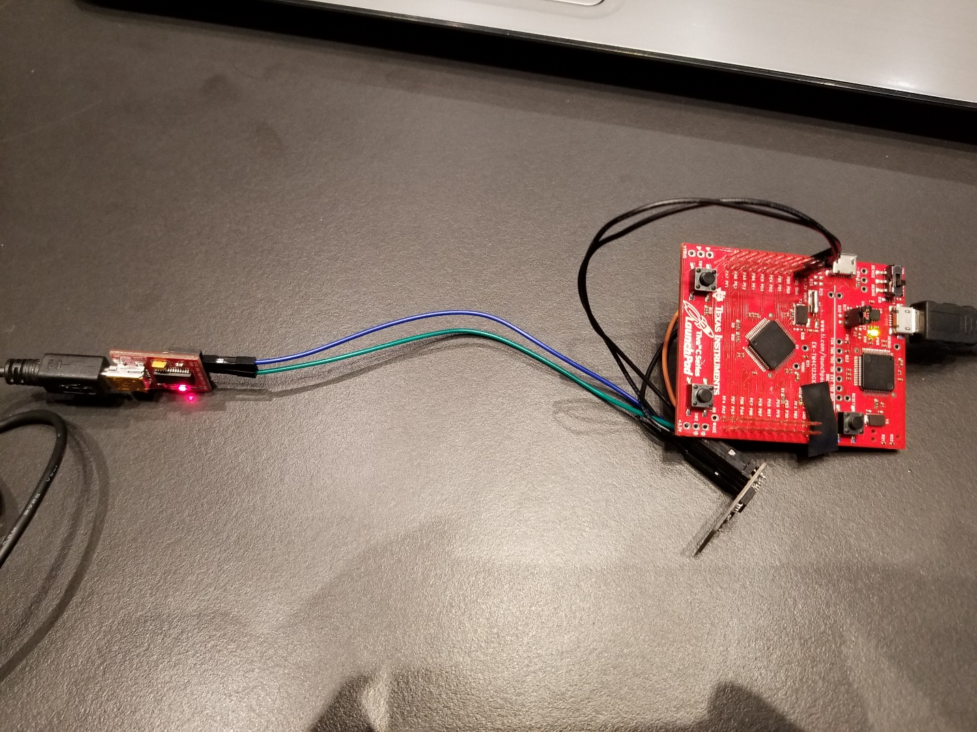

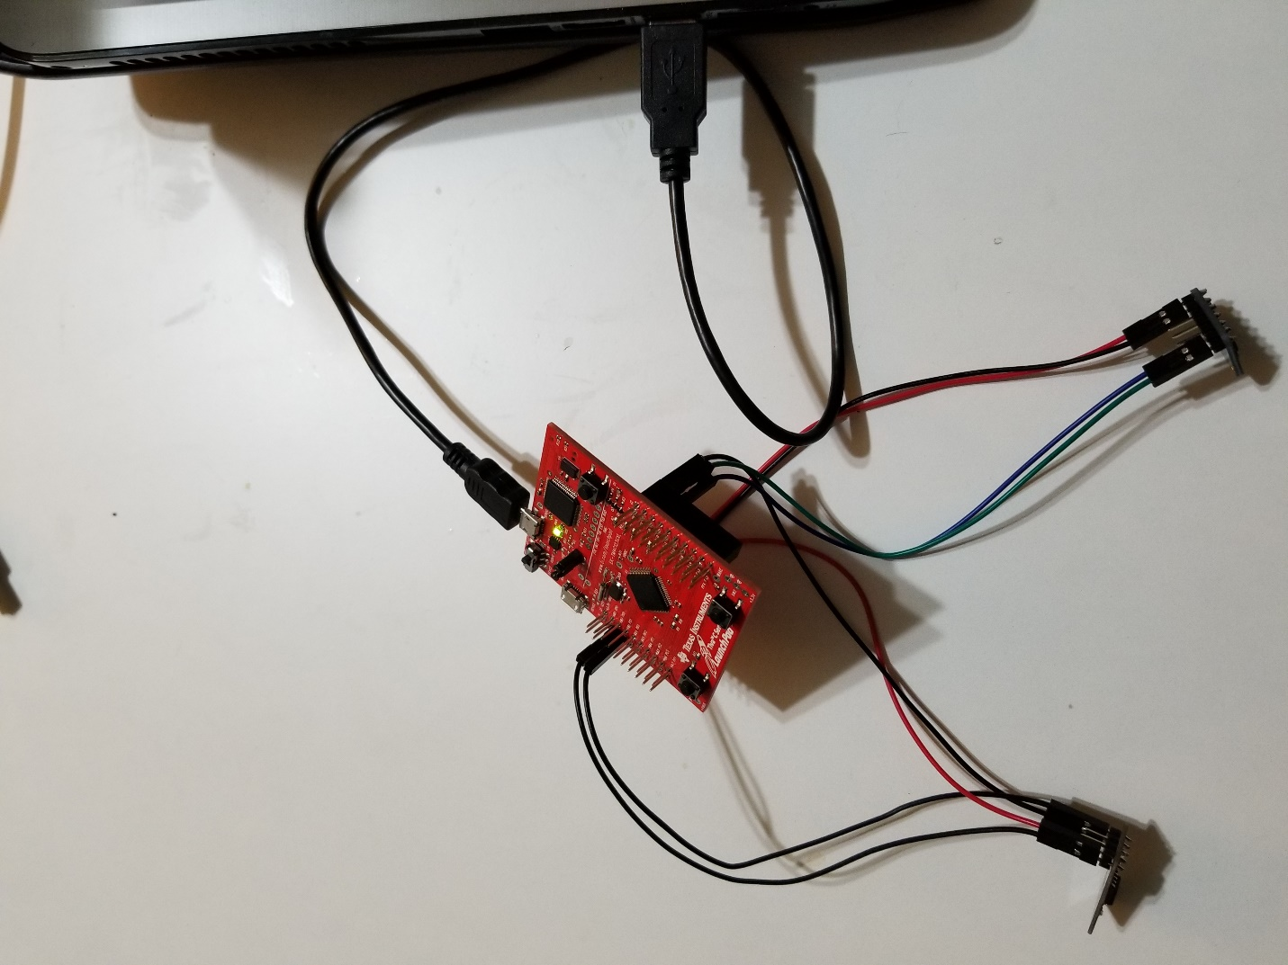

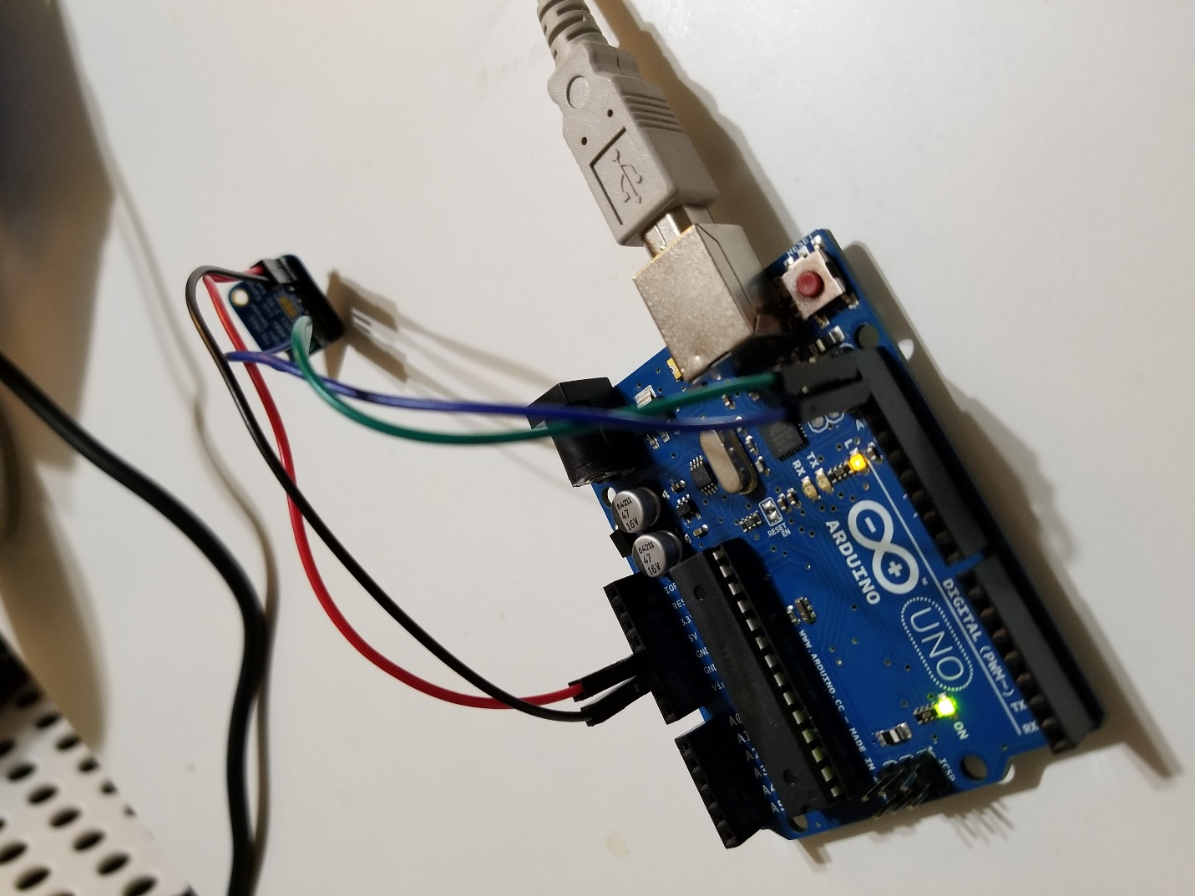

**4) Video links**

https://www.youtube.com/watch?v=pNSygQrSUX4

**5) Screenshots**

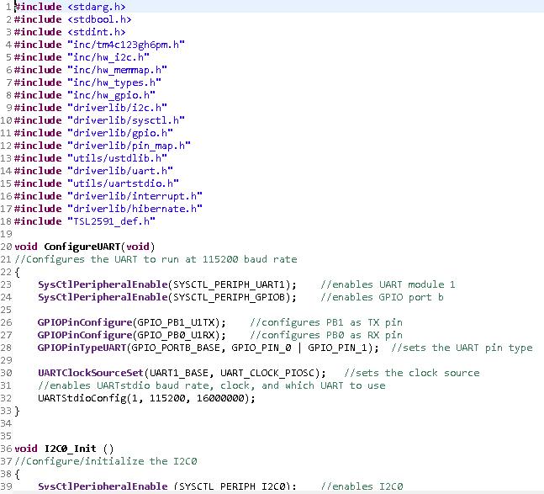

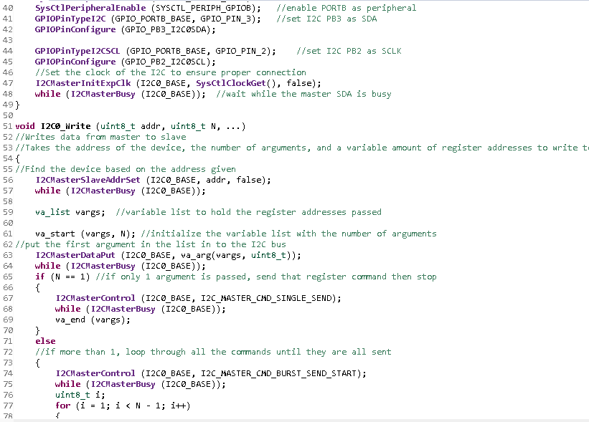

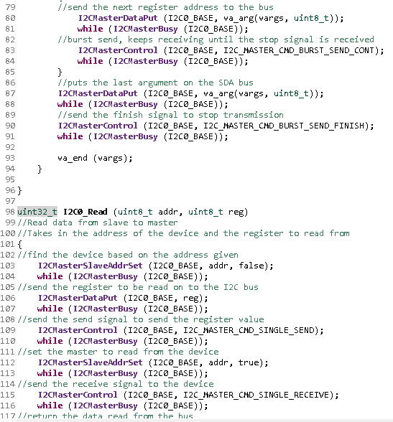

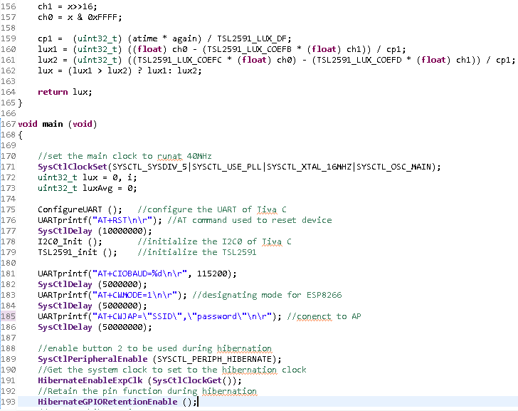

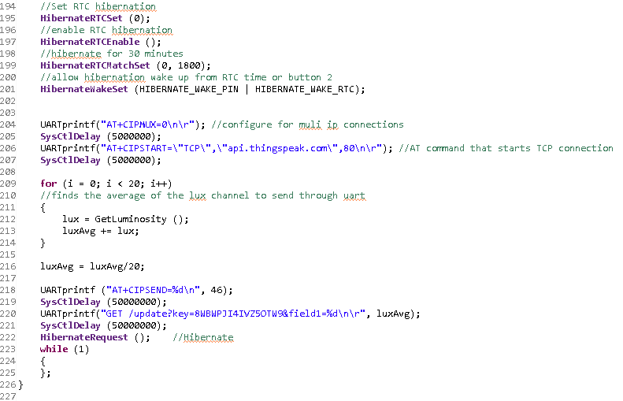

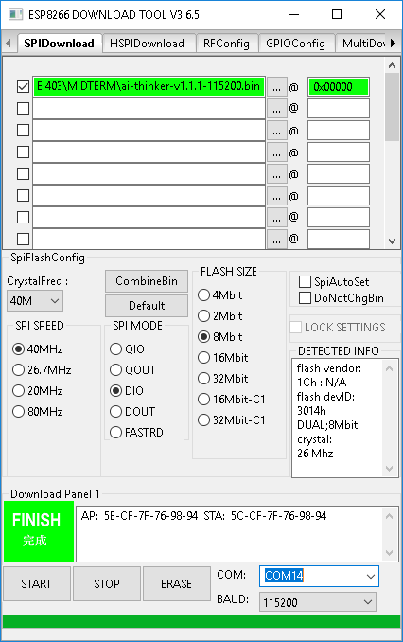

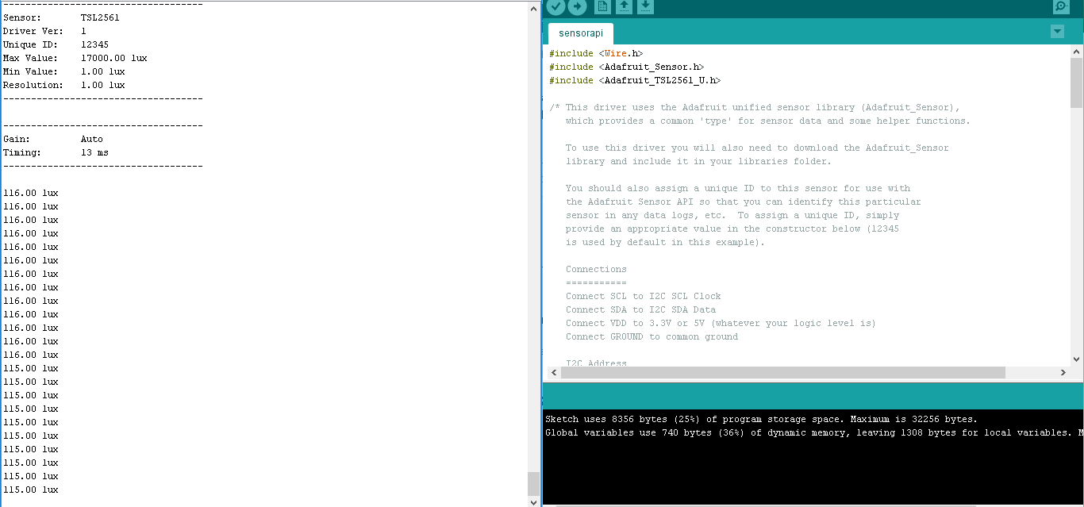

**6) Conclusions**

In conclusion, I have accomplished the goal to display the data given by the TSL2561 Lux sensor. This was possible due to the Arduino Uno. I ran into problems transmitting to thingSpeak. The ESP module flashed after much trial and error. The modification of the main file and the TSL2561 header file did not result in any positive results. I managed to display the luminosity with an Arduino Uno and the use f the given libraries by Adafruit.