Lab 18

Question 1: File comprehension in Python
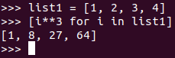

Question 2: Tuple File Comprehension in Python
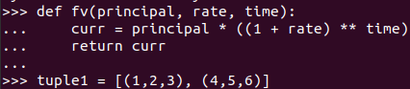

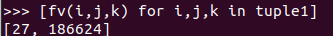
Answer:

Question 3: Python function for abbreviation
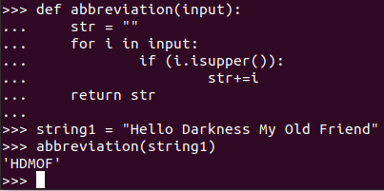

Question 4:
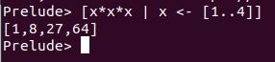

Question 5:

