Lab 19
Dexter Kale – CS – 3035 – 05

Question 1:

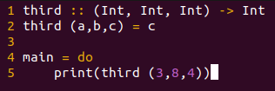

Question 2: I couldn’t get this to work.
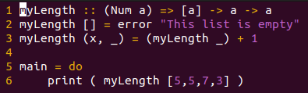

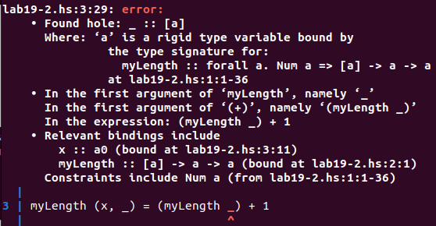

Question 3: I couldn’t get this to work.
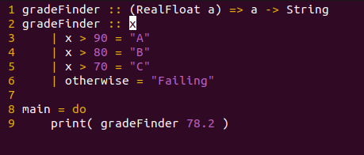

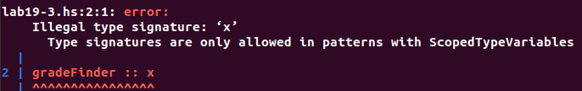
Question 4:
In C, reassigning is easy and doable. In Haskell, not so much as most things are immutable.

