Lab 12
Dexter Kale – CS 3035 – 05

1. Different Data Types
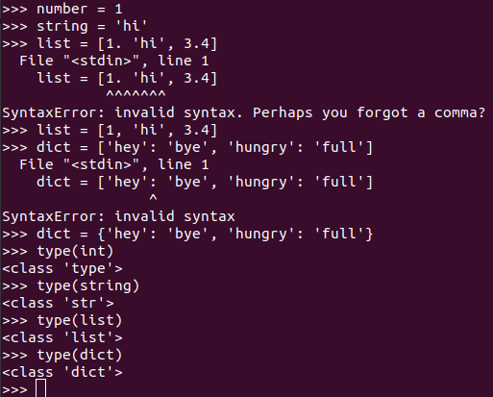
Note:type(int) wasn’t done correctly
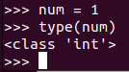

2.
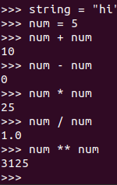
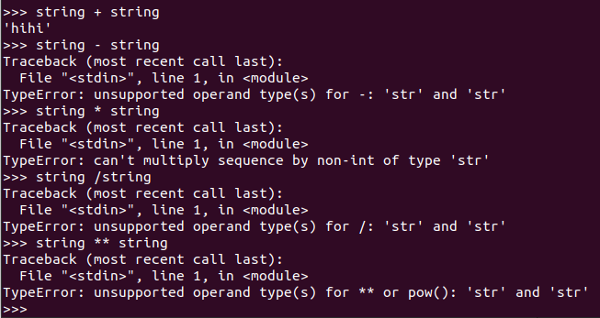
In conclusion:
int, string, can both add but
String can’t do any other operation, while int can do them all.

b.
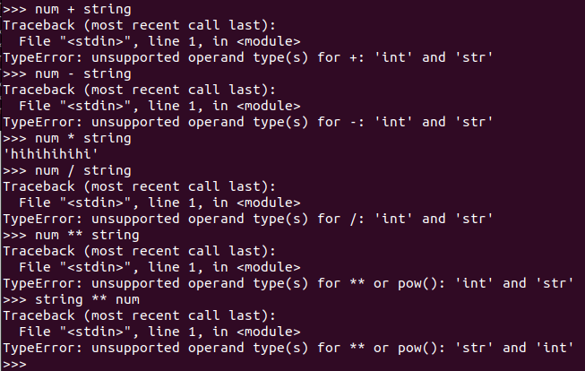
Only num * string seems to work, duplicating it.
Every other function doesn’t work, resulting in a type error.

Num * string’s output will be a string.

3.
List: .len(), .insert(), .append()
len() returns how many elements are in the list.
Insert will likely put in an element at the specified location.
append will likely be able to add on a new element at the end.

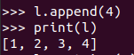
Append does in fact put elements in the end
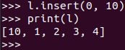
Insert does put elements in the requested index.
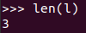
Length does return the length of it’s List.

String:

isdigit() probably just returns a boolean if it’s a number of any kind.
count() probably just returns the number of times something appears in that string
join() probably just combines 2 strings together.

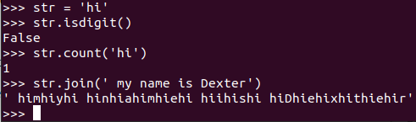
isDigit did return a boolean if the string was a digit.
Count did count the instances of a string in the string.

Join however did something that I didn’t expect at all. It seems to have instead put in the string at every instance of the new string, character by character.

Dictionary:

get() probably gets the requested item if the correct keyword was used.
Keys() probably prints all the keys.
Pop() probably removes and returns the element, with the correct key used.

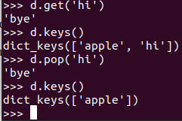
.get does get the requested element based on given key
.keys does return all keywords available in the dictionary
.pop does remove the element with the key given.

4.
floor() likely returns the number that’s up to the lower integer.
Ceil() likely returns the number that’s up to the higher integer.
Factorial() likely returns the factorial of the number given.

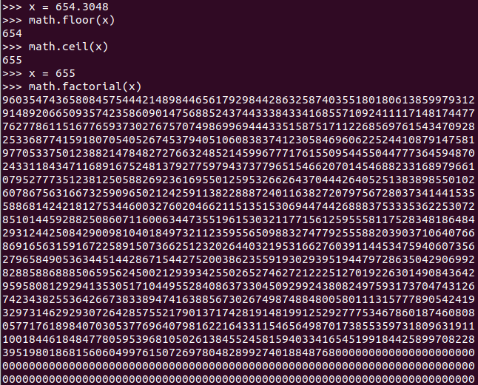

Floor does return the given float’s lower bounded integer
Ceil does return the given float’s higher bounded integer
Factorial does return the given integer’s factorial.

Dynamic/Strong typing generally doesn’t
have too many differences when it comes to
how the module works.

5.
It’s not completely true, as string can be added and multiplied together, but is just a concatenation.
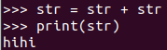
As we see here, it is mutable in being able to change the values directly.

