Lab 20
Dexter Kale
CS – 3035 – 05

Note: Made sure ahead of time that screenshotting code is acceptable due to vim being

Q1:
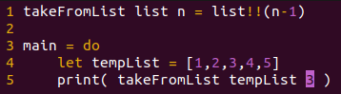

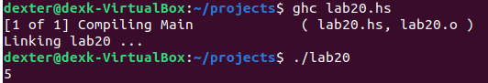

Q2:
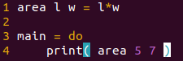

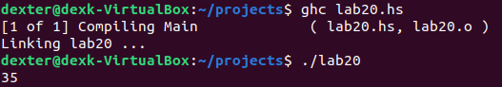

Q3:
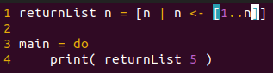

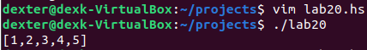

Q4:
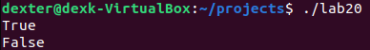

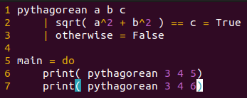

Q5:
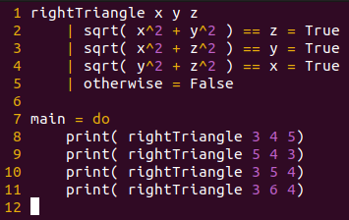

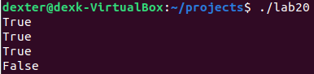

Q6:
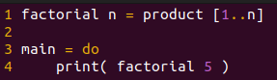

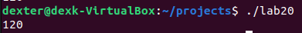

Q7:
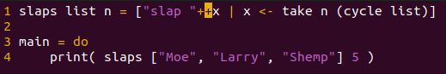

Q8:

