# Lab Assignment 1 – ArcGIS Pro and Vector Analysis

## Due Date - 9/16/2020

**Overview**

This assignment is designed to help you become familiar with ArcGIS Pro which we will start to use more often in addition to using ArcGIS Desktop such as ArcMap and ArcScene. You will also practice various analytical methods using vector data. The topics covered in this exercise include: spatial query, spatial join, and overlay operations. Spatial query and spatial join allow you to answer questions that involve locating features in one layer based on the location of other features in the same layer or other layer. These analytical functions can deal with features that have spatial relationships of containment, proximity, intersection, or adjacency. The overlay operations are the core functions of GIS. During the process of overlay, new features will be created as the geometry and/or attributes are modified based on the input(s).

**Objectives**

The objectives of this lab assignment are to help you:

* Get to know ArcGIS Pro and practice basic analyses.
* Become familiar with some of the common vector analyses.
* Know not only how to use various techniques, but, more importantly, know how to use appropriately and effectively.
* Develop a good understanding on the possibilities and limitations of vector analysis tools.

# Part I – Getting to Know ArcGIS Pro

ArcGIS Pro is the latest app in the ArcGIS suite and designed for GIS professionals to analyze, visualize, edit, and share maps in both 2D and 3D. It definitely represents the future of GIS which is becoming distributed and connected to the cloud. ArcGIS Pro is expected to take over Desktop ArcGIS in next few years. Therefore, it is critical that we get to know ArcGIS Pro and practice often to become proficient in this latest software and platform.

## Downloading and Installation

The first step to get started with ArcGIS Pro is to download and install the application. It can be downloaded from this link - [http://pro.arcgis.com/en/pro-app/get-started/install-and-sign-in-to-](http://pro.arcgis.com/en/pro-app/get-started/install-and-sign-in-to-arcgis-pro.htm) [arcgis-pro.htm](http://pro.arcgis.com/en/pro-app/get-started/install-and-sign-in-to-arcgis-pro.htm) You can also download from ELMS where I have posted the software file.

Once you have downloaded ArcGIS Pro, you can install it. Make sure you check the system requirements before you do so. [https://pro.arcgis.com/en/pro-app/get-started/arcgis-pro-system-](https://pro.arcgis.com/en/pro-app/get-started/arcgis-pro-system-requirements.htm) [requirements.htm](https://pro.arcgis.com/en/pro-app/get-started/arcgis-pro-system-requirements.htm)

## Getting License

After you complete the download and install ArcGIS Pro, you must have an authorized license to begin using the application. All licenses for ArcGIS Pro are provisioned as Named User license

by default. With a Named User license, you can use your ArcGIS Online or Portal for ArcGIS account credentials to sign in on any machine that has ArcGIS Pro installed, and the application runs with the level and extensions specified by your organization administrator in ArcGIS Online or Portal for ArcGIS.

I had already created the user accounts for you and also assigned the license. In addition, you have the license to many extensions such as Spatial Analyst, 3D Analyst, Network Analyst, etc.

## Exploring ArcGIS Pro

Once you get the license, you can start to explore ArcGIS Pro. You will be required to log in ArcGIS Online first. The user name and password must be the same ones that you got with my invitation from the University of Maryland Organization Account.

You can test by creating a new project – “Lab_1” to help organize all the data and files related to your Lab 1 assignment. An ArcGIS Pro project is much more than a map document as with ArcMap. It may contain multiple maps, geodatabases, folder connections, layer files, task lists, models, toolboxes, and more. It is like an easily sharable container that holds everything you need for your GIS project.

Explore and try out the menus to become familiar with the interface. Create a folder connection to your data folder of this class.

## Practicing ArcGIS Pro

Start a new map. Add the data from “DC” folder.

Query “DC_Census_Tracts” and select those with a population of at least 5,000 based on the value “**TOTAL00**”.

Export these selected census tracts into a new shapefile (name it “Pop_5000”) and then add to the data frame.

Turn off “DC_Census_Tracts” and leave “Pop_5000” on. Make a screen shot.

## Include the screen shot in the report.

Turn on “DC_Crimes_2017”.

Click Analysis < Tools and then search for the tool – Clip. Use it to create a new data layer showing only the crimes within “Pop_5000”.

Make a screen shot of the result.

## Include the screen shot in the report.

Use the tool – Split with “Pop_5000” as the Split Feature and the field – “NAME” as the Split field to split “DC_Crimes_2017”.

Make the result (i.e. the list of shapefiles) visible in Catalog View or ArcCatalog (need to launch separately). Then, make a screen shot.

## Include the screen shot in the report.

Turn off all these data layers. Now, add “Park_and_Rides”.

Create a multiple ring buffer for these points. The buffer distances are: 500 and 1000 meters respectively.

Make a screen shot of the result.

1. **Include the screen shot in the report.**

# Part II – Getting to Know ArcGIS Online

ArcGIS Online (AGOL) is a complete, cloud-based, collaborative content management system that lets organizations manage their geographic information in a secure and configurable environment. It is a platform but beyond that. It is also a portal for managing content, license, etc.

In addition, AGOL provides features and functions for data visualization and data analysis. In this brief exercise, you will try a simple analysis feature. We will try more sophisticated tools later on.

To learn more about AGOL, you can refer to the lecture slides and demos in Week 1. You may also refer to the links below:

* + <https://doc.arcgis.com/en/arcgis-online/get-started/what-is-agol.htm>
  + <https://www.esri.com/en-us/arcgis/products/arcgis-online/overview>

Log in AGOL – [www.arcgis.com](http://www.arcgis.com/) ; Explore the interface and features

In this simple exercise, you will add a dataset form your local computer to AGOL server. Then, you will perform a buffer analysis.

First, you need to prepare the data.

Extract the “Parks and Rides” data from the folder – “DC” you used in the previous session. Compress the files into a single zipped file.

Now, add this data to AGOL Map.

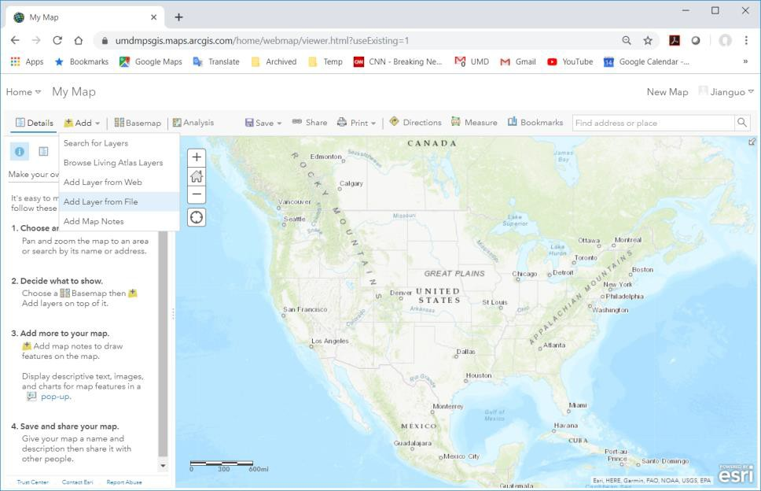

After the data (points) is displayed, you may want to change the symbology to make the points more visible on the map.

Then, you can click on Analysis tab, choose Use Proximity < Creat Buffers. Use the default parameters for now.

After you run the analysis, it should return the results similar to the one below.

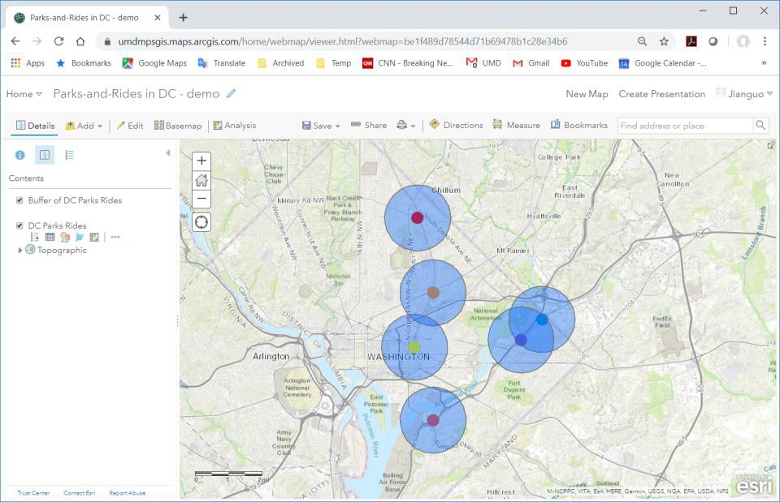

Then, save your map with a name that can indicate it is your work.

1. **Make a screenshot like the one above and include it in your lab report.**

# Part III – Spatial Query and Spatial Join

In this part of the assignment, you will practice the use of Spatial Query and Spatial Join.

## Spatial Query

Launch ArcGIS Pro.

Navigate to the Lab_1 data folder and then add all of the files.

### Point-on-line selection

Your first task is to do a spatial query and find out all of those sinkholes (points) that are located within 10 meters from the major roads in Florida.

You need to identify which one is the Target (Selection/Destination) Layer, and which one is the Reference/Source Layer. The Selection Layer(s) contain the features that we are interested in. The Reference Layer contains features that are known or selected.

Once you complete this spatial query, open the attribute table of the selection layer. Make a screen shot of this table. You don’t need to show the entire table. However, the screen shot should show the total number of records and the number of selected records. This way, I will know if you did it right or wrong.

## Include this screen shot in your report.

Notice that, even though the spatial query result tells you how many sinkholes are located within 10 meters from those major roads, it does not tell you the exact distance of each individual sinkhole from the roads. Now you can see that this is one of the limitations of Spatial Query.

### Point-on-polygon selection

Your second task is to do a spatial query to find out all those sinkholes that located within Hillsborough County.

Once you complete this spatial query, open the attribute table of the selection layer. Make a screen shot of this table. You don’t need to show the entire table. However, the screen shot should show the total number of records and the number of selected records.

## Include this screen shot in your report.

Now, what if the question is to find out how many sinkholes located within EACH county? Obviously, it will be a bad idea to do a similar spatial query for each of the 67 counties, which is extremely inefficient. Again, this is another limitation of Spatial Query. Fortunately, you can use different methods and solve the same problems.

## Spatial Join

In the previous section, you used Spatial Query to conduct some analysis but realized that it could not answer more complicated questions. In this part of assignment, you are going to use Spatial Join which may prove to be much more powerful in this particular case.

### Proximity

To improve on previous solution using Spatial Query, now your need to do a Spatial Join to address the following questions:

* + 1. How many sinkholes are located within 10 meters from major roads in Florida?
    2. What are the exact distances to the closest major roads?

You will find out exactly how to approach these questions using Spatial Join. But, first, you need to identify which one is the Destination Layer, and which one is the Join Feature (Source) Layer. The destination layer is the layer to make a selection on. The Join Feature (source) layer contains features that to be used for defining the selection on the destination layer.

***Hint:*** A query is required after Spatial Join.

## Answer the first question above. Then answer the second question with a table.

### Containment

Spatial Join can be equally convenient to solve the problem of finding out the exact number of sinkholes located within each county.

You will do a Spatial Join between the layers – “Sinkholes_Point” and “FL_cnty_bnd”. This time, the spatial relationship is containment.

After you finish the Spatial Join, you could easily count how many sinkholes within each county. But, again, this manual approach is not efficient. You need to find a different and automatic method.

You can either use the Summary Statistics tool or directly summarize on a selected field from the attribute table. Either way, the result is a summarized table containing one record for each unique value of the selected field, along with statistics summarizing any of the other fields that you chose.

Most GIS users have often overlooked this function. However, it is actually very useful and convenient. You might want to practice on your own if you haven’t done before.

## Make a screen shot of the Summarize table.

The dataset – “FL_sinkholes_area.shp” contains descriptions and soil compositions of Florida sinkholes. Open its attribute table and study the attributes. One of the fields is called “AREA_DESC” which has four categories:

* + AREA I
    - Bare or thinly covered limestone (sinkholes are few; generally shallow and broad; develop gradually; solution sinkholes dominate.)
  + AREA II
    - Cover is 30’ to 200’ thick (consists mainly of incohesive and permeable sand; sinkholes are few; shallow; of small diameter; develop gradually; cover-subsidence sinkholes dominate.)
  + AREA III
    - Cover is 30’ to 200’ thick (consists mainly of cohesive clayey sediments of low permeability; sinkholes are most numerous; of varying size and develop abruptly; cover-collapse sinkholes dominate.)
  + AREA IV
    - Cover is more than 200’ thick (consists of cohesive sediments with discontinuous carbonate beds; sinkholes are very few, but several large diameter and deep sinkholes occur; cover-collapse sinkholes dominate.)

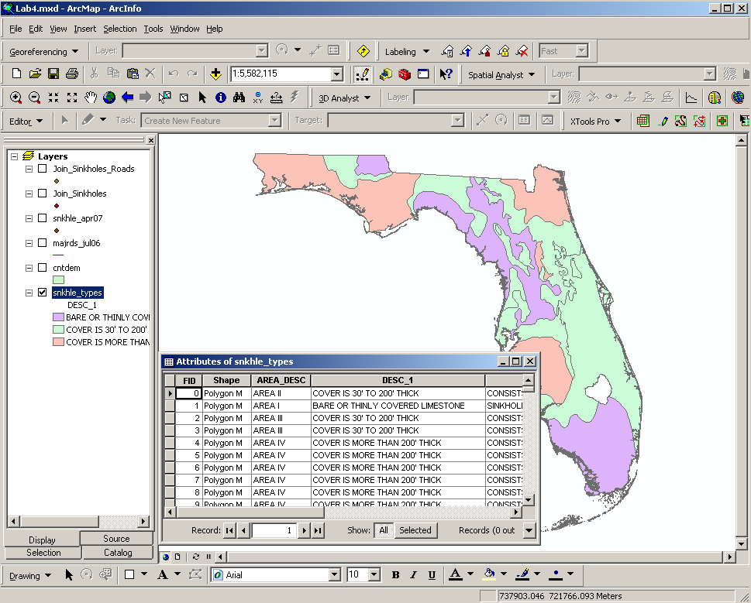

Now, the questions are:

* + What is the distribution of sinkholes in those areas with known soil compositions?
  + How many sinkholes are located within each area of soil types?

To address these questions you will take a similar approach: Spatial Join → Summarize.

1. **Make a screen shot of the Summarize table based on the result of spatial join. This should be sufficient to answer the questions above.**

# Part IV – Overlay Operations

Overlay operations are the core functions of ArcGIS because they are what GIS was initially designed for. They can process multiple feature classes to combine, erase, modify, or update spatial features in a new feature class. Often new information is created when overlaying one set of features with another.

## Intersect vs. Spatial Join

In Part I, you once used Spatial Join to find out how many sinkholes located within each county. Now, let’s try a different method to solve the same problem.

You are going to continue based on Part II using the same datasets.

Your task is to do an **Intersect** overlay of the sinkholes layer (points) and the county boundary layer. Once you finish the operation, open the attribute table of the output.

Then you will create a summarize table based on this attribute table.

### Answer this question:

* Are the results (i.e. number of sinkholes in each county) from this operation the same as that from Spatial Join in Part II?

## Include the answer in your report.

Now, create a new layer that is the boundary of Hillsborough County. Then, perform Clip using this new layer with the sinkholes layer (points). The result will be a new data layer representing all the sinkholes that are located within Hillsborough County.

Zoom to this layer. Create a screen shot of ArcGIS Pro at this point.

1. **Include the screen shot in your report.**

# Part V – Buffering

Buffering will identify or define an area within a specified distance around a feature which can be points, lines, or polygons. Buffers are usually used to delineate protected zones around features or to show areas of influence.

The most common buffers are zones that are created based a fixed distance around the objects. However, there are more innovative uses of buffers. For example: you can create multiple buffers using different distances around the same objects. Also you can create buffers using different distances for different types of objects in the same data set. Even negative distances can be used when buffering polygon features, to create buffers on the inside of the polygon features.

The Multiple Ring Buffer creates a new feature class using a set of buffer distances. You could use the multi-ring buffer tool to classify the areas around a feature into near, moderate distance, and long distance classes for an analysis.

In this exercise, you are going to practice buffering based on variable distance. Specifically, you are required to create buffers for those major roads within Hillsborough County. Before buffering, you need to extract those major road segments within the county boundary. The buffering distances will vary depending on the type of roads. For example: The Interstate will need much larger buffer distance compared to local roads.

The specification of buffer distances for various road types is listed in the table below.

|  |  |
| --- | --- |
| **Road Type** | **Buffer Distance** |
| ROADWAY FEATURE | 3 |
| RURAL: Local | 5 |
| RURAL: Major Collector | 20 |
| RURAL: Minor Arterial | 10 |
| RURAL: Minor Collector | 10 |
| RURAL: Principal Arterial - Interstate | 50 |
| RURAL: Principal Arterial - Other | 20 |
| URBAN: Collector | 15 |
| URBAN: Local | 10 |
| URBAN: Minor Arterial | 20 |
| URBAN: Principal Arterial - Interstate | 50 |
| URBAN: Principal Arterial - Other | 30 |
| URBAN: Principal Arterial - Other Freeways and Expressways | 30 |

Obviously you will need to create a new field which stores this variable distance in the attribute table of the input layer.

There are different ways to achieve this. Some solutions are more efficient than the others. In this case, one better option is to create an external table and then join it to the attribute table of the input layer. The buffer distance field will be appended to the attribute table. Now you can perform Buffering with this new field.

Now, your task is to create a new feature class that represents the buffered major roads in Hillsborough County. Buffers should be created using the specified distances listed in the table above for various road types.

Once you finish the buffering procedure, zoom in to the output layer so that the different sizes of buffer zones are visible. Make a screen shot at this point.

1. **Include the screen shot in your report.**

# Part VI – Land Cover and Land Use Change

Land use and land cover (LULC) change is a popular research topic as it concerns regional development and environmental issues. There are many ways of detecting LULC changes.

LULC data can come from different sources. In most cases, LULC data is generated from satellite images and stored commonly in a raster or grid data format, with each cell having a value that corresponds to a certain classification. Sometimes, LULC data may exist in vector format.

There are different ways to investigate LULC change, for example, Cross Tabulation. However, in this exercise, you are required to use an overlay operation - Union. It will demonstrate the creative use of overlay operations.

Add the LULC dataset (LU95.shp and LU04.shp in the Florida folder) in a new data frame in ArcMap.

Your task is to explore how you can answer these types of questions (in the table below):

* How much land cover and land use have remained unchanged during that time period?
* What classifications of land have changed?
* How much land has changed from type A to type B (in **square kilometers**) between year X and year Y?

Complete the table below using the LULC data provided as well as the Vector Analysis tools learned in this lab. There will be a lot of steps involved. The output should be presented in a table (see below) which contains the information about LULC change from 1995 to 2004. Notice that you are required to investigate only four types of land uses. (Remember units are km2.)

|  |  |  |  |  |  |
| --- | --- | --- | --- | --- | --- |
|  | | **2004 LULC** | | | |
| CROPLAND AND  PASTURELAND | MIXED RANGELAND | ROW CROPS | SHRUB AND BRUSHLAND |
| **1995**  **LULC** | CROPLAND AND  PASTURELAND | 0.13272089km^2 | 0.000038 km^2 | 14.10403021 km^2 | 5.96149497 km^2 |
| MIXED  RANGELAND | 0km^2 | 0.00355294km^2 | 0.00740822 | 0 |
| ROW CROPS | 2.71750663 | 0 | Intersect: 0.17349491 km^2 | 4.91389698 |
| SHRUB AND  BRUSHLAND | 3.81669167 | 0.20999014 | 11.29303541 | Intersect: 1.33101916km^2 |

### Hints:

* You will need to use multiple queries (Attribute and/or Spatial).
* Also, you need to recalculate the area for every polygon (using Calculate Geometry or Add Geometry Attribute in ArcGIS pro) after performing overlay operations unless you have created a geodatabase first.

1. **Include the summary table in your report. Not necessary to include answers to the three question above.**

# Part VII – Middle Navigation Line

(Optional)

Suppose that the State of Maryland is divided into two regions by the Chesapeake Bay.

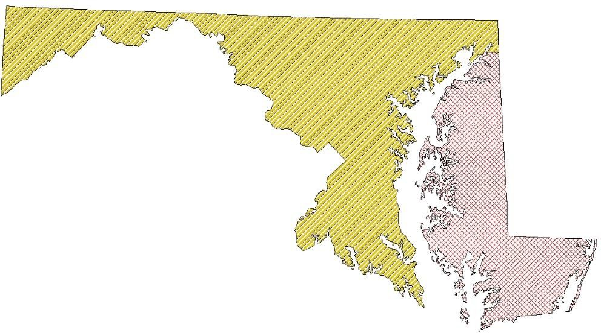

What if you are tasked to find out the navigation line that precisely divides the eastern and western Maryland including their respective islands?

Solve this problem and create a map of the result.

**Hint:** Given any point (PMi) along this invisible middle line, the closest distance from this specific point to a point (PEi) that belongs to Eastern Maryland shoreline or an island edge should be precisely the same as that to a point (PWi) that belongs to Western Maryland shoreline or an island edge.

Describe the steps and tools used. Make a screen shot of the result.

## This part is optional. You can get 5 bonus points if you complete this exercise.

**----- THE END -----**