***General Instructions***

The link <http://qpridesrv/hive/util/elisa/> on HIVE provides a user friendly and a fast tool to analyze the data obtained by running an ELISA experiment.

This tool is currently designed to analyze the results obtained from ELISA plate where samples were arranged in order as shown.

Reference sample Samples (in duplicates, e.g. columns 3 and 4 are for sample 1, columns 5 and 6 are for sample 2, etc)

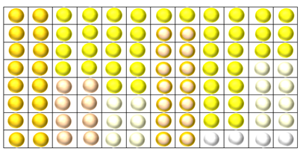Dilutions 1 2 3 4 5 6 7 8 9 10 11 12

|  |
| --- |
| A |
| B |
| C |
| D |
| E |
| F |
| G |
| H |

These four cells are left blank to measure background optical density

The values obtained from the experiment can be copy/pasted or entered manually in the ***Input Section*** of the page in the same way as the plate is filled-

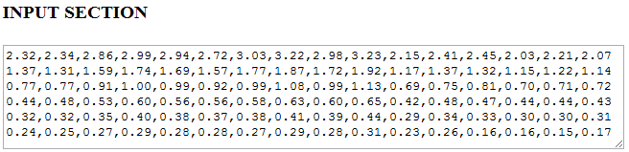

Reference Samples Blank (no sample)

The ***Experiment Parameters*** can be entered here-

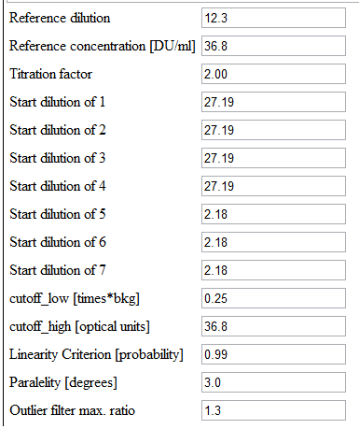

Difference from blank cell (no sample)

Optical Density should not be greater than this value

Linearity criteria for samples

Difference between the samples and the reference line

Two measurements of the same sample for the same concentration should not differ by more than by this value.

***Results-***

On clicking anywhere on the input area results appear as follows-

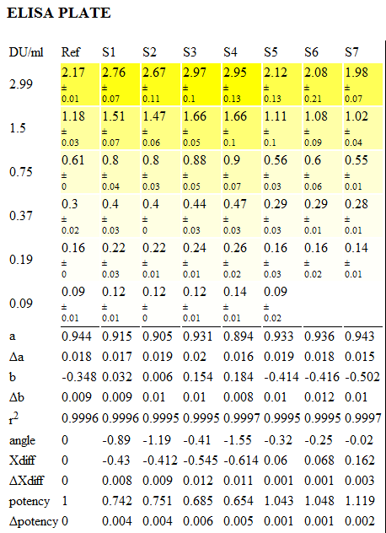

Systematic Error

Ref- Reference

S1-S7- samples

DU/ml- concentration units

***Computations-***

R

Log of concentrations

Reference

Y

X

Log of Optical Density

S1

The computations include all the measurements of the samples which satisfy the experimental parameters (N) and plotting a straight line along X and Y axis using Least Squares Method. The Method of Least Squares is a procedure to determine the best fit line to data. The proof uses simple calculus and linear algebra. The basic problem is to find the best fit straight line y = ax + b given that, for n $∈\left\{1…..N\}\right.$, the pairs (xn; yn) are observed.

The straight line is described by the equation

*y=ax+b*

where a and b are the constant, “a” determines the slope of that line, and the constant term "b" determines the point at which the line crosses the y-axis, otherwise known as the y-intercept.

R2 - R is the distance of the sample points from the reference and is computed as

R2=

We also compute the mean value for each sample and compute the variance which is which is a useful tool to quantify how much a set of data fluctuates about its mean.

Variance SSxx is computed as SSxx=

Variance SSyy is computed as SSyy =

Covariance SSxy is computed as SSxy =

Following the same straight line equation *X* is obtained as $\frac{y-b}{a}$

And *X*diff ( which is ?? )is computed as $\frac{y-b_{ref}}{a_{ref}}$- $\frac{y-b}{a}$

The standard errors (SE) are denoted as ∆a, ∆b and ∆x diff are computed as-

SE(a) = $S \sqrt{\frac{1}{N}+ \frac{({\overline{x}}^{2})}{{SS}_{xx}}}$ and SE(b) is $\frac{S}{\sqrt{{SS}_{xx}}}$

Where S = $\sqrt{\frac{{SS}_{yy}-b{SS}_{xy}}{N-2}}$ = $\sqrt{\frac{{SS}_{yy}-{{SS}_{x^{2}y}}/{{SS}_{xx}}}{N-2}}$

∆x diff =

Potency is determined by P and is computed as

P= D/C Xdiff and thestandard error is computed as

∆P= D lnc . C Xdiff . ∆Xdiff