AI Interview Trainer Agent
IBM SkillsBuild Internship Project Report

Submitted By
Arghadeep Pandit
B.Tech in Electronics and Communication Engineering
Institute of Engineering & Management (IEM), Kolkata
2026

Abstract
The AI Interview Trainer Agent is an intelligent conversational system developed using Langflow and IBM watsonx.ai. The project aims to assist students and job seekers in preparing for technical, HR, and campus placement interviews through realistic AI-driven mock interview sessions.
The system utilizes Large Language Models (LLMs) hosted on IBM watsonx.ai to generate interview questions, evaluate user responses, provide scores, identify strengths and weaknesses, suggest improvements, and generate ideal answers. The platform enables users to practice interview scenarios in a personalized and interactive environment.
The project demonstrates the practical application of Agentic AI, Prompt Engineering, Workflow Automation, and Large Language Models for career preparation and skill enhancement.
Keywords: Agentic AI, Langflow, IBM watsonx.ai, Large Language Models, Interview Preparation, Prompt Engineering, AI Assistant.

1. Introduction
Campus placements and job interviews play a critical role in determining career opportunities for students. Many candidates struggle with interview preparation due to lack of guidance, feedback, and realistic practice environments.
Recent advancements in Artificial Intelligence and Large Language Models provide opportunities to develop intelligent interview trainers capable of simulating real interview experiences.

Key Capabilities:
- Conducting mock interviews
- Generating technical questions
- Conducting HR interviews
- Evaluating responses
- Providing detailed feedback
- Scoring candidate performance
- Suggesting ideal answers
The system acts as a virtual interviewer available anytime for practice, removing barriers to consistent interview preparation.

2. Problem Statement
Students often face challenges in interview preparation due to:
- Limited access to mentors
- Lack of personalized feedback
- Insufficient mock interview practice
- Fear of real interview environments
- Difficulty identifying weak areas
The objective is to create an intelligent AI-based interview assistant that can simulate realistic interviews and provide constructive feedback.

3. Objectives
The primary objectives of this project are:
- Conduct AI-driven mock interviews
- Generate technical and HR interview questions
- Evaluate candidate responses
- Provide performance scores
- Suggest ideal answers
- Identify strengths and weaknesses
- Improve interview confidence and communication skills
- Demonstrate practical implementation of Agentic AI

4. Technology Stack

Software Tools:
- Langflow
- IBM watsonx.ai
- Python
- Large Language Models (LLMs)

AI Model:
Meta Llama 3.3 70B Instruct

Concepts Used:
- Agentic AI
- Prompt Engineering
- Workflow Design
- Conversational AI
- Large Language Models
- Human-AI Interaction

5. System Architecture
The overall workflow consists of four major components:
User Input
↓
Chat Input Node
↓
Prompt Template
↓
IBM watsonx.ai LLM
↓
Chat Output

The Prompt Template acts as the system instruction layer that defines the behavior of the AI Interview Trainer.
IBM watsonx.ai processes user queries using the selected foundation model and generates intelligent interview responses.

6. Methodology

Step 1: Project Creation
A new project named "AI Interview Trainer Agent" was created using Langflow.

Step 2: Workflow Design
The workflow consists of:
- Chat Input Node
- Prompt Template Node
- IBM watsonx.ai Model Node
- Chat Output Node

Step 3: Prompt Engineering
A detailed system prompt was designed instructing the AI model to:
- Act as an expert interview trainer
- Generate interview questions
- Evaluate answers
- Provide scores
- Suggest improvements

Step 4: IBM watsonx.ai Integration
The workflow was connected to IBM watsonx.ai using:
- Project ID
- API Key
- Watsonx Endpoint

Step 5: Model Selection
Meta Llama 3.3 70B Instruct model was selected for generating high-quality interview responses.

Step 6: Testing
Multiple interview scenarios were tested:
- Technical Interviews
- HR Interviews
- Campus Placement Interviews
- Answer Evaluation

7. Implementation

Workflow Overview
Below is the complete workflow design of the AI Interview Trainer Agent in Langflow:
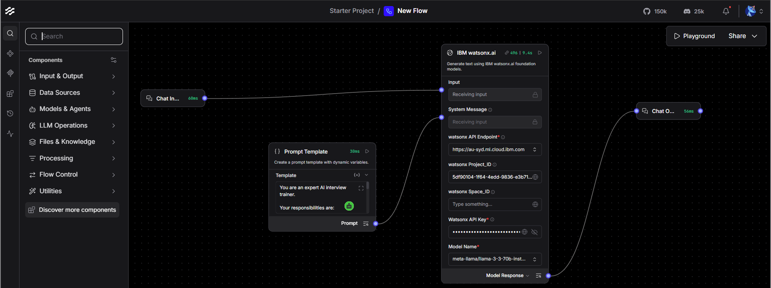

System Prompt Configuration
The system prompt is configured to guide the AI model's behavior:
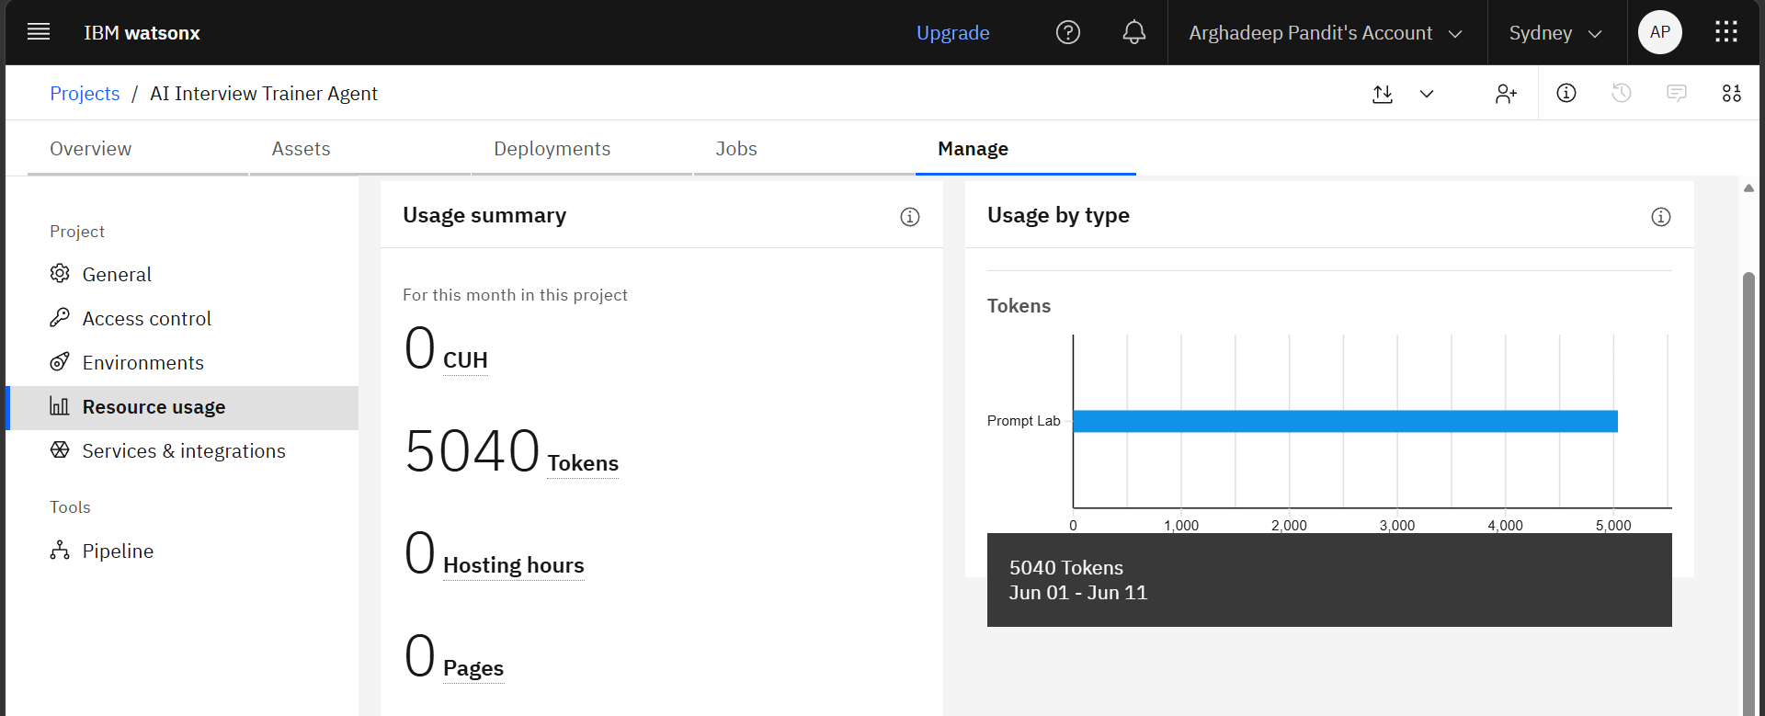

Chat Interface - Interview Session
Interactive chat interface showing a live interview session:
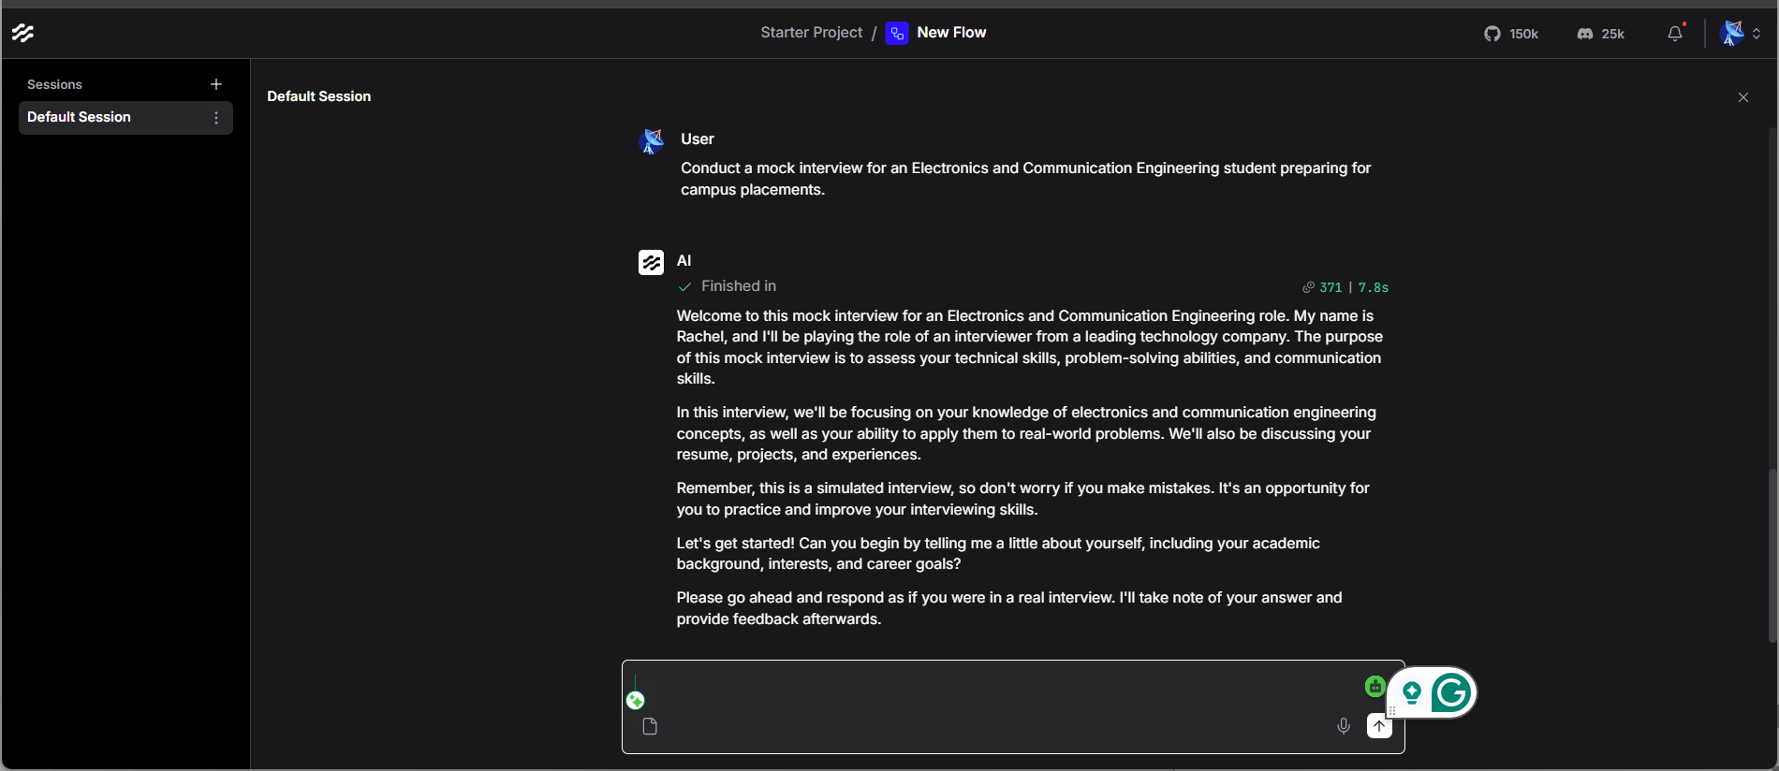

Question Generation & Evaluation
The system generates questions and evaluates responses in real-time:
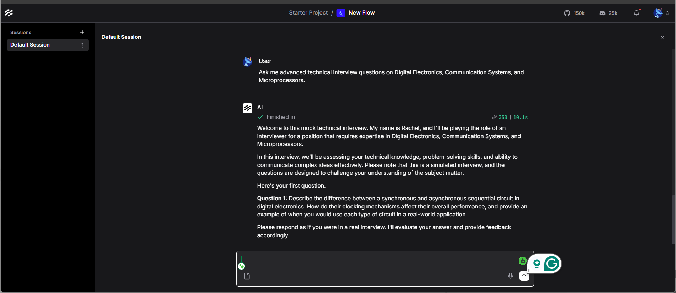

Technical Interview Mode
Demonstration of technical interview functionality:
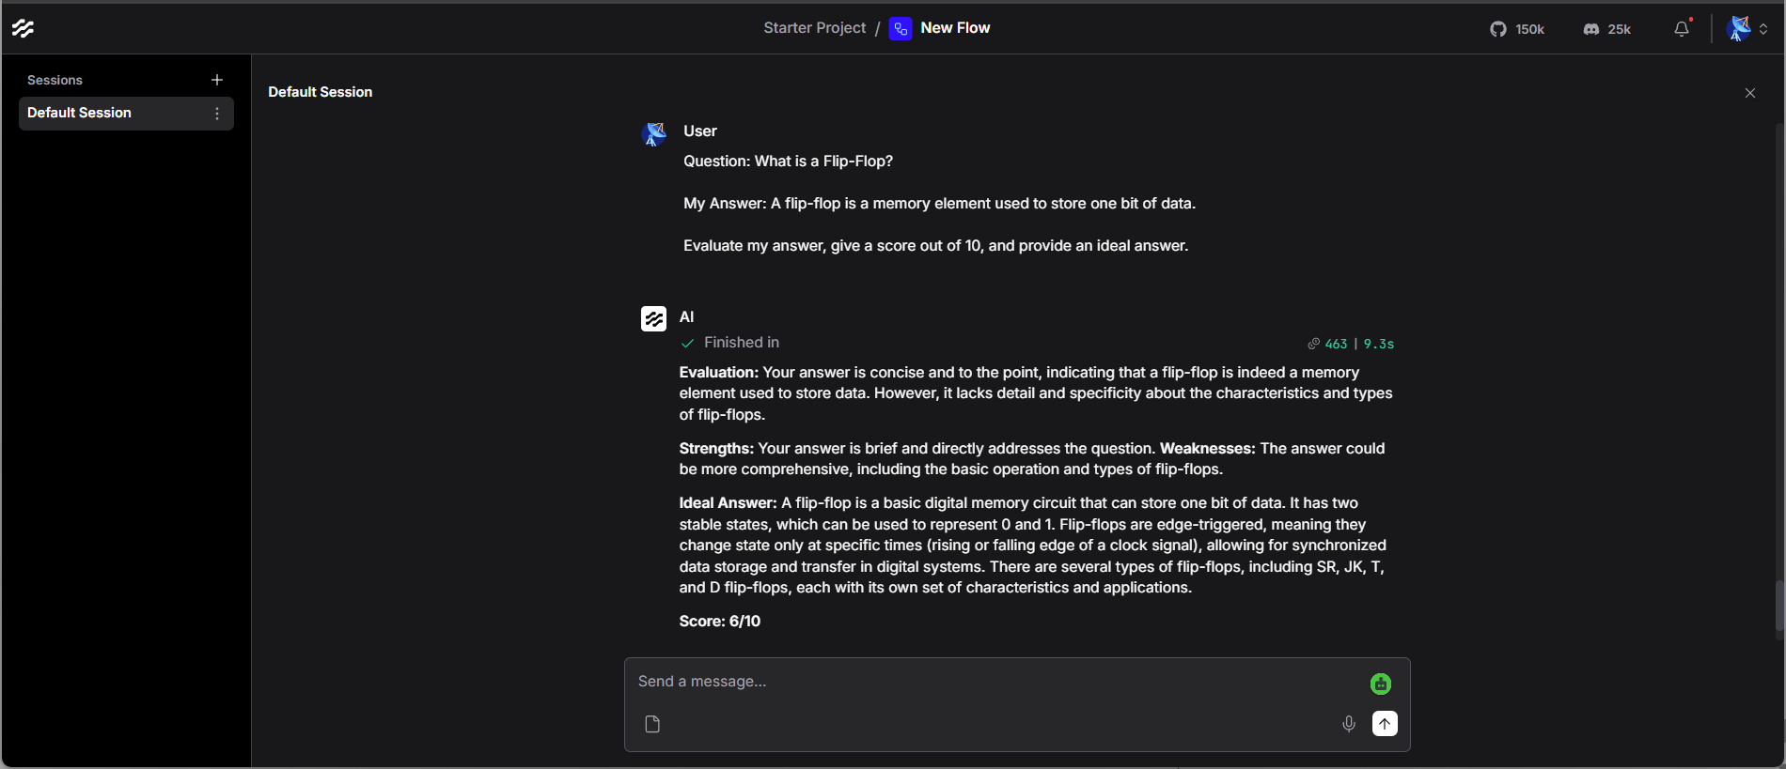

HR & Feedback Section
HR interview and feedback generation:
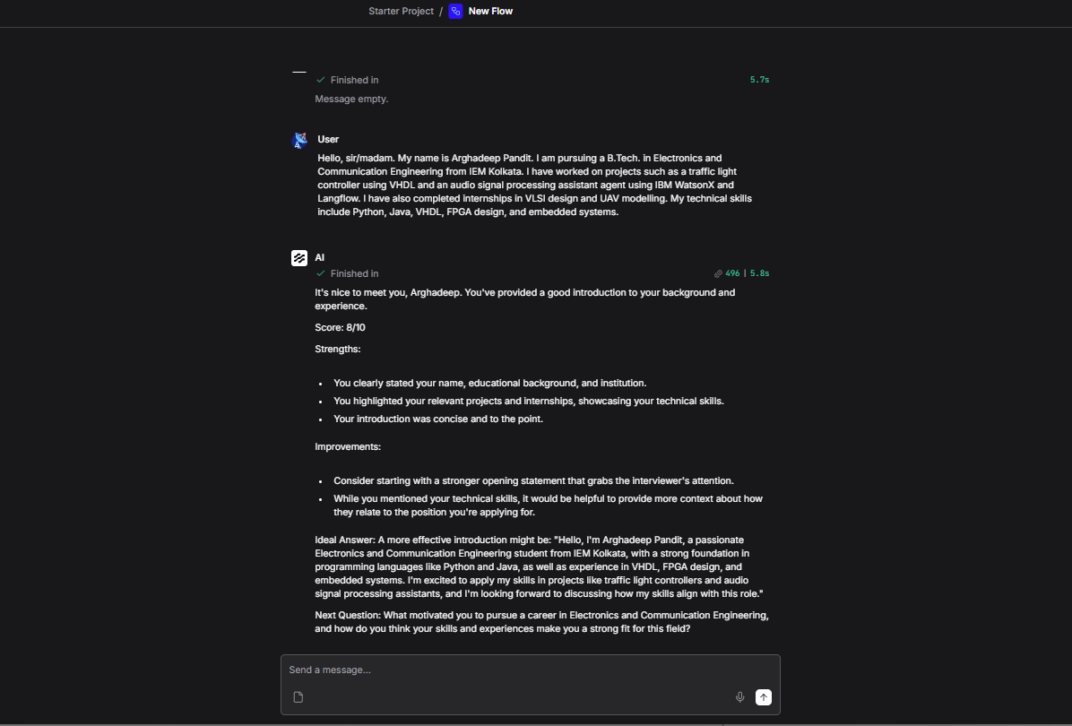

8. Key Features
- Interactive Interview Practice
- Technical Question Generation
- HR Question Generation
- Campus Placement Preparation
- Real-Time Feedback
- Answer Evaluation
- Score Generation
- Personalized Recommendations
- AI-Powered Learning

9. Modes of Operation

Technical Interview Mode
Generates advanced technical questions from domains such as:
- Digital Electronics
- Communication Systems
- Microprocessors
- Embedded Systems
- Programming

HR Interview Mode
Generates behavioral and personality assessment questions. Examples:
- Tell me about yourself
- Why should we hire you?
- Describe your strengths and weaknesses

Answer Evaluation Mode
The agent evaluates responses and provides:
- Performance Score
- Strength Analysis
- Improvement Suggestions
- Ideal Answer

10. Results and Observations

Mock Interview Generation
The system successfully generated structured interview sessions covering multiple domains and difficulty levels.

Technical Assessment
The agent produced advanced ECE-related interview questions that accurately assess technical knowledge.

Answer Evaluation
The system evaluated user responses and assigned scores based on quality, completeness, and relevance.

Personalized Feedback
Detailed suggestions and ideal answers were generated to improve performance and understanding.

11. Applications
- Campus Placement Preparation
- Technical Interview Practice
- HR Interview Training
- Communication Skill Development
- Competitive Examination Preparation
- Corporate Training Programs

12. Advantages
- Available 24/7 for practice
- Personalized Feedback tailored to user performance
- Cost Effective solution compared to hiring mentors
- Scalable to serve many users simultaneously
- Improves Confidence through repeated practice
- Realistic Interview Experience
- Continuous Learning Support with instant feedback

13. Future Scope
Future improvements may include:
- Voice-based Interview Mode with speech recognition
- Resume Analysis Integration for personalized questions
- Emotion Detection using facial analysis
- Speech Evaluation for confidence and clarity metrics
- Multi-Agent Interview Panels for complex scenarios
- Interview Performance Dashboard with analytics
- Interview History Tracking and progress reports
- Job-Specific Question Generation based on JD

14. Skills Learned
During this project, the following professional skills were acquired:
- Agentic AI Development and design patterns
- Advanced Prompt Engineering techniques
- Langflow Workflow Design and optimization
- IBM watsonx.ai Integration and deployment
- Large Language Model Application Development
- Conversational AI Systems architecture
- AI-Based Evaluation Systems implementation
- Human-AI Interaction Design principles
- Workflow Automation best practices
- AI Project Deployment and testing concepts

15. Conclusion
The AI Interview Trainer Agent successfully demonstrates the practical application of Agentic AI and Large Language Models for interview preparation. The developed system provides realistic interview experiences, evaluates candidate responses, and offers personalized guidance for improvement.
The project highlights how AI technologies can be leveraged to bridge the gap between academic learning and professional interview readiness. It serves as an effective educational tool for students preparing for technical, HR, and campus placement interviews.
This implementation showcases the potential of combining modern AI frameworks (Langflow and IBM watsonx.ai) with prompt engineering to create scalable, practical solutions for career development. The system is readily deployable and can be extended with additional features for enhanced functionality.

16. References
- IBM watsonx.ai Documentation - https://www.ibm.com/watsonx
- Langflow Documentation - https://docs.langflow.io
- Meta Llama 3 Foundation Model Documentation
- IBM SkillsBuild Learning Resources
- Agentic AI Concepts and Applications
- IEEE Standards for AI and Machine Learning Documentation

