Green Hydrogen from Organic Waste:
Biogas Upgrading with a Zeolite Membrane and Catalytic Methane Pyrolysis
BTP-1 Report
Arghadeep
November 2026
Process simulation in Aspen Plus V14 and Aspen Custom Modeler

Abstract
Wet organic waste is mostly landfilled, where it releases methane and its energy is lost. This work designs and analyses a process that converts such waste into hydrogen. Biogas from thermophilic anaerobic digestion is cleaned, compressed and upgraded in a DDR zeolite membrane, and the methane-rich retentate is cracked at 790 °C over a catalyst into hydrogen and solid carbon. The process was simulated in Aspen Plus V14; a key part of the work is a custom membrane module developed in Aspen Custom Modeler (ACM) and integrated into the flowsheet. The developed and verified model converts 8.5 t/d of wet biomass into 4.65 kg/h of H₂ and 16.3 kg/h of solid carbon. The membrane raises methane from 59.4 % to 76.4 % with 97.1 % methane recovery.
The process needs 86.7 kW of heat and 5.7 kW of electricity, which is 18.6 kWh of heat and 1.22 kWh of electricity per kg of H₂. Two-thirds of the heat goes to the 790 °C pyrolysis section. An exergy analysis shows that 76 kW of exergy is destroyed, 80 % of it in hydrolysis and digestion, and that the digestate carries a third of the input exergy out of the process. The exergy efficiency is 22 % for H₂ alone and 45 % for H₂ plus solid carbon. Scope 1 + 2 emissions are 5.5 kg CO₂e per kg H₂ with natural-gas heating and grid electricity. A screening heat-integration case (digestate heat recovery, a product economiser and use of the CO off-gas as fuel) cuts external heat by about 79 % and emissions to about 1.9 kg CO₂e per kg H₂, below the 2 kg limit of the India Green Hydrogen Standard. These results define the BTP-2 work: an economiser and energy analysis, followed by pinch analysis and optimisation.

Contents
1 Introduction
2 Process description and simulation model
3 Results per unit
4 Material and energy balance
5 Exergy analysis
6 CO₂ emissions (Scope 1 + 2)
7 Sensitivity: feed pressure vs separation
8 Membrane models for zeolite membranes
9 Limitations
10 Conclusions and future work (BTP-2)
References
Appendix A: Assumptions

1 Introduction

1.1 Organic waste and conventional routes
Large amounts of wet organic waste (food and market waste, agricultural residues, animal manure) are produced every day. The conventional routes handle this waste poorly from an energy and climate point of view:
- Landfill: organic matter decomposes without air and releases methane, a strong greenhouse gas, together with leachate. Its energy is lost.
- Open burning: releases CO₂ and air pollutants and recovers no energy.
- Composting: recovers nutrients but not energy.
- Incineration: recovers some heat or power, but wet waste burns poorly.
Anaerobic digestion instead converts wet waste into biogas (about 60 % CH₄ and 40 % CO₂) under controlled conditions, so the methane is captured rather than released, and the digestate can be used as fertiliser. This work takes the next step: upgrading the biogas and turning its methane into hydrogen.

1.2 Routes to hydrogen
Most hydrogen today is made by steam reforming of natural gas ("grey" hydrogen), which emits about 10–12 kg CO₂e per kg H₂ [9]. Alternatives include reforming with CO₂ capture ("blue"), water electrolysis with renewable power ("green") and methane pyrolysis ("turquoise"), in which methane is split into hydrogen and solid carbon without forming CO₂:
CH₄ → C(s) + 2 H₂ ΔH°₂₉₈ = +74.8 kJ/mol
When the methane comes from biogas, the carbon is biogenic. Storing it as solid carbon can make the route carbon-negative. India’s Green Hydrogen Standard sets a limit of 2 kg CO₂e per kg H₂ (well-to-gate) for hydrogen to count as green [8].

1.3 Problem statement and objectives
Problem statement. Wet organic waste is mostly landfilled, where it releases methane and its energy is lost. This project designs and analyses an integrated process that converts wet organic waste into hydrogen and solid carbon, through anaerobic digestion, zeolite-membrane biogas upgrading and catalytic methane pyrolysis, and identifies where its energy use, exergy losses and CO₂ emissions can be reduced.
The goals are to produce hydrogen from a greener source, reduce CO₂ emissions, use the excess heat of the process and minimise its overall energy use. The objectives of BTP-1 are to:
- Develop and verify an Aspen Plus model of the integrated process, including a custom membrane model;
- Report the results of each unit and the integrated material and energy balance, and identify the largest energy users;
- Carry out an exergy analysis of each unit and the whole process;
- Estimate Scope 1 + 2 CO₂ emissions;
- Study the effect of membrane feed pressure on separation, and compare membrane models.

2 Process description and simulation model

2.1 Flowsheet
Figure 1 shows the process. Wet biomass (8.5 t/d, about 75 % water) is mixed with 13 t/d of process water and hydrolysed at 55 °C. The hydrolysate is digested in a continuous stirred reactor at 55 °C with a residence time of 15 days. The biogas is cooled to 25 °C to condense water, cleaned of H₂S and NH₃, compressed in two intercooled stages to 10 bar and fed to the zeolite membrane. The retentate (methane-rich) is let down to 1 bar, heated to 790 °C and cracked in a catalytic plug-flow reactor. The permeate (mostly CO₂) leaves the process.
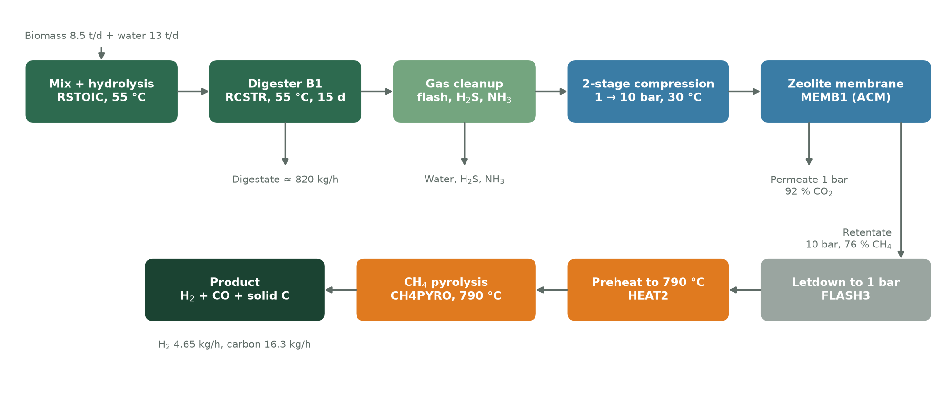
Figure 1. Process flow diagram with Aspen block names.

2.2 Hydrolysis and digestion
Hydrolysis is modelled in an RSTOIC block with 13 stoichiometric reactions run in series at fixed conversions: cellulose and starch to glucose, hemicellulose to acetic acid and xylose, fats to glycerol and long-chain fatty acids, proteins and keratin to amino acids and gases, and ethanol steps. The digester (RCSTR block B1) uses ADM1-style kinetics [1]: Monod substrate terms multiplied by inhibition terms for ammonia, long-chain fatty acids, acetate and hydrogen. The reactions cover acidogenesis (sugars, glycerol), acetogenesis (fatty acids and volatile fatty acids), amino-acid degradation (Stickland reactions), acetoclastic and hydrogenotrophic methanogenesis, and an equilibrium reaction for homoacetogenesis. Ten Fortran calculator blocks compute the rate constants from the reactor concentrations, and a damped Wegstein tear loop converges them.

2.3 Gas cleanup and compression
A flash at 25 °C removes most of the water. Two component separators remove H₂S and all species other than CH₄, CO₂, H₂ and CO (ideal cleanup). Two isentropic compressors (efficiency 0.75) raise the pressure from 1 to 3.2 to 10 bar, each followed by a cooler to 30 °C.

2.4 Custom zeolite membrane module (Aspen Custom Modeler)
A central part of this work is a custom membrane module. Aspen Plus has no standard permeance-based gas-membrane block, so the membrane was written as a new model, Zeo_real, in Aspen Custom Modeler (ACM), exported as a model library and linked into the Aspen Plus flowsheet as block MEMB1. In the flowsheet it behaves like any other unit: it receives the feed stream with its full 62-component composition and returns the retentate and permeate streams with temperature, pressure and enthalpy.
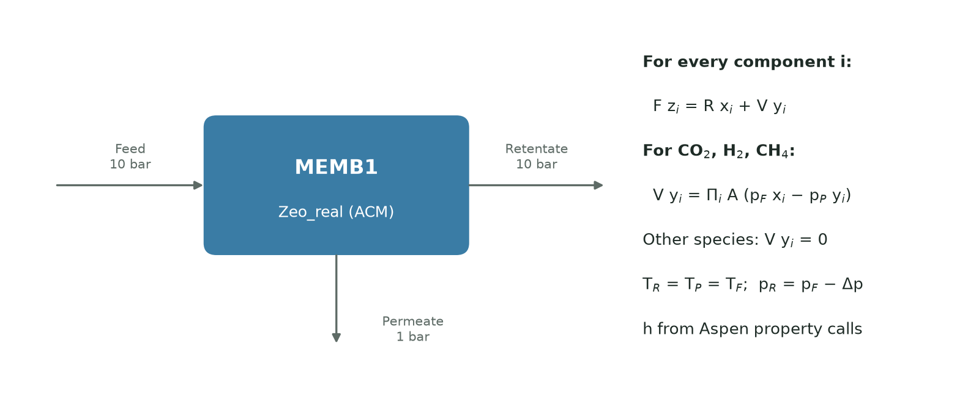
Figure 2. Structure of the custom membrane module and its equations.
Model equations. The module is a well-mixed, single-stage membrane. For every component i in the component list, a mass balance links the feed (F, z_{i}) to the retentate (R, x_{i}) and permeate (V, y_{i}):
F · z_{i} = R · x_{i} + V · y_{i}
For the permeating gases (CO₂, H₂ and CH₄) the permeate flow follows the partial-pressure flux law of Perry’s Handbook (Eq. 20-85) [2]:
V · y_{i} = Π_{i} · A · (p_{F} · x_{i} − p_{P} · y_{i})
All other species have zero permeate flow and stay in the retentate. Both outlets leave at the feed temperature, the retentate pressure equals the feed pressure minus a pressure drop (zero here), and the permeate pressure is specified (1 bar). Molar enthalpies of both outlets are computed with Aspen’s own property procedures, so the energy balance is consistent with the rest of the flowsheet.
Inputs. DDR zeolite permeances at 297 K [3]: CO₂ 2.1×10⁻⁷, H₂ 1.36×10⁻⁷ and CH₄ 3.03×10⁻⁹ mol/(m²·s·Pa), giving a CO₂/CH₄ selectivity of 69. The area is 5 m², the feed is at 10 bar and the permeate at 1 bar. Permeances, area and pressure drop are parameters, so the module can be reused for other membranes.
Verification. The module solves 193 equations and converges in 5 iterations inside the flowsheet. The mass balance closes exactly (64.3 kg/h in = 40.1 kg/h retentate + 24.2 kg/h permeate), outlet streams are electrically neutral, and an independent calculation with the same flux law reproduces the module’s results.

2.5 Methane pyrolysis
The pyrolysis reactor (RPLUG block CH4PYRO) runs isothermally at 790 °C and 1 bar with 24.7 kg of catalyst. Two power-law reactions on a catalyst-mass basis are included: methane cracking (CH₄ → C(s) + 2 H₂) and the reverse water-gas shift (CO₂ + H₂ → CO + H₂O), which consumes the CO₂ left in the retentate. Solid carbon is a conventional solid (CISOLID).

2.6 Physical properties
The NRTL activity model is used, with Peng–Robinson as the secondary method. CO₂, CH₄, H₂, H₂S and CO are Henry components. The component list has 62 species, including sugars, fatty acids, 17 amino acids, biomass (C₅H₇NO₂), gases and solid carbon.

2.7 Challenges during development and how they were solved
Several problems came up while building the model. Each was solved as follows:
- Membrane model: Aspen Plus has no standard gas-membrane block, so a custom model was written in ACM. The first version used a component ID that did not exist, did not conserve mass, had a fixed split and no energy equations. It was rewritten from first principles; it now conserves mass and energy and converges in 5 iterations.
- Membrane driving force: with biogas at 1 bar there was almost no pressure difference across the membrane, so CO₂ could not permeate. Two-stage intercooled compression to 10 bar was added.
- Digester kinetics: rates computed from inlet concentrations underestimated degradation. The calculator blocks now use reactor concentrations and are converged with a recycle (tear) loop; coding errors in the calculators and the temperature corrections were also resolved.
- Balances: some hydrolysis and fatty-acid reactions were not mass- or element-balanced (palmitic acid had been entered with the wrong component). The stoichiometry was rebalanced.
- Hydrolysis order: running the hydrolysis reactions in series was needed so that the ethanol and xylose steps act on the products of earlier steps.
- Properties: Henry components were added for the dissolved gases, and inconsistent property entries were cleaned up.
The final run finishes with 0 errors and 4 minor warnings. Key results were checked against Perry’s Handbook: pH window, thermophilic temperature range, methane yield, methanogen yield and the membrane flux law [2]. The pyrolysis outlet was checked against chemical equilibrium (Section 3.3).

3 Results per unit

3.1 Digester and biogas
The digester produces 2.36 kmol/h of dry biogas (about 53 Nm³/h) containing 59.4 % CH₄, 40.3 % CO₂ and 0.3 % H₂. This is about 31 Nm³/h of methane, or 0.24 m³ CH₄ per kg COD fed. Perry’s gives a theoretical maximum of 0.35 m³ per kg COD destroyed and a typical biogas range of 50–80 % CH₄ [2]. About 820 kg/h of digestate leaves at 55 °C.

3.2 Compression and membrane
Compression to 10 bar needs 5.7 kW. The membrane raises methane from 59.4 % to 76.4 % in the retentate (1.78 kmol/h, 10 bar) and removes 56.3 % of the CO₂ into a permeate of 92 % CO₂ (0.58 kmol/h, 1 bar). It keeps 97.1 % of the methane; the remaining 2.9 % leaves with the permeate (Figure 2).
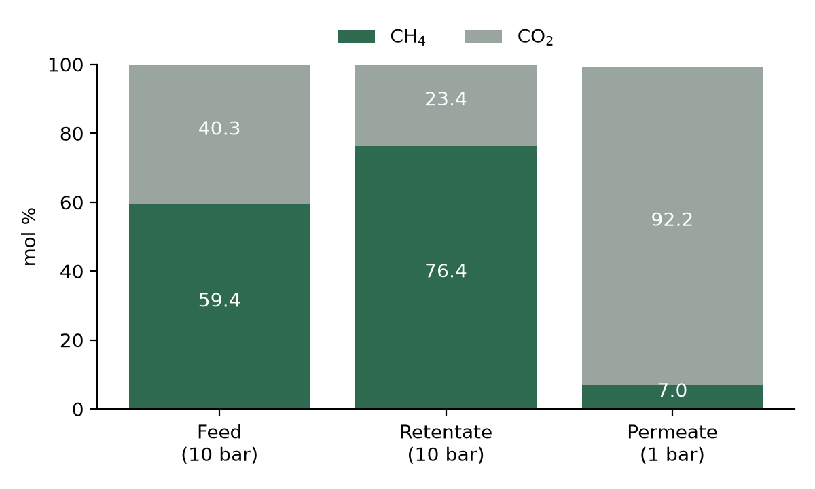
Figure 3. Composition of membrane feed, retentate and permeate (mol %).

3.3 Pyrolysis and final product
At 790 °C methane is converted almost completely. The reactor produces 2.31 kmol/h of H₂ (4.65 kg/h, about 110 kg/day) and 1.36 kmol/h of solid carbon (16.3 kg/h). The CO₂ still in the retentate (23 %) reacts with hydrogen to CO and water, so the product gas is about 73.5 % H₂, 13.2 % CO and 13.2 % H₂O (about 85 % H₂ on a dry basis). This side reaction uses about 15 % of the hydrogen that could otherwise be produced.
Both reactions are modelled as irreversible. A check against chemical equilibrium at 790 °C, using Perry’s thermodynamic data, gives about 94 % equilibrium conversion of methane and puts the model’s H₂ output about 4 % above equilibrium. This is stated as a limitation.

3.4 Key streams
Table 1. Key streams at the design point.
Stream | Flow (kmol/h) | T (°C) | P (bar) | CH₄ % | CO₂ % | H₂ %
Biogas to membrane (GAS2C) | 2.358 | 30 | 10 | 59.4 | 40.3 | 0.3
Retentate (RET) | 1.779 | 30 | 10 | 76.4 | 23.4 | 0.2
Permeate (PER) | 0.580 | 30 | 1 | 7.0 | 92.2 | 0.6
Pyrolysis feed (PYROIN) | 1.779 | 790 | 1 | 76.4 | 23.4 | 0.2
Product gas (FINPROD) | 3.137 + 1.359 C(s) | 790 | 1 | ≈ 0 | ≈ 0 | 73.5

4 Material and energy balance

4.1 Material balance
Table 2 shows the overall material balance, which closes exactly. About 92 % of the mass leaves as digestate, so the process is dominated by water.
Table 2. Overall material balance (kg/h).
In | kg/h | Out | kg/h
Biomass (wet) | 354.2 | Digestate (LIQUID) | 821.2
Process water | 541.7 | Flash water, NH₃ and H₂S purges | 10.3
 |  | Membrane permeate (mostly CO₂) | 24.2
 |  | Product gas (H₂ 4.65, CO 11.6, H₂O 7.5) | 23.8
 |  | Solid carbon | 16.3
Total in | 895.8 | Total out | 895.8

4.2 Energy balance
The process needs 86.7 kW of heat and 5.7 kW of electricity (Figure 3). The pyrolysis section (preheat to 790 °C and the endothermic reactor) takes 58.5 kW, two-thirds of all heat. Heating the feed to 55 °C in the hydrolysis step takes 24.7 kW, mostly to warm the 13 t/d of process water. Per kg of hydrogen, the process uses 18.6 kWh of heat and 1.22 kWh of electricity. About 11 kW is removed by coolers.
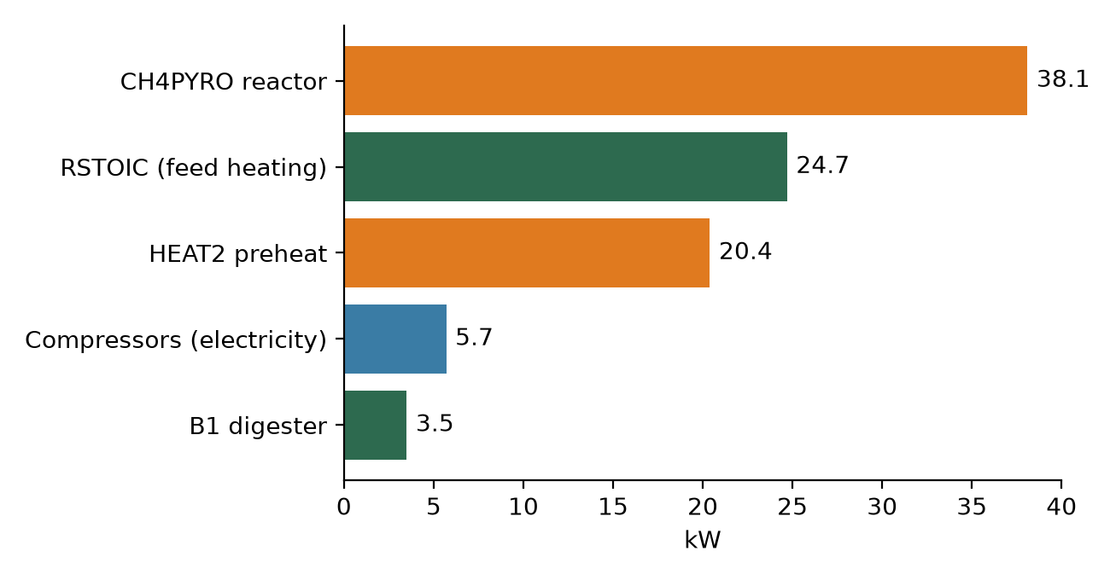
Figure 4. Energy input by unit (kW), design point.

4.3 Reducing the energy demand
Three heat sources in the process are currently unused: the warm digestate (55 °C), the hot product gas (790 °C, about 24 kW of sensible heat) and the CO in the product gas (32.7 kW on a lower-heating-value basis). Table 3 lists screening estimates for using them; Figure 4 shows the effect.
Table 3. Heat-integration options (screening estimates).
Measure | Saving
Digestate (55 → 30 °C) preheats the digester feed | about 24 kW of low-temperature heat
Hot product preheats the pyrolysis feed (economiser) | about 18 kW (90 % of HEAT2)
Burn the CO in the product gas for the 790 °C heat | about 26 kW
Expander on the 10 → 1 bar letdown | about 1.6 kW of power
Together | external heat 86.7 → 18.3 kW (−79 %)

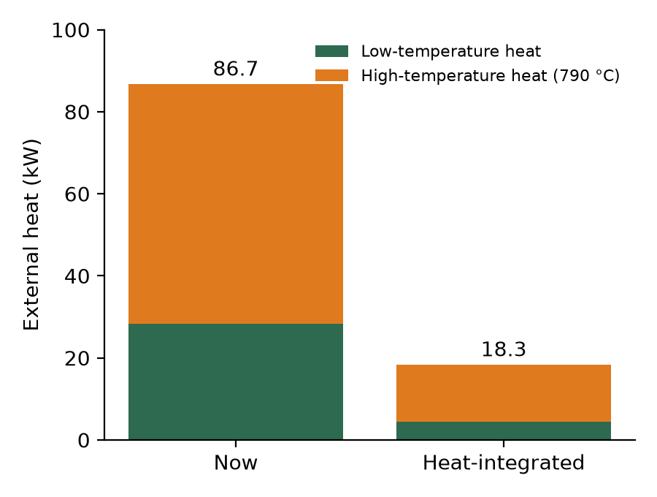
Figure 5. External heat demand now and with heat integration (kW).
These are first estimates with approach temperatures of 25–50 K. A pinch analysis is needed to confirm them, and the hot solid carbon must be separated from the product gas before any heat exchanger.

5 Exergy analysis

5.1 Method
The dead state is T₀ = 25 °C and P₀ = 1.013 bar. The exergy of each stream is calculated from Aspen’s enthalpy and entropy, which are on a formation basis (elements at 25 °C and 1 atm), plus the standard chemical exergies of the elements from Szargut [4] (C 410.26, H₂ 236.09, O₂ 3.97, N₂ 0.72 and S 609.6 kJ/mol):
Ex = F · (H − T₀ S) + Σ_{e} n_{e} · ex°_{e}
For each unit the exergy destroyed is:
Ex_{D} = Σ Ex_{in} − Σ Ex_{out} + Q · (1 − T₀/T_{s}) + W
Heat is assumed to come from hot water at 90 °C for the digester section and from a furnace at 1000 °C for the pyrolysis section. Heat rejected to cooling water at T₀ carries no exergy. As a check, the enthalpy change of every unit matches the Aspen duty within 0.1 %, element balances close, and independent textbook exergy calculations for the gas streams agree within 0.12 %.

5.2 Exergy destruction per unit
A total of 76 kW of exergy is destroyed (Figure 5). Hydrolysis (38.6 kW) and digestion (21.9 kW) account for 80 %, mostly because the biochemical reactions are inherently irreversible and because the feed is heated with fresh heat. The pyrolysis section destroys 10.4 kW (14 %), mainly through heat transfer from the furnace. The pressure letdown after the membrane destroys 2.7 kW, about half of the compressor work. Compression, membrane and gas cleanup together account for less than 4 %.
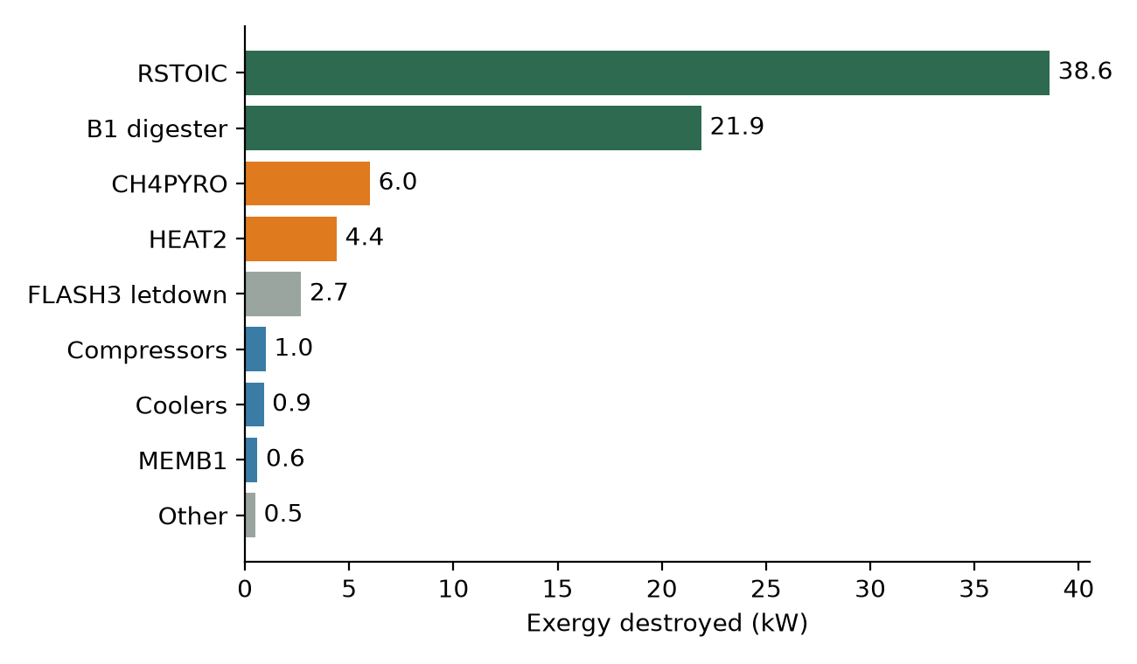
Figure 6. Exergy destroyed per unit (kW).

5.3 Whole-process exergy balance
Table 4. Whole-process exergy balance (kW).
Exergy in | kW | Exergy out | kW
Biomass | 585.4 | Product: H₂ 143.7, carbon 147.1, CO 30.1, heat 11.6 | 332.0
Process water | 7.8 | Digestate (lost) | 207.1
Electricity | 5.5 | Permeate (lost) | 12.6
Heat (exergy of 83.8 kW) | 47.5 | H₂S, NH₃ and water purges (lost) | 18.3
 |  | Destroyed in units | 76.3
Total | 646.2 | Total | 646.2

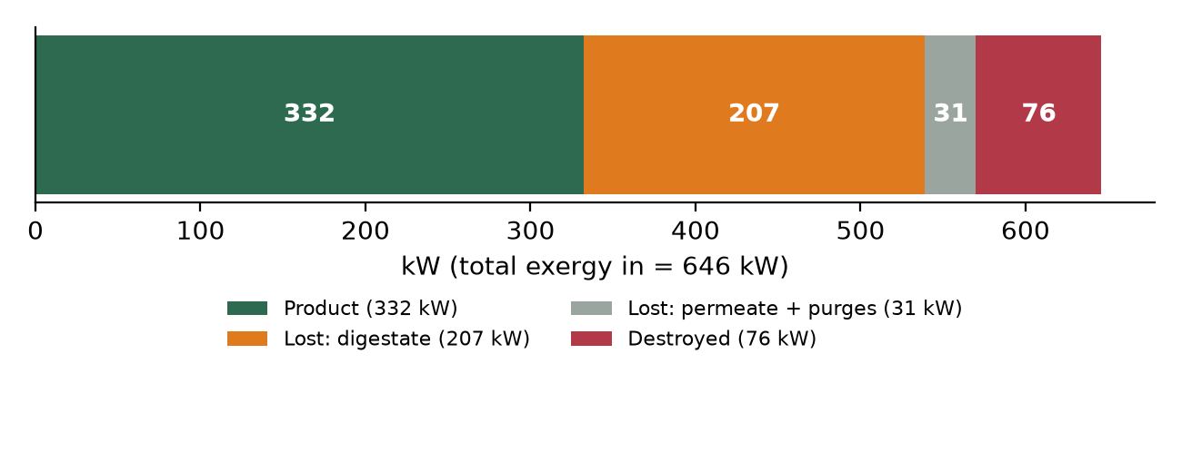
Figure 7. Where the input exergy goes.
The exergy efficiency is 22 % if only hydrogen is counted and 45 % if the solid carbon is counted as a product. The largest single loss is the digestate, which carries 207 kW (a third of the input) as undigested organic matter and warm water.

5.4 Problems identified and the BTP-2 plan
Table 5. Problems identified by the exergy analysis and proposed solutions.
Problem | Proposed solution (BTP-2)
Hot product at 790 °C is not used | Economiser: preheat the pyrolysis feed
Feed heated to 55 °C with fresh heat while the digestate leaves warm | Digestate–feed heat exchanger
Fired heat at 790 °C (fuel and CO₂) | Burn the CO off-gas; energy analysis and pinch analysis
Compression energy lost at the 10 → 1 bar letdown | Expander, or use the pressure downstream

The main focus of BTP-2 will therefore be the economiser and an energy analysis, followed by pinch analysis and optimisation.

6 CO₂ emissions (Scope 1 + 2)

6.1 Boundary and method
Emissions follow the GHG Protocol [8]. Scope 1 covers direct emissions: fuel burned on site for process heat and methane slip in the membrane permeate. Scope 2 covers purchased electricity. Biogenic CO₂ (the CO₂ separated from biogas, and CO₂ from burning biogas-derived gases) is reported separately, as the GHG Protocol requires; biogenic methane that escapes is counted in Scope 1. Scope 3 will be added later.
Table 6. Main inputs to the emission calculation.
Item | Value | Source
Heat demand | 86.7 kW (28.3 low-T, 58.5 high-T) | Aspen simulation
Electricity | 5.69 kW | Aspen simulation
Heater efficiency | boiler 90 %, furnace 80 % | Assumption
Natural gas emission factor | 56.1 kg CO₂/GJ | IPCC 2006, Vol. 2 [6]
India grid | 0.727 kg CO₂/kWh (FY 2023-24) | CEA v20.0 [7]
Coal / thermal power | 0.962 kg CO₂/kWh | CEA operating margin [7]
Hydro, solar | 0 (no combustion) | GHG Protocol Scope 2
CH₄ slip in permeate | 0.65 kg/h, flared at 98 % | Aspen; assumption
GWP of biogenic CH₄ | 27.0 | IPCC AR6 [6]

6.2 Results
Figure 6 compares three heat-supply cases (natural gas, electric heating, heat-integrated) for each electricity source.
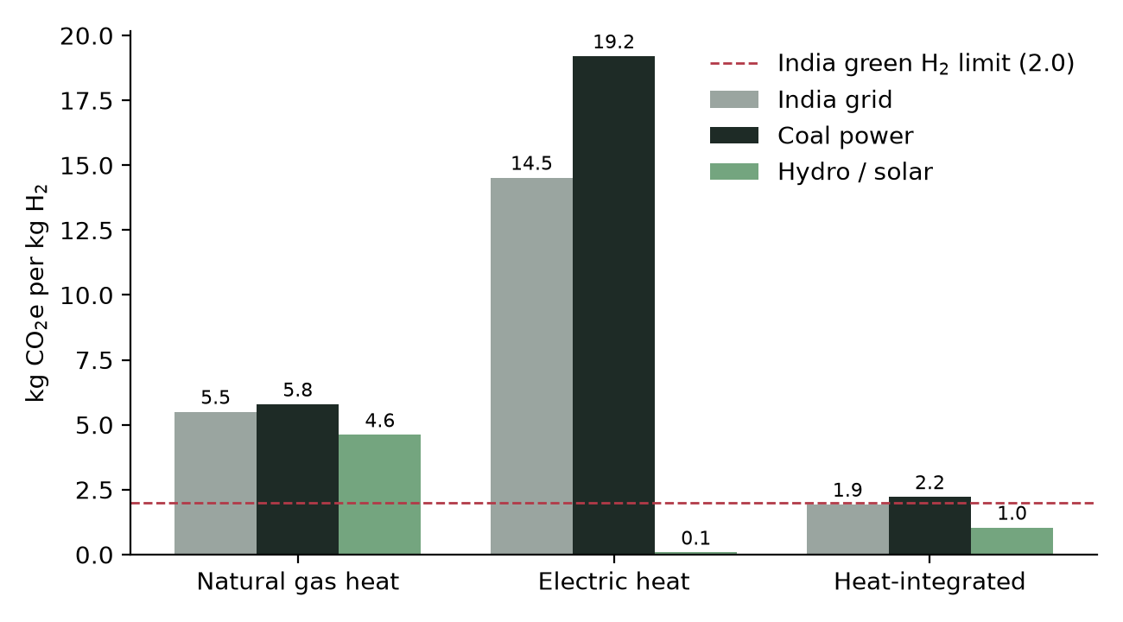
Figure 8. Scope 1 + 2 emissions (kg CO₂e per kg H₂).
- Base case (natural-gas heat, grid electricity): 5.5 kg CO₂e/kg H₂, of which 4.5 comes from natural gas for heat.
- Electric heating is worse on the Indian grid (14.5) or coal power (19.2), but close to zero with hydro or solar power.
- Heat-integrated case: 1.9 kg CO₂e/kg H₂ on grid power, below the 2 kg green-hydrogen limit; about 1.0 with solar or hydro electricity.
- Permeate venting must be avoided: venting the 0.65 kg/h of methane in the permeate instead of flaring it would add 3.8 kg CO₂e/kg H₂.
- The permeate also contains 23.5 kg/h of biogenic CO₂. Capturing it in an absorption column (amine) is planned; together with the stored solid carbon, this could make the process net-negative.
Grey hydrogen emits about 10–12 kg CO₂e/kg H₂ [9]. Even the base case is about half of that.

7 Sensitivity: feed pressure vs separation
The membrane feed pressure sets both the separation and the compression cost. A higher pressure removes more CO₂, which protects hydrogen from the reverse water-gas shift in the pyrolysis reactor, but needs more compressor power and stronger equipment. Perry’s notes that pressure ratios above about 6 become expensive [2].
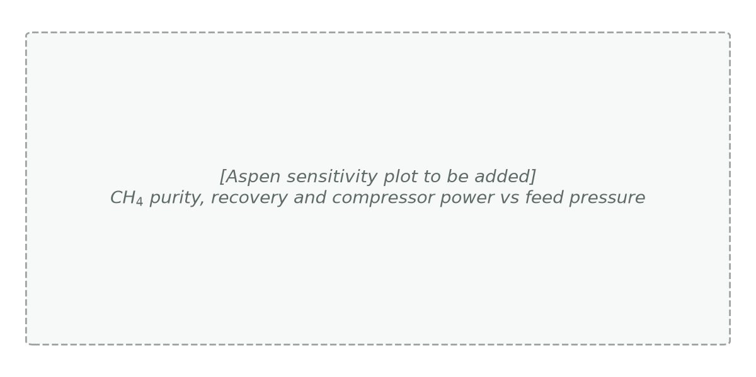
Figure 9. Sensitivity of CH₄ purity, recovery and compressor power to feed pressure (Aspen sensitivity results to be added).
Result: the sensitivity study shows that the current design (10 bar feed, 1 bar permeate, 5 m²) is near optimal. Lowering the pressure saves some compression power but lets more CO₂ reach the reactor, where it consumes hydrogen. The cost of pressure will be weighed in BTP-2.

8 Membrane models for zeolite membranes
Three modelling approaches are commonly used for gas permeation through zeolite membranes. Table 7 compares them and the difficulties of each.
Table 7. Comparison of zeolite membrane transport models.
 | 1. Constant permeance (used) | 2. Adsorption–diffusion (Maxwell–Stefan) | 3. Activated diffusion
Basis | Flux = permeance × partial-pressure difference | Gases adsorb in the pores (Langmuir), then diffuse; CO₂ hinders CH₄ | Molecular sieving; permeance follows an Arrhenius law with temperature
Data needed | One permeance per gas | Adsorption isotherms and Maxwell–Stefan diffusivities per gas | Permeance and activation energy per gas
Captures | Basic separation; simple and robust | Mixture and pressure effects | Temperature effect
Difficulties | Ignores pressure and mixture effects; data measured at 2 bar used at 10 bar | Many parameters; stiff equations; harder to converge in ACM | Activation energies for DDR are scarce; no mixture effect

The constant-permeance model was chosen because reliable DDR permeance data are available [3] and it converges robustly inside Aspen Plus. Building it in ACM brought its own difficulties: the first version used a component ID that did not exist, did not conserve mass, had a hard-coded split and no energy equations. All of these were corrected in the current model. A Maxwell–Stefan model [5] would capture competitive adsorption of CO₂ and CH₄ and is a candidate for later work if isotherm data for DDR can be obtained.

9 Limitations
- Pyrolysis reactions are irreversible, so H₂ is about 4 % above equilibrium; the Boudouard reaction is not included.
- Digester pH is fixed at 6.5–7 (no electrolyte chemistry).
- Hydrolysis conversions are fixed and not yet taken from a source.
- Gas cleanup is ideal (perfect removal of water, H₂S and NH₃).
- The membrane is well-mixed with constant permeances (ideal gas; data at 2 bar applied at 10 bar).
- The catalyst mass (24.7 kg) is small for the tube volume; conversion is nevertheless complete.
- Some amino-acid property data are placeholders; they affect only small streams.
- Heat integration and the CO₂ heat-integrated case are screening estimates, not a pinch analysis; Scope 3 emissions are not included.

10 Conclusions and future work (BTP-2)

Conclusions
- A custom zeolite membrane module was developed in Aspen Custom Modeler and integrated into the Aspen Plus flowsheet; it conserves mass and energy and converges robustly.
- A verified Aspen Plus/ACM model converts 8.5 t/d of wet organic waste into 4.65 kg/h of H₂ and 16.3 kg/h of solid carbon.
- The zeolite membrane at 10 bar raises methane from 59 % to 76 % with 97 % recovery; this pressure is near optimal.
- The 790 °C pyrolysis section needs two-thirds of the process heat; hydrolysis and digestion destroy 80 % of the exergy, and the digestate carries a third of the input exergy out.
- Scope 1 + 2 emissions are 5.5 kg CO₂e/kg H₂ in the base case, about half of grey hydrogen, and about 1.9 with heat integration (below the 2 kg green limit).

Future work (BTP-2)
- Economiser and detailed energy analysis; pinch analysis, then optimisation.
- CO₂ absorption column (amine or ethanol) on the membrane permeate to capture CO₂.
- CO₂ methanation as an alternative to the membrane, and comparison with the current process.
- Cost analysis by electricity source: conventional (coal, hydro) vs solar.
- Further sensitivity studies: pyrolysis temperature, dilution water and digester residence time.
- Scope 3 emissions.

References
[1] Batstone D.J., Keller J., Angelidaki I., et al. (2002). Anaerobic Digestion Model No. 1 (ADM1). IWA Scientific and Technical Report No. 13. IWA Publishing.
[2] Green D.W., Perry R.H. (eds.) (2008). Perry’s Chemical Engineers’ Handbook, 8th ed. McGraw-Hill.
[3] Yang S., Cao Z., Arvanitis A., Sun X., Xu Z., Dong J. (2016). DDR-type zeolite membrane synthesis, modification and gas permeation studies. Journal of Membrane Science 505, 194–204.
[4] Szargut J., Morris D.R., Steward F.R. (1988). Exergy Analysis of Thermal, Chemical, and Metallurgical Processes. Hemisphere.
[5] Krishna R., Wesselingh J.A. (1997). The Maxwell–Stefan approach to mass transfer. Chemical Engineering Science 52, 861–911.
[6] IPCC (2006). Guidelines for National Greenhouse Gas Inventories, Vol. 2, Table 2.2; IPCC (2021). AR6 WG1, Chapter 7, Table 7.15.
[7] Central Electricity Authority (2024). CO₂ Baseline Database for the Indian Power Sector, User Guide Version 20.0.
[8] Ministry of New and Renewable Energy (2023). Green Hydrogen Standard for India; WRI/WBCSD GHG Protocol Corporate Standard and Scope 2 Guidance.
[9] International Energy Agency (2023). Global Hydrogen Review 2023. IEA, Paris.
[10] Smith J.M., Van Ness H.C., Abbott M.M. Introduction to Chemical Engineering Thermodynamics. McGraw-Hill (ideal-gas heat capacities).

Appendix A: Assumptions
Table 8. Main assumptions used in the analysis.
Area | Assumption
Exergy | Dead state 25 °C, 1.013 bar; Szargut element exergies; heat from 90 °C hot water (digester) and a 1000 °C furnace (pyrolysis)
Exergy data | INERT treated as ash (no chemical exergy); retentate entropy from ideal-gas pressure correction
CO₂ | Boiler efficiency 90 %, furnace 80 %; flare efficiency 98 %; 8000 h/yr; GWP of biogenic CH₄ 27.0
Heat integration | Digestate cooled to 30 °C; 90 % of HEAT2 recoverable from hot product; CO burned at 80 % efficiency
Membrane | Well-mixed, ideal gas, no pressure drop; permeances at 297 K applied at 303 K
Pyrolysis | Isothermal 790 °C, 1 bar; power-law kinetics on catalyst mass (carbon-type catalyst)

