**Mockups**

**Online Quiz Application**

James Tory

Arghawan Siddiq

Joyce Borla

Emanuel Ko

**Login**

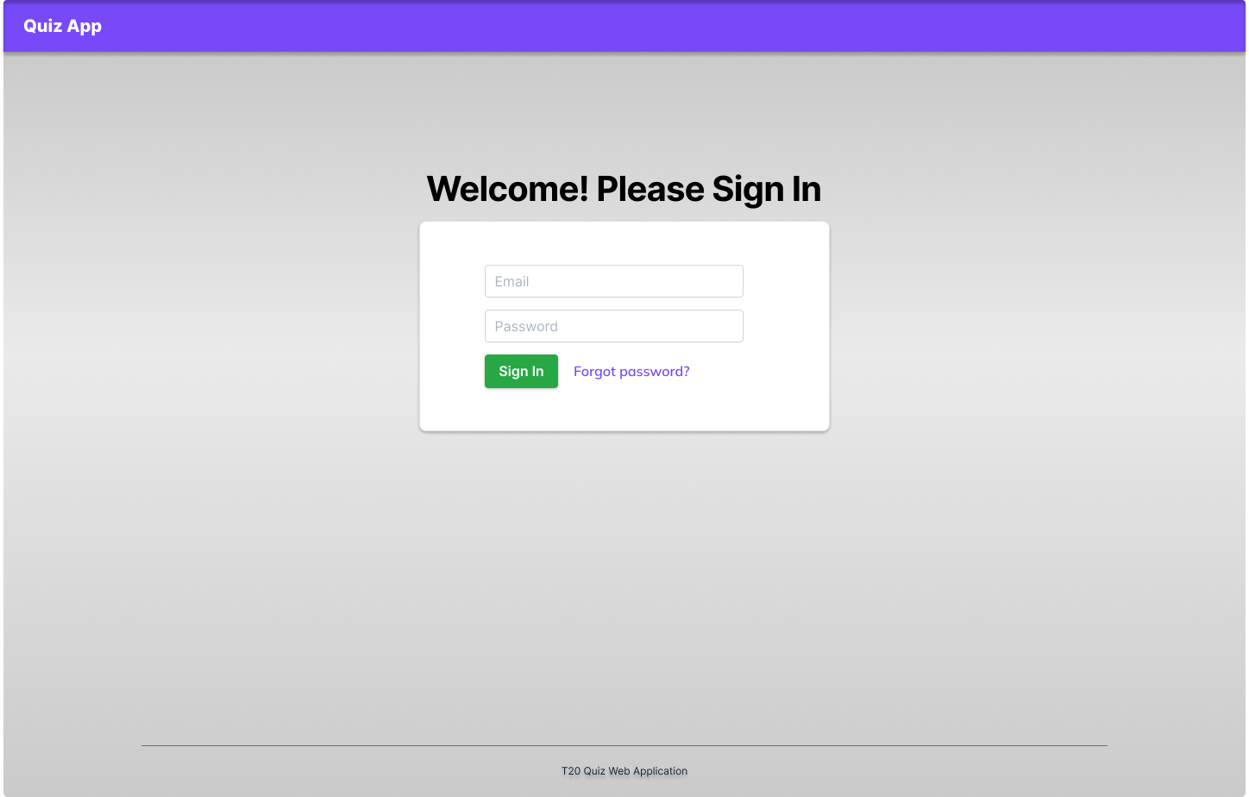

**Student Profile**

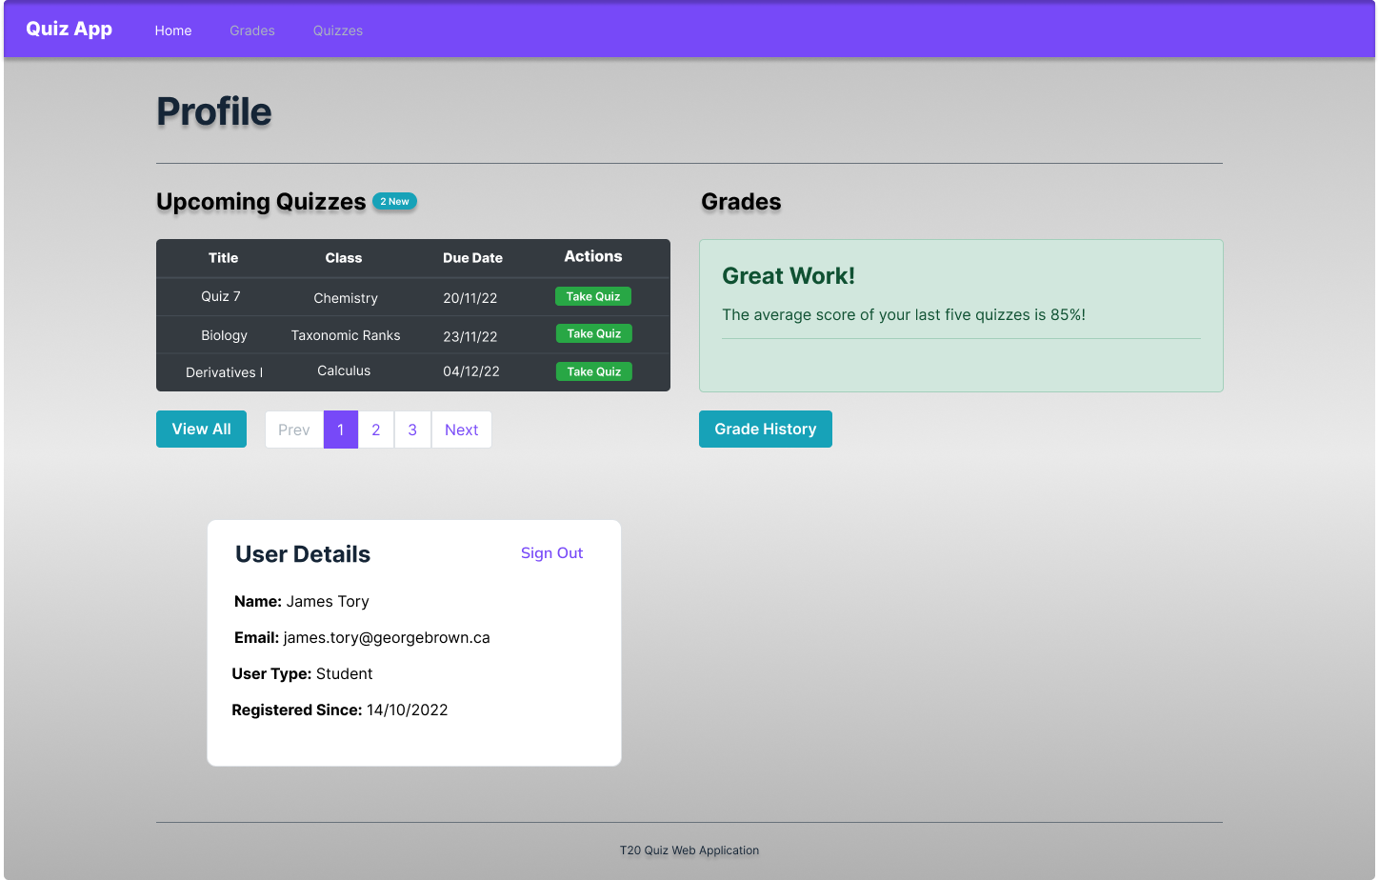

**Student Quizzes**

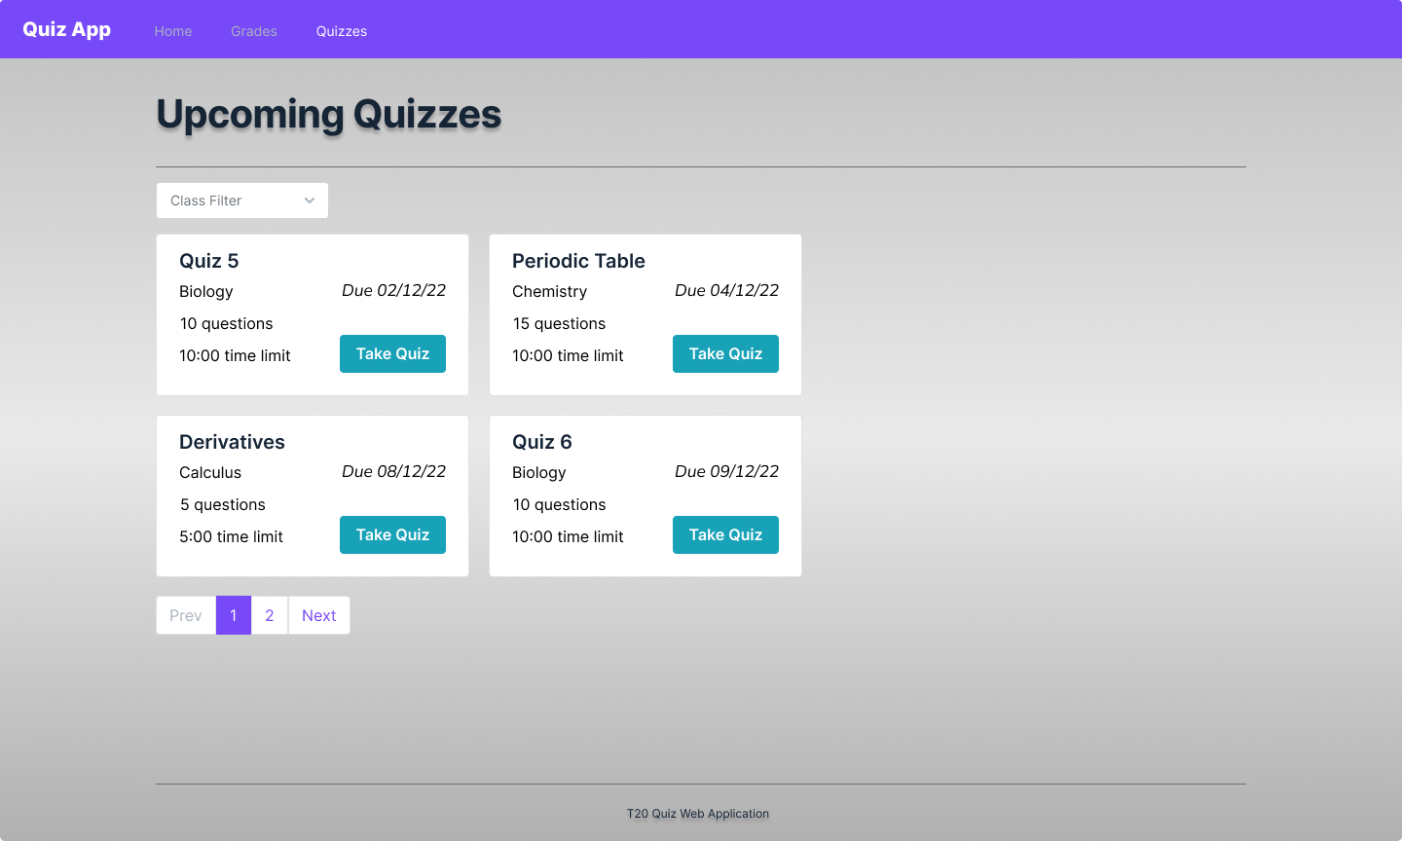

**Student Grades**

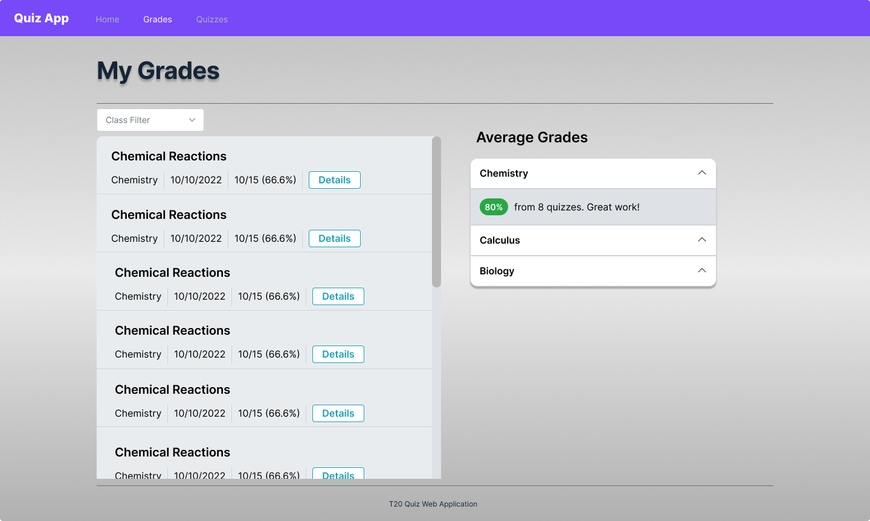

**Quiz Multiple-Choice Question**

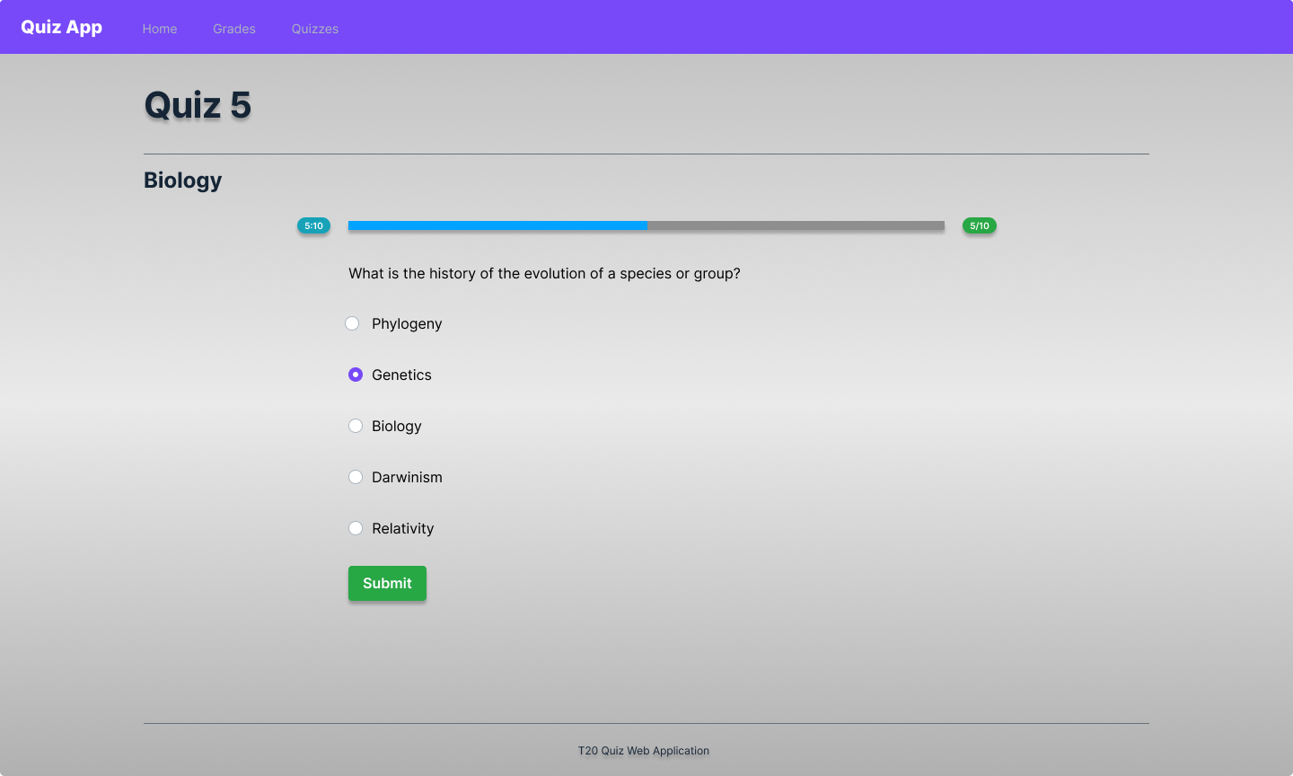

**Quiz Fill-in-the-Blank Question**

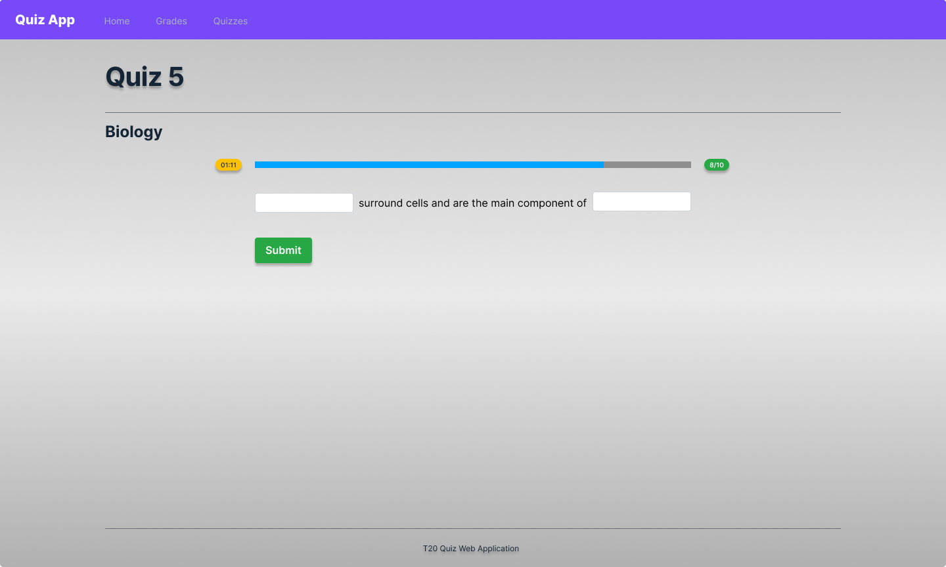

**Quiz Result**

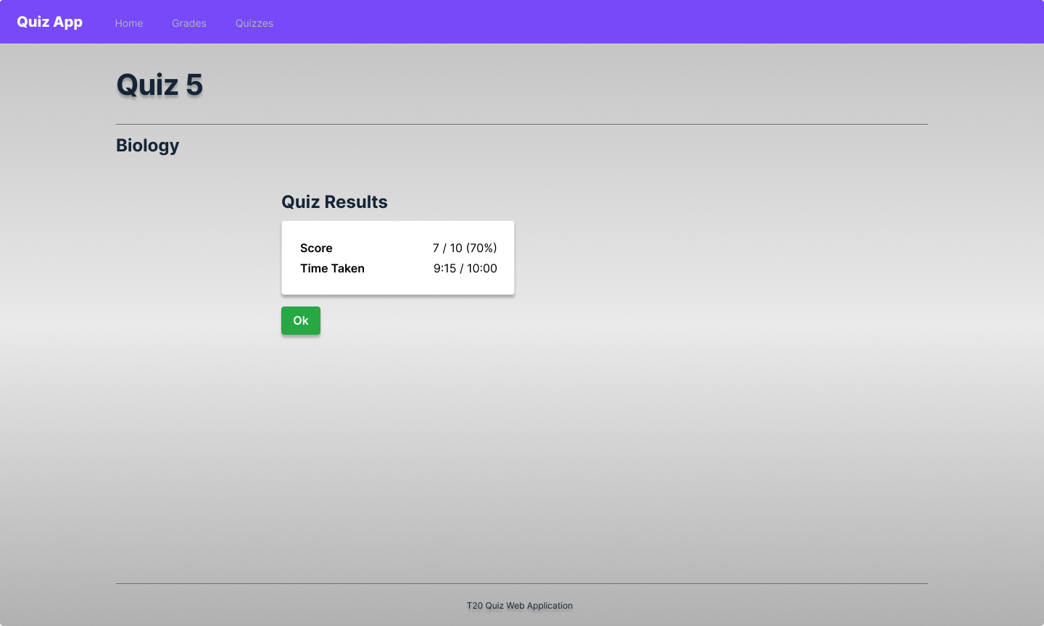

**Instructor Profile**

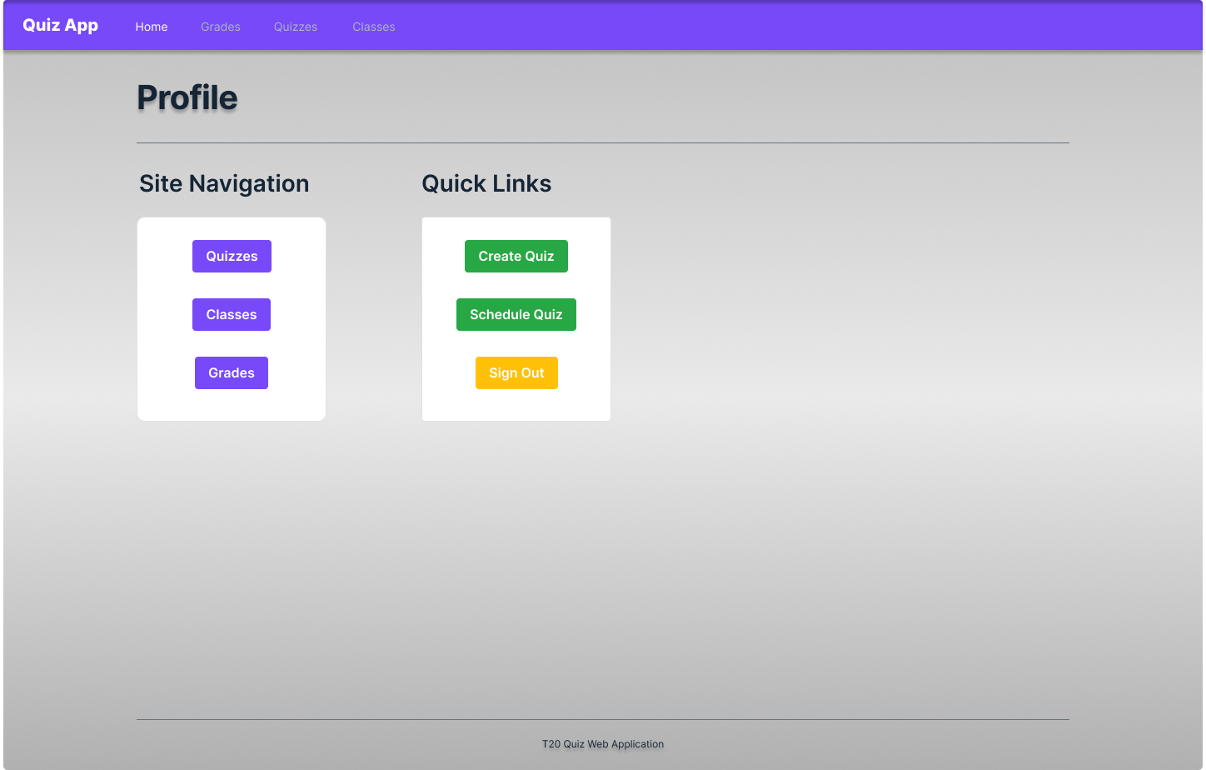

**Instructor Quizzes**

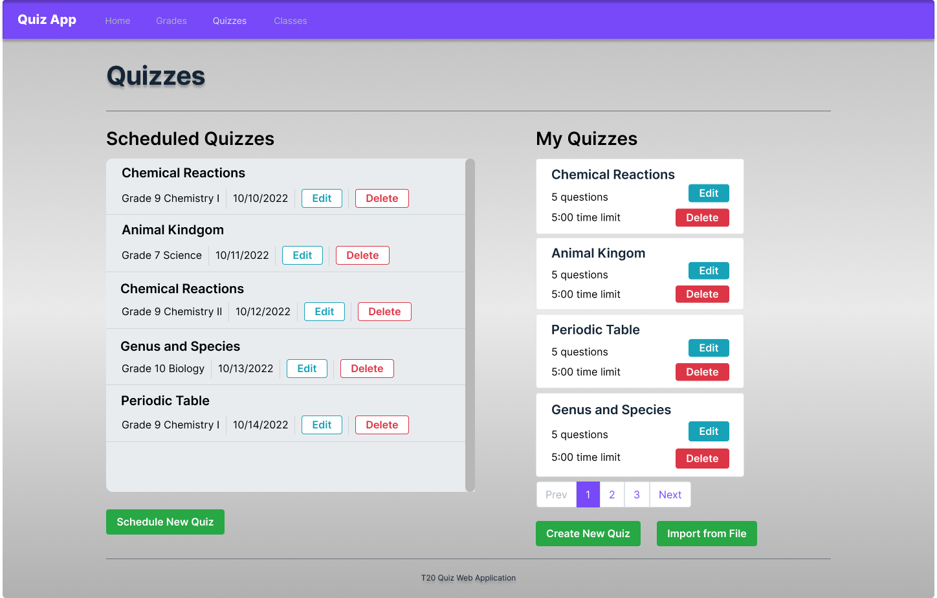

**Instructor Grades**

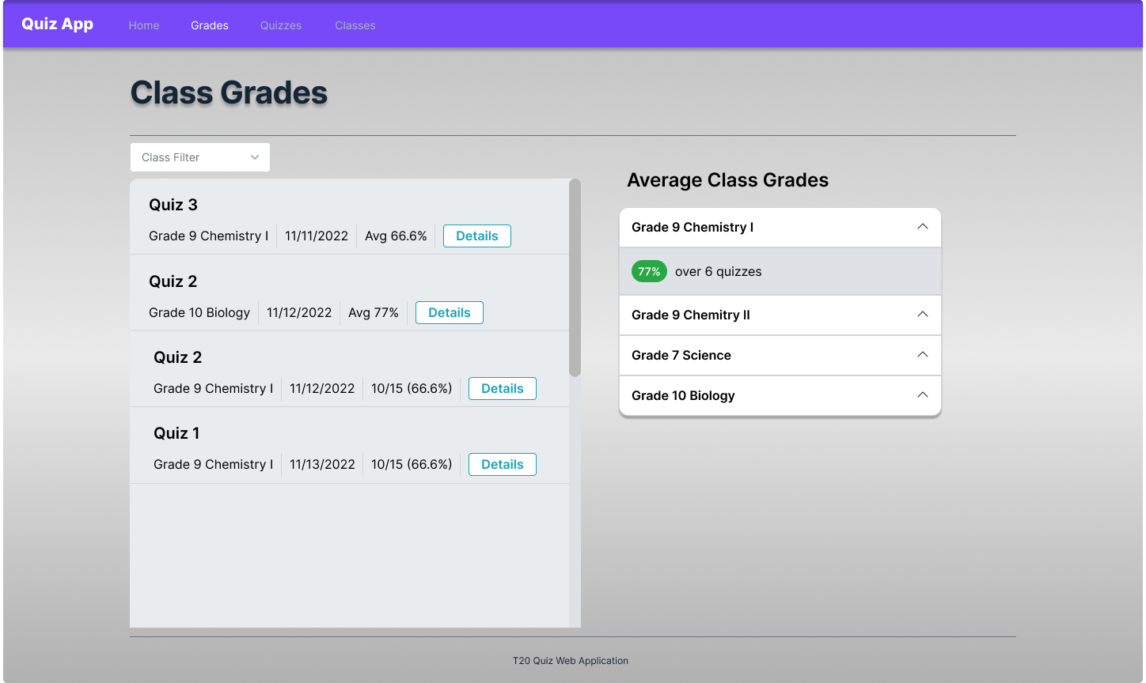

**Instructor Classes**

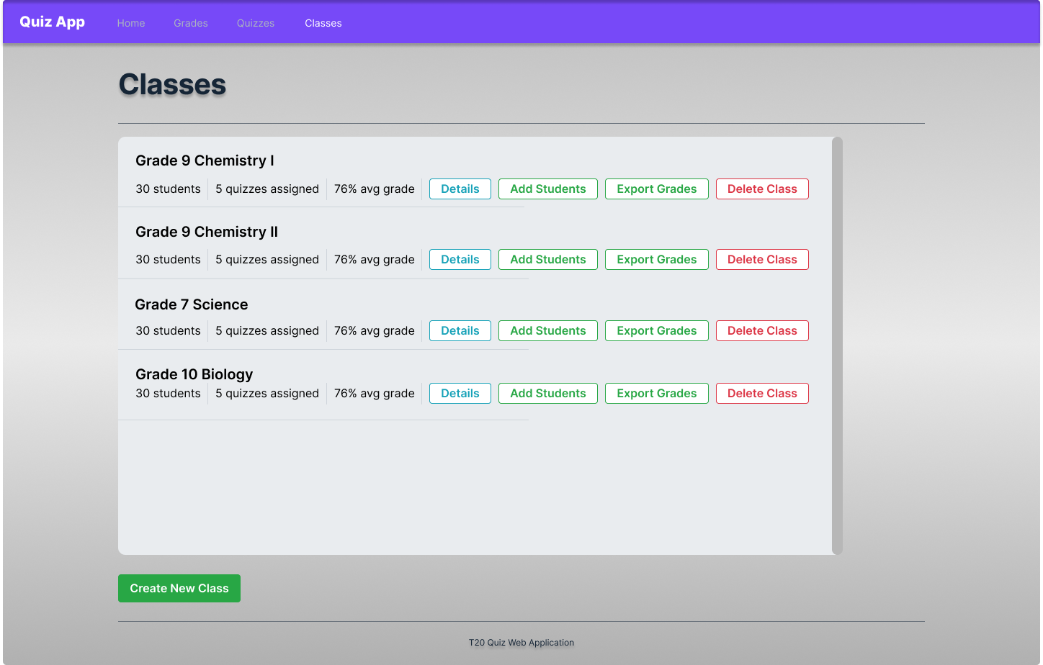

**Create Quiz**

