Project Identification

Project: | Group #20 – Online Quiz Application
Prepared By: | James Tory
Document Version: | 0.3
Published Date: | Oct. 2, 2022

Contributors
The following individuals contributed to this document.
Name | Title
James Tory

Distribution
This document is distributed to all the following people.
Name | Title
James Tory
Joyce Borla
Emmanuel Ko
Arghawan Siddiq

Referenced Documents
This document refers to the following materials
Version number | Title | Author | Date | Source / Location

Revision History

Version Number | Revision Date | Summary of Changes | Modified by
0.1 | 2022/09/28 | First draft | James Tory
0.2 | 2022/09/31 | Added business context diagram | James Tory
0.3 | 2022/10/01 | Updated HLR | James Tory

TABLE OF CONTENTS
1. Business Context Diagram 3
2. REquirements Scope Statements 4
3. High Level Business Requirements (HLR) Traceability 4
4. High Level Business Requirements Sign-Off 5

- Business Context Diagram
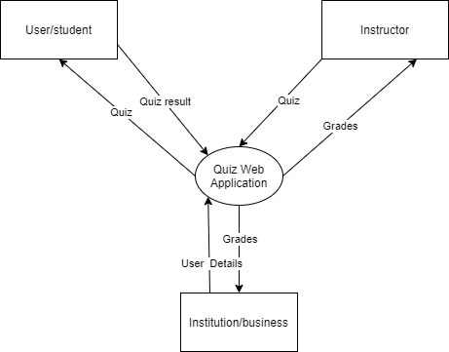

Requirement Scope Area | Description
Quiz Web Application | Area where customers can create educational quizzes for school/training for their students who can then take the quiz online

External Entity | Description
Institution | Educational/training institution that will register multiple instructors and users.
Instructor/teacher | Responsible for creating and scheduling quizzes that will be taken by the users.
User/student | Takes the quizzes that are assigned to them by the instructor as part of their education/training.

Information Flows | Description
Quiz | A quiz created by an instructor using the Quiz Web Application. The users take the quiz after it has been created and assigned by the instructor.
Quiz Result | The result of a single quiz taken by a user (grade and responses chosen)
Grades | Grades of users that have taken quizzes, with different format options, e.g. individual user, class average for a single quiz, average score for all quizzes in the class.
User details | Names and email addresses of users provided by an institution for registration
- Requirements Scope Statements
HLR# | Description | Priority  (H, M, L)
 | Instructor must be able to customize all aspects of the quiz | H
 | Instructor must be able to invite students to use the app through email | H
 | User must receive immediate feedback for their quiz results (if the instructor enables this option) | H
HLR04 | Institution must be able to register instructors and users with them | H
HLR05 | Institution must be able to view grades for all classes of all instructors registered with them
HLR06 | User must be able to join a quiz by entering a unique code provided by the instructor | H
HLR07 | Instructor must be able to save quizzes so they can be used again in the future | H
HLR08 | Instructor must be able to import quiz questions from a formatted file | M
HLR09 | Instructor must be able to create question bank for a quiz so not all users answer the same questions | M

- High Level Business Requirements Sign-Off
Following approval of this document, requirements changes will be governed by the project’s change management process, including impact analysis and appropriate reviews and approvals, under the general control of the Project Plan and according to company policy. Approved Change Request Documents, if present, will be attached to this Requirements Document as updates.

Name | Project Role and  Functional Area | Date Signed
James Tory |  | 2022/10/02
Joyce Borla |  | 2022/10/02
Emmanuel Ko |  | 2022/10/02
Arghawan Siddiq |  | 2022/10/02

* Note: physical signatures are not required. Email approvals are acceptable and should be appended to project documents.

