Blockchain-Based Supplier Registration, Resource Management, and Compliance System
  - Architecture, Functionality, and Business Rules
[Group 8]

Table of Contents
1. Executive Summary 3
2. Problem Statement 3
3. System Architecture 3
4. Data Model 4
5. Business Rules Enforced On-Chain 5
6. Events and Auditability 5
7. Functionality Summary 6
8. Access Control 6
9. Testing 7
10. Business Advantages 8
11. Technology Stack 8
12. Demonstration 9
13. Conclusion 9

Executive Summary
This project implements a decentralized application (DApp) for managing humanitarian resource suppliers on an Ethereum-compatible blockchain. The system automates supplier registration, resource declaration, one-day compliance enforcement, duration-based penalty calculation, and statistical monitoring through a Solidity smart contract. By encoding every business rule in immutable code, it eliminates dependence on centralized authorities and provides a transparent, tamper-resistant audit trail for every action.

Problem Statement
Humanitarian resource management is traditionally handled through centralized databases. This creates single points of failure, allows silent tampering with records, hides compliance information from public view, and requires manual human effort to enforce penalties and deactivations. This project replaces the centralized approach with a self-executing contract that any stakeholder can independently verify.

System Architecture
The system is organized into four layers:
- Presentation Layer — An HTML/CSS/JavaScript frontend served over HTTP. It uses Ethers.js for all blockchain interaction and integrates with MetaMask for signing transactions.
- Wallet Layer — MetaMask holds the user’s private key, prompts for transaction confirmation, and connects the browser to the blockchain through the Ethereum provider API.
- Blockchain Layer — A Hardhat local node (Chain ID 31337, RPC at http://127.0.0.1:8545) hosts the deployed contract and stores all state.
- Contract Layer — The SupplierCompliance.sol contract, written in Solidity 0.8.19, enforces all business rules, holds supplier and resource state, emits events, and exposes view functions for monitoring.
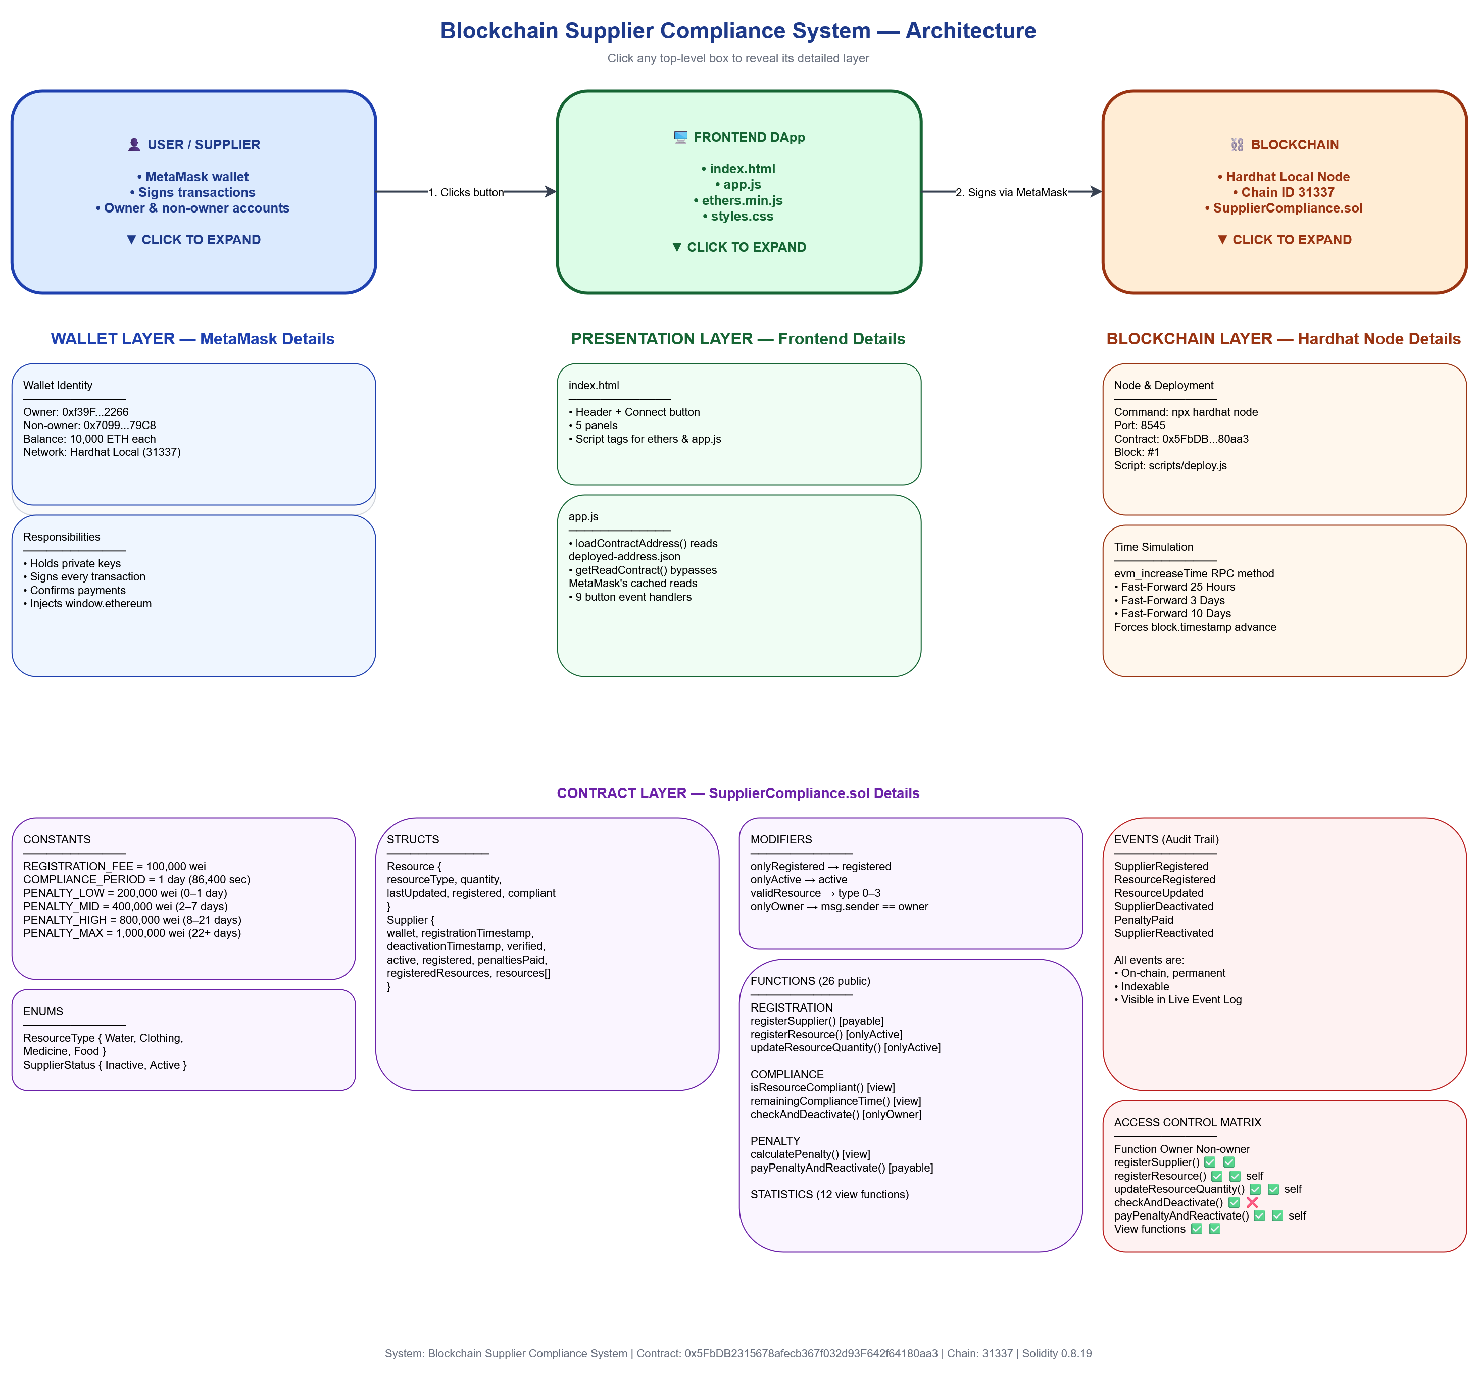
System architecture: The three top-level components (User, Frontend, Blockchain) plus the four layers below (Wallet, Presentation, Blockchain, Contract).

Data Model
The contract uses two structures:
Resource stores the resource type, quantity, last-updated timestamp, a registered flag, and a compliance flag.
Supplier stores the wallet address, registration timestamp, deactivation timestamp, three boolean flags (verified, active, registered), total penalties paid, a list of resource types, and a mapping from resource type to Resource.
All suppliers are held in a mapping keyed by wallet address, and a parallel array tracks addresses for enumeration.

Business Rules Enforced On-Chain
- Registration requires exactly 100,000 wei.
- Duplicate supplier registration is rejected.
- Only four predefined resources are accepted: Water, Clothing, Medicine, Food.
- Only active suppliers can register or update resources.
- Every resource must be updated within 24 hours (86,400 seconds) of its last update.
- Suppliers that fail the compliance rule are automatically deactivated.
- Only the compliance officer (the deploying wallet) can trigger a deactivation.
- Inactive suppliers cannot update resources or register new ones.
- Reactivation requires payment of the exact penalty amount.
- Penalties are tiered by days inactive:
Days Inactive | Penalty
0–1 | 200,000 wei
2–7 | 400,000 wei
8–21 | 800,000 wei
22 + | 1,000,000 wei

Events and Auditability
Every state change emits an event: SupplierRegistered, ResourceRegistered, ResourceUpdated, SupplierDeactivated, PenaltyPaid, SupplierReactivated. These events are permanently recorded on-chain, can be indexed by any block explorer, and form the audit trail that makes the system independently verifiable.

Functionality Summary
Registration. A supplier pays the 100,000 wei fee, and the contract creates a Supplier record. Duplicate registration is rejected.
Resource Declaration. An active supplier registers Water, Clothing, Medicine, or Food with an initial quantity. Each registration sets a compliance timestamp.
Quantity Updates. A supplier updates the quantity of any registered resource. Each update refreshes the compliance timestamp for that resource.
Compliance Monitoring. The contract computes block.timestamp - lastUpdated. If this exceeds 24 hours for any resource, the supplier is non-compliant.
Deactivation. The compliance officer triggers checkAndDeactivate, which sets active = false and records the deactivation timestamp.
Penalty Calculation. The contract computes days since deactivation and returns the appropriate tier. The penalty caps at 1,000,000 wei for 22+ days.
Reactivation. The supplier pays the exact penalty amount via a payable function, and the contract sets active = true and resets every resource’s compliance timer.
Statistics. Public view functions return supplier counts, active and inactive counts, aggregate resource quantities, per-supplier details, and total penalties collected.

Access Control
The contract implements two forms of access control.
Status-based. The onlyActive modifier restricts resource operations to currently active suppliers. The onlyRegistered modifier restricts operations to wallets that have registered as suppliers.
Role-based. The contract records the deploying wallet as owner (the compliance officer) in an immutable state variable. The onlyOwner modifier restricts checkAndDeactivate to that wallet. Any other wallet that attempts to call it receives a revert with the message Only compliance officer can call this.
Function | Owner | Non-owner
registerSupplier() | ✅ | ✅
registerResource() | ✅ | ✅ (self)
updateResourceQuantity() | ✅ | ✅ (self)
checkAndDeactivate() | ✅ | ❌
payPenaltyAndReactivate() | ✅ | ✅ (self)
View functions | ✅ | ✅

Testing
The test suite contains 25 automated tests covering registration, resource declaration, quantity updates, the compliance mechanism, deactivation, penalty calculation across all four tiers, reactivation, statistics, and access control. All 25 tests pass. The compliance and penalty tests use Hardhat’s time.increase() helper to advance the blockchain clock, exercising the time-based rules without waiting real hours.
Test coverage by category:
- Supplier Registration — 4 tests
- Resource Registration — 5 tests
- Quantity Management — 2 tests
- Compliance Mechanism — 4 tests
- Deactivation — 3 tests
- Penalty and Reactivation — 5 tests
- Statistics — 2 tests

Business Advantages
Automated compliance. The 24-hour update rule is enforced by block.timestamp checks inside the contract. No compliance officer needs to review records. The rule applies identically to every supplier.
Transparency. Any stakeholder — a donor, an auditor, a member of the public — can query the contract for the complete state of any supplier. Nothing is hidden behind administrative privilege.
Traceability. Every registration, update, penalty, and reactivation is timestamped and immutable. Historical records cannot be altered, edited, or deleted. A supplier’s full history can be reconstructed from the event log.
Automated penalty enforcement. Penalties are calculated and enforced by the contract. The supplier cannot resume operations until the exact penalty is paid. There is no invoicing step, no collection cost, and no opportunity for dispute over the amount.
Resource monitoring. Statistics are computed on-chain in real time. Aggregate quantities per resource, active and inactive supplier counts, and total penalties collected are available instantly via view functions.
Reduced dependence on centralized control. No single party can alter the rules, hide a deactivation, or favor one supplier over another. The contract’s behavior is identical for every participant. Only the compliance officer’s role is privileged, and even that role cannot alter historical data.

Technology Stack
Component | Technology | Version
Smart Contract | Solidity | 0.8.19
Development Framework | Hardhat | 2.29.1
Local Blockchain | Hardhat Network | —
Wallet | MetaMask | Latest
Frontend Library | Ethers.js | 5.7.2
Testing | Chai + Mocha | —
Runtime | Node.js | 18+
Package Manager | npm | Latest

Demonstration
The DApp was demonstrated end-to-end:
- A supplier was registered with the 100,000 wei fee.
- Resources were declared (Water, Food) with initial quantities.
- Quantities were updated, refreshing the compliance timers.
- The compliance deadline was simulated using Hardhat’s evm_increaseTime RPC method.
- The compliance officer deactivated a non-compliant supplier.
- An attempted update by the inactive supplier was rejected.
- The penalty was calculated at each tier from 200,000 to 1,000,000 wei.
- The penalty was paid, and the supplier was reactivated.
- Resource updates resumed successfully.
- A second wallet was used to verify that only the compliance officer can trigger deactivation.
Every step was captured as a screenshot in the screenshots/ folder.

Conclusion
This project demonstrates that a smart contract can deliver the full lifecycle of supplier management — registration, monitoring, compliance enforcement, penalty collection, and reactivation — with more reliability and transparency than a centralized database. The system is tested, documented, and fully functional. It provides a production-ready model for humanitarian resource governance on an Ethereum-compatible blockchain.
Contract Address: 0x5FbDB2315678afecb367f032d93F642f64180aa3
Network: Hardhat Local (Chain ID 31337)
Deployer / Compliance Officer: 0xf39Fd6e51aad88F6F4ce6aB8827279cffFb92266

