House Price Prediction — Analysis Report
Property Valuation Analysis | Dataset: 545 Residential Properties

Objective
To build a predictive model that estimates property price based on key attributes such as area, number of rooms, amenities, and locational advantages — and to identify which factors influence price most strongly.

Approach
- Data was cleaned and verified: no missing values or duplicate records were found, and categorical attributes were converted into numerical form.
- The dataset was split 80/20 into training and testing sets.
- Two models were trained and compared: Linear Regression and Random Forest Regressor.

Model Results
Model | MAE | RMSE | R² Score
Linear Regression | ₹9.70 Lakh | ₹13.25 Lakh | 0.653
Random Forest | ₹10.23 Lakh | ₹14.01 Lakh | 0.611

Actual vs Predicted Price
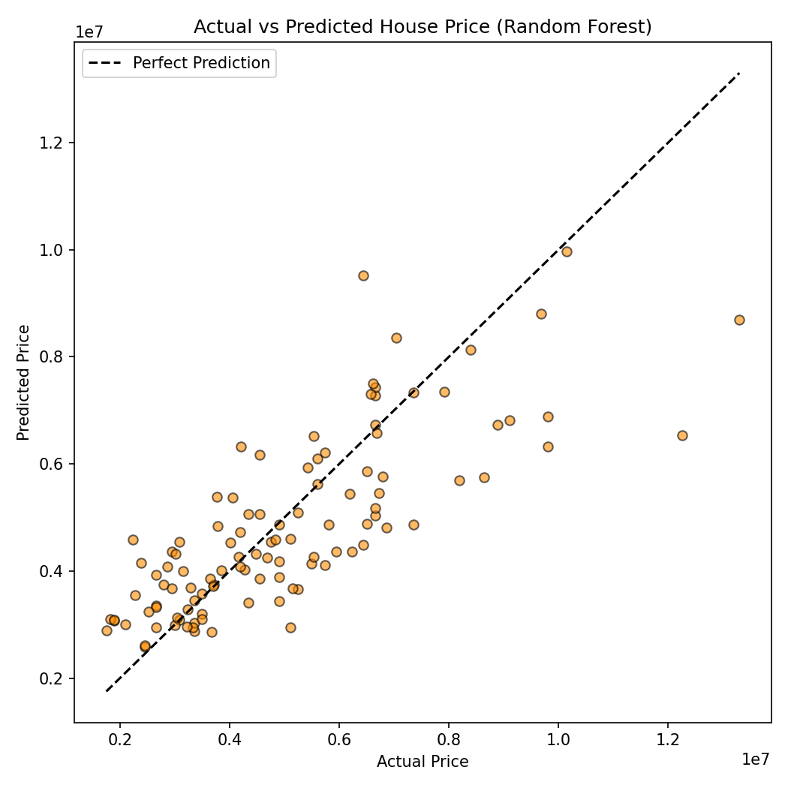

Key Insights
- Property area and number of bathrooms have the strongest influence on price, followed by air conditioning and preferred-area location.
- Linear Regression (R² = 0.65) performed marginally better than Random Forest (R² = 0.61), likely because the dataset is limited in size and the underlying relationships are largely linear.
- The model tends to under-predict high-value properties, most likely due to limited representation of premium listings in the dataset.

Recommendation
Property listings should prominently feature carpet area and bathroom count, as these are the strongest price drivers. Highlighting amenities such as air conditioning and preferred-locality status as value-add features may further support stronger pricing. For premium/luxury properties, manual valuation review is advised, as the model's accuracy is comparatively lower in that segment.

