Contents

Purpose 2

Step 1: Create Application Load Balancer 2

Step 2: Create Security Group for the would-be EC2 instances 5

Step 3: Create Launch Template 6

Step 4: Create Auto Scaling Group 8

Step 5: Verification 13

# Purpose

Purpose of this exercise is to create an Application Load Balancer & have the underlying EC2 instances created by an Auto Scaling Group using a Launch Template. It is demonstrated in following diagram

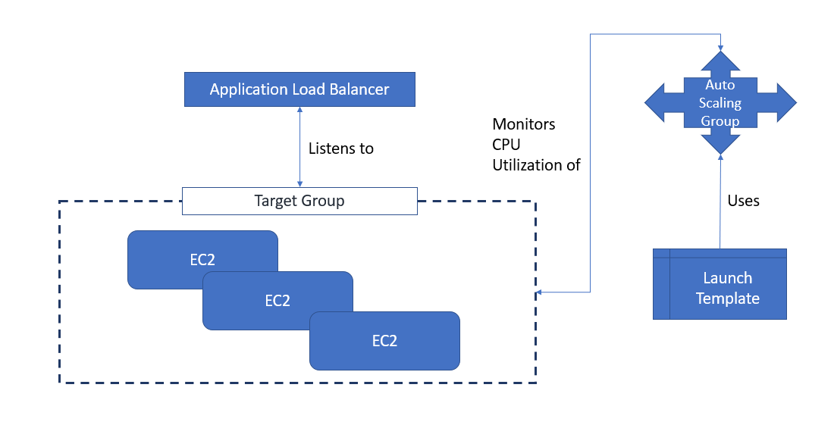

# Step 1: Create Application Load Balancer

In this step we will create an Application Load Balancer that will forward HTTP 80 traffic to port 8081

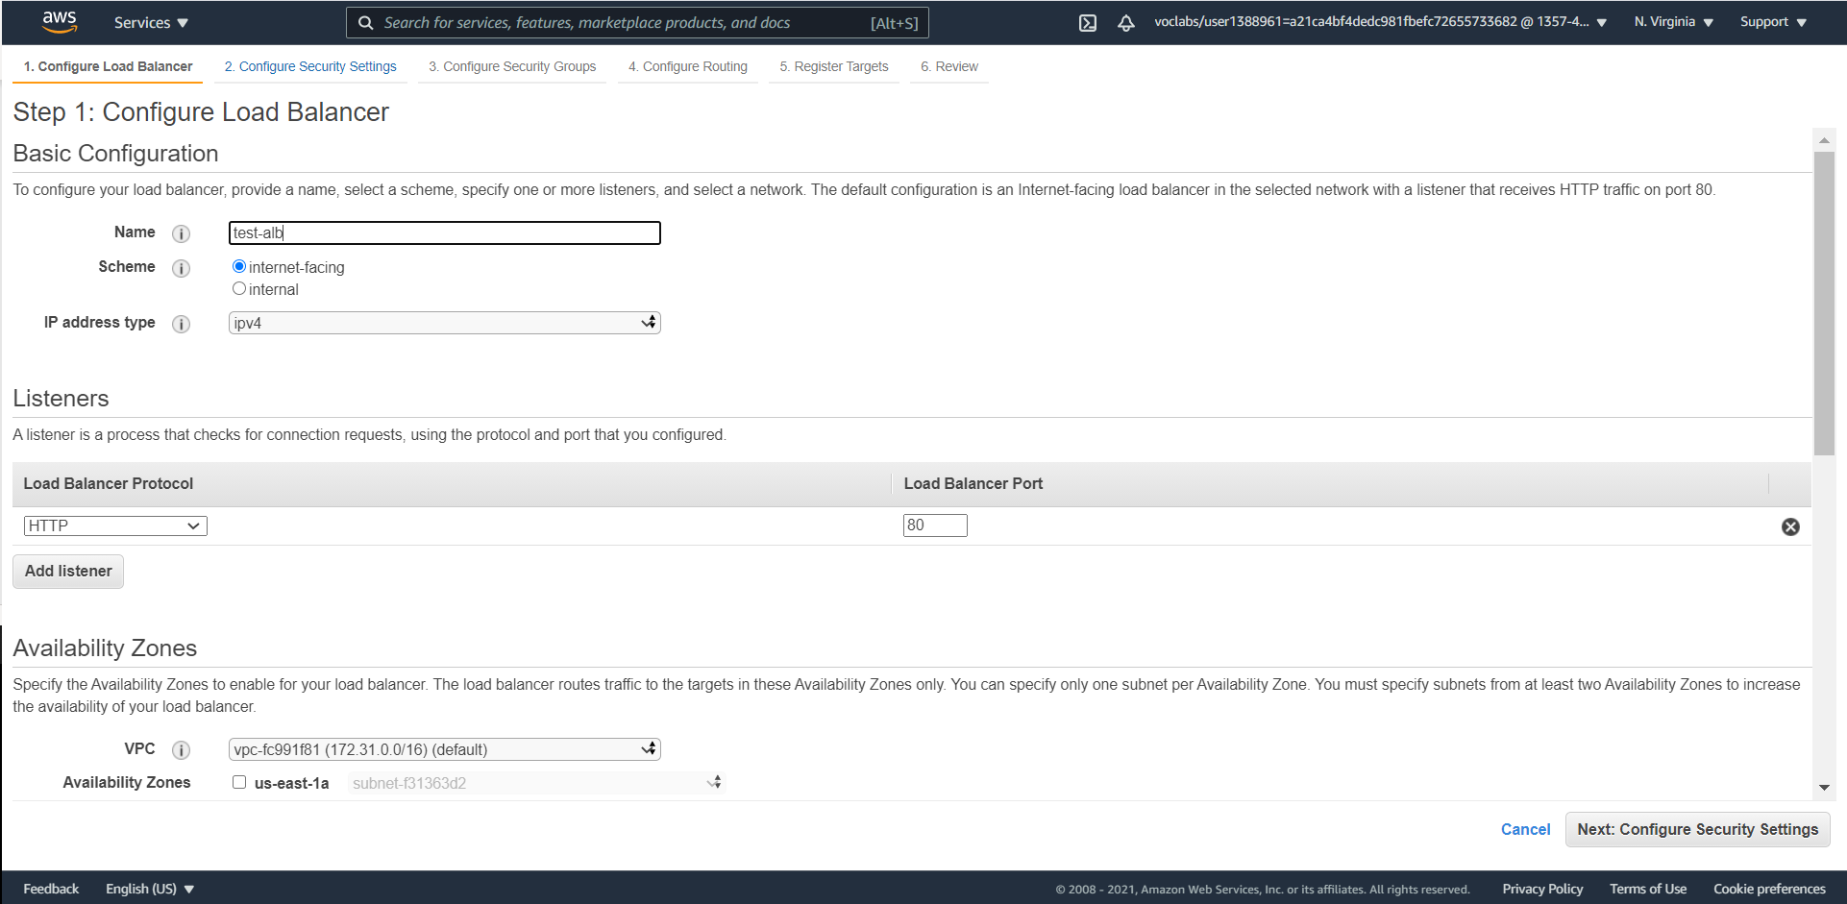

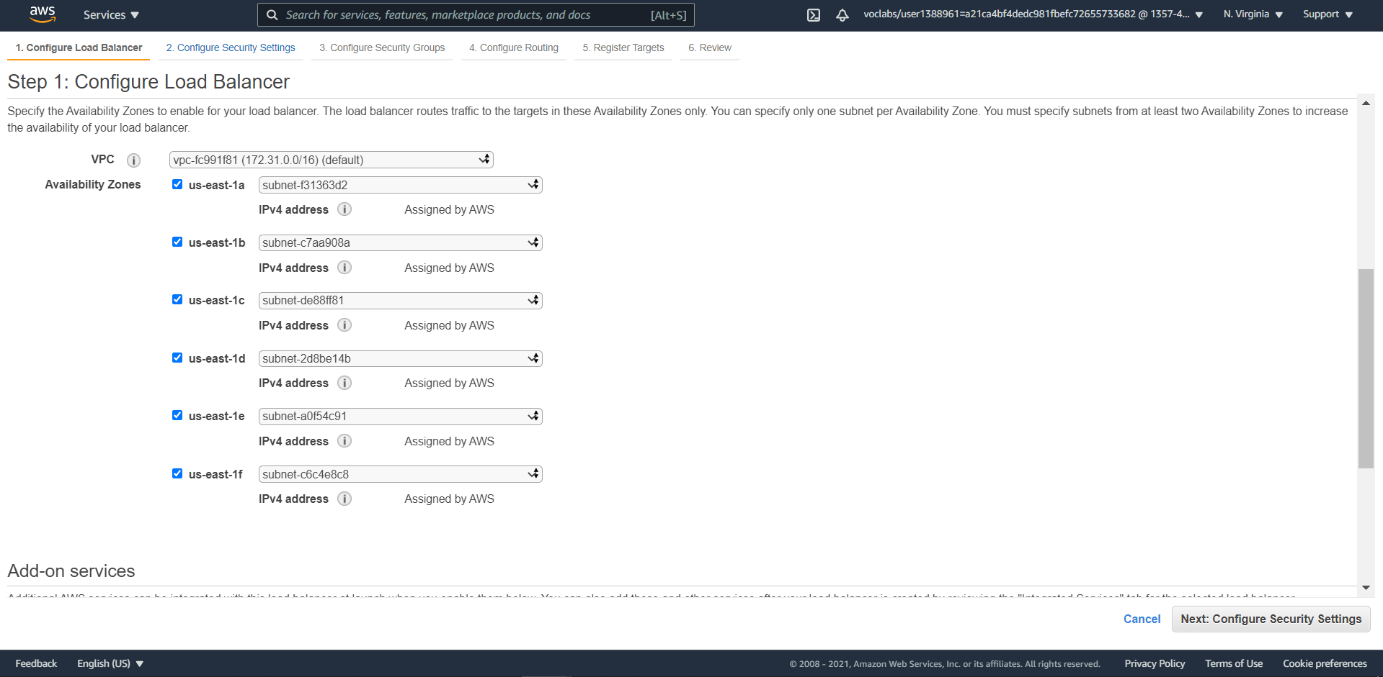

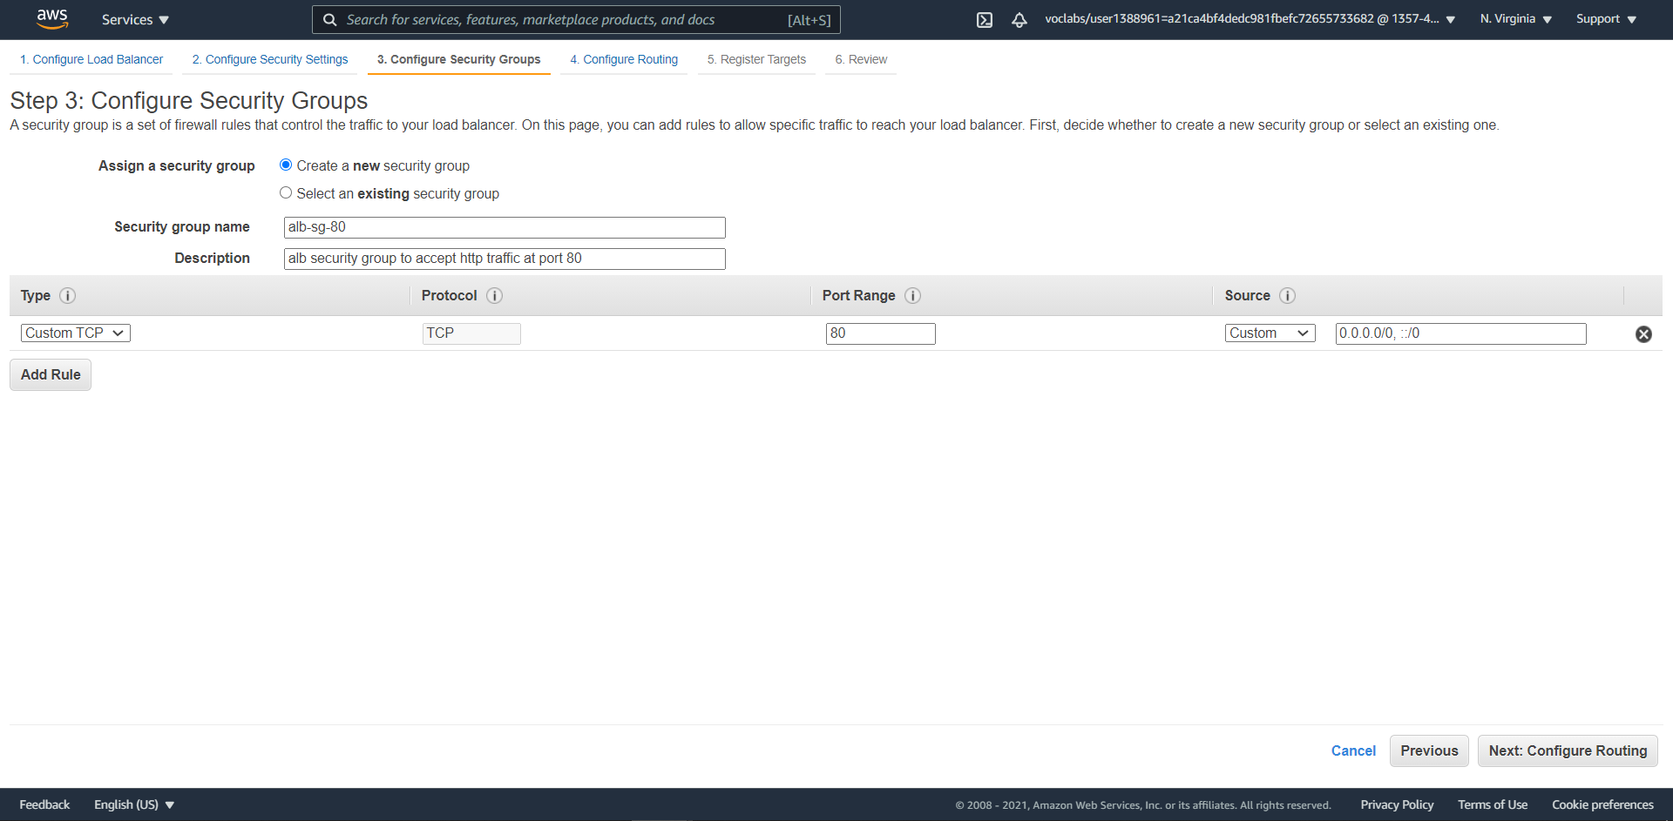

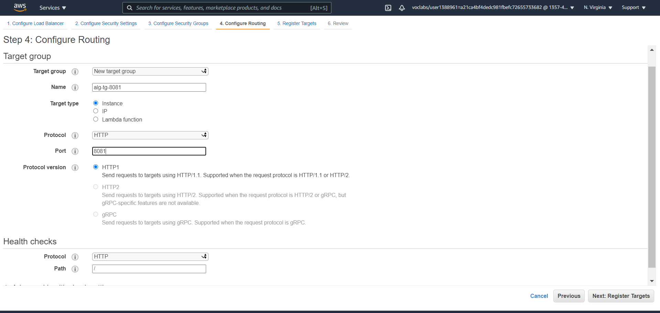

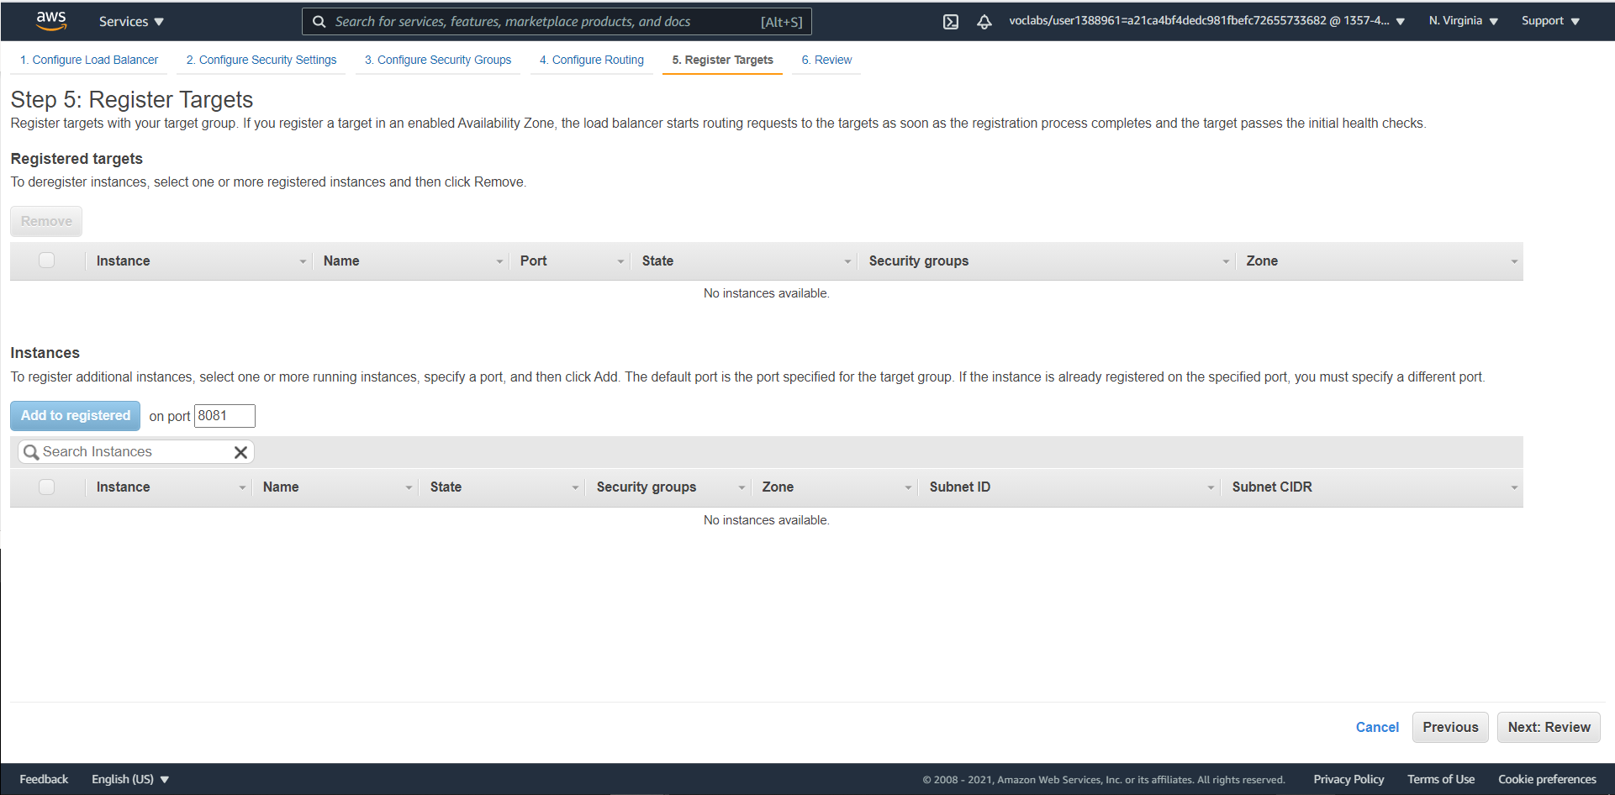

**DO NOT REGISTER ANY TARGETS. THEY WIL BE ADDED BY ASG**

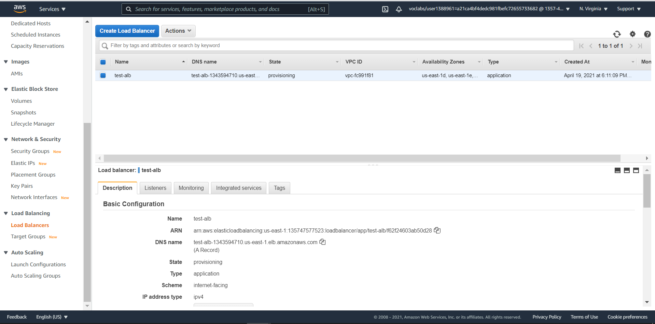

# Step 2: Create Security Group for the would-be EC2 instances

In this step we will create a Security group that will accept

1. Ssh traffic from anywhere
2. HTTP 8081 traffic from the Application Load Balancer Security Group

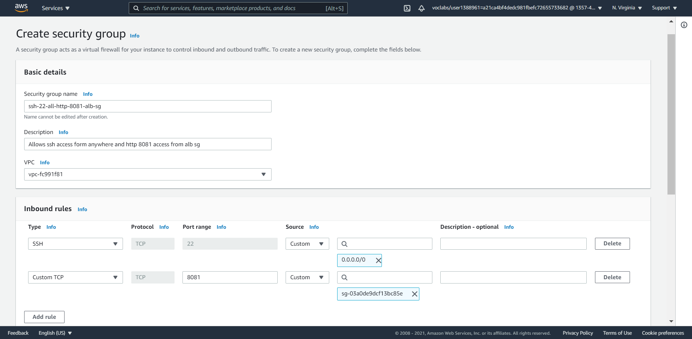

Security Group of The Application Load Balancer

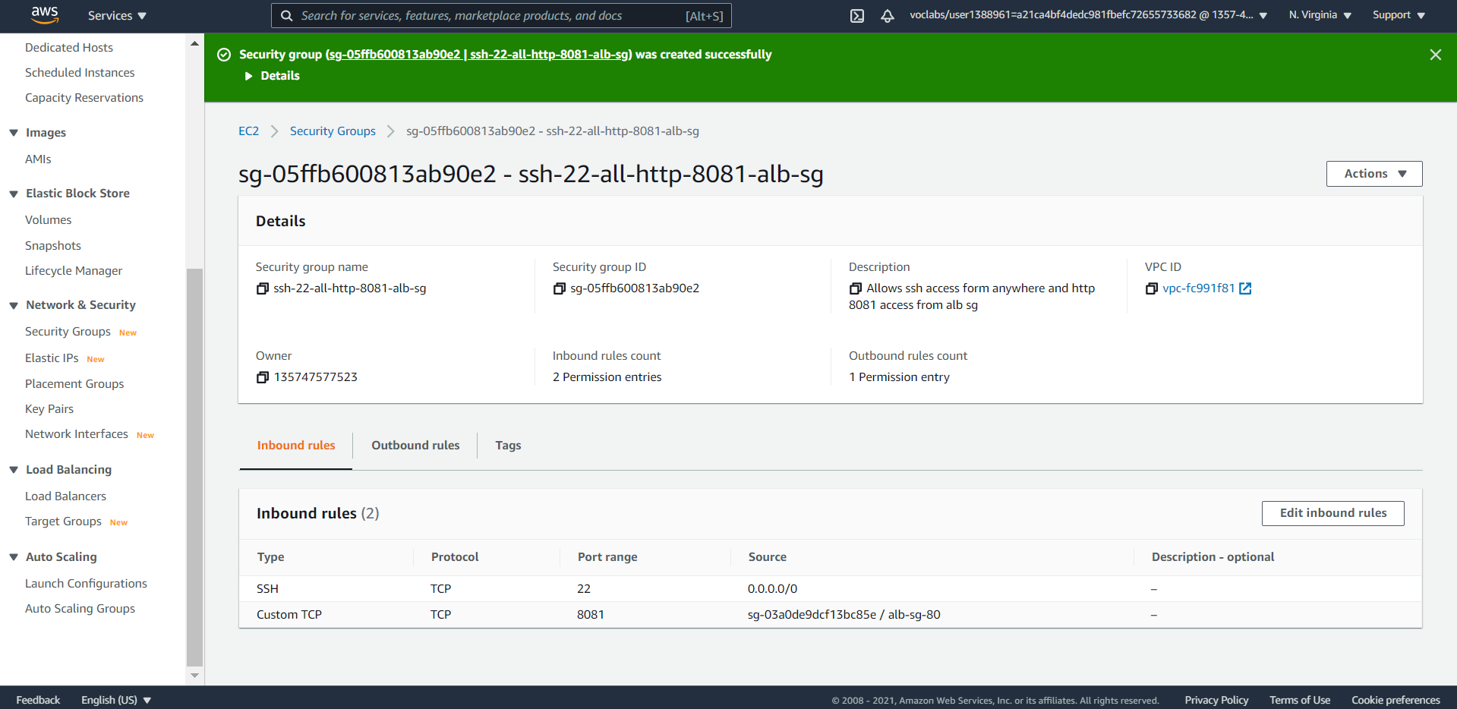

# Step 3: Create Launch Template

In this step we will create the launch template using which Auto Scaling Groups can create new EC2 instances

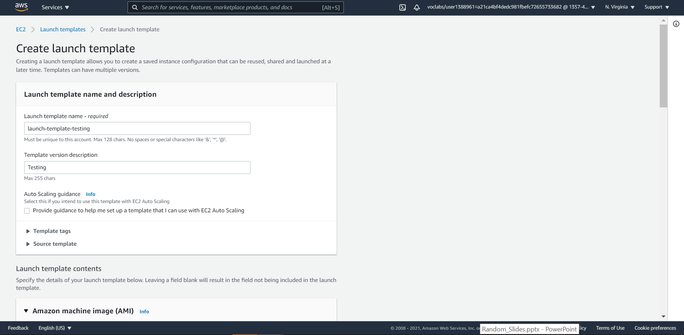

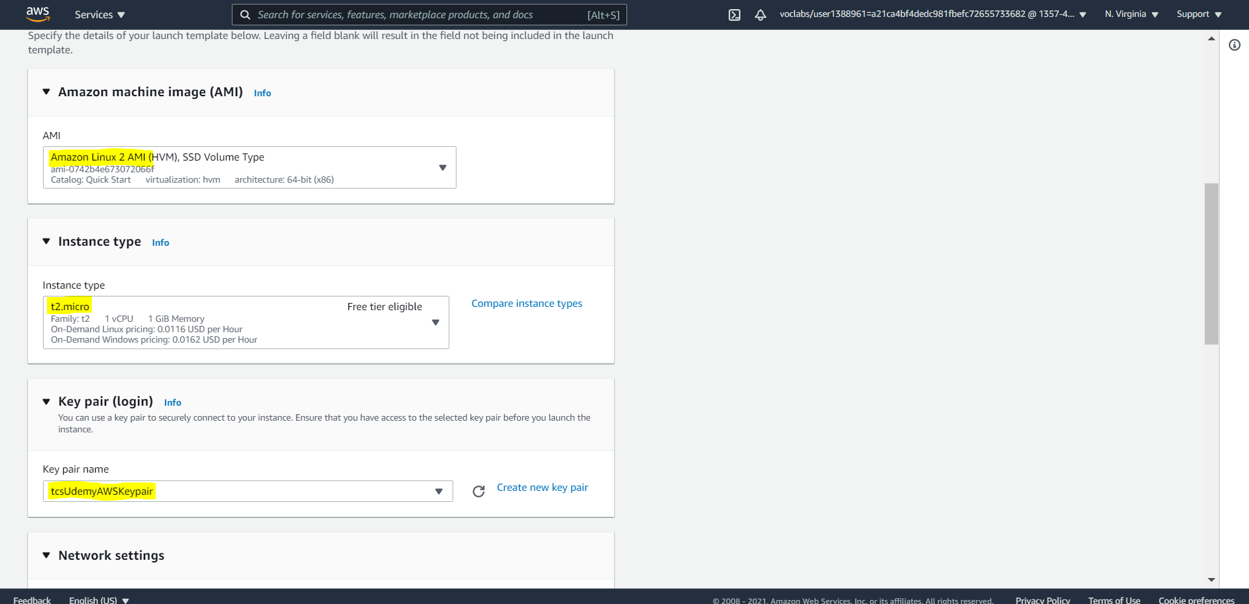

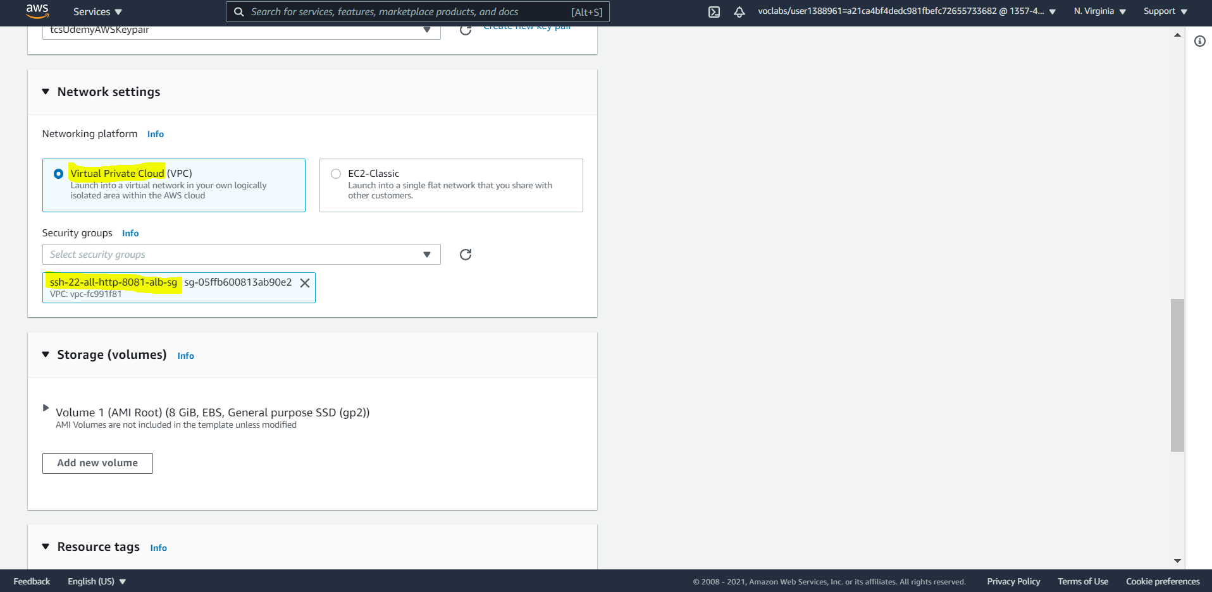

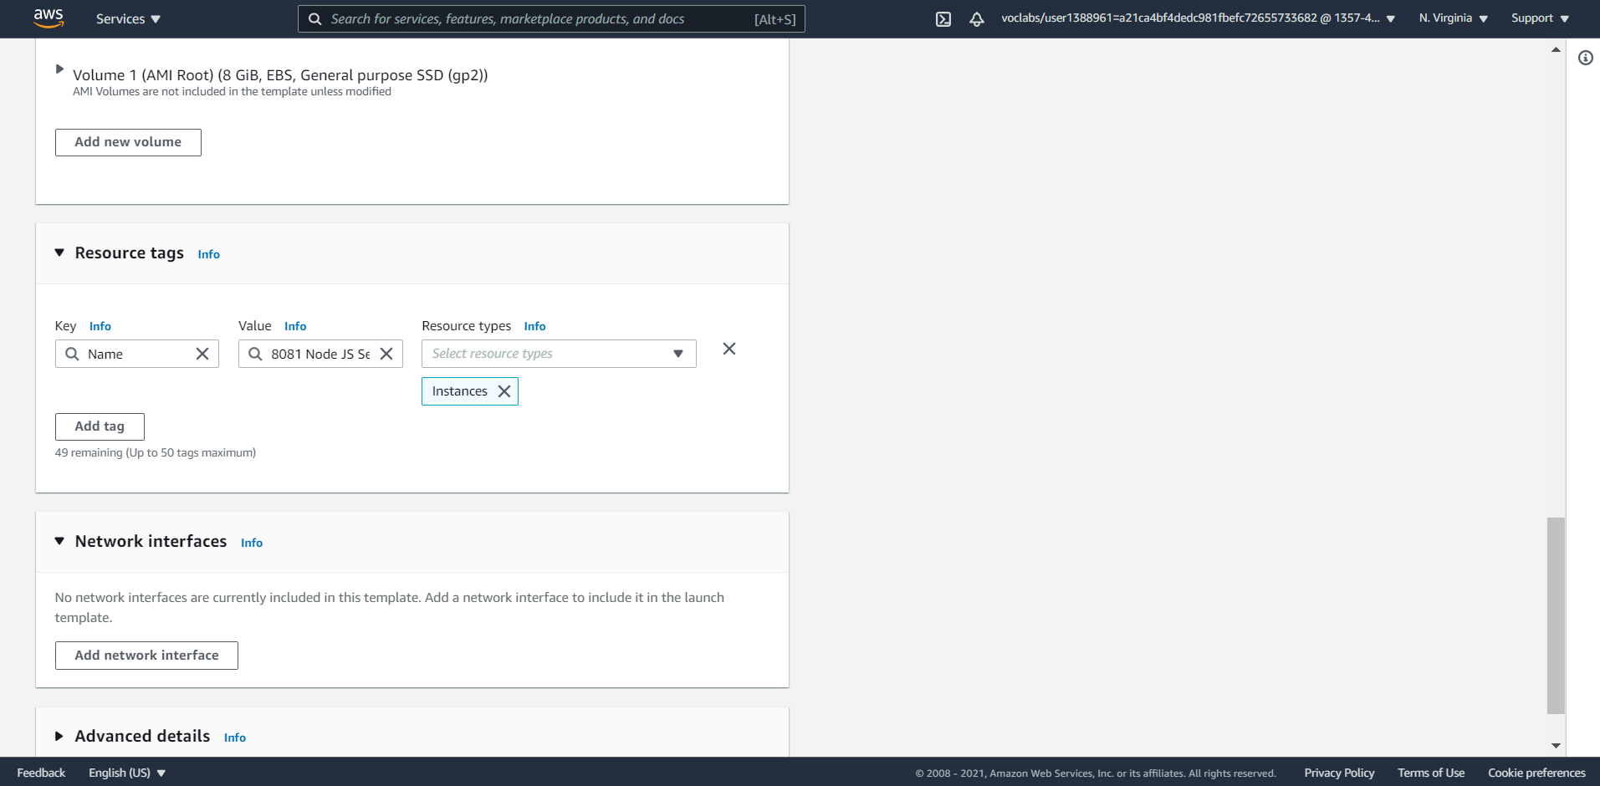

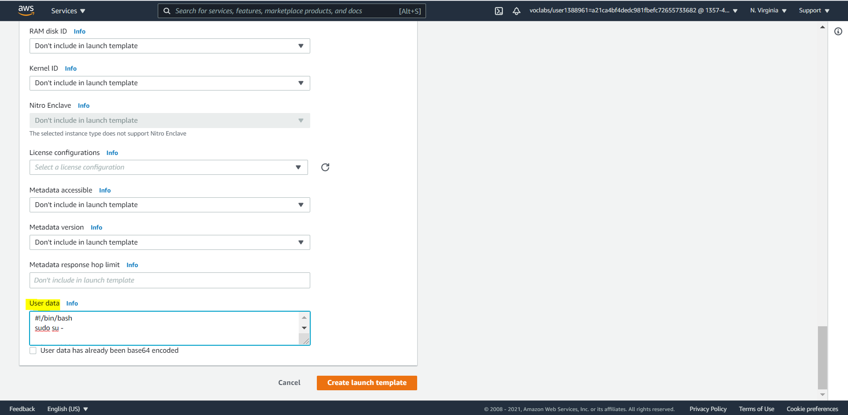

IMPORTANT: Expand “Advanced” section 🡪 Scroll to the end 🡪 Copy paste the content of “ec2-user-data.sh”. This will allow node js to be installed, a server script to be created and the service started

# Step 4: Create Auto Scaling Group

Now that all other pieces of puzzle are ready, its time to create the Auto Scaling Group that will bring all the pieces together

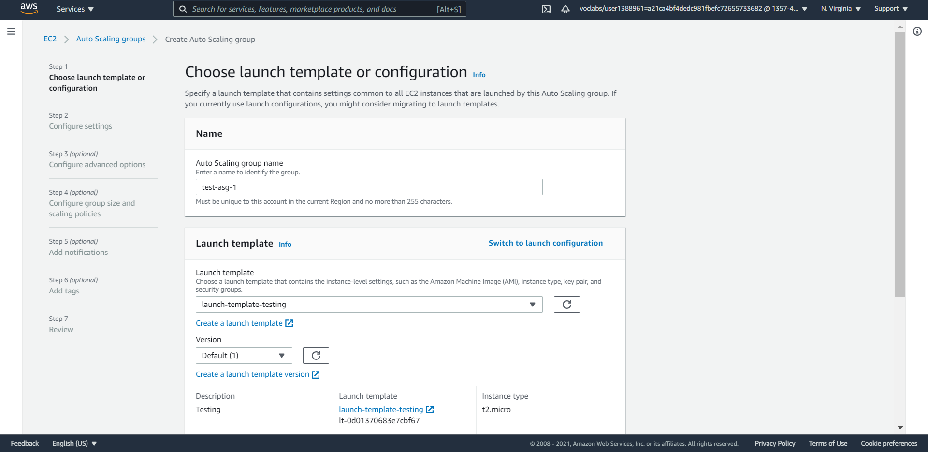

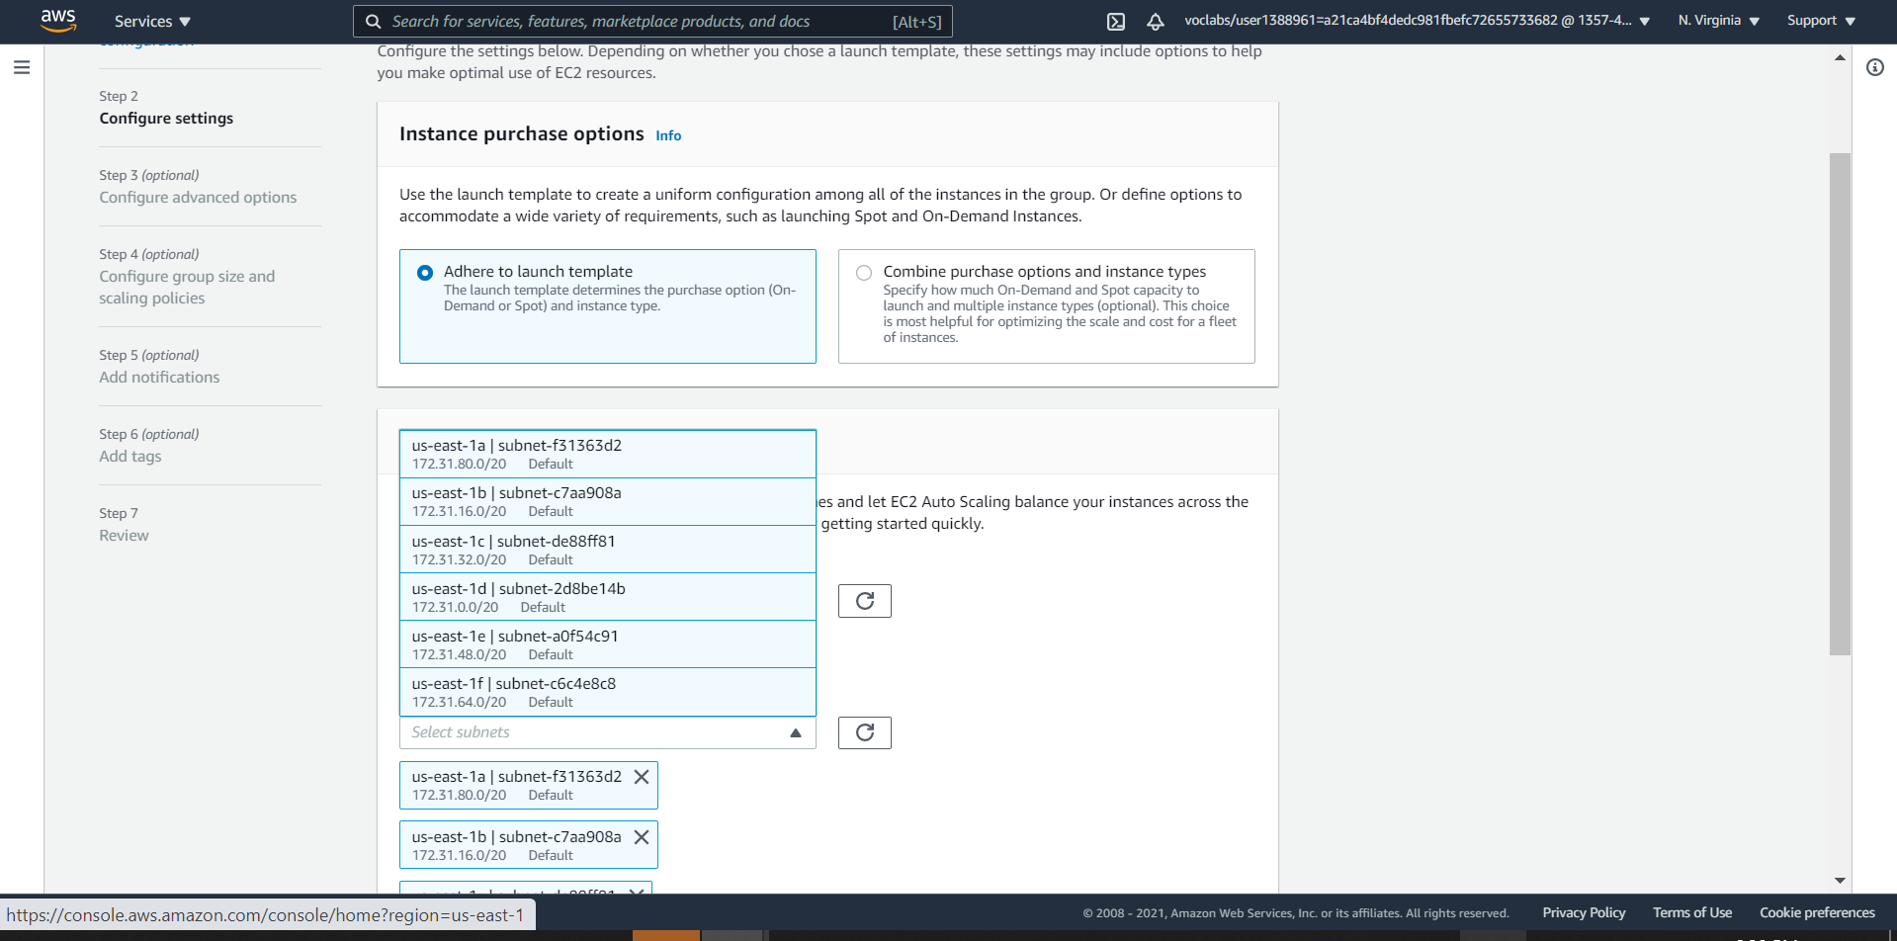

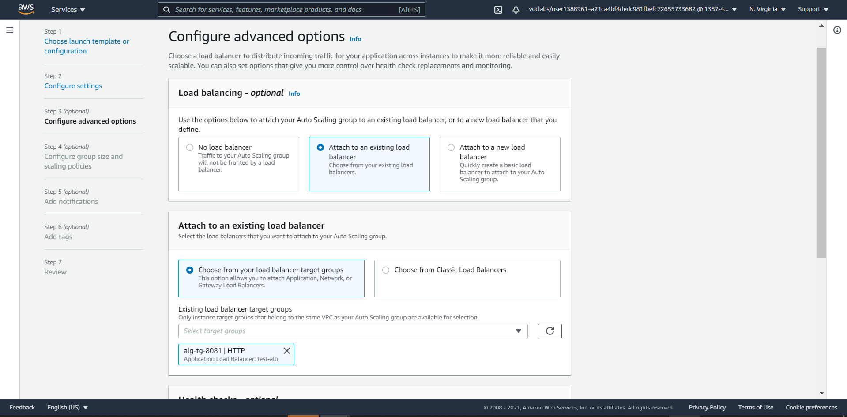

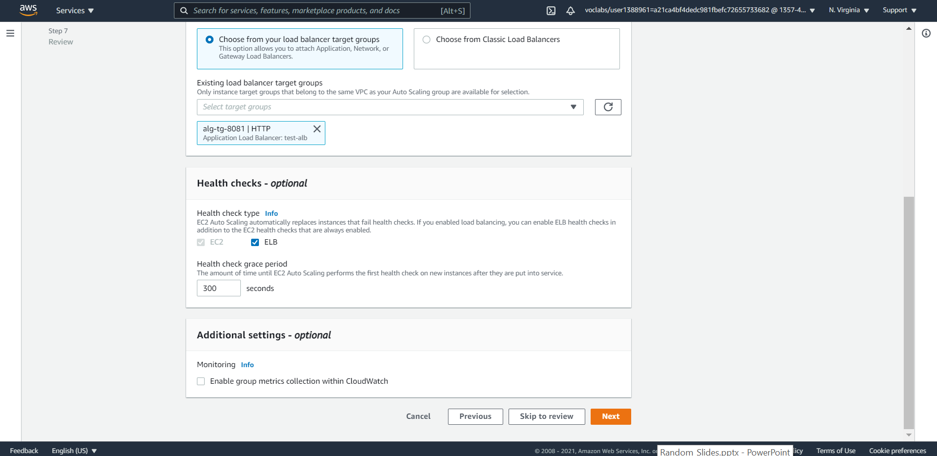

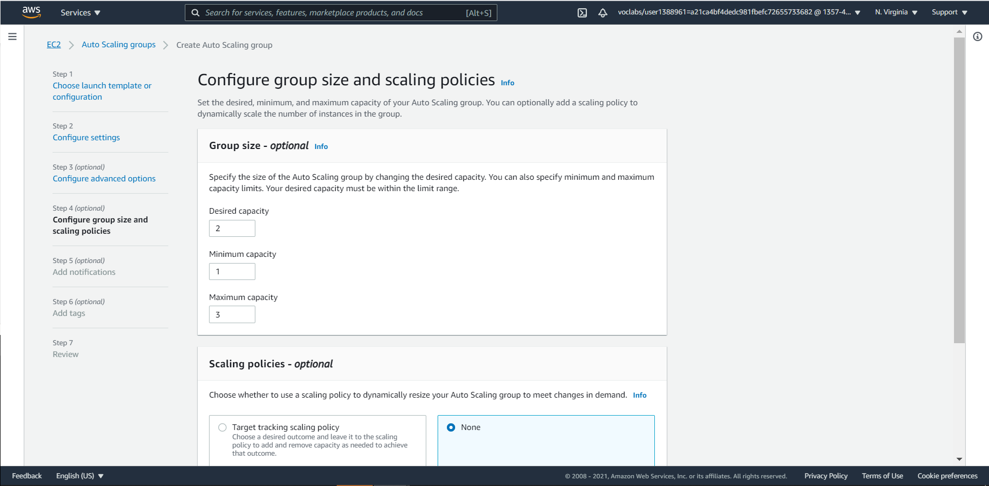

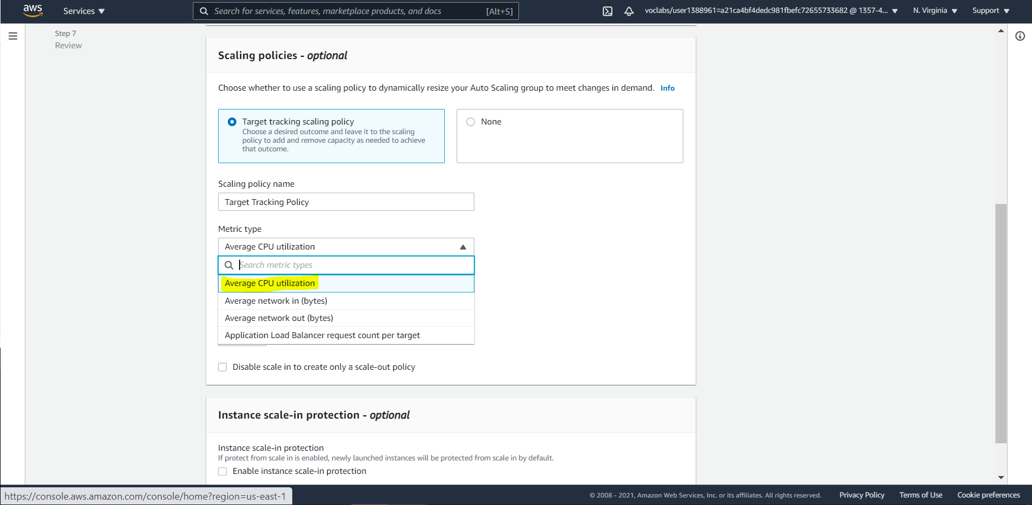

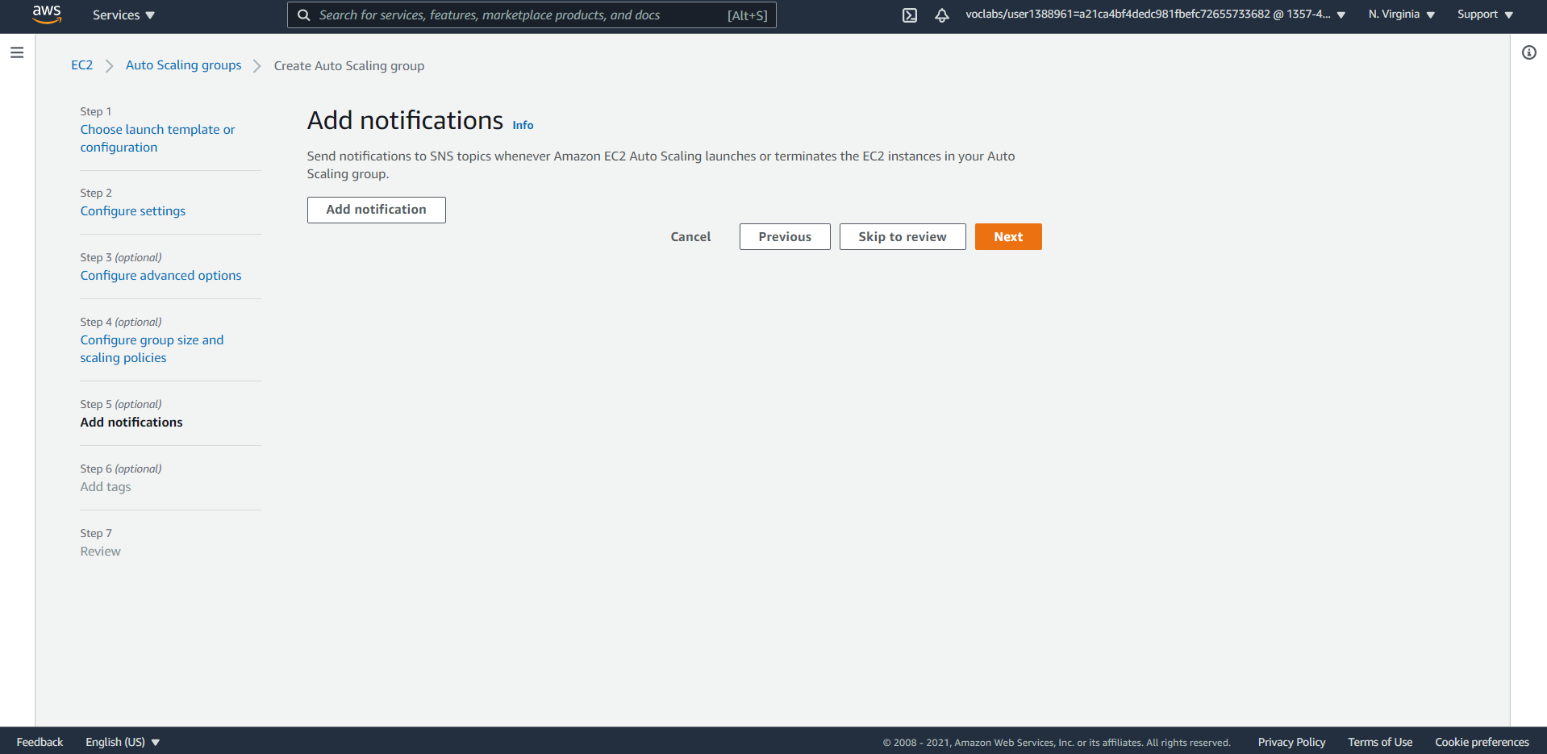

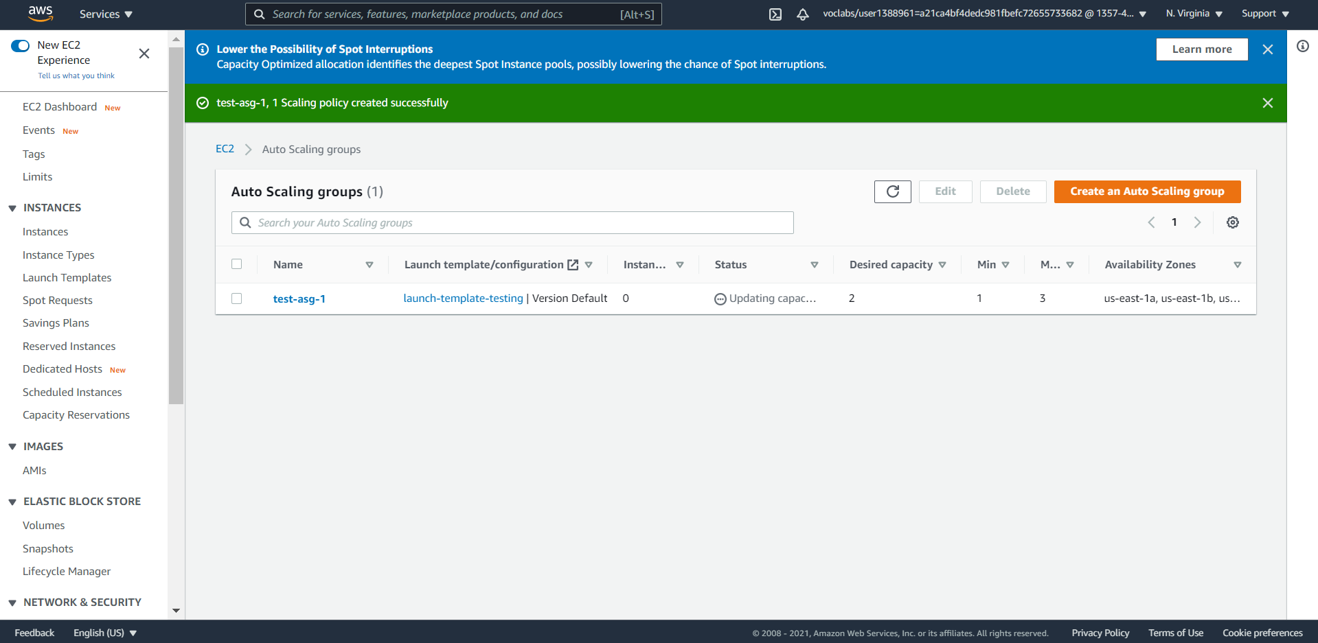

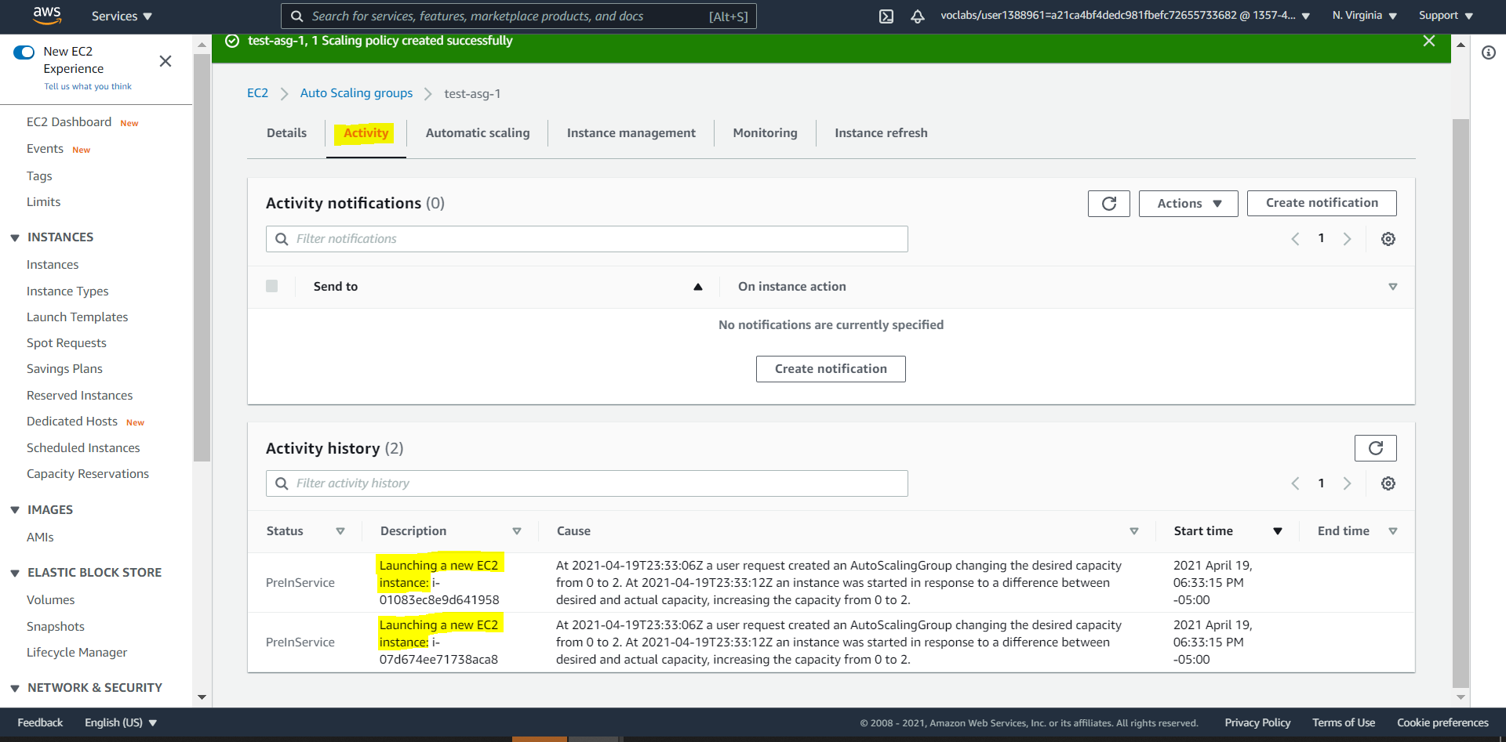

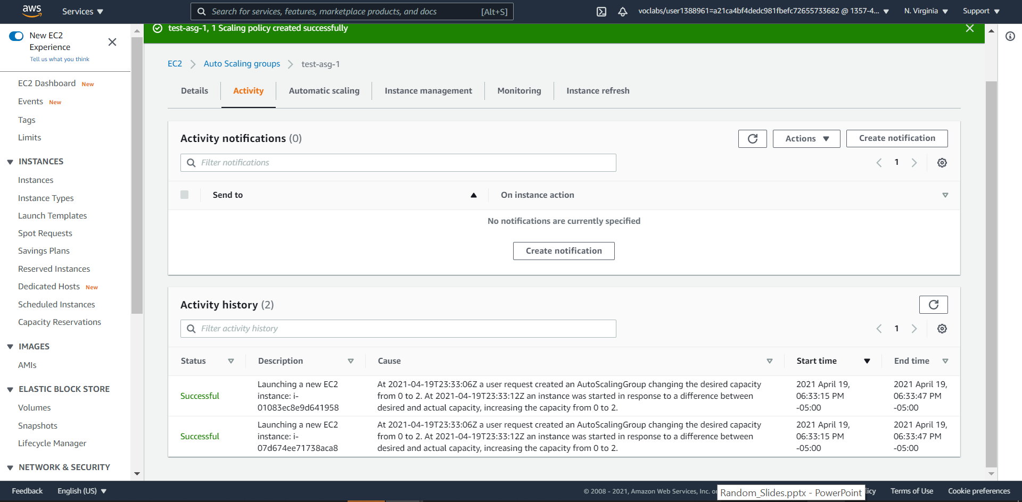

# Step 5: Verification

Now that we can see that the instances are brought up by Auto Scaling Group, we should be able to use the Load Balancer DNS name to reach to the EC2 instances

