Table of Contents

Create an EC2 instance 1

Wait till the instance state is “Running” and then collect the “Public IP” 5

Open a command prompt 5

Open a browser window and type http://<public ip>:8081 and you should see “Hello World” 6

Now, create another instance following the exact same steps, except for following changes 6

Once the second EC2 instance is created, collect the Public IP of that instance & login to it using similar steps 6

Now if you open a browser window and type http://<public ip>:9091, it should also give “Hello World” from the second instance 6

Now that the instances are set, we will create a couple of “Target Groups” for Application Load Balancer. Target groups determine for which incoming traffic what would be sent to which instance groups. We will create three target groups 7

Steps for “void-tg”: 7

Steps for “8081-tg” 10

Steps for “9091-tg” is exactly same as “8081-tg”, except for the fact that assign “9091 Node JS Server” instance instead 12

Now, its time to create an Application Load Balancer 13

Now, ideally, if we open the Application Load Balancer Public DNS & open a browser & enter following address, corresponding things should happen 19

Now, the last thing pending is to remove the rules for port 8081 & 9091 from the EC2 instance Security Groups and ONLY allow traffic from Application Load Balancer Security Group 21

Now still the access through ALB works 24

But the direct access via the EC2 public IP & port does not 25

# Create an EC2 instance

* 1. Add a tag with “Name : 8081 Node JS Server”
  2. Add create a Security Group with name “ssh-http-8081-9091-elb-sg” with configurations that allow SSH traffic and also Custom TCP Ports 8081 & 9091.
  3. We need to modify this Security Group again after creating ALB
  4. DO NOT FORGET TO SELECT (and optionally download) A KEY PAIR AT THE LAST STEP

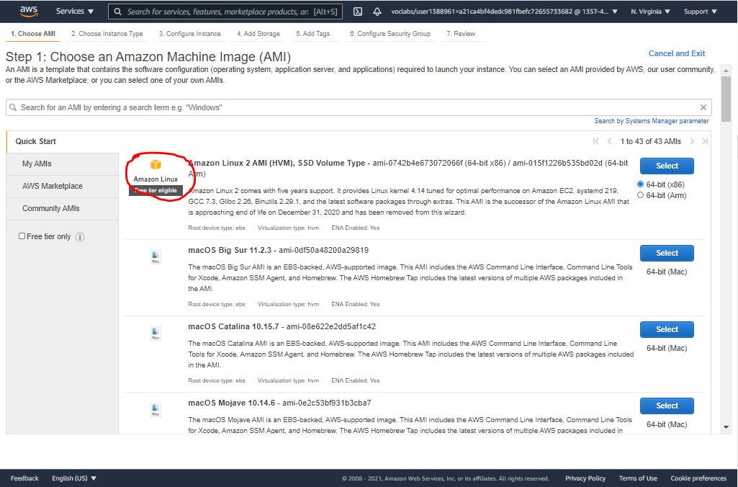

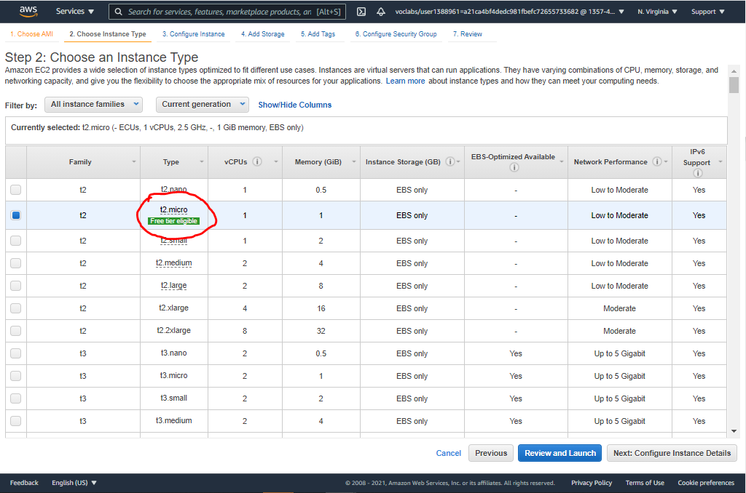

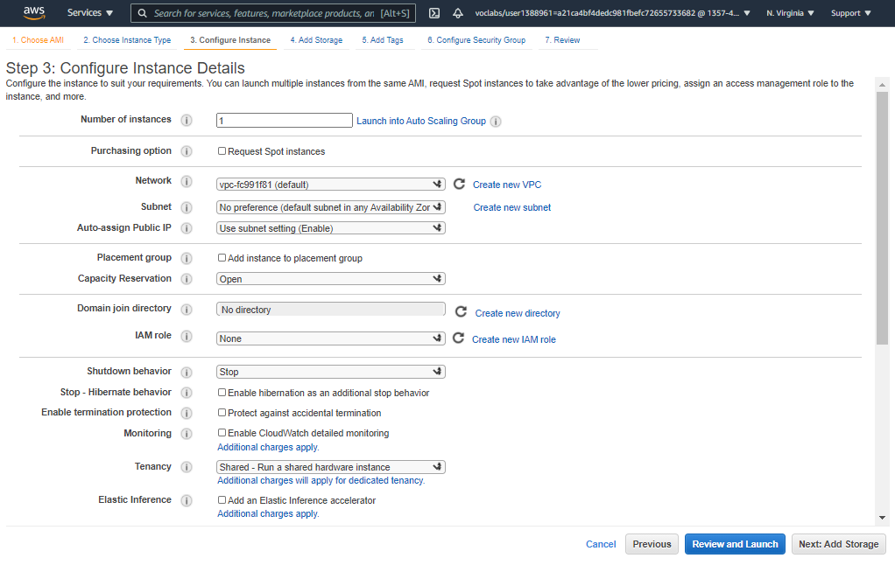

**KEEP DEFAULT**

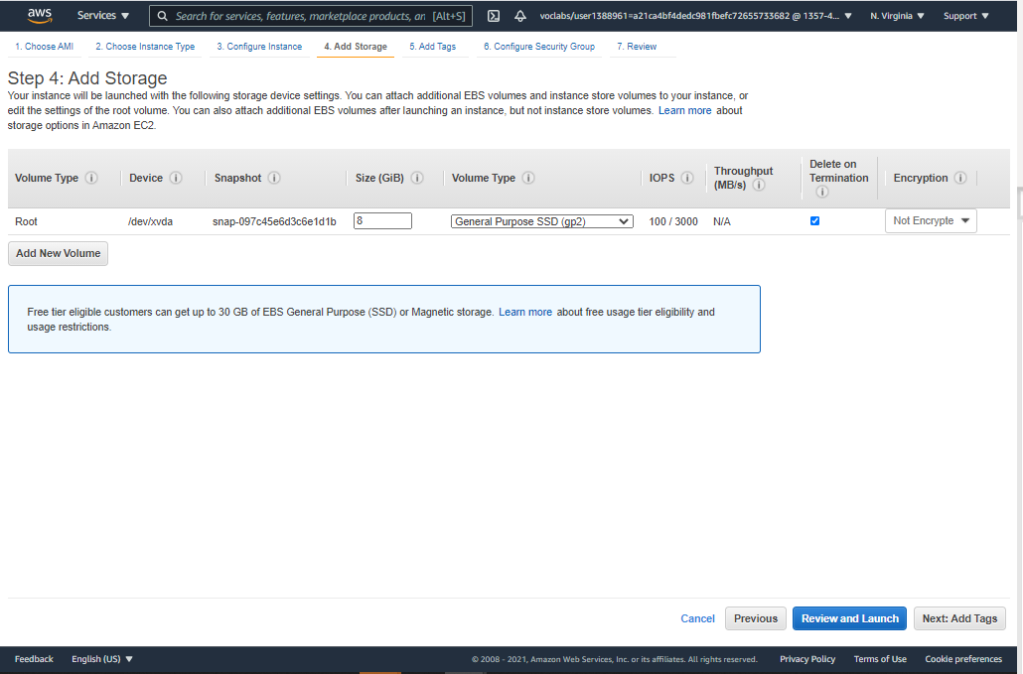

**KEEP DEFAULT**

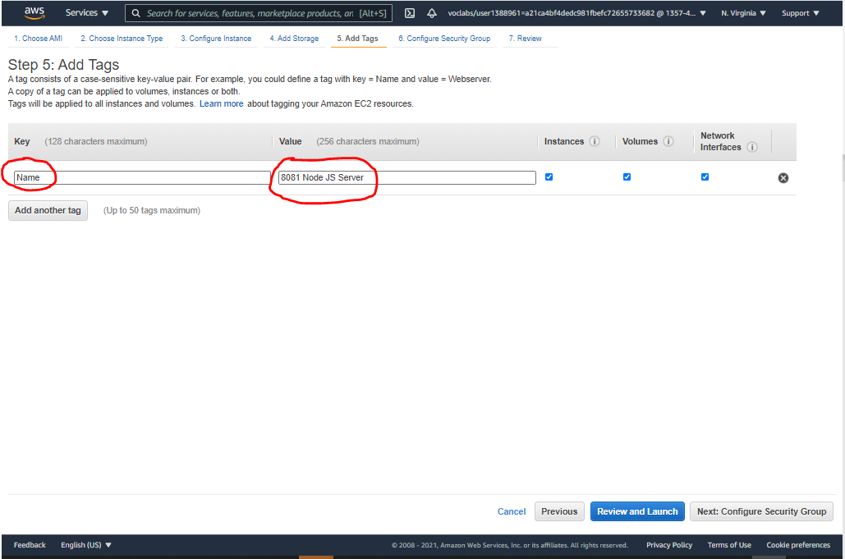

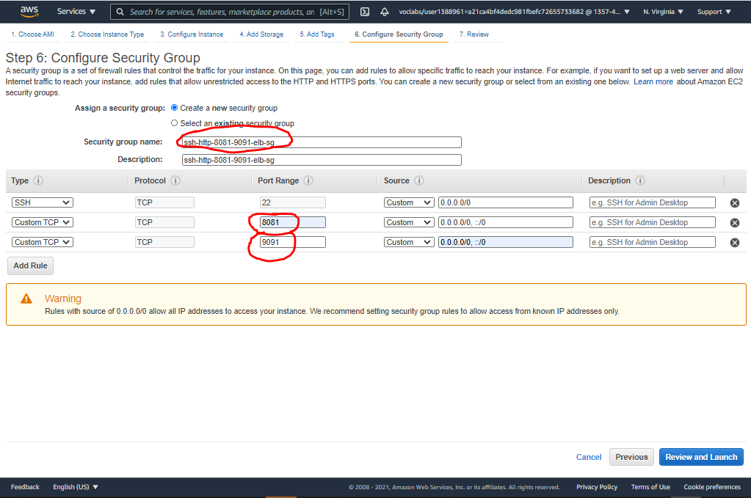

# Wait till the instance state is “Running” and then collect the “Public IP”

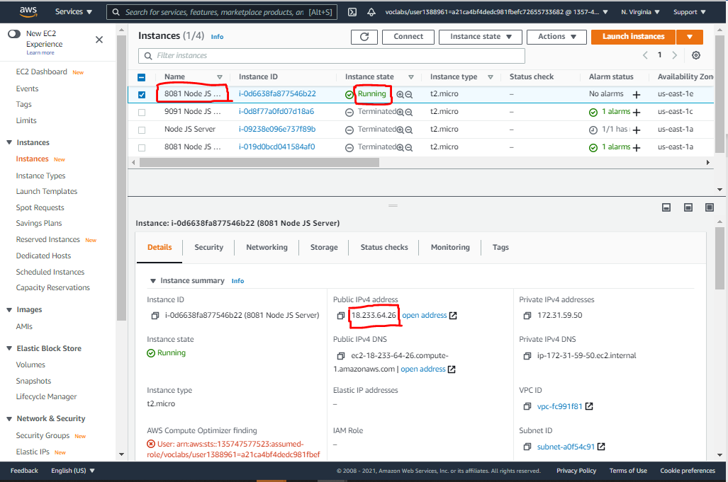

# Open a command prompt

* 1. Go to the path where the AWS EC2 key is downloaded
  2. Then do `chmod 0400 <keyName.pem>`
  3. Then do `ssh -i <keyName.pem> ec2-user@<public ip>`
  4. You should now be in the instance
  5. Now do `vi configure_and_run_nodejs_service.sh`
  6. Copy/paste the content of the shell script from github
  7. Then save and exit
  8. Then do: `chmod 777 configure_and_run_nodejs_service.sh`
  9. Then do: `./configure_and_run_nodejs_service.sh`
  10. This will configure the instance with a node js service running at port 8081

# Open a browser window and type http://<public ip>:8081 and you should see “Hello World”

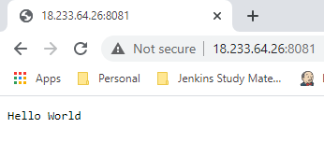

# Now, create another instance following the exact same steps, except for following changes

* 1. Add a tag with “Name : 9011 Node JS Server”
  2. Add the existing Security Group “ssh-http-8081-9091-elb-sg”

# Once the second EC2 instance is created, collect the Public IP of that instance & login to it using similar steps

* 1. Go to the path where the AWS EC2 key is downloaded
  2. Then do `chmod 0400 <keyName.pem>`
  3. Then do `ssh -i <keyName.pem> ec2-user@<public ip>`
  4. You should now be in the second instance
  5. Now do `vi configure_and_run_nodejs_service.sh`
  6. Copy/paste the content of the shell script from github
  7. Then change the line that says “port = 8081” 🡪 “port = 9091”
  8. Then save and exit
  9. Then do: `chmod 777 configure_and_run_nodejs_service.sh`
  10. Then do: `./configure_and_run_nodejs_service.sh`
  11. This will configure the instance with a node js service running at port 9091

# Now if you open a browser window and type http://<public ip>:9091, it should also give “Hello World” from the second instance

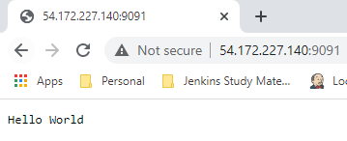

# Now that the instances are set, we will create a couple of “Target Groups” for Application Load Balancer. Target groups determine for which incoming traffic what would be sent to which instance groups. We will create three target groups

* 1. void-tg: This will contain no instances. We would assign this group to the default ALB listener, so that by default it does not route traffic to any instance
  2. 8081-tg: This will contain “8081 Node JS Server” instance and all the traffic that is coming to the ALB at port 8081 will be routed here
  3. 9091-tg: Similar thing for “9091 Node JS Server”

# Steps for “void-tg”:

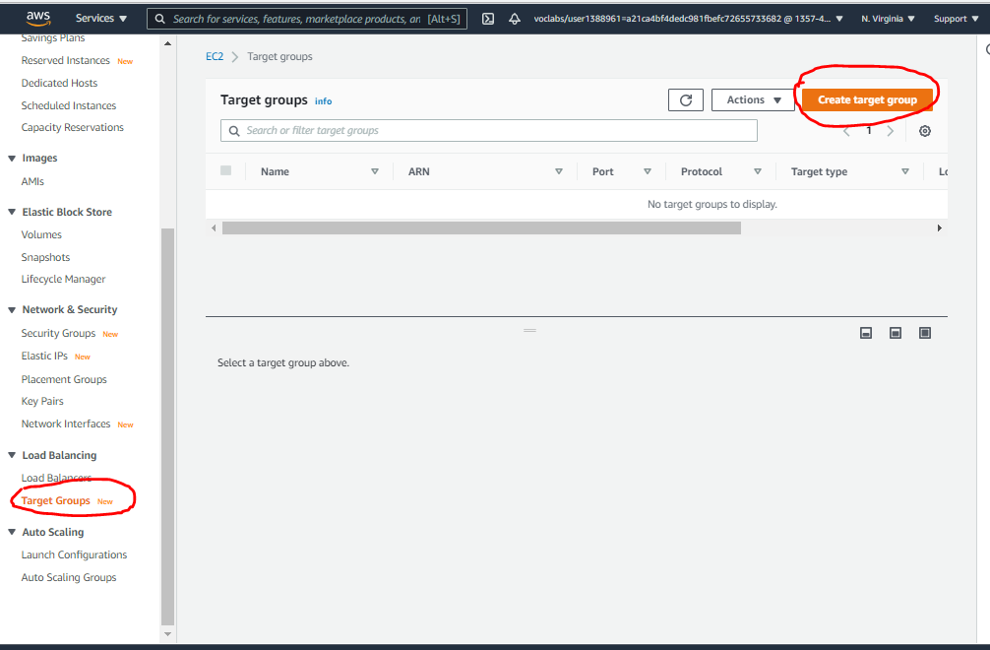

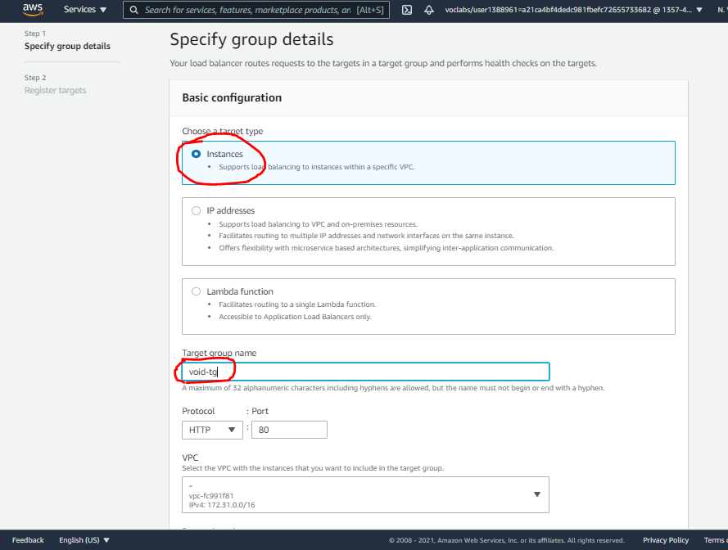

**KEEP OTHER DETAILS AS-IS**

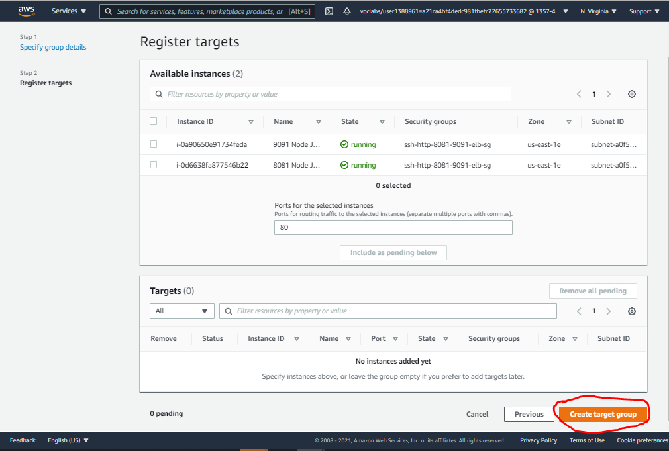

**KEEP THINGS AS-IS, DO NOT MAKE ANY CHANGES**

# Steps for “8081-tg”



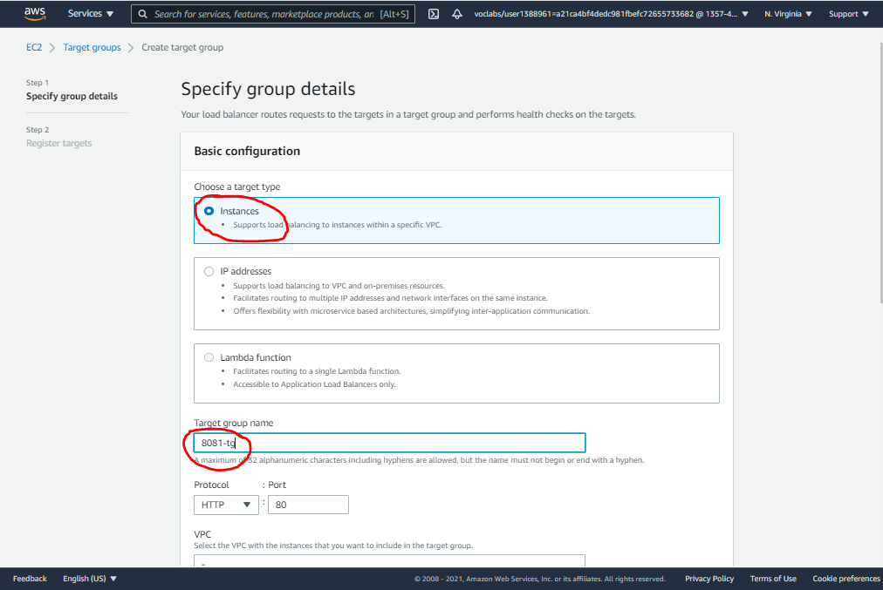

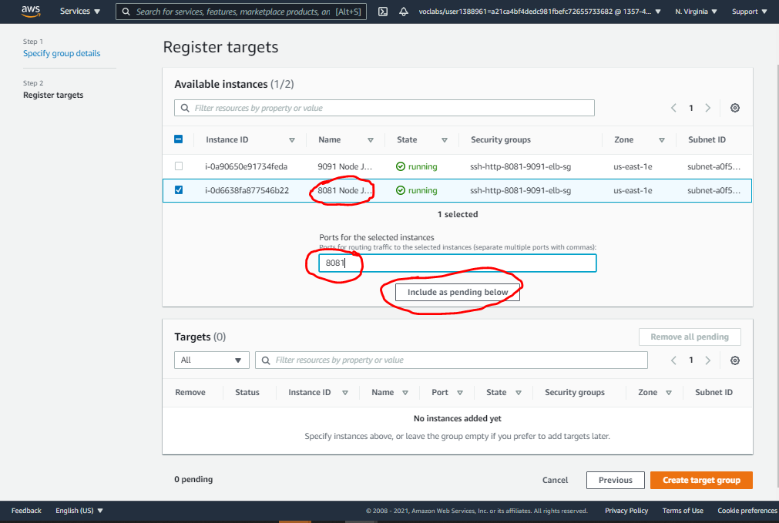

# Steps for “9091-tg” is exactly same as “8081-tg”, except for the fact that assign “9091 Node JS Server” instance instead

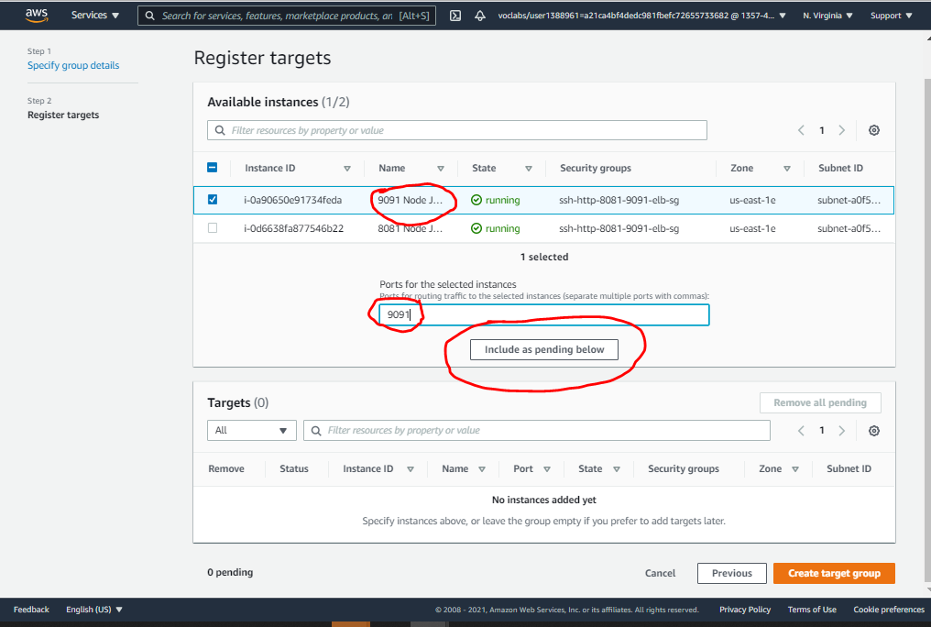

# Now, its time to create an Application Load Balancer

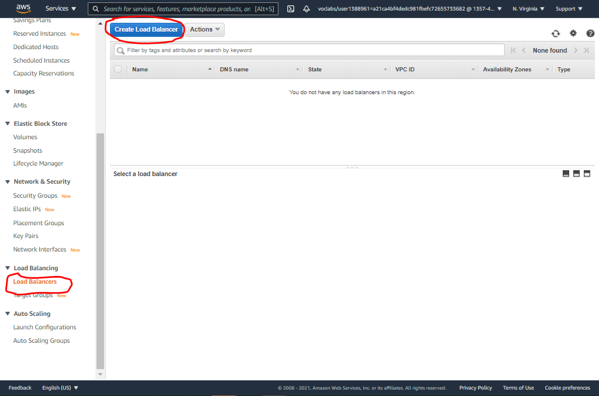

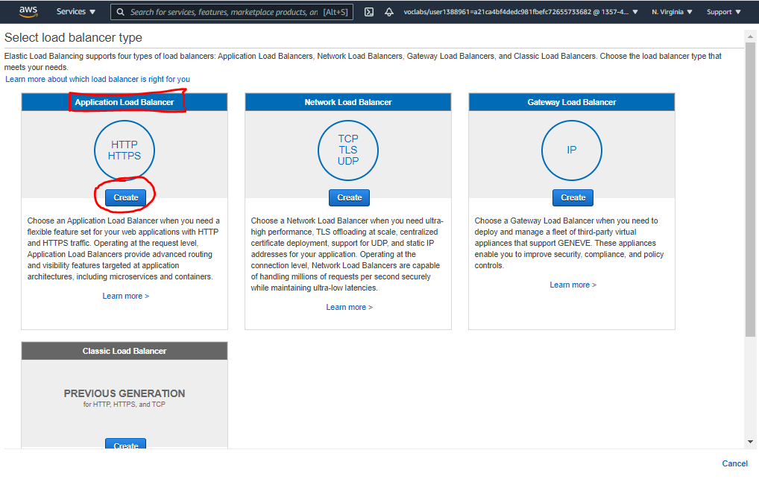

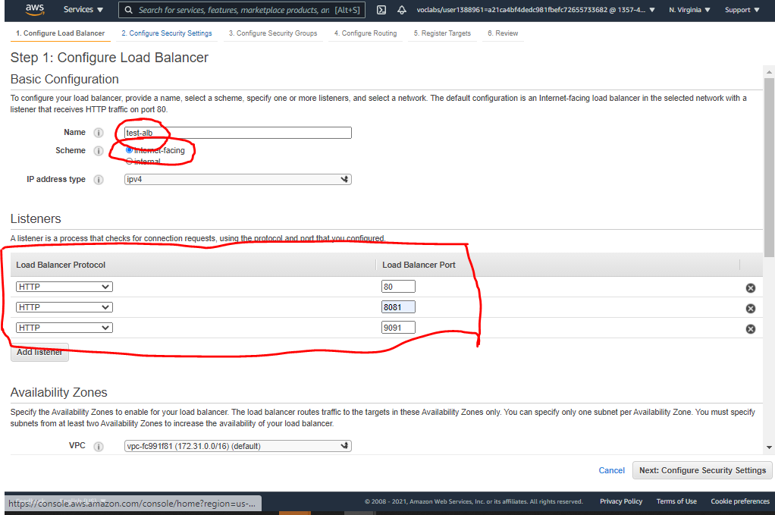

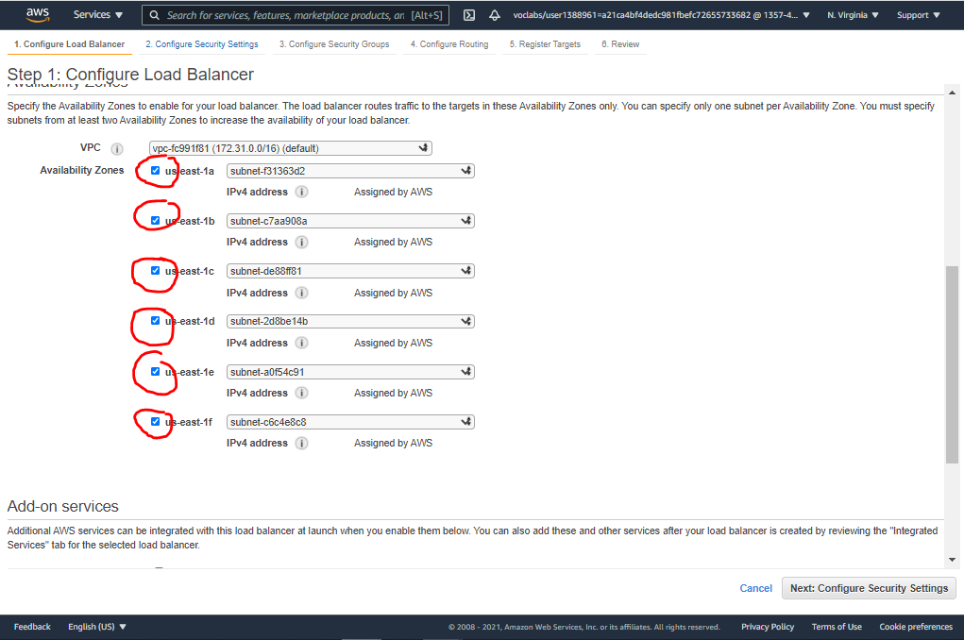

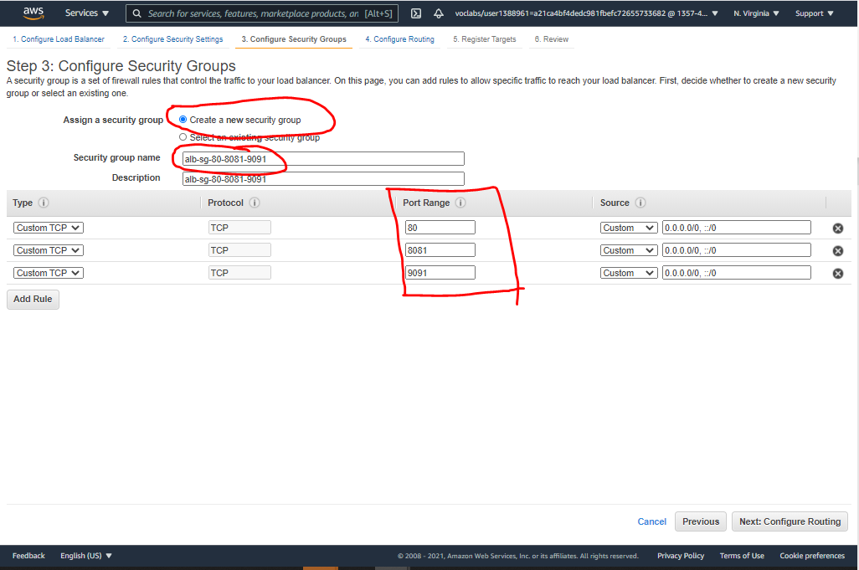

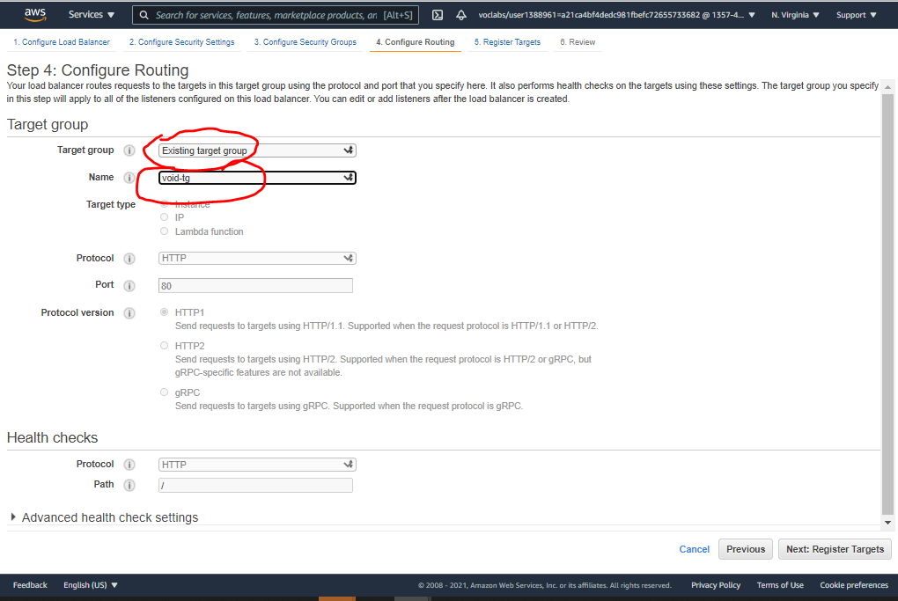

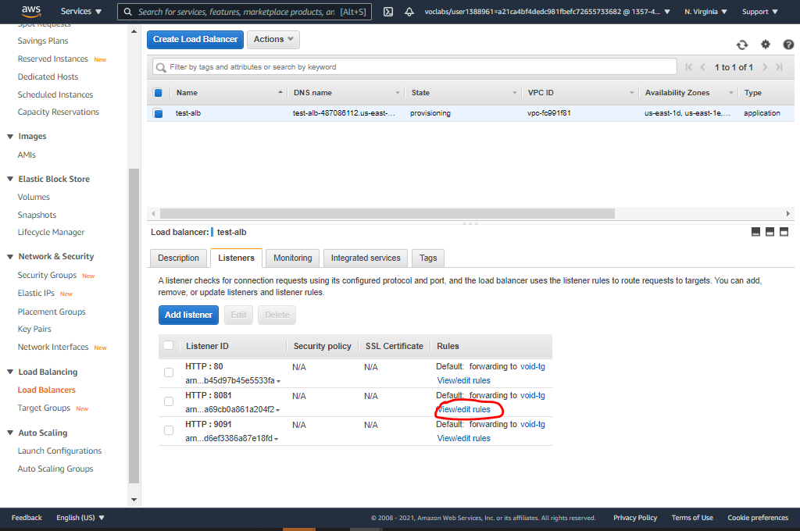

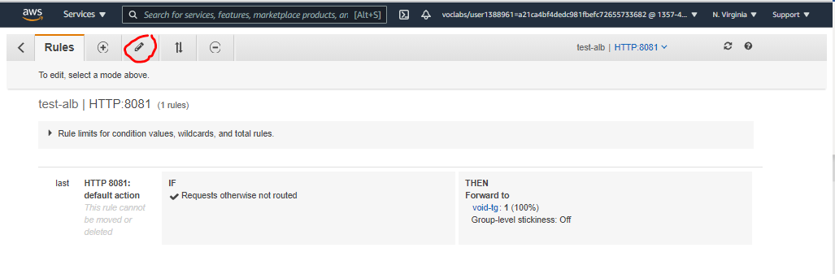

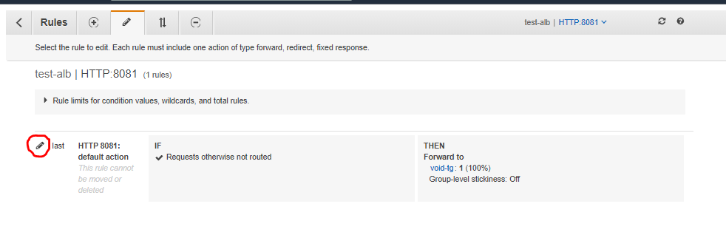

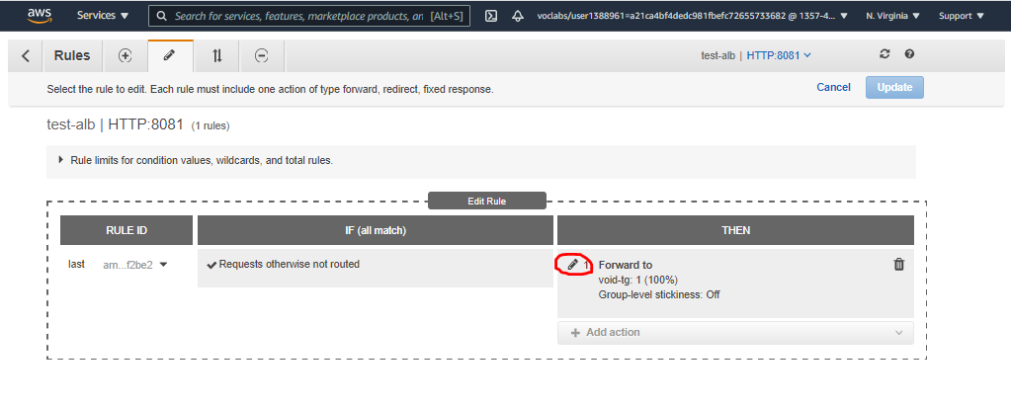

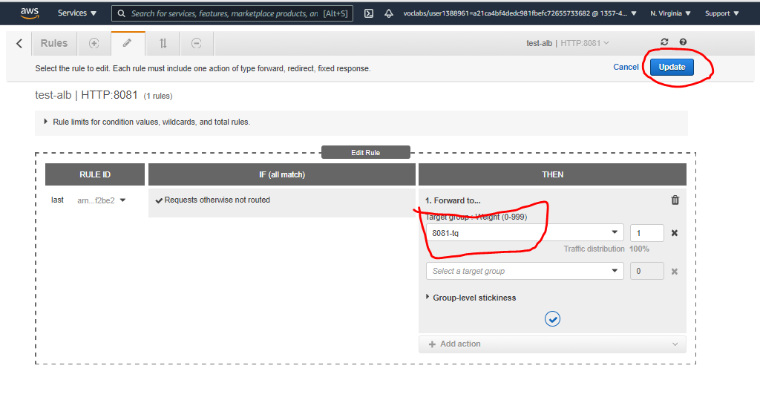

**NEXT, UPDATE the HTTP:9091 LISTENER AND ASSIGN 9091-tg AS TARGET GROUP IN SIMILAR WAY**

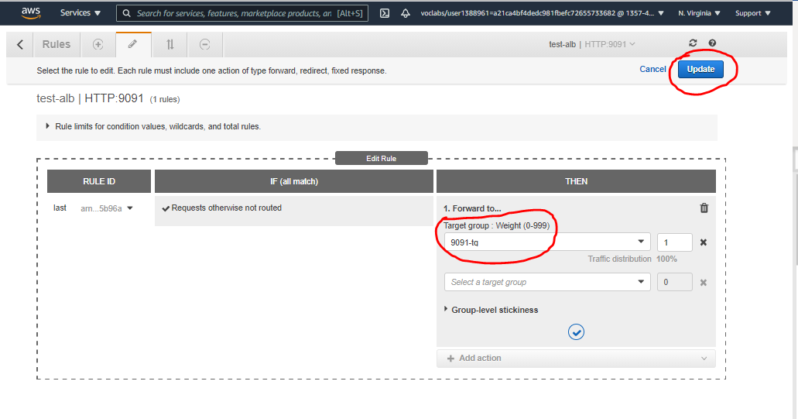

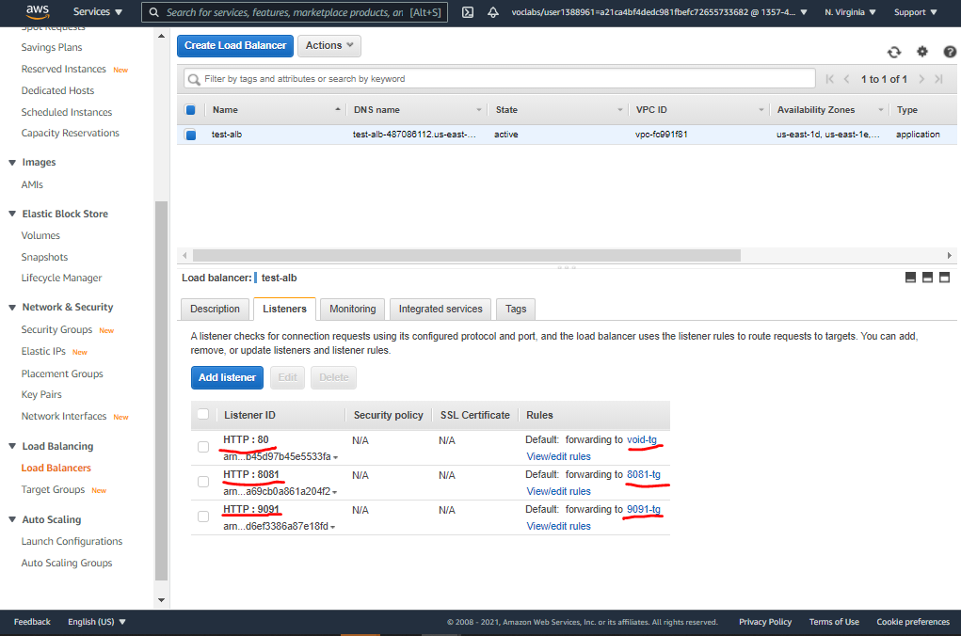

# Now, ideally, if we open the Application Load Balancer Public DNS & open a browser & enter following address, corresponding things should happen

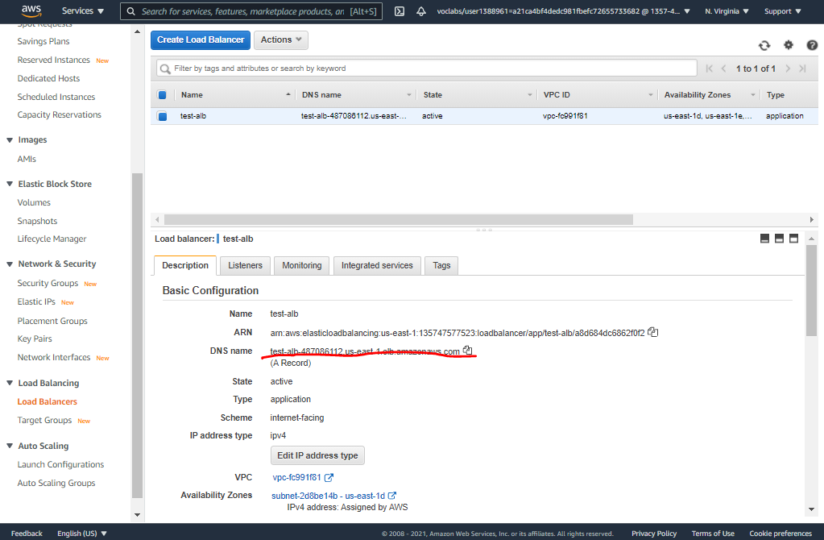

* 1. http://<alb dns>:80

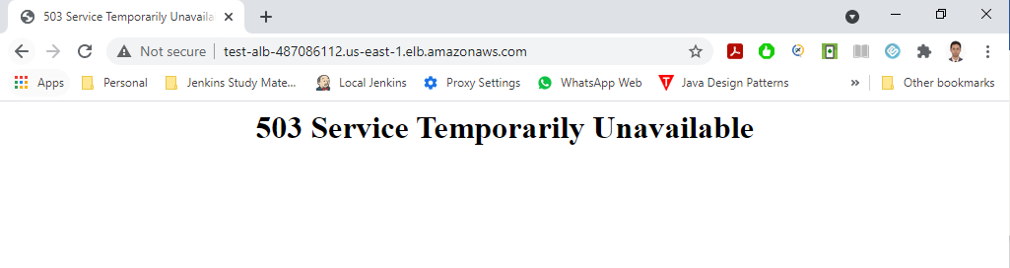

**Since there are no instances/target groups backing it**

* 1. http://<alb dns>:8081

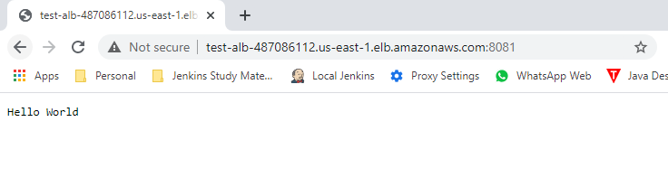

**From 8081-tg**

* 1. http://<alb dns>:9091

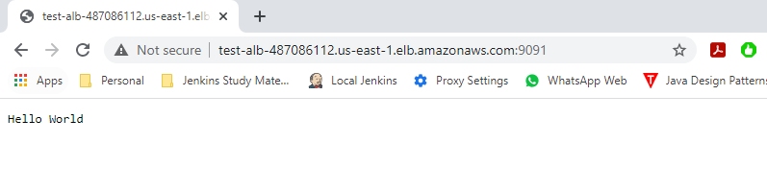

**From 9091-tg**

# Now, the last thing pending is to remove the rules for port 8081 & 9091 from the EC2 instance Security Groups and ONLY allow traffic from Application Load Balancer Security Group

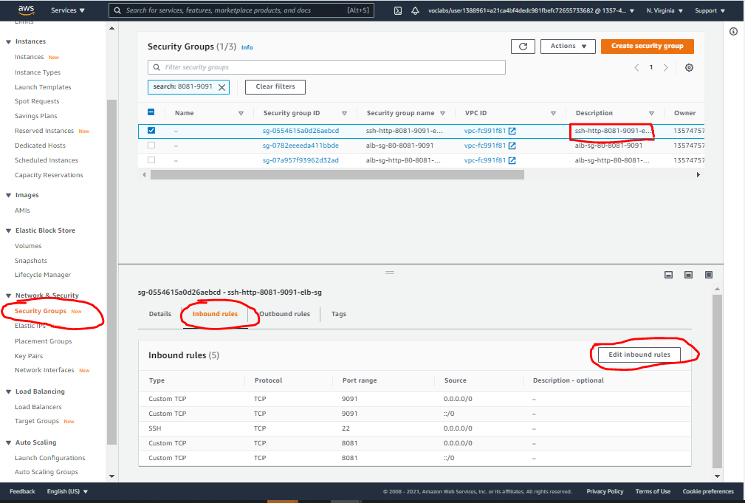

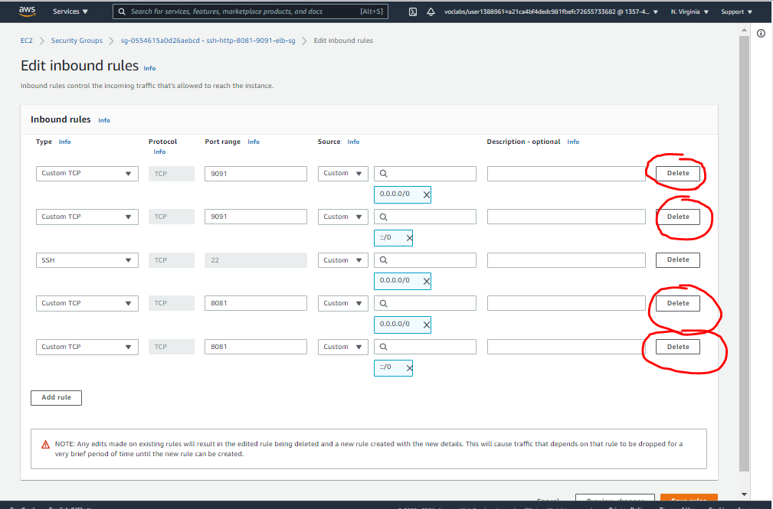

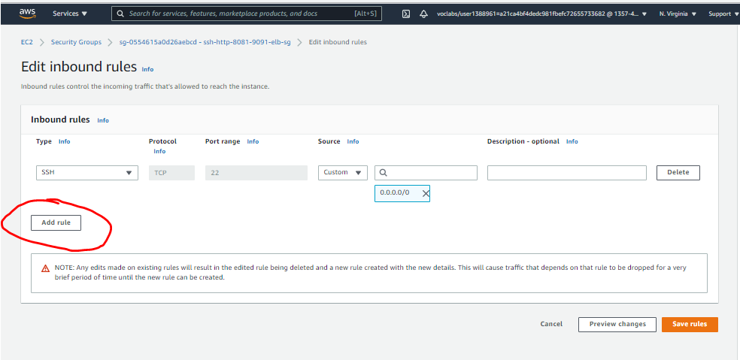

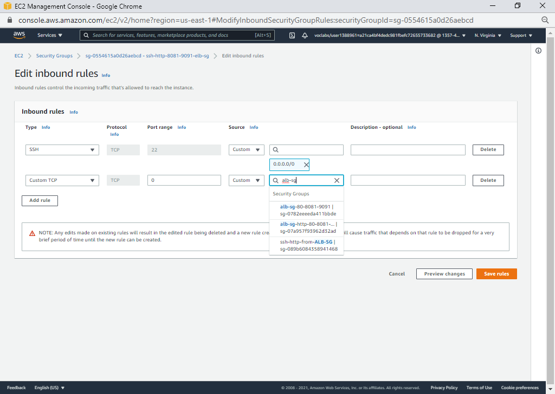

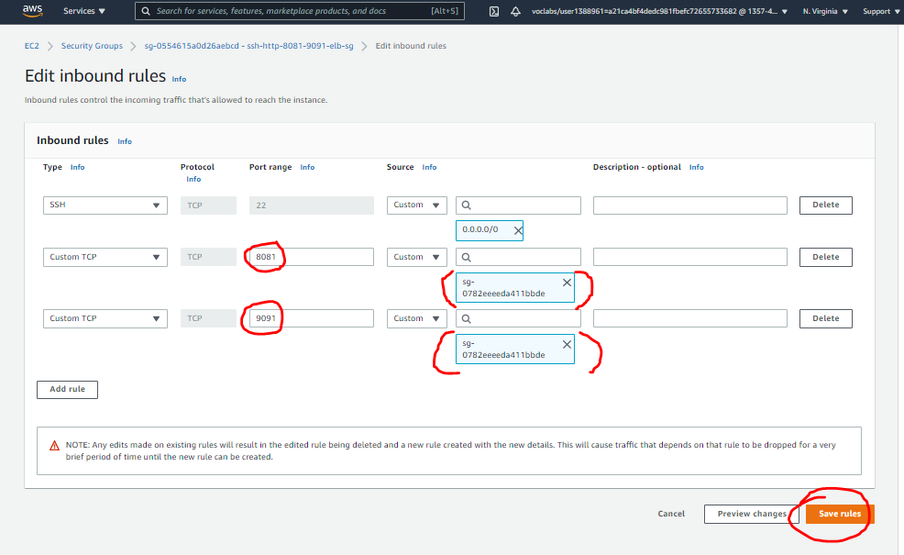

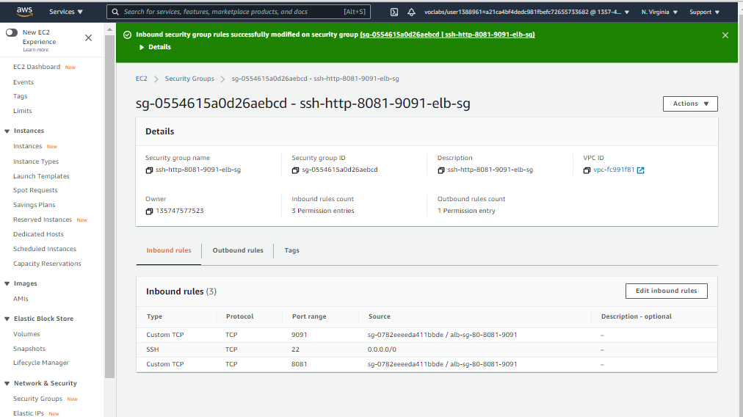

# Now still the access through ALB works

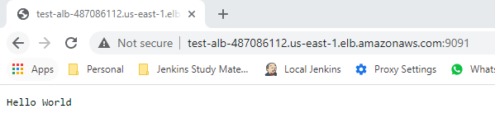

# But the direct access via the EC2 public IP & port does not

