Link- https://www.javacodegeeks.com/2019/05/spring-core-annotations.html

1. @Bean -> To tell this is a bean of container.
2. @Configuration -> Telling spring that it is a configuration class. Where we declare the bean.
3. @Autowired ->Use to do auto wiring in a particular bean.
4. @Qualifier("bean_name")----------->above the @Autowired we use to set auto wiring by bean name.
5. @Scope ------->To set the scope of the bean singleton or prototype.
6. @Componenet ------> Use to top of the class to set class obj as a bean in spring container.
7. @ComponentScan(basePackages = {"com.mycompany.app"})--> Scan all the bean associate with this base package.
8. @Primary
9. @Required:
10. @Value:
11. @Repository

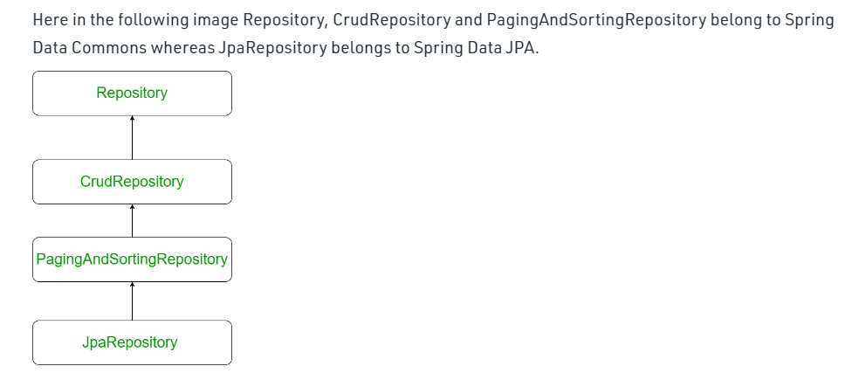

1. @RestController.
2. @RequestMapping("author")
3. @PostMapping
4. @GetMapping
5. @DeleteMapping("{id}")
6. @PutMapping
7. @Entity
8. @Id
9. @Service
10. @SpringBootApplication