Wildlife news articles -- RESULTS

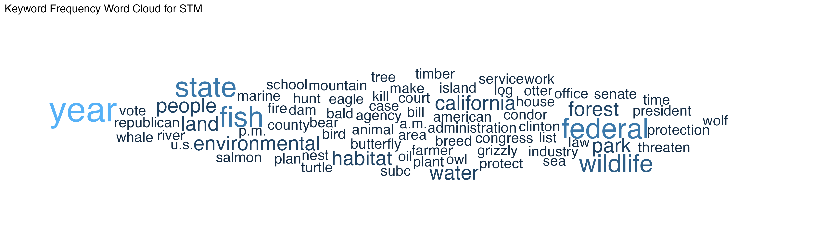

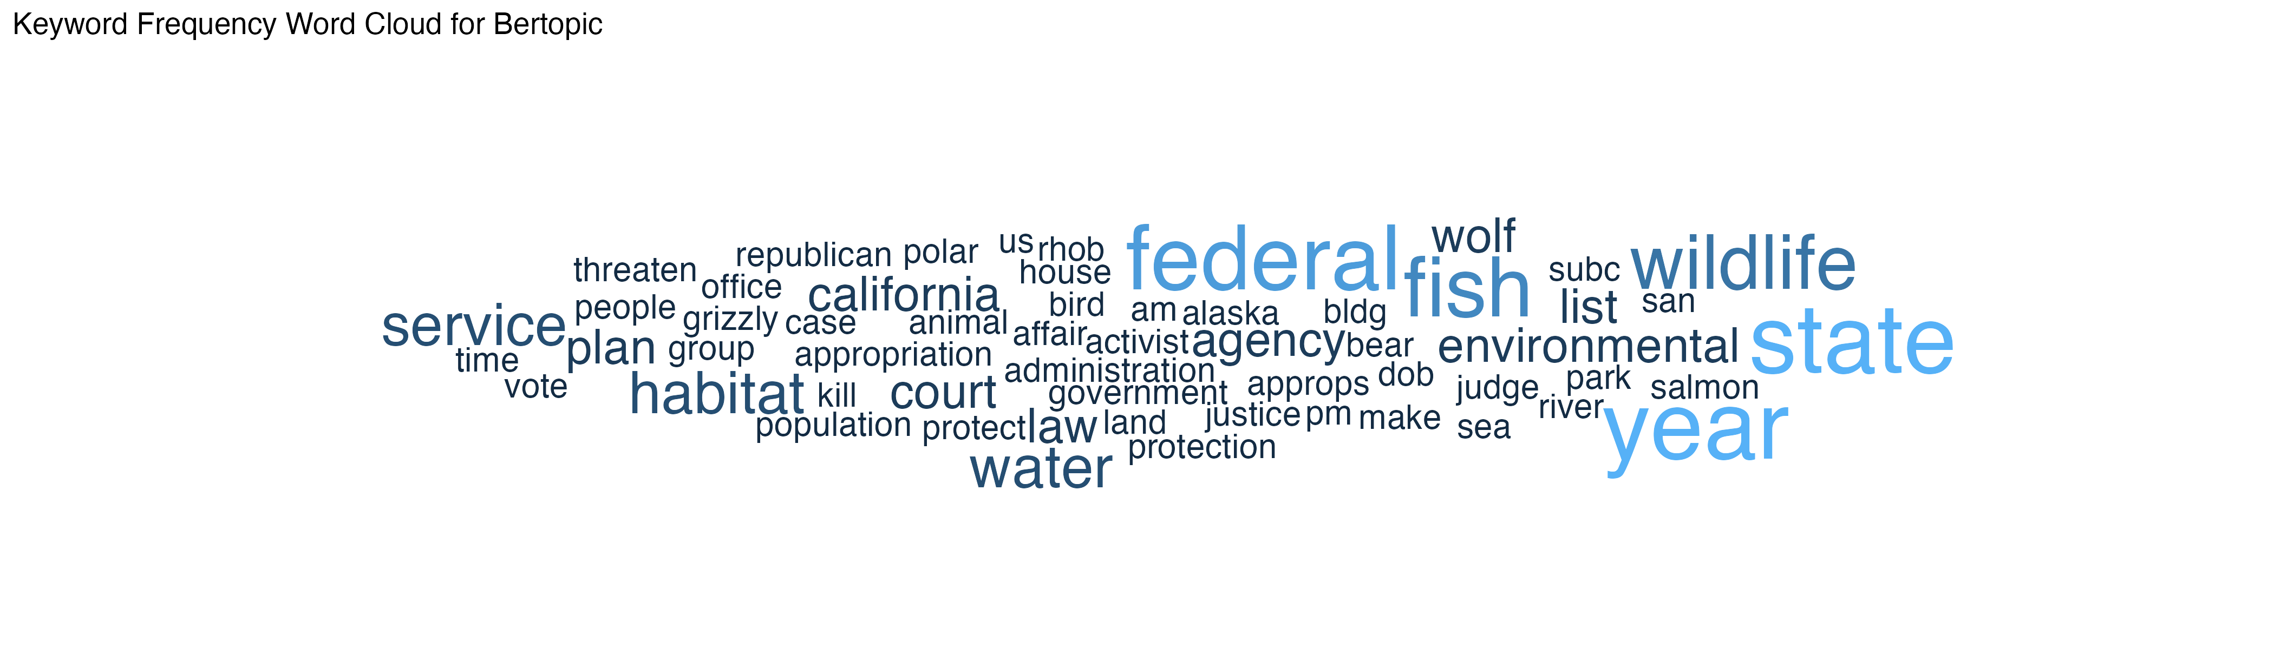

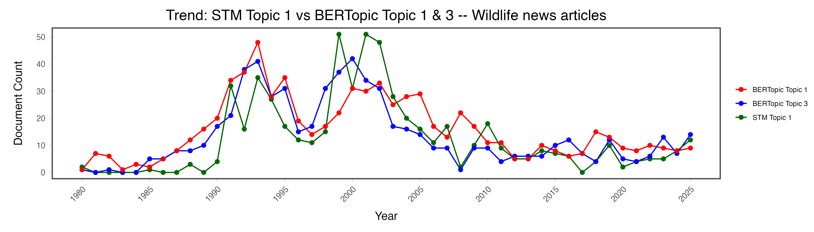

Congressional data – RESULTS

