Argo Translation. Inc.

Creating Understanding in Every Language

They care about our business. They’re not just a vendor, they’re a partner… they understand our business.

When accuracy is critical you’ll have peace of mind knowing that we back our certified translations all the way.

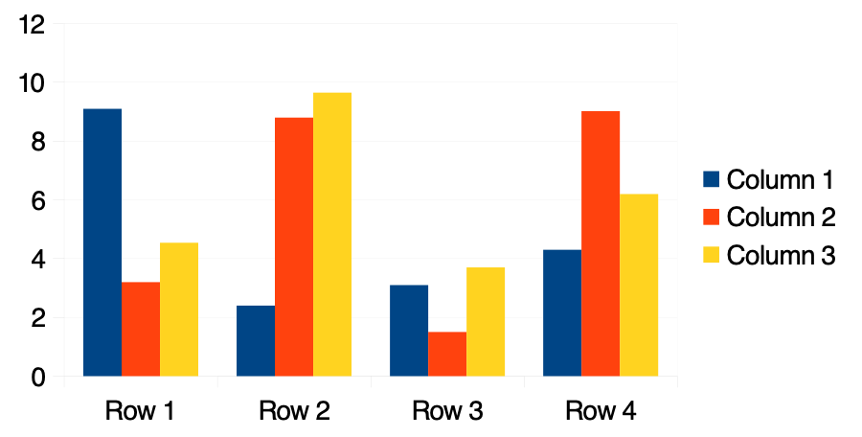

We know successful translation goes well beyond literal, word-for-word substitution.