Supplementary Material

Carbonate lithium isotope systematics indicate cooling triggered mass extinction during the Frasnian-Famennian transition

Yang-Yang Wang¹, Kun Liang², Yilin Xiao^{1,3*}, Bo Chen^{2*}, Erhao Shan¹, Tingyu Yang¹, Meng Zhang¹, He Sun⁴, Hai-Ou Gu⁴, Fengtai Tong¹, Lulu Fu¹, Dong-Yong Li¹, Yigan Lu¹, Wenkun Qie²

¹ CAS Key Laboratory of Crust-Mantle Materials and Environments, School of Earth and Space Sciences, University of Science of Technology of China, Hefei, 230026, China
² State Key Laboratory of Palaeobiology and Stratigraphy and Center for Excellence in Life and Paleoenvironment, Nanjing Institute of Geology and Palaeontology, Chinese Academy of Sciences, Nanjing, 210008, China
³ CAS Center for Excellence in Comparative Planetology, Hefei, China
⁴ School of Resources and Environmental Engineering, Hefei University of Technology, Hefei, 230009, China

*Corresponding author:
ylxiao@ustc.edu.cn (Y. X.), chenbo@nigpas.ac.cn (B. C.)

Contents
- Geological setting
- Geochemistry composition of the Yangdi and Dongcun sections
- Box model for seawater Li isotope evolution
- Modeling low δ⁷Li value of the late Devonian seawater
- Limited Li isotopic fractionation during rapid clay mineral formation
- Modeling for invariant Sr isotope ratios at the F-F boundary
- Modeling for positive Li isotopic excursion at the F-F boundary
- References
- Figures S1-S11
- Tables S1-S5

Geological setting
During the Late Devonian, the South China Craton was situated on the east of the Paleotethys around the equator. The Yangdi section (also called Fuhe in some studies) is located along a road cut ~35 km southeast of Guilin city, Guangxi Zhuang Autonomous Region (Fig. 1). The Dongcun section is ~10 km south of the Yangdi section (Fig. 1). Both of them were located in a spindle- to rhomb-shaped basin filled with the Devonian shallow- to deep-water carbonates (Chen et al., 2001). From the beginning of the Devonian, marine waters gradually invaded South China and reached their maximum extent in the Frasnian. The deposition environments of the studied sections represent a transitional zone from a carbonate platform to an inter-platform trough with the epicontinental sea of the South China block opened to the Paleotethys, suggesting an open-marine setting (Chen et al., 2001; Chen and Tucker, 2003). Such a setting is further verified by the global-consistent isotopic records (Xu et al., 2012).
The Yangdi section was composed of the Frasnian Xiangtian Formation and the Famennian Wuzhishan Formation. The ~28 m thick Xiangtian Formation was formed in a slope depositional setting and could be subdivided into 4 lithological parts (Huang and Gong, 2016 and references therein). The lowermost part (~14 m thick) is characterized by gray to dark gray thin-bedded wackstone which is intercalated with banded cherts. The following strata upward is only ~2 m thick and composed of dark gray thick-bedded brecciated limestones. The upper part (~9 m thick) is characterized by gray argillaceous limestones and some intercalations of nodular limestones. The uppermost part (~3 m thick) is composed of dark gray thin-bedded calcareous turbidites intercalated with argillaceous limestones. The Wuzhishan Formation mainly consists of light gray nodular limestones with minor calcareous turbidite in the middle part (Huang and Gong, 2016 and references therein). By contrast, the Dongcun section is much more homogeneous in lithology. The Frasnian and Famennian strata is ~ 26 m thick and ~17 m thick, respectively. The whole section was mainly composed of interlayers of dark and gray micrite. Occasionally, some intercalations of siliceous rocks in the Frasnian part with thickness of ~10 cm could be observed (Xu et al., 2012).
High-resolution conodont biostratigraphy schemes for both sections have been well established (Wang and Ziegler, 2002; Huang and Gong, 2016). The Upper Kellwasser horizon in the Yangdi section was identified in the uppermost part of the Xiangtian Formation based on a pelagic fauna turnover and conodont biofacies change (linguiformis/triangularis, Huang and Gong, 2016). Whereas in the Dongcun section, the F-F (linguiformis/triangularis) boundary is assigned at 2.0 m above a thin dark micritic limestone due to the disappearance of most of conodonts of the linguiformis fauna (Wang and Ziegler, 2002; Xu et al., 2012). The two sections can be well correlated to each other, and with other sections worldwide using the conodont biostratigraphy.

Geochemistry composition of the Yangdi and Dongcun sections
All the isotopic and elemental compositions of the Yangdi and Dongcun sections are listed in Table S1-S3 and Fig. S1. As revealed by the low Mg/Ca ratios (<55 mmol/mol), all the sample are dominated by calcite. Li/Ca ratios of the Yangdi samples range from 1.0 μmol/mol to 19.1 μmol/mol with a considerable part lower than 4 μmol/mol. By contrast, the Dongcun samples have low Li/Ca ratios, ranging from 0.2 μmol/mol to 2.9 μmol/mol. For the Na/Ca ratios, the Yangdi samples also have higher values (0.65-2.42 mmol/mol) than the Dongcun ones (mostly < 0.7 mmol/mol). Positive correlation could be observed between Li/Ca and Na/Ca ratios especially for the Yangdi samples (Fig. S2). Al/Ca ratios for the Yangdi samples are lower than 1.0 mmol/mol, and mostly <0.4 mmol/mol. In the Dongcun section, the lower part (upper rhenana zone) shows much higher Al/Ca ratios ranging from 1.5 to 42.7 mmol/mol, possibly indicating contamination from silicate materials. By contrast, Al/Ca ratios of the other parts are as low as those of the Yangdi section. Li/Ca ratios of all the samples show no correlation with Al/Ca ratios (Fig. 2), implying the samples with high Li content are probably pristine with limited contamination from silicate materials. The Yangdi samples have Sr/Ca ratios ranging from 0.24 to 0.75 mmol/mol, slightly higher than the Dongcun ones (mostly ranging from 0.13 to 0.36 mmol/mol with one exception of 0.81 mmol/mol). All the samples show Mn/Sr ratios lower than 5.0 mol/mol with the Yangdi samples slightly higher than the Dongcun samples (Fig. S1). The Yangdi samples also have higher Fe/Ca ratios than the Dongcun samples. The other element concentrations are comparable with each other for the two sections. The Yangdi section also have slightly negative excursion for Mg/Ca and Sr/Ca ratios but an increasing trend of Li/Ca ratios around the F-F boundary (Fig. S1). Whereas in the Dongcun section, only Ba/Ca and Fe/Ca ratios show a slightly positive excursion around the F-F boundary (Fig. S1). In addition, although the insoluble residue weight percent varies, no correlations were observed with carbonate δ7Li values and Li/Ca ratios.
δ⁷Li values of the Yangdi samples range from 1.8 ‰ to 8.9 ‰. Whereas in the Dongcun section, the samples yield more varying δ⁷Li values, ranging from 3.4 ‰ to 18.4 ‰. Both sections show positive Li isotopic excursions around the F-F boundary. Some additional isotopic excursions could be only observed in one of the investigated sections (Fig. S1), such as the positive Li isotopic excursion at the upper rhenana zone in the Dongcun Section.
The correlations between different geochemical compositions are shown in Fig. S3 and Fig. S4 for the samples in the Yangdi section and the Dongcun sections, respectively. A positive correlation between Li/Ca and Na/Ca could be observed for the Yangdi sections. For the Dongcun section, positive correlation could be observed between Li/Ca and Al/Ca. Although the Yangdi samples have higher Mn/Sr ratios than the Dongcun samples, but poor correlations between Li/Ca, δ⁷Li, Mn/Sr, Mn/Ca and Fe/Ca ratios exclude possible contamination from Fe-Mn-enriched materials.
C isotopic isotope compositions measured in this study are consistent with previous studies (Fig. S1, Xu et al., 2012), showing an increasing trend from ~-0.5 ‰ to ~2 ‰ in the upper rhenana zone and another increasing trend from ~1 ‰ to 3 ‰ across the F-F boundary. Conodont Sr isotope ratios vary from 0.7080 to 0.7082. They have small fluctuations (< 0.0001) in the linguiformis zone, but keep almost unchanged around the F-F boundary.

Box model for seawater Li-Sr isotope evolution
Here the box model (Misra and Froelich, 2012, Poggevan Strandmann et al., 2013) is utilized to model seawater Li-Sr isotopic variations. The variations of oceanic Li inventory are balanced by different input and output endmembers:
$\frac{dN^{Li}}{dt}=F_{riv}^{Li}+F_{HT}^{Li}-F_{ms}^{Li}$ (1)
Where N^{Li} is the oceanic Li inventory, F^{Li} represents the Li flux with subscripts “riv”, “HT”, and “ms” being river, hydrothermal, subduction reflux and marine sinks, respectively. F_{ms} means the total Li sinks from seawater, which is assumed to be proportional to N, i.e., having a constant partitioning coefficient k:
$F_{ms}^{Li}=k^{Li}∙N^{Li}$ (2)
Where k is assumed to t_{rs} in values. Based on the above equations, the isotopic balance equation is given by:
$N^{Li}\frac{dδ^{7}{Li}_{sw}}{dt}=F_{riv}^{Li}(δ^{7}{Li}_{riv}-δ^{7}{Li}_{sw})+F_{HT}^{Li}(δ^{7}{Li}_{HT}-δ^{7}{Li}_{sw})-F_{MS}^{Li}(δ^{7}{Li}_{ms}-δ^{7}{Li}_{sw})$ (3)
For Sr, the above equations can be written as (Palmer and Edmond, 1989)
$\frac{dN^{Sr}}{dt}=F_{riv}^{Sr}+F_{HT}^{Sr}+F_{dia}^{Sr}-F_{ms}^{Sr}$ (4)
$F_{ms}^{Sr}=k^{Sr}∙N^{Sr}$ (5)
$N^{Sr}\frac{d{\left(\frac{{}_{}^{87}{Sr}}{{}_{}^{86}{Sr}}\right)}_{SW}}{dt}=F_{riv}^{Sr}{\left(\frac{{}_{}^{\text{87}}{\text{S}}\text{r}}{{}_{}^{\text{86}}{\text{S}}\text{r}}\right)}_{riv}+F_{HT}^{Sr}{\left(\frac{{}_{}^{\text{87}}{\text{S}}\text{r}}{{}_{}^{\text{86}}{\text{S}}\text{r}}\right)}_{HT}+F_{dia}^{Sr}{\left(\frac{{}_{}^{\text{87}}{\text{S}}\text{r}}{{}_{}^{\text{86}}{\text{S}}\text{r}}\right)}_{dia}-{F_{ms}^{Sr}\left(\frac{{}_{}^{87}{Sr}}{{}_{}^{86}{Sr}}\right)}_{sw}$ (6)
Where the subscript “dia” represent diagenetic fluid endmember.
At steady state where N (for both Li and Sr), δ⁷Li_{sw} and ⁸⁷Sr/⁸⁶Sr_{sw} keep constant, the left sides of the equations (1), (3), (4) and (6) are zero. Therefore,
$F_{riv}^{Li}+F_{HT}^{Li}=F_{ms}^{Li}$ (7)
$δ^{7}{Li}_{sw}=\frac{F_{riv}^{Li}δ^{7}{Li}_{riv}+F_{HT}^{Li}δ^{7}{Li}_{HT}}{F_{riv}^{Li}+F_{HT}^{Li}}+Δ^{7}{Li}_{sw-ms}$ (8)
$F_{riv}^{Sr}+F_{HT}^{Sr}+F_{dia}^{Sr}=F_{ms}^{Sr}$ (9)
${\left(\frac{{}_{}^{87}{Sr}}{{}_{}^{86}{Sr}}\right)}_{SW}=\frac{F_{riv}^{Sr}{\left(\frac{{}_{}^{\text{87}}{\text{S}}\text{r}}{{}_{}^{\text{86}}{\text{S}}\text{r}}\right)}_{riv}+F_{HT}^{Sr}{\left(\frac{{}_{}^{\text{87}}{\text{S}}\text{r}}{{}_{}^{\text{86}}{\text{S}}\text{r}}\right)}_{HT}+F_{dia}^{Sr}{\left(\frac{{}_{}^{\text{87}}{\text{S}}\text{r}}{{}_{}^{\text{86}}{\text{S}}\text{r}}\right)}_{dia}}{F_{riv}^{Sr}+F_{HT}^{Sr}+F_{dia}^{Sr}}$ (10)
Where Δ⁷Li_{sw-ms} represents the isotopic fractionation value between seawater and marine sink (during reverse weathering).
$Δ^{7}{Li}_{sw-ms}=δ^{7}{Li}_{sw}{-δ}^{7}{Li}_{ms}$ (11)
At non-steady state where the input Li (or Sr) flux and weighted-average δ⁷Li values (or ⁸⁷Sr/⁸⁶Sr ratios ) are not equal to output ones, the seawater Li (or Sr) isotope composition thus is dynamically changed depending on the changes in riverine flux, hydrothermal flux (and diagenetic flux for Sr isotopes), marine sink flux as well as the isotope composition of every endmember (Equations 1-6).

Modeling low δ⁷Li value of the late Devonian seawater
The reconstructed δ⁷Li value of the late Devonian seawater is as low as 11‰ (see discussion in main text), which is much lower than modern times. We combine steady state box model (Equations 4-5) and Monte Carlo method to give a mathematical solution. Base on the modern estimation a variation range is set for every endmember in order to run the Monte Carlo modeling more realistic. For riverine endmember, the Li flux is set to vary from 2 to 40 Gmol/yr and δ⁷Li values from 0 ‰ to 40 ‰, covering the variation range of estimated global runoff (Misra and Froelich, 2012). The hydrothermal Li flux is set to from 2 to 30 Gmol/yr, i.e., from one-fifth to triple the modern value. The hydrothermal δ⁷Li values are assumed to be limited changed and are set to a value same as the modern one (6 ‰) during the modeling (Coogan et al., 2017). The Li isotopic fractionation factor during reverse weathering (Δ⁷Li_{sw-ms}) is set to range from 0 ‰ to 20 ‰, also covering the estimated variation range during different sediment precipitation (Misra and Froelich, 2012).
We input 10000 sets of random data including Friv, δ⁷Li_{riv}, F_{HT}, Δ⁷Li_{sw-ms} into the steady state box model to compare the resulted δ⁷Li_{sw} with the target value. The modeling results are shown in Fig. S7 and we could reach the following conclusions when matching δ⁷Li_{sw} value of ~11 ‰ for a steady state with error range of ± 1 ‰.
(1) δ⁷Li_{riv} value is likely less than 20 ‰ whereas the riverine Li flux does not have a more preferential value than others (Fig. S6a, b, e).
(2) Hydrothermal endmember does not have a significant influence on δ⁷Li_{sw} value as the matched hydrothermal Li fluxes distribute randomly covering the whole variation range and do not correlate with any other endmember (Fig. S6c, f, g, j).
(3) Δ⁷Li_{sw-ms} is restricted to the range less than 11 ‰ (Fig. S6d).
(4) The matched Δ⁷Li_{sw-ms} values are negatively correlation with δ⁷Li_{riv} values (Fig. S6i) and have no correlation with other endmembers (Fig. S6h, j).
According to the modeling results, δ⁷Li_{riv} and Δ⁷Li_{sw-ms} are the key endmembers controlling the δ⁷Li_{sw} values at steady state. The modern values for δ⁷Li_{riv} and Δ⁷Li_{sw-ms} are 23 ‰ and 15 ‰, respectively (Misra and Froelich, 2012), both of which are higher than the modeling results and also deviate from the correlation line as modelled. We adopt a median value of the matched variation range for δ⁷Li_{riv} (8 ‰) and Δ⁷Li_{sw-ms} (4.8 ‰) for next modeling (big green cross in Fig. S6), and the values are consistent with the modeling results of long-term seawater Li isotopic evolution given by Kalderon-Asael et al. (2021). The modern-like values are used for other endmembers as shown in Table S4. Two sets of extreme values (low riverine Li flux and Δ⁷Li_{sw-ms} but high δ⁷Li_{riv}, high riverine Li flux and high Δ⁷Li_{sw-ms} but low δ⁷Li_{riv}) that match the ~11.8 ‰ steady state ocean (small green and blue cross in Fig. S6) are also used during next modeling in order to verify the final conclusion.

Limited Li isotopic fractionation during rapid clay mineral formation
As clay mineral formation is a major Li sink with respect to ocean Li inventory, marine Li and Si cycles are intimately related with each other. In the absence of diatom, Si concentration in the Devonian seawater was proposed to be much higher than modern times (Conley et al., 2017). High dissolved Si in the seawater could result in rapid and extensive clay formation (Isson and Planavsky, 2018), which means high rates of Li sink process. High reaction rate means newly-formed clay minerals are unlikely equalized with the whole ocean. By contrast, the reaction probably took place in a restricted seawater pool. In this case, the water/rock ratio during clay mineral formation is lower than expected, and thus effective Li isotopic fractionation is much more limited.
We simply modeled the relationship between effective Li isotopic fractionation and the water/rock ratio during clay mineral formation. During the modeling, the mass balance of Li could be described as:
${Li}_{{sw}_{r}}*f_{w}+{Li}_{clay}*\left(1-f_{w}\right)={Li}_{sw_{0}}$ (7)
Where Li represents Li concentration with the subscripts sw_{r}, clay, sw₀ representing reactant seawater (only a part of the whole seawater), clay mineral and initial seawater. f_{w} is the seawater proportion in the reactant pool during clay mineral formation. It could be transformed from the water/rock ratio (WR):
$f_{w}=WR/(WR+1)$ (8)
Under equilibrium state, Li concentration in the clay and seawater should be correlated by the partition coefficient D:
${Li}_{{sw}_{r}}={Li}_{clay}/D$ (9)
Thus, Li concentration of the clay mineral could be calculated as:
${Li}_{clay}=\frac{{Li}_{sw_{0}}}{\frac{f_{w}}{D}+1-f_{w}}$ (10)
Finally, Li concentration of the whole seawater after effective mixing (Li_{sw}) is
${Li}_{sw}={Li}_{{sw}_{r}}*f_{rs}+{Li}_{{sw}_{0}}*(1-f_{rs})$ (11)
Where f_{rs} is the proportion of reactant seawater in the whole ocean.
Similarly, the mass balance equation with respect to Li isotope composition (δ⁷Li) could be described as:
${δ^{7}{Li}_{{sw}_{r}}*{Li}_{{sw}_{r}}*f_{w}+δ}^{7}{Li}_{clay}*{Li}_{clay}*\left(1-f_{w}\right)= {δ^{7}Li}_{sw_{0}}*{Li}_{sw_{0}}$ (12)
Where under equilibrium state, the Li isotopic difference between seawater and clay is related to the isotope fractionation factor (α_{clay-sw})：
$δ^{7}{Li}_{{sw}_{r}}=\frac{δ^{7}{Li}_{clay}+1000}{α_{clay-sw}}-1000$ (13)
So, Li isotope composition of clay mineral could be transformed to:
$δ^{7}{Li}_{clay}=\frac{{δ^{7}Li}_{sw_{0}}*{Li}_{sw_{0}}*α_{clay-sw}-1000*{Li}_{{sw}_{r}}*f_{w}*(1-α_{clay-sw})}{{Li}_{clay}*\left(1-f_{w}\right)*α_{clay-sw}+{Li}_{{sw}_{r}}*f_{w}}$ (14)
For Li isotope composition of the well-mixed seawater, it could be calculated by simple two-endmember mixing:
$δ^{7}{Li}_{sw}=\frac{{{{δ^{7}Li}_{clay}*{Li}_{clay}*f_{rs}+δ}^{7}Li}_{sw_{0}}*{Li}_{sw_{0}}*(1-f_{rs})}{{Li}_{sw}}$ (15)
The effective isotopic fractionation is thus calculated as the difference value between δ⁷Li_{sw} and δ⁷Li_{clay}.
The modeling use parameters that are similar to the modern earth. In particular. Li concentration of the seawater is 0.19 ppm, where that of the clay mineral could be as high as >200 ppm. The modern Li sink associated with clay mineral formation is 2.9 × 10¹⁰ mol/yr, which accounts for ca. a millionth of the seawater inventory. Assuming an average of 50 ppm for the Li concentration in clay mineral, it could be calculated that the water/rock ratio for the marine clay mineral formation is 2.63 × 10⁸. Therefore, f₂ could be expressed as:
$f_{2}=\frac{WR}{2.63*{10}^{8}}$ (16)
The average Li partition coefficient during clay mineral formation is assumed to be 263 (50 ppm in clay mineral divide 0.19 ppm in the seawater). Li isotopic fractionations between seawater and clay mineral are estimated to be ~15‰ (α_{clay-sw}=0.985) although different mineral species may have distinct fractionation values from <10 ‰ to >20 ‰. The modeling results indicate that the effective Li isotopic fractionation decreases significantly from the intrinsic value when the mass ratio of reactant seawater to clay mineral is lower than 10000:1 (Fig. S7). Furthermore, a very low water/rock ratio will result in unfractionated signature between the whole seawater and the clay mineral (Fig. S7).
We also test the effects of different Li isotopic fractionation factor (α_{clay-sw}) and partition coefficient (D) on the modeling trajectories. Under the same water/rock ratio, lower α_{clay-sw} and higher D will generate lower effective Li isotopic fractionation (Fig. S7). As some lines of evidences demonstrate partition coefficient tend to increase when the reaction rate, i.e., deposition rate of clay mineral, is high, changes of them make a certain contribution to lowering the effective Li isotopic fractionation.

Modeling for invariant Sr isotope ratios around the F-F boundary
Because seawater Sr isotope ratios are unchanged during the target time period, we just model the sensitivity of seawater Sr isotope ratios to different extents of changes for riverine and hydrothermal fluids. During modeling, the initial parameters were set to be similar with the present-day values. As seawater ⁸⁷Sr/⁸⁶Sr ratios around the F-F boundary is much lower than modern seawater (0.70808 versus 0.7091), the riverine flux was adjusted (16 Gmol/yr compared with present-day value of ~33 Gmol/yr) to make seawater ⁸⁷Sr/⁸⁶Sr ratios equal to 0.70808. In order to match Li isotopic modeling (see the following section), the parameters were set to change abruptly at the starting time and back to the initial value at 0.2 Ma. We run the model with different changes of riverine Sr flux (10% lower, 10% higher, 50% lower and two-fold higher), the results show that 10% changes of riverine Sr flux will not lead to observable seawater Sr isotopic shifts (Fig. S8). By contrast, seawater Sr isotope ratios show significant fluctuations when riverine Sr flux change extent is higher than 10%. However, synchronous changes (50% lower or two-fold higher) of riverine and hydrothermal Sr fluxes will not shift seawater Sr isotope ratios (Fig. S8). Therefore, the observed invariant seawater Sr isotope ratios around the F-F boundary indicate that (1) riverine Sr flux changes by <10%, or (2) riverine and hydrothermal Sr flux change proportionally.

Modeling for positive Li isotopic excursion at the F-F boundary
As discussed in main text, ~2‰ increase of δ⁷Li_{sw} values is observed in the latest Franian. According to Equation 3, any changes of input endmembers (including riverine Li flux, δ⁷Li_{riv} and hydrothermal Li flux) and the output endmembers (Li flux and isotopic fractionation during reverse weathering) could result in the shift of δ⁷Li_{sw} values. We employ dynamic box model (Equation 1-3) to obtain the possible factors shifting δ⁷Li_{sw}. The modeling time step (dt) is set to 1000 yr.
During the modeling, the target evolution line of δ⁷Li_{sw} value for modeling is set by referring to the Li isotopic records in the Yangdi sections, with δ⁷Li_{sw} value increasing linearly from 11.8‰ to 13.8‰ within 0.2 Ma and decreasing to 11.8‰ linearly within another 0.2 Ma. Every individual modeling will give an evolution line of δ⁷Li_{sw} value and then is compared with the target line.
As mentioned above, the median of the matched δ⁷Li_{riv} (8‰) and Δ⁷Li_{sw-ms} (4.8‰) in the steady state modeling were adopted for the initial values (big green cross in Fig. S6). The initial riverine and hydrothermal Li flux were set to be similar with modern times. In order to get a rapid change of the calculated δ⁷Li_{sw}, the parameters were set to change abruptly at the starting time and back to the initial value at 0.2 Ma. It should be noted that riverine Li concentration and δ⁷Li_{riv} are negatively correlated during continental weathering unless the weathering intensity is extremely high (which favors extremely low denudation rate and will result in extremely low riverine Li concentration, probably not fitting our case). The further modeling will thus change riverine Li flux and δ⁷Li_{riv} synchronously but by different directions.
Test modeling indicates that Li residence time in the ocean (t_{rs}) are the key factor control the response rate of δ⁷Li_{sw} especially the decrease rate after reaching the acme. By using modern t_{rs} value (1 Ma), higher δ⁷Li_{riv} (Fig. S9) and/or Δ⁷Li_{sw-ms} could result in rapid increase of δ⁷Li_{sw}. However, the decrease process of δ⁷Li_{sw} after reaching the acme will last for a time far more than 1 Ma (Fig. S9), which is not the case for the reconstructed paleo-seawater Li isotope composition. Moreover, the required changes for the endmembers are too large to be easily realized. By contrast, a shorter Li residence time could result in a rapid δ⁷Li_{sw} recover process and smaller changes for the endmember. For example, under conditions of t_{rs} = 1 Ma, an increase of δ⁷Li_{riv} to 32‰ or Δ⁷Li_{sw-ms} to 16‰ is required to resulting in a shift of δ⁷Li_{sw} by 2‰. But the δ⁷Li_{sw} values at 0.4 Ma (i.e., 0.2 Ma after the endmembers change back to the initial value) remain high (>13.4‰) (Fig. S9). When t_{rs} is reduced to be 0.5 Ma, small increase of δ⁷Li_{riv} to 21‰ or Δ⁷Li_{sw-ms} to 11‰ is sufficient with δ⁷Li_{sw} values at 0.4 Ma closer to the pre-set value (Fig. S9). Using even smaller t_{rs} value of 0.3 Ma, increase of δ⁷Li_{riv} to 16.5‰ or Δ⁷Li_{sw-ms} to 9‰ could better match the requirements (Fig. S9). We thus infer Li residence time in the Devonian ocean is short and we will do contrastive modeling between t_{rs} of 1 Ma and 0.5 Ma.
In order to drive a positive seawater δ⁷Li excursion, δ⁷Li_{riv} or Δ⁷Li_{sw-ms} should have higher values, otherwise seawater δ⁷Li tends to decrease. Riverine Li flux is thus set to decrease with increasing δ⁷Li_{riv}. The 1 Ma-t_{rs} modeling results show that significant increase of δ⁷Li_{riv} or Δ⁷Li_{sw-ms} is required when other endmembers keep unchanged (Fig. S10a). However, the prolonged recovery after the acme makes modeled seawater δ⁷Li like far away from the target line (even out of the overall uncertainty for reconstructed seawater δ⁷Li values) (Fig. S10a). Synchronous changes of δ⁷Li_{riv} and Δ⁷Li_{sw-ms} can to remarkably reduce the required change extents of each endmember (Fig. S10a). Nevertheless, all the modeling attempts cannot get a satisfied recovery rate for seawater δ⁷Li, which is similar with test modeling results. By reducing t_{rs} to 0.5 Ma, the required change extents of δ⁷Li_{riv} or Δ⁷Li_{sw-ms} for modeling ~2‰ increase of seawater δ⁷Li are much smaller (Fig. S10b). More importantly, the recovery of seawater δ⁷Li after reaching acme is accelerated. Although the modeled seawater δ⁷Li line still deviates from the target line, it now plots within the uncertainty of the latter (Fig. S10b). The 0.5 Ma-t_{rs} modeling gives more satisfied results and thus represent more likely scenarios to drive the observed seawater δ⁷Li excursion. Nevertheless, our modeling indicates that increasing δ⁷Li_{riv} (accompanied by decreasing riverine flux) and/or Δ⁷Li_{sw-ms} should be responsible for the observed Li isotopic excursion in the late Devonian.
The other modeling attempts using different initial values (small green and blue cross in Fig. S6) indicate similar variation trends for the corresponding parameters (Fig. S11). This suggests that the above inference is independent of initial values, and is highly likely the real reason for the observed Li isotopic excursion in the late Devonian.

References
Chen, B., Chen, J., Qie, W., Huang, P., He, T., Joachimski, M.M., Regelous, M., Pogge von Strandmann, P.A.E., Liu, J., Wang, X., Montañez, I.P. and Algeo, T.J., 2021. Was climatic cooling during the earliest Carboniferous driven by expansion of seed plants? Earth and Planetary Science Letters, 565.
Chen, D. and Tucker, M.E., 2003. The Frasnian–Famennian mass extinction: insights from high-resolution sequence stratigraphy and cyclostratigraphy in South China. Palaeogeography, Palaeoclimatology, Palaeoecology, 193(1): 87-111.
Chen, D., Tucker, M.E., Zhu, J. and Jiang, M., 2001. Carbonate sedimentation in a starved pull-apart basin, Middle to Late Devonian, southern Guilin, South China. Basin Research, 13(2): 141-167.
Conley, D.J., Frings, P.J., Fontorbe, G., Clymans, W., Stadmark, J., Hendry, K.R., Marron, A.O. and De La Rocha, C.L., 2017. Biosilicification Drives a Decline of Dissolved Si in the Oceans through Geologic Time. Frontiers in Marine Science, 4.
Coogan, L.A., Gillis, K.M., Pope, M. and Spence, J., 2017. The role of low-temperature (off-axis) alteration of the oceanic crust in the global Li-cycle: Insights from the Troodos ophiolite. Geochimica Et Cosmochimica Acta, 203: 201-215.
Huang, C. and Gong, Y., 2016. Timing and patterns of the Frasnian–Famennian event: Evidences from high-resolution conodont biostratigraphy and event stratigraphy at the Yangdi section, Guangxi, South China. Palaeogeography, Palaeoclimatology, Palaeoecology, 448: 317-338.
Huang, C., Joachimski, M.M. and Gong, Y.M., 2018. Did climate changes trigger the Late Devonian Kellwasser Crisis? Evidence from a high-resolution conodont delta O-18(PO4) record from South China. Earth and Planetary Science Letters, 495: 174-184.
Huh, Y., Chan, L.H., Zhang, L. and Edmond, J.M., 1998. Lithium and its isotopes in major world rivers: Implications for weathering and the oceanic budget. Geochimica Et Cosmochimica Acta, 62(12): 2039-2051.
Isson, T.T. and Planavsky, N.J., 2018. Reverse weathering as a long-term stabilizer of marine pH and planetary climate. Nature, 560(7719): 471-+.
Isson, T.T., Planavsky, N.J., Coogan, L.A., Stewart, E.M., Ague, J.J., Bolton, E.W., Zhang, S., McKenzie, N.R. and Kump, L.R., 2020. Evolution of the Global Carbon Cycle and Climate Regulation on Earth. Global Biogeochemical Cycles, 34(2).
Li, G.J. and West, A.J., 2014. Evolution of Cenozoic seawater lithium isotopes: Coupling of global denudation regime and shifting seawater sinks. Earth and Planetary Science Letters, 401: 284-293.
Misra, S. and Froelich, P.N., 2012. Lithium Isotope History of Cenozoic Seawater: Changes in Silicate Weathering and Reverse Weathering. Science, 335(6070): 818-823.
Murphy, M.J., Porcelli, D., von Strandmann, P.A.E.P., Hirst, C.A., Kutscher, L., Katchinoff, J.A., Morth, C.M., Maximov, T. and Andersson, P.S., 2019. Tracing silicate weathering processes in the permafrost-dominated Lena River watershed using lithium isotopes. Geochimica Et Cosmochimica Acta, 245: 154-171.
Palmer, M.R. and Edmond, J.M., 1989. The Strontium Isotope Budget of the Modern Ocean. Earth and Planetary Science Letters, 92(1): 11-26.
Pogge von Strandmann, P.A.E., Jenkyns, H.C. and Woodfine, R.G., 2013. Lithium isotope evidence for enhanced weathering during Oceanic Anoxic Event 2. Nature Geoscience, 6(8): 668-672.
Vigier, N., Decarreau, A., Millot, R., Carignan, J., Petit, S. and France-Lanord, C., 2008. Quantifying Li isotope fractionation during smectite formation and implications for the Li cycle. Geochimica Et Cosmochimica Acta, 72(3): 780-792.
Wang, C.-Y. and Ziegler, W., 2002. The frasnian-famennian conodont mass extinction and recovery in South China. Senckenbergiana lethaea, 82(2): 463-493.
Xu, B., Gu, Z.Y., Wang, C.Y., Hao, Q.Z., Han, J.T., Liu, Q., Wang, L. and Lu, Y.W., 2012. Carbon isotopic evidence for the associations of decreasing atmospheric CO2 level with the Frasnian-Famennian mass extinction. Journal of Geophysical Research-Biogeosciences, 117.
Zhang, L., Chen, D., Huang, T., Yu, H., Zhou, X. and Wang, J., 2020. An abrupt oceanic change and frequent climate fluctuations across the Frasnian–Famennian transition of Late Devonian: Constraints from conodont Sr isotope. Geological Journal, 55(6): 4479-4492.

Figures S1-S10
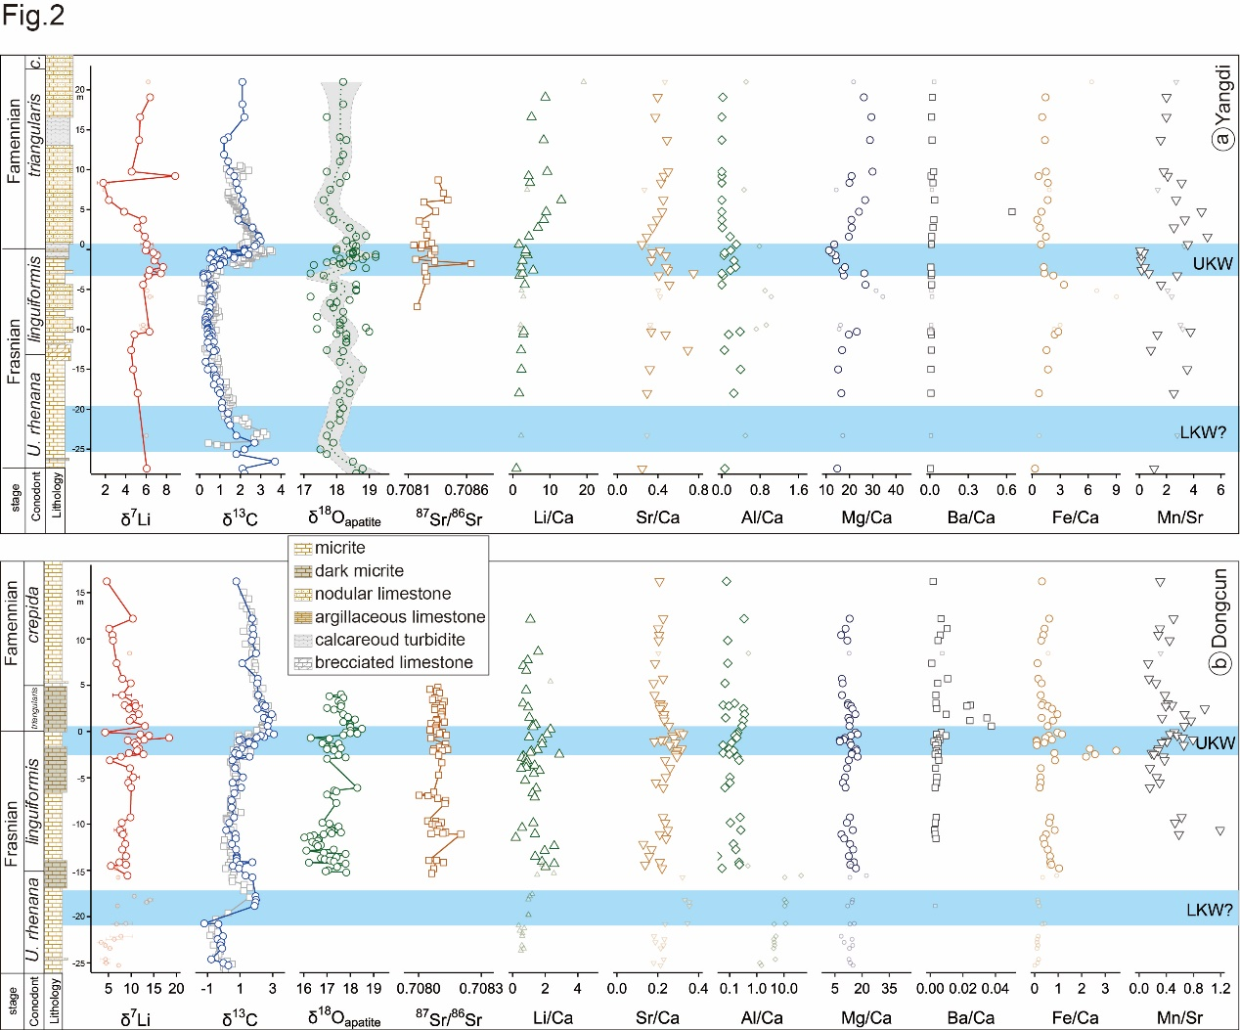
Fig. S1. Depth profiles of Li-C-O-Sr isotope compositions and selected element to calcium ratios of the Yangdi (a) and Dongcun (b) sections. All the Li isotope data and element ratios are for this study. In Yangdi section(a), carbonate δ¹³C data are from Huang et al. (2018) (blue cycles) and Xu et al. (2012) (grey squares); conodont O isotope (δ¹⁸O_{apatite}) data are from Huang et al. (2018); the green dotted line and grey area represents the locfit regression results; Sr isotope data are from Zhang et al. (2020). In Dongcun section (b), carbonate δ¹³C data data are from this study (blue cycles) and Xu et al. (2012) (grey squares); δ¹⁸O_{apatit} data are from Chen et al. (2021); Conodont Sr isotope data are from this study. Li, C, O isotopes data are reported in ‰. The error bars in Li isotope panel are absolute values in 2sd with some smaller than the symbol. Li/Ca ratios are in μmol/mol, other element ratios are in mmol/mol except for Mn/Sr ratios in mol/mol. The smaller and light-colored symbols in the δ⁷C, Li/Ca and Sr/Ca panels represent the samples with Al/Ca ratios higher than 0.4 mmol/mol. The light blue bands represent Upper Kellwasser (UKW) and Lower Kellwasser (LKW) events, respectively. c.: crepida.

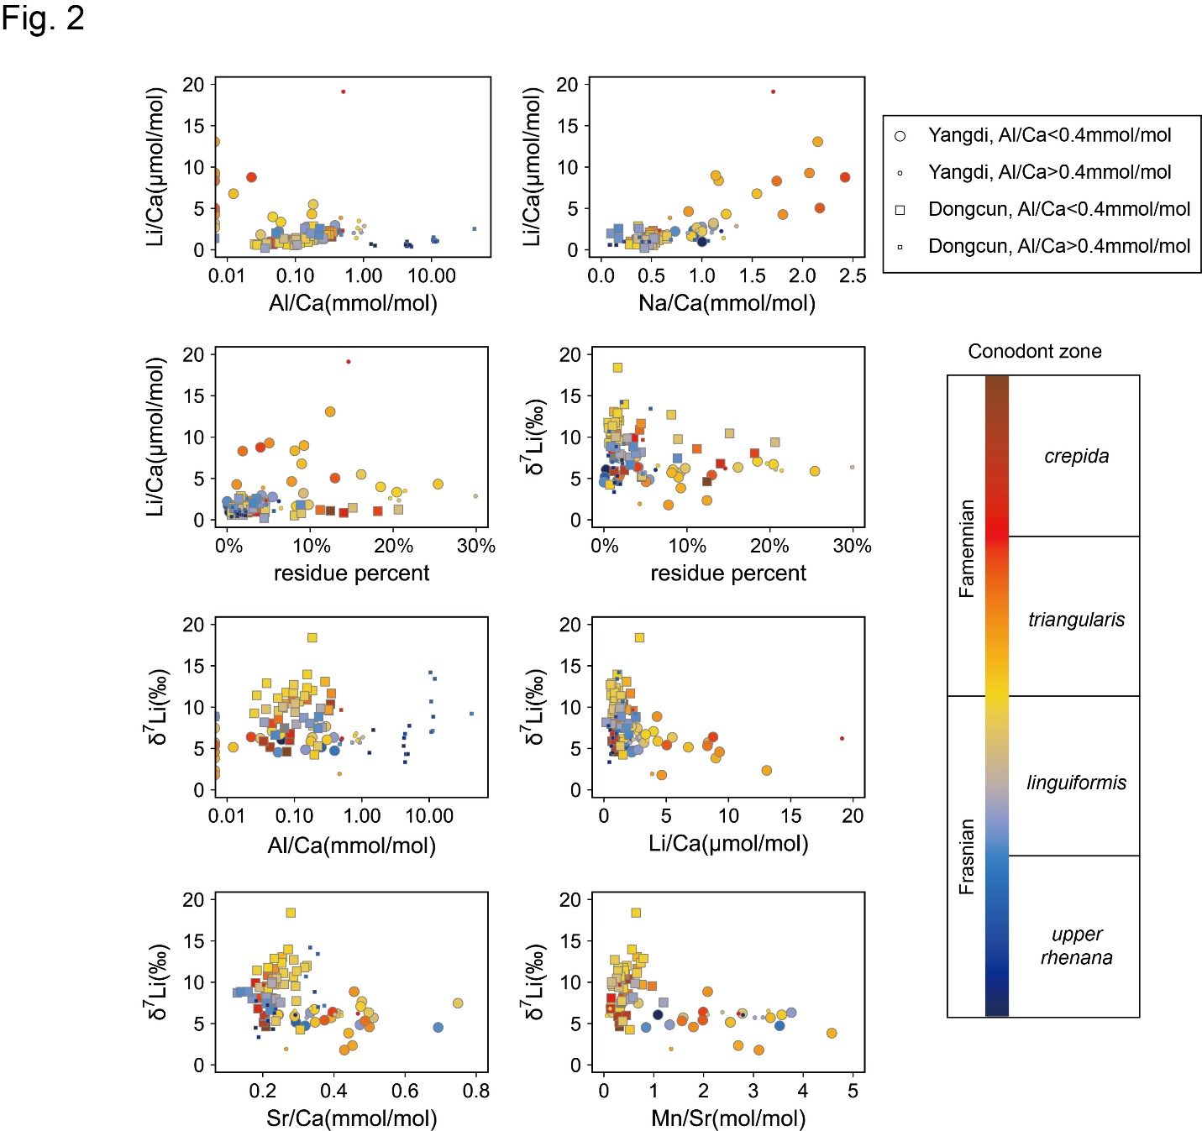
Fig. S2. Correlations between carbonate δ7Li, Li/Ca, Al/Ca, Na/Ca, Sr/Ca, Mn/Sr ratios and insoluble residue percent. The cycle and square represent samples from the Yangdi section and the Dongcun section, respectively. Al/Ca ratios with cut-off value of 0.4 mmol/mol are expressed by different symbol sizes. The position of each sample (conodont zone) is distinguished by gradually varied fill colors.

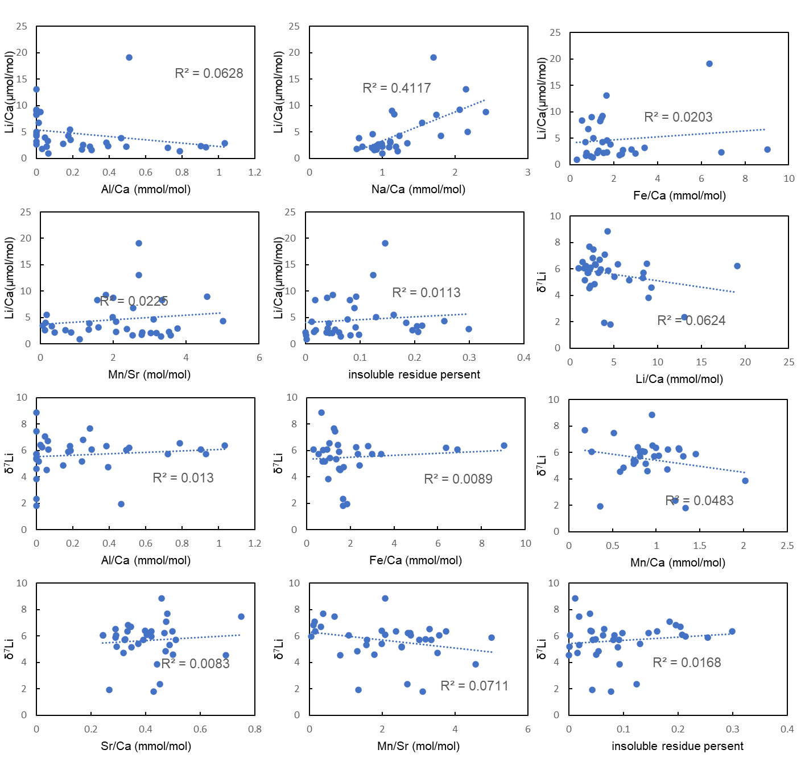
Fig. S3. Correlations between geochemical compositions of the carbonate from the Yangdi section.

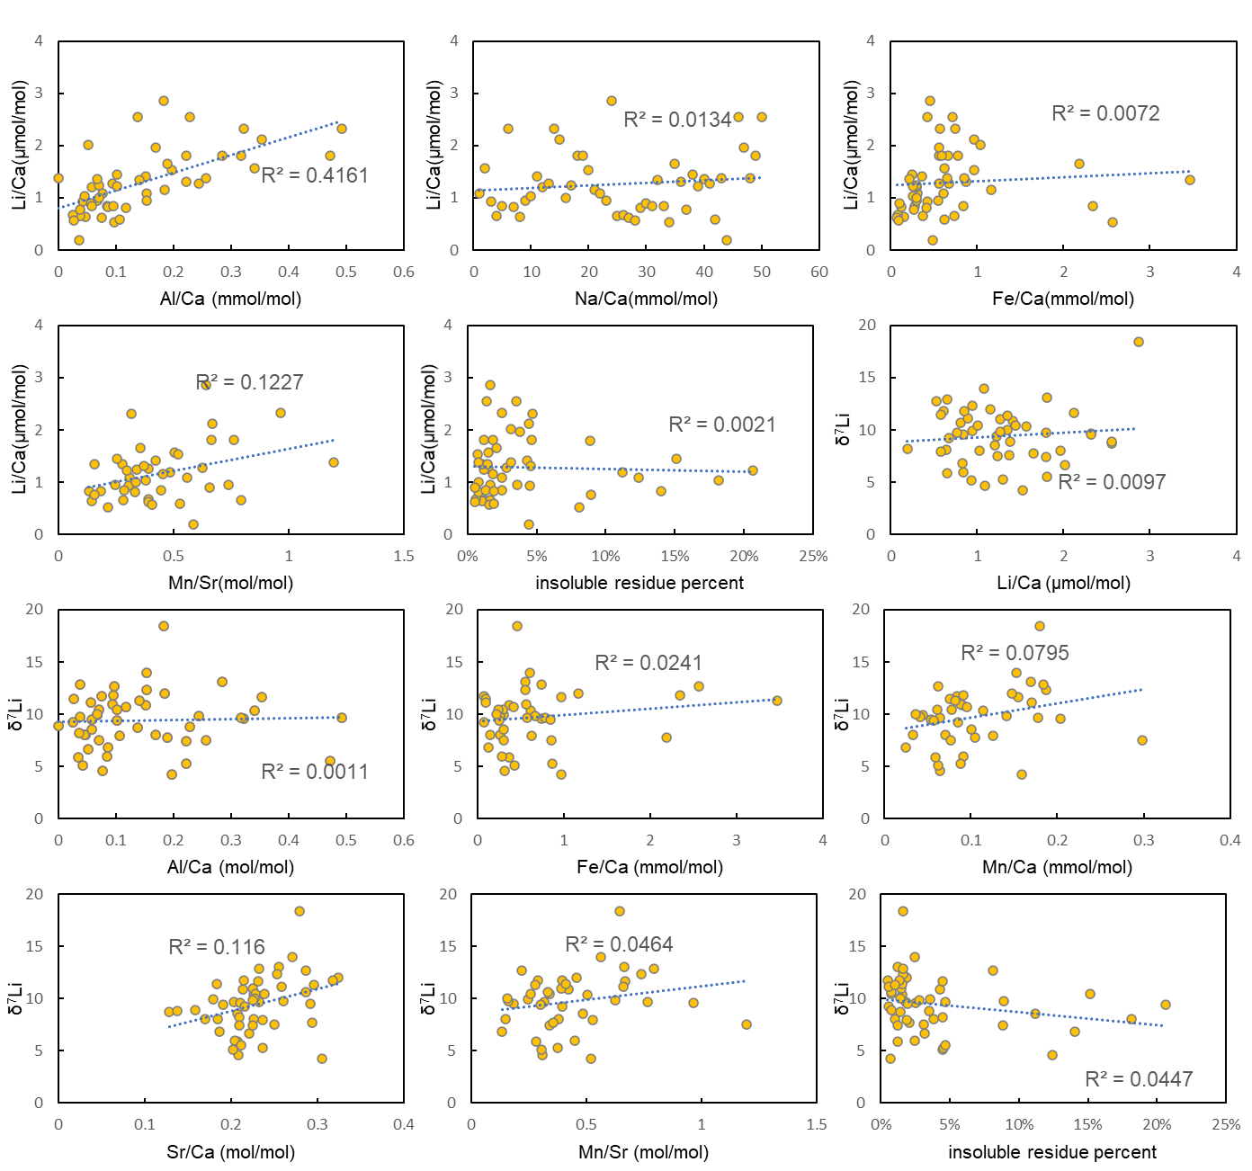
Fig. S4. Correlations between geochemical compositions of the carbonate from the Dongcun section. The samples with very high Al/Ca ratios (>1.2 mmol/mol) are not included.

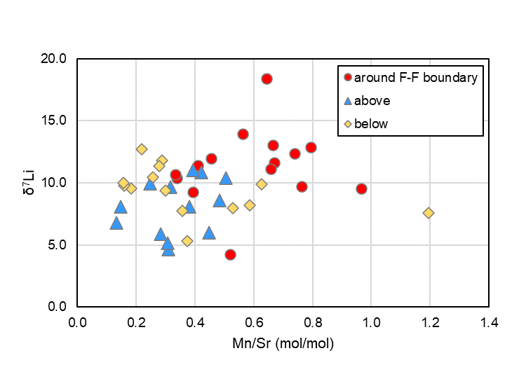
Fig. S5. Contrasting δ⁷Li and Mn/Sr ratios for of the carbonate around the F-F boundary and those far away from the boundary in the Dongcun section

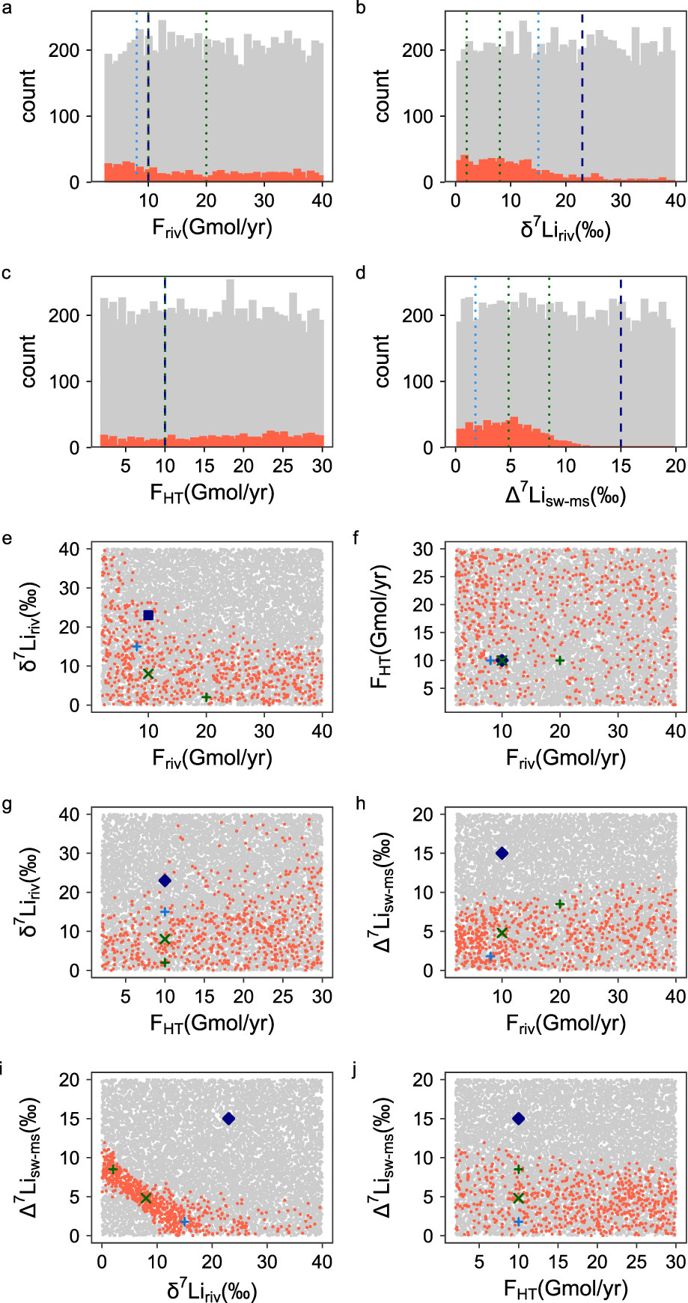
Fig. S6. Correlations between the endmembers associated with ~11.8±1.4 ‰ steady state modeling for seawater Li isotope composition. F represents Li flux (in Gmol/yr) for the corresponding endmember with the subscripts riv being riverine endmember, HT being hydrothermal endmember. Δ⁷Li_{sw-ms} is Li isotopic fractionation factor during reverse weathering. The grey dots are all the random values input into the modeling and the red ones represent the values matching the requirements. The navy dash line (panels a-d) and diamonds (panels e-j) represent modern values (δ⁷Li_{riv}=23 ‰, Δ⁷Li_{sw-ms}=15 ‰) from Huh et al. (1998), Vigier et al. (2008), Li and West (2014) and Murphy et al. (2019). The light blue and dark green dotted line (panels a-d) and crosses (panels e-j) are the initial values used for further modeling.
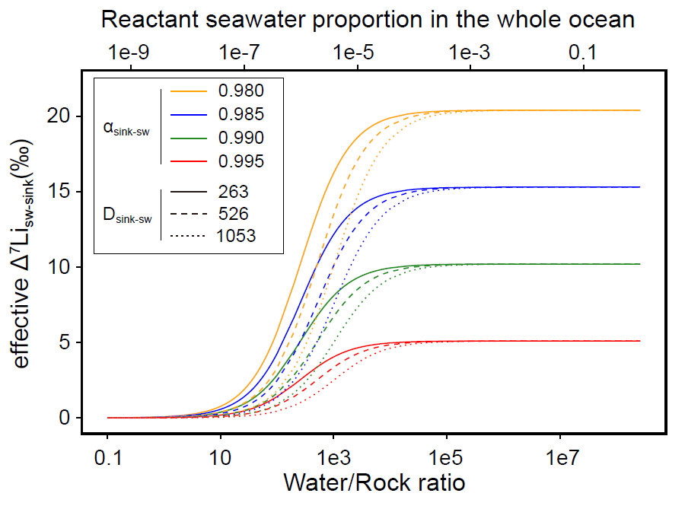

Fig. S7. Water/rock ratio dependent effective Li isotopic fractionation between seawater and the marine sinks (including seafloor weathering and marine authigenic clay mineral formation). Different line colors and line types represent real Li isotopic fractionation factor (α_{sink-sw}) and Li partition coefficient between clay mineral and seawater (D_{sink-sw}) during clay mineral formation.

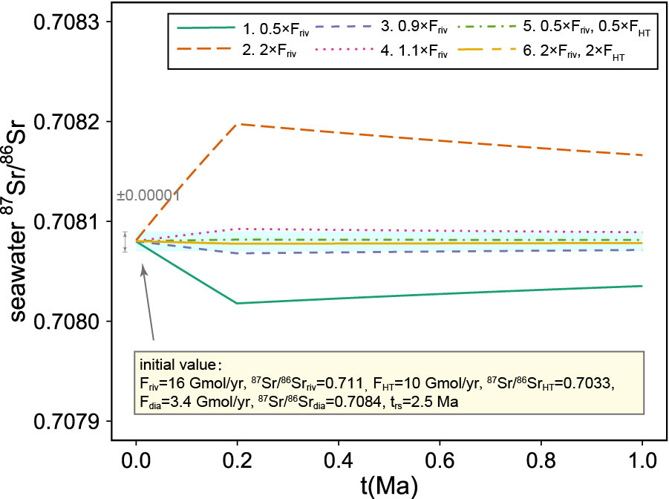
Fig. S8. Modeled seawater ⁸⁷Sr/⁸⁶Sr ratio changes responding to different changes of riverine and hydrothermal Sr flux. The light cyan band represents ±0.00001 variations (measurement uncertainty) for the initial seawater ⁸⁷Sr/⁸⁶Sr ratios. The initial values for each parameter at starting time are listed in the yellow box. F_{riv}, F_{HT} and F_{dia} are riverine, hydrothermal and diagenetic Sr flux, respectively.

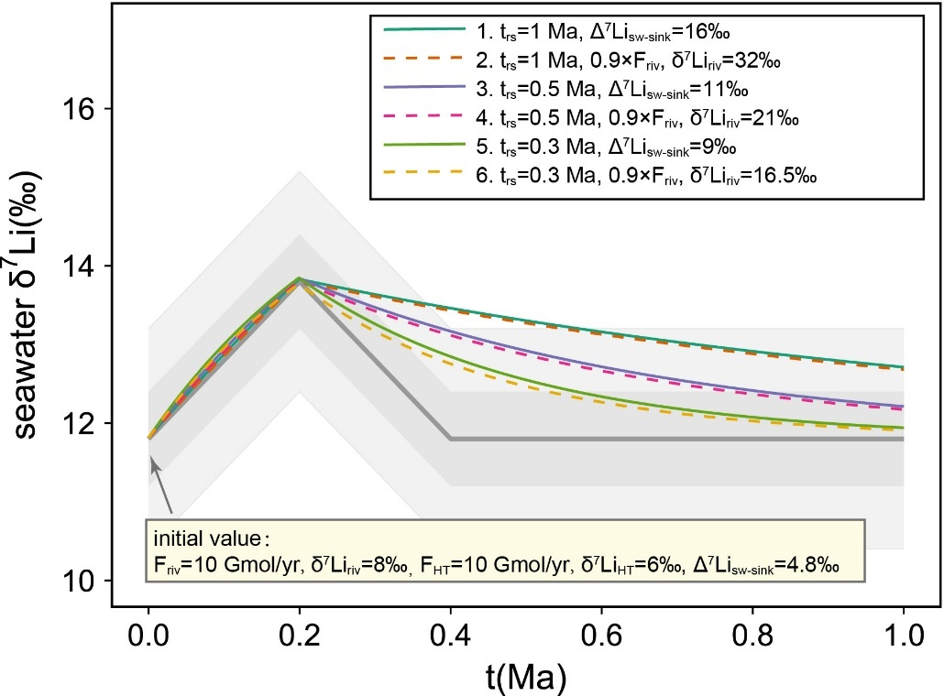
Fig. S9. Modeled seawater δ⁷Li evolution lines at different Li residence time (t_{rs}). The dark grey line denotes the pre-set target line, with grey and light grey bands represent the uncertainty of ±0.6‰ (measurement uncertainty) and ±1.4‰ (overall uncertainty for reconstructed seawater δ⁷Li), respectively. The initial values for each parameter at starting time are listed in the yellow box. The lines with different color and different line types represent different t_{rs} and input parameter values.

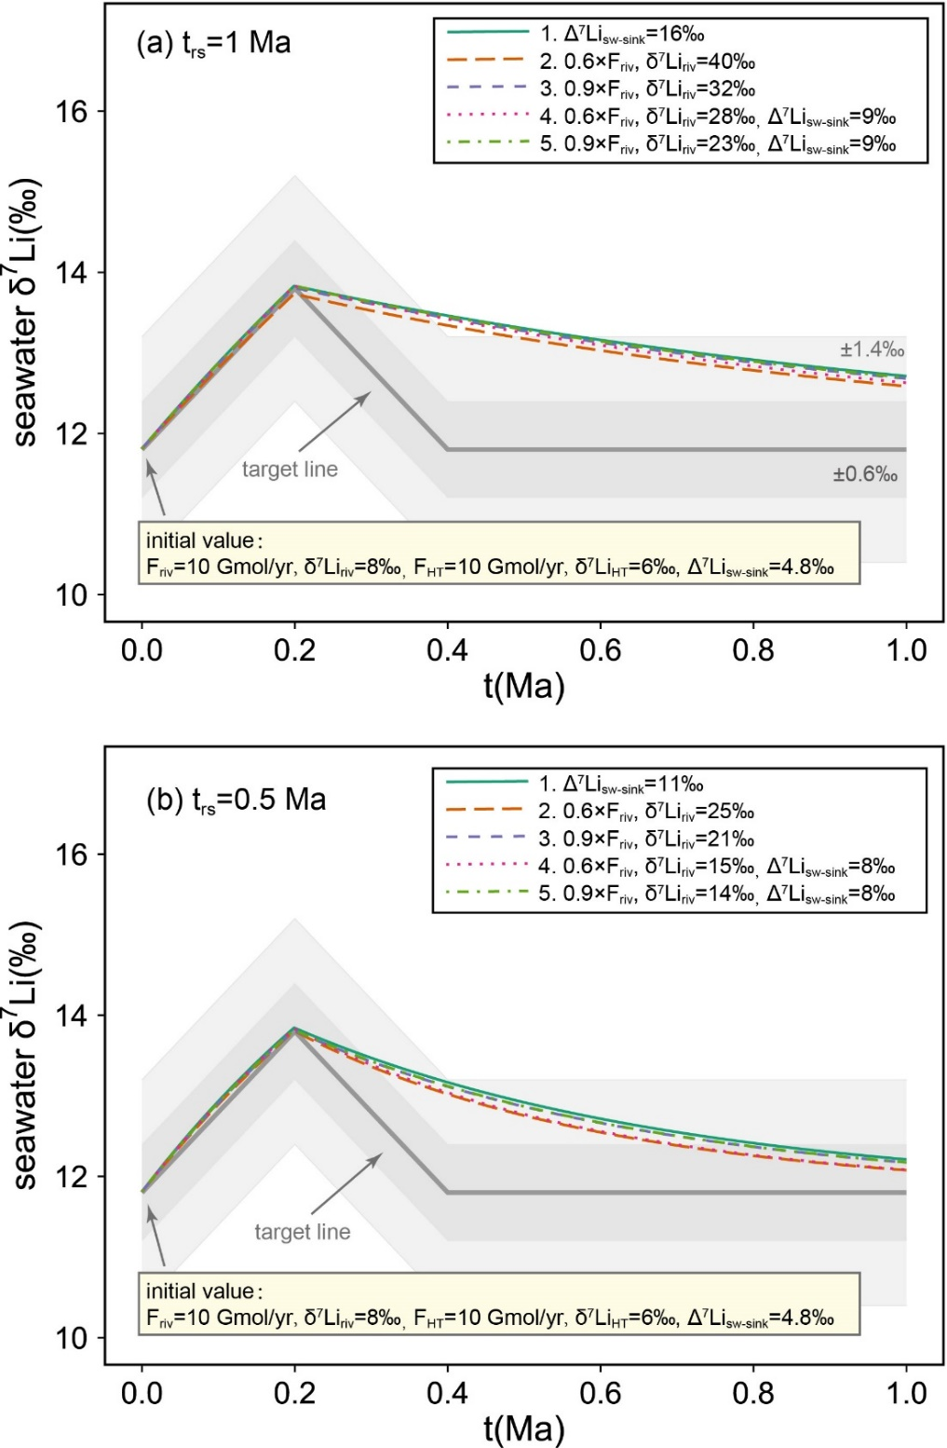
Fig. S10. Modeled seawater δ⁷Li evolution lines by changing different parameters. The Li residence time (t_{rs}) is marked in the upper left corner. The dark grey line denotes the pre-set target line, with grey and light grey bands represent the uncertainty of ±0.6‰ (measurement uncertainty) and ±1.4‰ (overall uncertainty for reconstructed seawater δ⁷Li), respectively. The initial values for each parameter at starting time are listed in the yellow box. F_{riv} and F_{HT} are riverine and hydrothermal Li flux. The lines with different color and different line types represent different input parameter values. The parameters were set to be changed abruptly in the beginning and keep for 0.2 Ma before another abrupt change to the initial value.

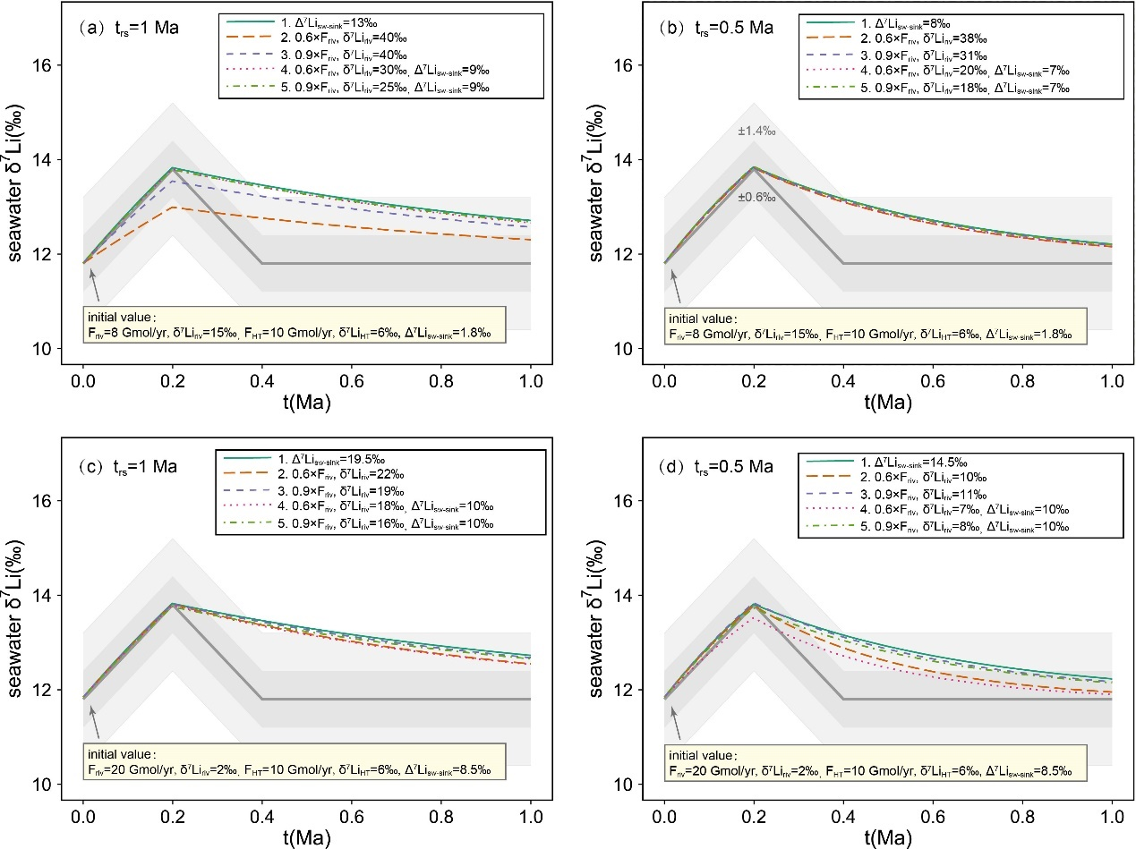
Fig. S11. Modeled seawater δ⁷Li evolution lines using different initial values. The Li residence time (t_{rs}) is marked in the upper left corner. The dark grey line denotes the pre-set target line, with grey and light grey bands represent the uncertainty of ±0.6‰ (measurement uncertainty) and ±1.4‰ (overall uncertainty for reconstructed seawater δ⁷Li), respectively. The initial values for each parameter at starting time are listed in the yellow box. F_{riv} and F_{HT} are riverine and hydrothermal Li flux. The lines with different color and different line types represent different input parameter values. The parameters were set to be changed abruptly in the beginning and keep for 0.2 Ma before another abrupt change to the initial value.
Tables S1-S5 could be seen in separated excel files.

