Using the GFM 4.0 Graphical User Interface to Build, Run, and Review Models: Two Examples

Introduction

When you enter the GFM GUI you will see the GFM welcome screen which identifies the program and shows a picture of the inside of a glass furnace. The most important item on the screen is the main menu bar located at the top of the screen just beneath a standard window style title bar. By clicking on the menu items you can enter into any of the three GFM GUI environments:

- Pre-Processor – where you prepare the inputs required by the GFM CFD application code
- Simulation – where you run and monitor the simulation
- Post-Processor – where you examine the simulation output.

These environments are kept separate; you must return to the welcome screen to move between these environments. Environments are designed so that you can perform your work in one session or do some of your work, save it, exit the GUI, and return at a later session to continue work on the same or on a different furnace.

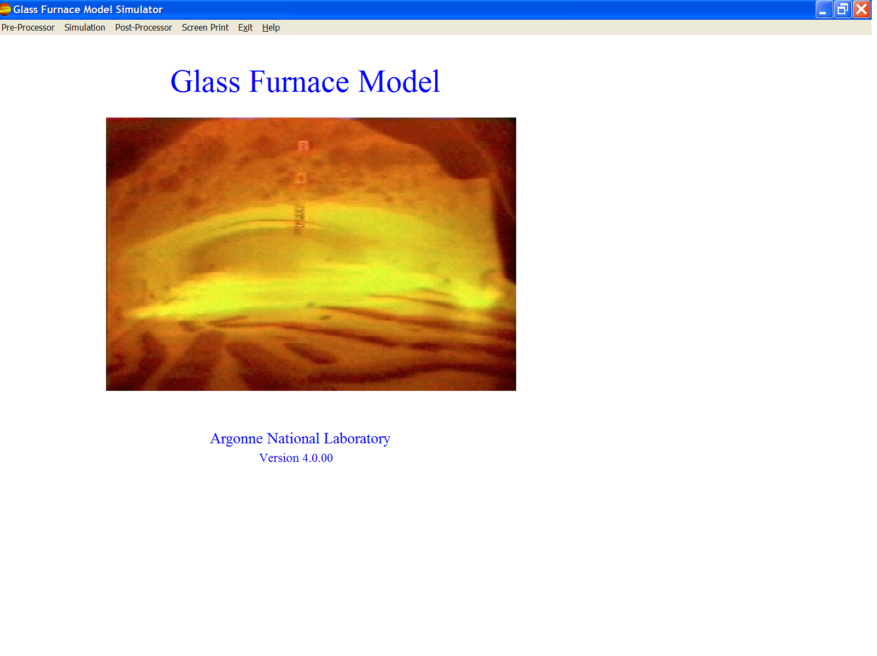
Figure 1. Welcome Screen

Key Terms

Flow Domain. A glass furnace is divided into two distinct flow domains: the upper combustion space and the lower melt space. Usually in this document the word “furnace” refers to the half furnace associated with a specific flow domain. The GFM GUI deals with each of these domains separately and the GFM CFD application has both a combustion code and a melt code used to simulate a furnace. Files created and used by the GUI are kept in either a “combustion” or a “melt” subdirectory for the appropriate flow domain. Most filenames will contain either a “c” or “m” to identify their association with the combustion and melt flow domains respectively.

Case. Each simulation for a given furnace configuration and set of run conditions is identified by a case number. The GFM GUI operates on a case basis rather than on an individual file basis. The case creation, modification, and saving of case data are menu actions within the combustion and melt environments. Corresponding combustion and melt geometries and conditions that are going to be run as a coupled simulation (where melt surface conditions are exchanged between the simulations of the combustion and melt space) must be assigned the same case number by the user. All the files associated with a case will contain the case number within the filename.

Short Work Flow Step List
Example 1: Create a new case from scratch,
Simulate a new furnace design

Start GFM.
In the Pre-Processor environment:
- Select flow domain and create a new case with default furnace.
- Adjust furnace dimensions.
- Modify/add furnace objects (burners, exhausts, etc.).
- Specify physical properties and simulation run parameters.
- Build the grid.
- View the grid.
- Optionally enhance the grid with hand edits.
- Save the case.
- Leave the Pre-Processor environment.
In the Simulation environment:
- Select flow domain and an existing case to start up a CFD simulation.
- Monitor the simulation run.
- Use additional monitoring capability.
- Leave the simulation environment
In the Post-Processor environment:
- Select flow domain and an existing case.
- Look at the simulation output
- Leave the Post-Processor environment.
Exit GFM.
Example 2: Create a new case from a previous case,
Simulate same furnace with different run parameters

Start GFM.
In the Pre-Processor environment:
- Select flow domain and open previous case.
- Save copy of previous case as a new case.
- Adjust simulation run parameters.
- Return to main menu and proceed with simulation and post processing as was done in creating a new case from scratch.
Exit GFM.

Example 1: Create a New Case from Scratch,

Simulate a New Furnace Design

Start GFM
In Pre-Processor environment:
- Select flow domain and create a new case with default furnace.
- From the main menu click on Pre-Processor to display the submenu showing the domain choices.
- Click on the Combustion Space or the Glass Melter menu item to choose the flow domain you want to work in. This action displays a blank screen with the Pre-Processor menu bar.
- Click on the File menu item to display the File submenu items.
- Pass mouse over the File → New Case menu item to get to the submenu showing the choices for the shapes of the furnace. For the combustion flow domain click on either the Box or Crown Top item. For the melter flow domain click on either the Melter or Melter with Refiner item. This action pops up a “Create New Case” dialog window listing the cases already in the appropriate directory, “combustion” or “melt”.
- Enter the new case number and click OK to create the case folder and to pop up a “Case nnnn Description” dialog window requesting that you enter a title and description of the case
- Enter a short, single line title and/or a multi-lined description for the new case. . (You may leave these items blank; they are optional for your use.) Click OK. This action gets rid of the pop-up and displays a figure outline of a default furnace. The figure is not shown to exact scale. The default combustion furnace has one burner labeled b1 and one exhaust, e1. The default melt furnace has one charger labeled c1 and one outlet, o1.
- For the melter with refiner default furnace, the figure has two parts. The upper part shows the full melter with throat and refiner components. The lower part shows one component at a time.
- The screen with the figure is called the figure view.

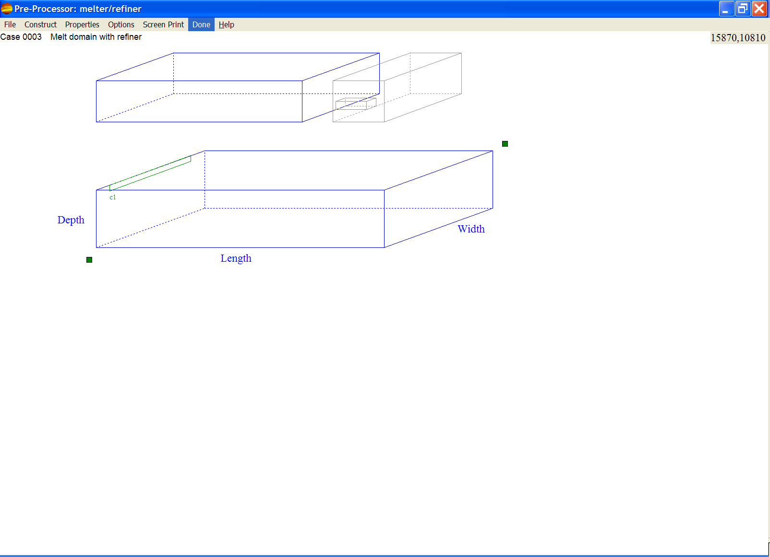
Figure 2. Initial Sample Figure View Showing Melter with Refiner

- Now that the case has been created:
- Construct, Properties, and Options menu items have been added to the menu bar.
- The Update… and Save… submenu items under the File menu item have become active while the other submenu items have become inactive. Even though you just have a default figure on the screen, it does represent a savable case.
- The case number and title appear on the upper left of the screen display area under the menu bar. This information with the case description has also been stored in the casennnn[c|m].txt file, where nnnn is the case number.
- The small green box near the upper right of the figure is a handle that you can grab by holding down with the left mouse button and drag to enlarge or diminish the figure size. An alternative to adjusting the figure size is to use the Options → Zoom menu item.
- The small green box near the lower left of the figure is a handle that you can grab by holding down with the left mouse button and drag to reposition the figure. An alternative to adjusting the figure position is to use the Options → Diagram Position menu item.
- The current mouse coordinates are shown in the upper right corner of the screen. Knowing how to identify a point on the screen may help you to position the figure. The figure’s reference position is the lower left corner of its box.

- Adjust furnace dimensions
- Dimension values are for the interior of the furnace without the walls.
- By default the units are in the SI (metric) system. You may change to the British system by clicking the desired unit system item under the Options → Units menu item.
- The dimension labels on the figure are active. Click on one of them to see the dimension highlighted in red and to get a pop up window in which you can enter a new value. After one dimension is changed, a green geometry list box displays on the lower left of the screen showing all the dimensions with values. For the melter with refiner, the geometry list box consists of multiple boxes. Click on the component names in the first box to choose which component will be displayed in the lower part of the figure.
- Alternatively, clicking on the Construct → Geometry menu item will also display the geometry list box.
- Clicking on any item in the geometry list box or dimension label on the figure will allow you to change that dimension value via a popup input box.

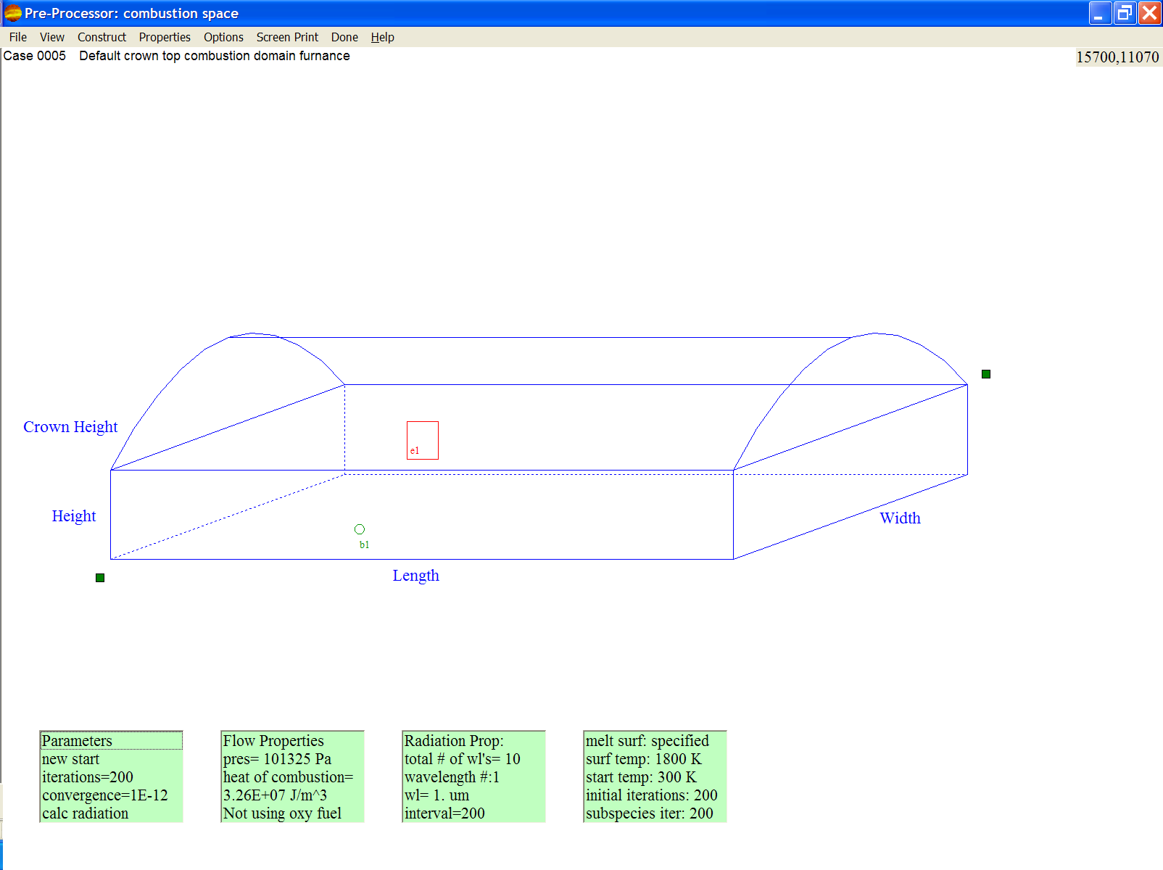
Figure 3. Combustion Figure View with the Green List Boxes

- Modify/add furnace objects (burners, exhausts, etc.).
- Submenu of combustion space furnace objects:
- Construct → Burner (inlet)
- Construct → Exhaust (exit)
- Construct → Components → Dog House (Warning: feature not validated)
- Submenu of melt space objects:
- Construct → Charger (inlet)
- Construct → Outlet (exit)
- Construct → Components → Bubbler (Warning: feature not validated)
- Construct → Components → Electric Booster (Warning: feature not validated)
- Click on any of the object submenu items to get to the list box for that object where you can add, delete, relocate, resize, or change properties associated with the object. Alternatively, click on the top line of the list box to go to the next construct menu item. Note that the list box changes for each object and additional boxes are added to the right of the first list box as needed for a given item. Update the values in the list boxes as desired.
- Clicking on the second line in the leftmost list box will get to the next object of the type identified in the first line of the list box.
- The list box lines function in a variety of ways when clicked and some changes may cause other lines to also be changed:
- An input box pops up so that you can see the current value and modify it.
- The value of the line changes to the next value within a predetermined set of valid values.
- Nothing happens; the line is just a heading.

- Specify physical properties and simulation run parameters
- Submenu of combustion space properties:
- Properties → Emissivities
- Properties → Wall Properties
- Properties → Simulation Parameters
- Properties → Soot Kinetics
- Properties →Radiation Controls
- Submenu of melt space properties:
- Properties → Glass Exit Temperature
- Properties → Glass Properties
- Properties → Wall Properties
- Properties → Simulation Parameters
- Click on the Properties submenu items and update the values as needed. The submenu items function in a variety of ways when clicked:
- Another level of menu items appears.
- An input box pops up so that you can see the current value and modify it.
- The value of the line changes to the next value within a predetermined set of valid values.
- The item toggles between being checked and unchecked.
- Green list boxes appear on the bottom of the screen. Update as needed.
- Choose whether or not the simulation progress will be displayed on the screen (approximately every half minute). Click on either the “Simulation Progress Display On” or “Simulation Progress Display Off” item under the Options → Simulation Display Updates menu item.
- Click on the Options → Collect Run Data menu item to pop up a list of the types of data to collect during the simulation run. Click an entry to check or uncheck which data to collect.

- Build the grid
- Click on the Construct → Grid menu item. This action causes the grid to be built and displayed on the screen. The screen display is called the grid view.

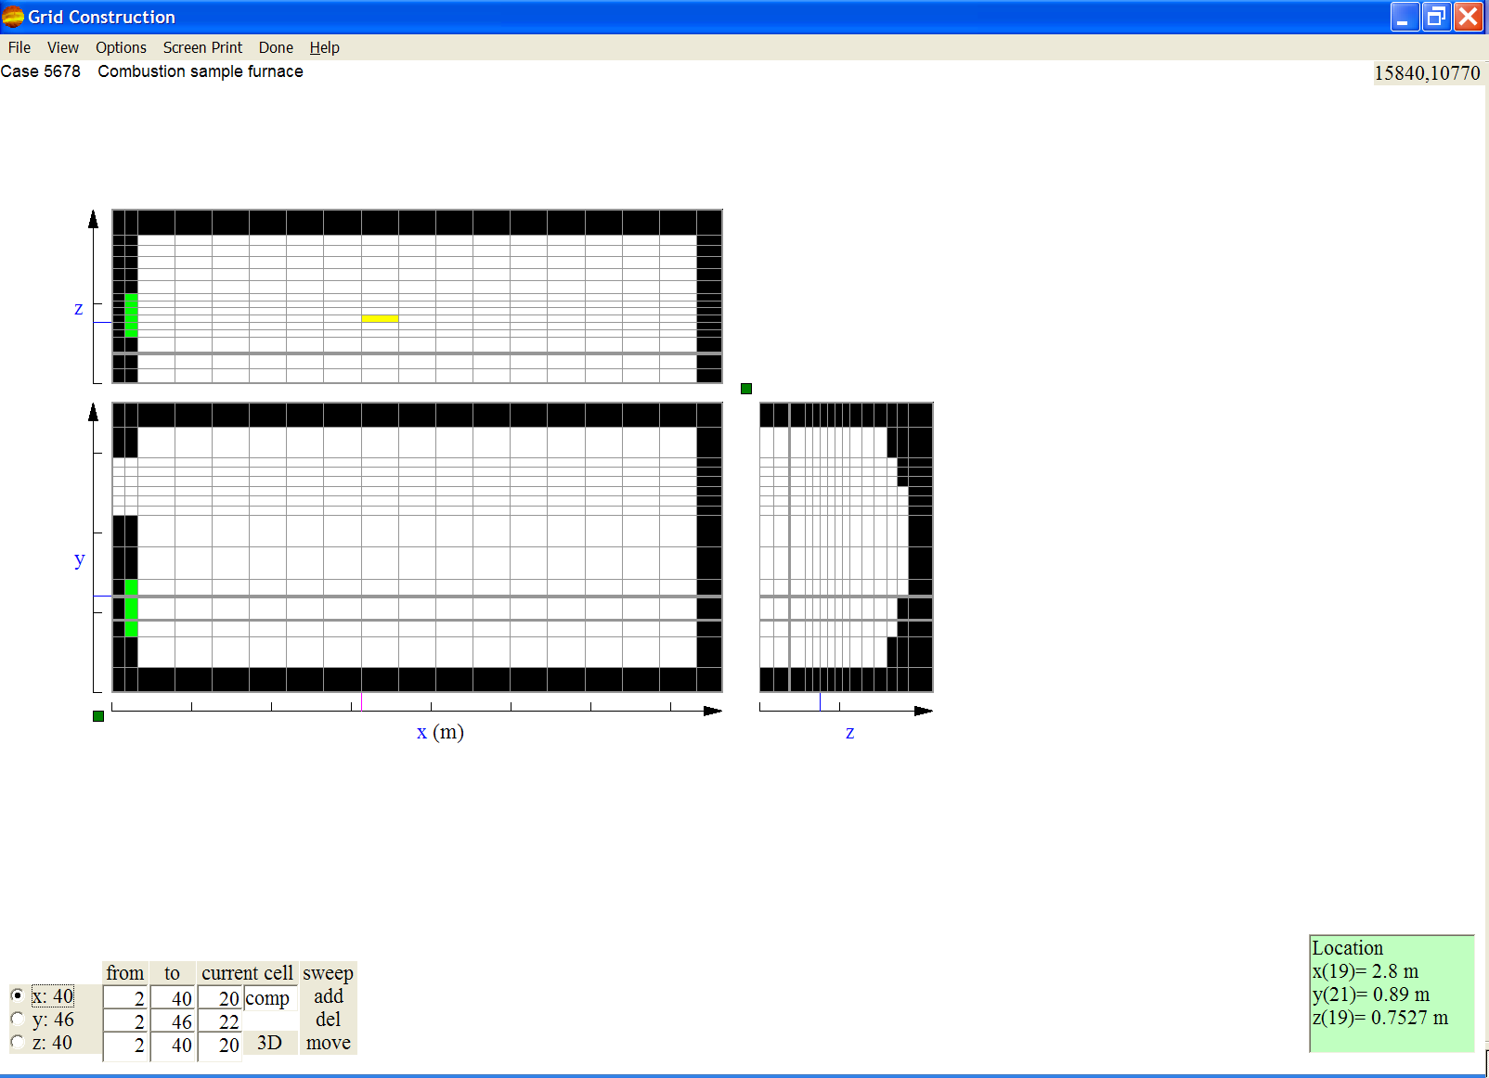
Figure 4. Sample Grid View

- Note the following changes to the screen display:
- The figure is changed to a set of three flat grid planes, one for each dimension, going thru the center cell (determined by grid index, not physical position). The cells are color coded:
  - White for open to flow computational cells
  - Black for walls
  - Cyan for glass melt surface
  - Light green for inlets
  - Bright red for exits
  - Dark red for electric boosters (melt space only)
  - Dark green for bubblers (melt space only)
- The Construct menu item is not present in the grid view.
- After a grid is constructed a new View menu item appears in both the figure and grid views to allow switching between the figure view and the grid view so that you can see how changes in the figure are reflected in the grid. Remember that the grid will need to be reconstructed before changes made to the figure are reflected in the grid.
- A Grid Density submenu appears in the Options menu item. Initially, the grid is built with uniform spacing except for specific grid lines required for object positioning. Optionally use the Grid Density submenu to make the grid denser or courser in all or individual directions. A courser grid will shorten the simulation time and a denser grid will lengthen the simulation time. However, a denser grid may be required for accuracy and to resolve flow features, such as recirculation zones within the flow field.
- A grid control block replaces the list boxes from the figure view in the lower left corner of the screen.
- The location of the current cell is given in grid index values and positions are given as distances from the lower left corner of the grid. These values are displayed in a box in the lower right corner of the screen. The current cell is colored yellow in the grid. The current cell, whose indexes and position are displayed, can be changed by merely clicking on the cell you want to make current. This action causes the displayed grid planes to change so that they intersect the new current cell.

- View the grid.
- You can change how you see the grid by clicking on any of the visible cells to change the current cell to the clicked cell. Or you could change the planes being displayed by clicking in the white space between the grid and any of the labeled axes.
- You can change the unit type via the Options → Units menu item or you could click on the unit designation displayed on the x axis label.
- Look at the grid control block; it will help you view the grid. Consider the block as being a table with rows and columns.
- Column 1 (leftmost) has a radio button for each direction with the associated maximum cell index in that direction. (Cell indexes are even, Cell faces have odd indexes). The active direction radio button is pressed. You can click on these buttons to change the active direction.
- Column 2 shows the beginning cell indexes.
- Column 3 shows the ending cell indexes.
- Column 4 shows the current cell indexes.
- Column 5 shows the current cell type and color in the second row and a dimension indicator in the fourth row. You can click on this indicator to change between the flat 2D and grid slices in a 3D view.
- Column 6 shows a set of grid controls. These controls will vary between the GUI environments. Use the top control sweep at this step. Clicking sweep automatically displays successive grid planes in the current direction in either 2D or 3D slices and changes the control label to stop. When you want to stop the sweeping, click stop and the label will change back to sweep.
- Changing values of beginning and ending cell indexes in columns 2 and 3 of the grid control block allows zooming in on portions of the grid by clipping the displayed portion to these limits. The resize handle at the upper right of the xy-plane can be dragged to enlarge the view of the clipped region.
- Switch back and forth between the figure view and grid view as needed to assist in modifying the grid to best represent the furnace.

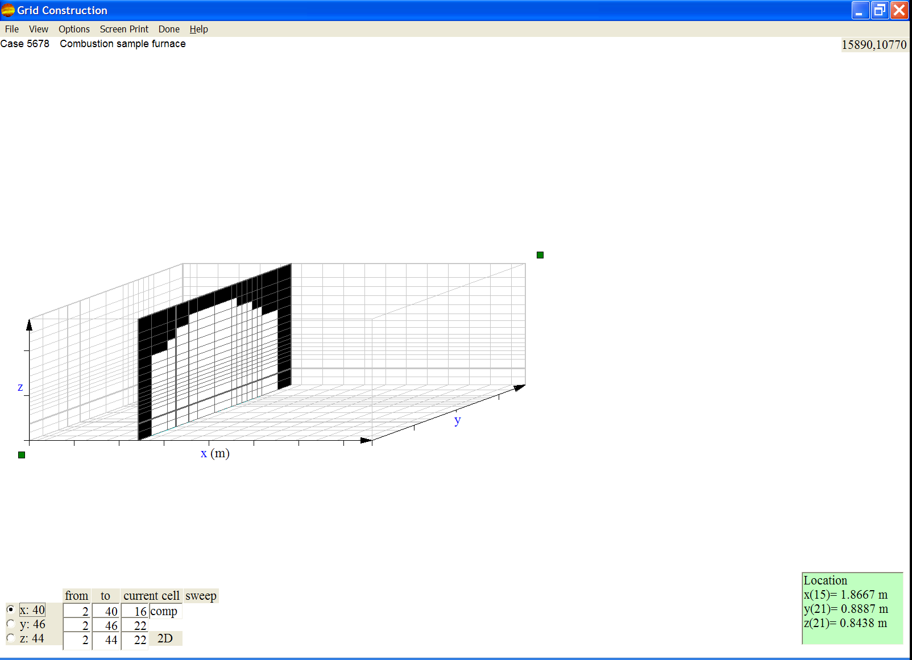
Figure 5. Sample Grid View in 3D Mode

- Optionally enhance the grid with hand edits.
- Enhancements include adding, deleting, and moving individual grid lines. They also include changing grid cell types.
- Examples of why you might want to enhance a grid:
- You are particularly interested in the flow pattern near a specific grid object. Then you would add more grid lines in that neighborhood to get more details of the flow there.
- You know the simulation will take a long time. There is a region of the furnace that is devoid of objects and flow pattern, temperature, etc. are expected to change slowly with distance. Then the grid can be made coarser in this region by deleting some of the grid lines in this region to speed up the simulation.
- The furnace contains a shelf or baffle. You need to represent those items by changing the associated grid cells from the open cell type to the wall type.
- To add a grid line, select the current cell and direction of the add by clicking one of the x, y, or z radio buttons in column 1 of the grid control block. Note that this direction choice determines the orientation of the grid line to be added. Then click the add control in column 6 of the grid control block. This action puts a new grid line thru the middle of the current cell.
- To delete a grid line, select the current cell and direction of the delete by clicking one of the x, y, or z radio buttons in column 1 of the grid control block. Note that this direction choice determines which grid line will be deleted. Then click the del control in column 6 of the grid control block. This action deletes the grid line that was the lower index of the current cell for the given direction.
- To move a grid line between the current and the previous cell, select the current cell and the direction of the move by clicking one of the x, y, or z radio buttons in column 1 of the grid control block. Note that this direction choice determines which grid line will be moved. Then click the move control in column 6 of the grid control block. This action will highlight in yellow the 2 grids lines that you will be moving between and it will pop up a box in which you can specify the location you want the line to be moved to between the highlighted lines.
- To change the current cell type, click on the control in column 5 row 2 until the desired type appears.
- To change the cell type of a block of cells:
  - Click on the current cell label on the top of columns 4 and 5. It will change to select cells.
  - Move the current cell to the desired beginning location (which is the lower left corner of the block you want to change) and click the from label on the top of column 2.
  - Move the current cell to the desired ending location (which is the upper right corner of the block you want to change) and click the to label on top of column 3.
  - Click the desired cell type in column 5.
  - Click the select cells label. It will change back to current cell.
- Note that the inlet cell type should not be changed. Inlets are determined by the positions of the burners in combustion flow and of chargers in the melt flow as indicated by the information from the figure view. Go back to the figure view to change inlets.
- Note that the exit cell type should not be changed. Exits are determined by the positions of the exhausts in combustion flow and of outlets in the melt flow as indicated by the information from the figure view. Go back to the figure view to change exits.
- Up to this step the information for the figure and grid has been kept consistent. However with hand edits, the grid information diverges from the figure information and the grid cannot be reconstructed without destroying the hand edits. But, you can still switch between views and modify parameters and properties.
- The GUI will warn you about this situation when you attempt to make your first enhancement to the grid. It will also put the pre-processor into Protect-Grid-Edits mode as indicated by the Options → Protect-Grid-Edits menu item being checked. In this mode, modifications which would require the grid to be constructed are disabled. You may get out of the protect mode by clicking the Options → Protect-Grid-Edits menu item to uncheck it.
- Save the case.
- Click on the File → Save Case menu.
- If the grid is not enhanced and the grid has been modified after being constructed, then the GUI will reconstruct the grid.
- The GUI creates three files (where nnnn is the case number and “c” is changed to “m” for the melt flow domain):
- pre-process file, gdnnnnc.pre. This file is needed if you ever want to change information in the figure view again.
- grid file, gdnnnnc.dat. This file is required input to the GFM CFD code.
- conditions file, sbcnnnnc.dat. This file is required input to the GFM CFD code.
- In the combustion domain, the GUI will create a default information transfer file, itnnnnt.dat, when the melt surface temperature had been specified in the rightmost Simulation Parameters green list box. An itnnnnt.dat file is created during a melt domain simulation run; it will contain the calculated melt surface temperature.
- In the melt domain, the GUI will create a default information transfer file, itnnnnm.dat, when a uniform heat flux had been specified in the rightmost Simulation Parameters green list box. An itnnnnm.dat file is created during a combustion domain simulation run; it will contain the calculated melt surface heat flux.

- Leave the Pre-Processor environment.
- Click on the Done menu item to return to the main GUI menu.

In the Simulation environment:
- Select flow domain and an existing case to start up a CFD simulation.
- From the main menu click on Simulation to display the submenu showing the domain choices.
- Click on the Combustion Space, Melter, or one of the Cycle menu items to choose the type of simulation to run. (For information about cycling, click on the Help menu and then on the “Cycling” item in the pop-up box.) This action pops up a “Select Existing Case to Simulate” dialog window listing the cases already in the appropriate directory, “combustion” or “melt”.
- Select the previous case you saved in the Pre-Processor by clicking on its filename and click Simulate to start the simulation. This action also brings up a new screen display that is similar to the grid view with the following changes:
- The View menu item is deleted from the menu bar.
- The File and Options submenus have fewer active items.
- The Done menu item is replaced by the Stop Run menu item.
- The location box from the lower right corner has been removed.
- A status box (actually two boxes) is displayed at the bottom center of the screen indicating that the simulation is being initialized.
- The grid controls in column 6 of the grid control block have changed.

- Monitor the simulation run.
- As soon as the CFD simulation has been initialized and is reporting status information to the GUI, the grid on the screen display is replaced with a colored plot of the temperature or radiation energy in the simulated furnace and more status information is displayed in the status box. This screen display is the plot view. It is frequently updated while the simulation runs – for minutes, hours, or days depending on the complexity and size of the furnace and the density of grid cells.
- Note that if the “Simulation Progress Display Off” item under the Options → Simulation Display Updates menu item has been checked, then the grid will not be replaced with the colored plot and status information will not be displayed in the status block. You can change the display off and on while the simulation is running. Turning the display off will speed up the simulation.
- You can change the plot from color to black and white by clicking the B/W control in column 6 of the grid control block. Then you can change the plot back to color by clicking the control again when it is labeled color.
- You can show the grid temporarily rather than the plot by clicking the grid control in column 6 of the grid control block. You can change the current cell position, as you could on a grid view in the pre-processor, to see different planes thru the plot.
- You can pause the plot by clicking on the pause control in column 6 of the grid control block and then allow it to be updated again by clicking the (same) auto control. One thing you might want to do while the plotting is paused is to click on the Screen Print menu item to make a bitmap file of the screen display without having the plot changed during the screen capture.
- The CFD simulation normally ends when either the convergence criteria or the maximum number of iterations (previously specified as parameters on the figure view) has been met. Then the small box in the upper right corner of the grid control block will turn bright green and show the cont label (meaning continue). The Stop Run menu item will also change to Done.
- You could decide to stop the simulation earlier by clicking the Stop Run menu item or the stop label in the upper right corner of the grid control block. The grid control will change to ending after the request to stop the simulation has been sent from the GUI to the CFD simulation. The label will be changed to cont after the GUI recognizes that the CFD code has stopped.

- Use additional monitoring capability.
- When the CFD code is running, a command prompt window will exist for the combustion or melt executable program. This window is normally minimized to a small icon entry on the bottom bar of the screen. If this window does not exist, then you know that the CFD code is not running. You can maximize the window to see ongoing status information.
- Click on the Options → Activate RunPlot menu item to start up the RunPlot program which will display lines for various data collected during the simulation. Note that you could specify what extra data to collect when you were in the Pre-Processor environment and clicked on the Options → Collect Run Data menu item.
- You may start up multiple instances of the RunPlot program. (For information about this program, click on the Help menu and then on the “RunPlot” item in the pop-up box.)

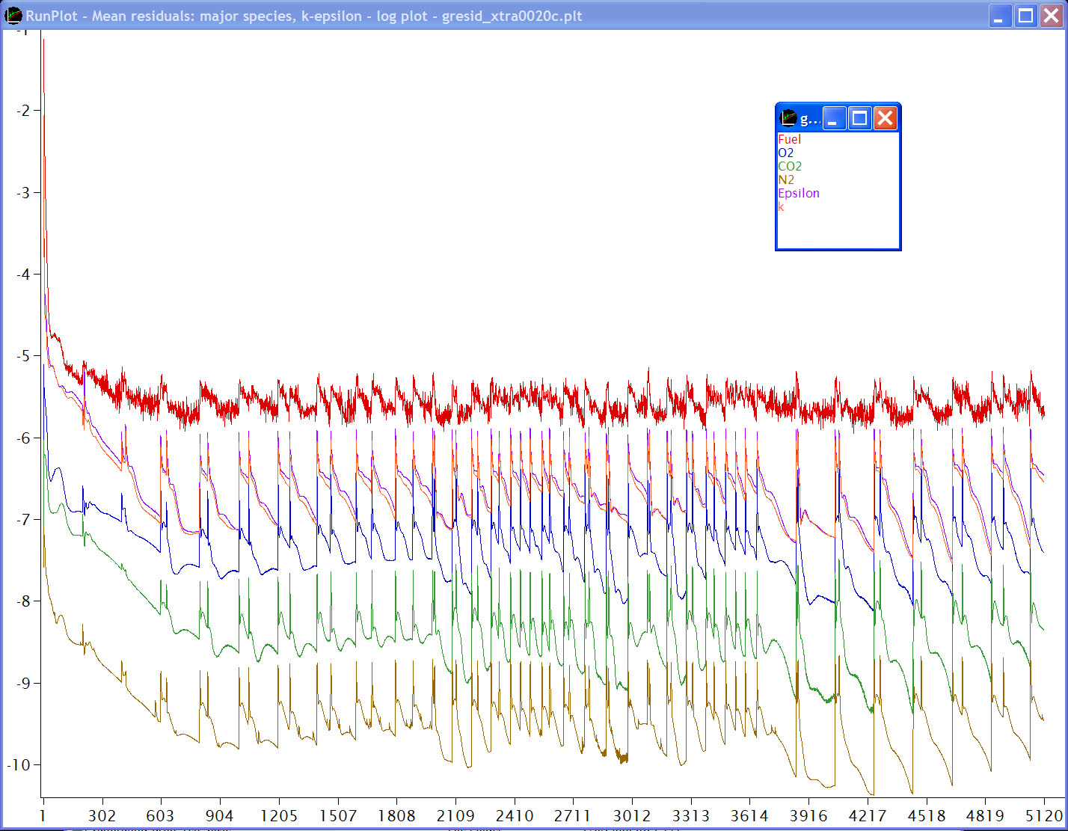

Figure 6. Sample RunPlot Logarithmic Display with Legend Window Superimposed

- Leave the simulation environment.
- When you see the small green box with cont you can restart the simulation run (to continue from where it stopped) by clicking the cont or you can return to the main menu by clicking the Done menu item.

In the Post-Processor environment:
- Select flow domain and an existing case.
- From the main menu click on Post-Processor to display the submenu showing the domain choices.
- Click on the Combustion Space or the Melter menu item to choose the flow domain you want to work in. This action pops up an Open dialog window listing the cases already in the appropriate directory, “combustion” or “melt”.
- Select the previous case you simulated by clicking on its filename and click Open to load the simulation results. This action also brings up the plot view screen display with the following changes:
- The File submenu allows you to open up a different case to look at simulation outputs.

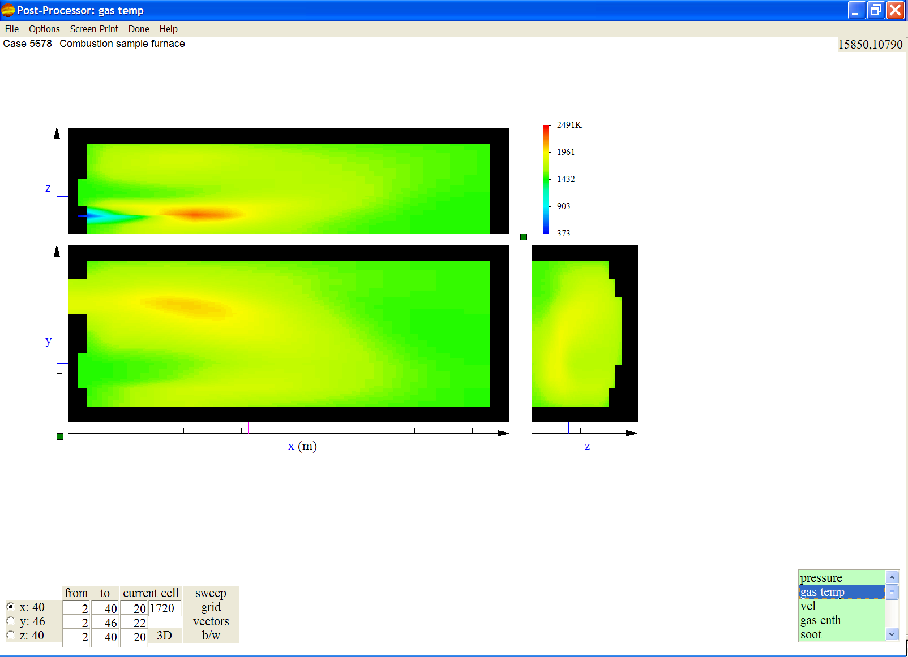
Figure 7. Sample Plot View

- A scrollable list of output field variables is shown in the lower right corner of the screen. The first variable in the output list is displayed on the plot.
- There is no need for the simulation status box so it is not displayed.
- The grid controls in column 6 of the grid control block have changed.

- Look at the simulation output.
- Click on the variable list item that you want displayed.
- You can use the same viewing techniques that were described in step 6 above.
- Click on the Options → Plot submenu items or on the controls in column 6 of the grid control block to change how the plot is displayed. The sweep and B/W controls have already been explained. When you click the grid control, the grid lines will be superimposed on the plot. When you click on vectors, the velocity vectors will be superimposed on the plot. The grid and vectors will be removed when you click on an output variable.
- You may also start up the RunPlot program after the simulation has been stopped by clicking on the Options → Activate RunPlot menu.
- Leave the Post-Processor environment.
- Leave the Post-Processor environment of the GUI by clicking the Done menu item to return to the main menu.

- Exit GFM by clicking the Exit menu item.

Example 2: Create a New Case from a Previous Case,

Simulate Same Furnace with Different Run Parameters

Start GFM.

In Pre-Processor environment:
- Select flow domain and open a previous case.
- From the main menu click on Pre-Processor to display the submenu showing the domain choices.
- Click on the Combustion Space or the Melter menu item to choose the flow domain you want to work in. This action displays a blank screen with the Pre-Processor menu bar.
- Click on the File → Open Case menu item to display a “Select Existing Case to Open” dialog window listing the cases already in the appropriate directory, “combustion” or “melt”.
- Select the case filename and click Open to open the case and display the figure view. If the case grid had been enhanced then the case will come up in the protect-grid-edits mode.

- Save copy of previous case as a new case.
- Click on the File → Save Case As (Setup Only) menu item to display another “Create New Case” dialog window.
- Enter a new case number and click OK. The files in the old case are copied and the new files are named with the new case number.

- Adjust simulation run parameters.
- Click on the Properties → Simulation Parameters menu item to display parameter list boxes.
- Update the parameters as desired.
- Click on the File → Save Case menu item.

- Return to the main menu by clicking the Done menu item and proceed with simulation and post processing as was done for a new case from scratch.

Exit GFM.

