1D: 10x10
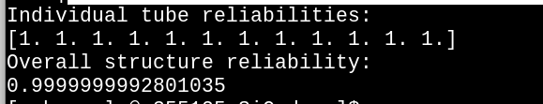
1D: 10x20
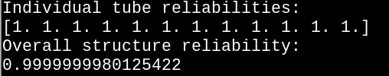

1D: 20x20

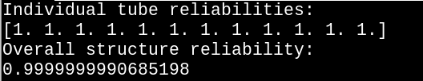

Weibull Normal Tensile Stress model predictions for 1D: (nalpha,nbeta) = (100,100)
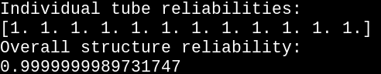

PIA model predictions:
